CHEM 121 2018 CA ASSIGNMENT MARK SCHEME
Note: extra sf will not be penalised but rounding errors which result in an answer not correct to 3sf will be penalised
1. | (a) | C₈H₁₈ + 12.5O₂ 8CO₂ + 9H₂O (1)
 | (b) | moles of octane = 1000/114 = 8.77 moles (1)  energy released = 5740 x 8.77 = 50,400 kJ (1)
 | (c) | Moles of octane = 100000/5740 = 17.4 moles so moles of CO₂ = 17.4 x 8 = 139 moles (1)  Mass of CO₂ = 139 x 44 = 6132 g or 6.13 kg (1)  [5]
2. | (a) | ΔT = 45.4 – 18.1 = 27.3 ºC and mass of alcohol burned = 208.8 – 208.58 = 0.22 g (both = 1)  q = 50 x 4.18 x 27.3 = 5706 J (1)  moles of alcohol = 0.22/74 = 0.00297 (1)  molar enthalpy change = 5706/0.00297 = -1920 kJmol⁻¹ (1) must be negative
 | (b) | Heat loss from the flame to the surrounding air (1)  [5]
3. | (a) | 2AgNO₃ + Zn Zn(NO₃)₂ + 2Ag (1)
 | (b) | q = 3.2 x 4.18 x 50 = 668.8 J (1)
 | (c) | Moles of AgNO₃ = 0.2 x 50/1000 = 0.01 (1)  So moles of Zn = 0.01/2 = 0.005 (1)  Molar enthalpy change = 668.8/0.005 = -133760 Jmol⁻¹ or -134 kJmol⁻¹ must be negative (1)  [5]
4. | (a) | Bonds broken = 4 C-H, 1 C-C, (1 C=O), 2.5 O=O = 3980 (or 3244) (1)  Bonds formed = 4 x O-H, 3/4 x C=O = 4800 (or 4064) (1)  ΔH = 3980 - 4800 = -820 kJmol⁻¹ (1)
 | (b) | Bond enthalpies are mean values; specific bond enthalpies in reactants and products may differ (1)  Water is a gas in above equation but liquid in standard enthalpy of combustion (1)  [5]
5. | (a) | C₄H₁₀(g) + 6.5O₂(g) 4CO₂(g) + 5H₂O(l) species and balanced (1) state symbols (1)
 | (b) | ΔH = ΣΔH_{f}(p) - ΣΔH_{f}(r) or correct cycle (1)  = 4 x (-394) + 5 x (-286) – (-126) (1)  = -2880 kJmol⁻¹ (1)  [5]
6. | (a) | 4C(s) + 2H₂(g) + 2O₂(g) C₄H₄O₄(s) species and balanced (1) state symbols (1)
 | (b) | ΔH = ΣΔH_{c}(r) - ΣΔH_{c}(p) or correct cycle (1)  = 4 x (-393.5) + 2 x (-285.8) – (-1356) (1)  = -789.6 kJmol⁻¹ (1)  [5]
7. | (a) | Ti(s) + 2Cl₂(g) TiCl₄(l) species and balanced (1) state symbols (1)
 | (b) | ΔH = ΣΔH_{f}(p) - ΣΔH_{f}(r) or correct cycle (1)  -232 = x + (-394) – (-912) so x = -232 + 394 – 912 (1)  = -750 kJmol⁻¹ (1)  [5]

8. | (a) | Ca(s) + F₂(g) CaF₂(s) (1)
 | (b) | As below, but Ca should replace Mg and F should replace Cl  Clear cycle showing species and states on each line (1)  Correct states, multiples and shape (1)  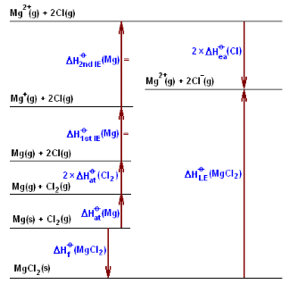
 | (c) | ΔH_{f} = 193 + 2(79) + 590 + 1150 + 2(-348) – 2611 (1) (-2611 is the correct value for LE, not +193)  = -1216 kJmol⁻¹ (1)  Note: using the incorrect value for LE (+193) given in the original assignment, answer = +1588 kJmol⁻¹  [5]
9. | (a) | 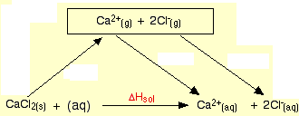  Lattice dissociation and hydration (1) balanced (1)
 | (b) | CaCl₂(s) Ca²⁺(aq) + 2Cl⁻(aq) (1)
 | (c) | 2(-364) + (-1650) – (-2237) (1)  = -141 kJmol⁻¹ (1)  [5]

