DEPARTMENT OF CHEMISTRY
FOURAH BAY COLLEGE
UNIVERSITY OF SIERRA LEONE

CHEM 311

PHYSICAL ANALYTICAL CHEMISTRY II

Unit 2 – Electroanalytical Techniques

CONTINUOUS ASSESSMENT
ASSIGNMENT

This assignment must be submitted no later than 2 pm on Friday March 23rd 2018
You must submit this cover sheet with your assignment.

Name: ……………………………………………………

Admission No. ………………..

Note:
Unit 2 Continuous Assessment is worth 10% of the total marks for CHEM312
Your score will be divided into three parts:
Lecture and Tutorial Attendance 10%
Assignment 40%
Test 50%

1. | (a) | (i) M1: potentiometric titration  (ii) M2: amperometric titration  (iii) M3: polarography  (iv) M4: chronopotentiometry
 | (b) | (i)  (ii)  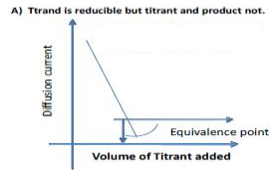  (iii)  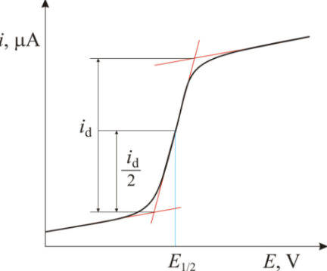  (iv)  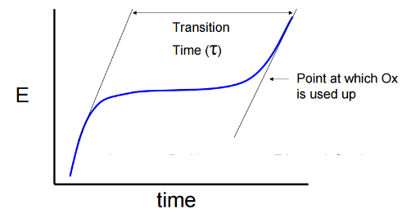 |  | M5: potential on y-axis, volume on x-axis  M6: shallow-steep-shallow in either direction  M7: current on y-axis, volume on x-axis  M8: either V-shaped or obtuse angle flat before or after intersection  M9: current on y-axis, potential on x-axis  M10: shallow-steep-shallow in either direction  M11: potential on y-axis, time on x-axis  M12: steep-shallow-steep in either direction
 | (c) | - M13: constant current  M14: potential depends on concentration of electroactive species  - M15: constant potential  M16: current depends on concentration of electroactive species  - M17: diffusion current depends on concentration of electroactive species  M18: half-wave potential depends on identity of electroactive species  - M19: constant potential  M20: transition time depends on concentration of electroactive species
 | (d) | - M21: burette and beaker  M22: electrodes and voltmeter  - M23: burette and beaker  M24: electrodes and ammeter  - M25: dropping mercury electrode and non-polarisable electrode  M26: potentiometer and galvanometer  - M27: electrodes, digital timer and voltmeter  [max 25]
2. | 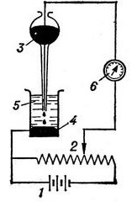  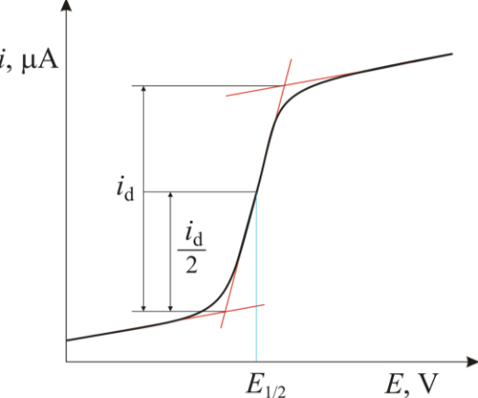 |  | M1: polarograph – apparatus used in polarography  M2: diagram showing DME and one other electrode  M3: diagram showing potentiometer, cell and galvanometer  M4: polarogram – graph produced in polarography  M5: diffusion current shown on diagram as vertical distance between shallow sections  M6: half-wave potential shown as mid-point of steep section  [max 5]
3. | Describe the main features of a dropping mercury electrode and explain why it is useful in polarography.  M1: mercury drops slowly through a capillary onto the anode  M2: the electrode is polarisable (it is difficult for current to actually flow)  Any two from:  M3: The dropping continually exposes fresh electrode to the electrolyte  M4: This prevents the products of electrolysis from accumulating  M5: The droplets can be reproduced exactly  Any one from:  M6: hydrogen has a high over-potential on mercury so the technique can be used in acid solutions  M7: mercury forms stable alloys (amalgams) with many metals and this can be used to analyse them  [max 5]

4. | (a) |  | M1: the current produced during electrolysis  M2: when the process is limited by the rate at which the electroactive species is able to reach the electrode due to diffusion
 | (b) |  | M3: I = f_{M}z_{M}AF  M4: so I = z_{M}AFD_{M}$\frac{d[M]}{dx}$
 | (c) |  | M5: I_{D} is reached when [M] at electrode is zero so I = z_{M}AFD_{M}$\frac{\left[M\right]}{\sqrt{πDt}}$  M6: I = [M]z_{M}AF$\sqrt{\frac{D_{M}}{πt}}$
 | (d) |  | M7: m = mass per second = Vρt⁻¹ so V = mtρ⁻¹  M8: V = $\frac{4πr^{3}}{3}$  M9: r³ = $\frac{3V}{4π}$ = $\frac{3mt}{4πρ}$  M10: A = 4πr² = 4π${(\frac{3mt}{4πρ})}^{\frac{2}{3}}$  M11: A = $\sqrt[3]{36π}{(\frac{mt}{ρ})}^{\frac{2}{3}}$
 | (e) |  | M12: I = [M]z_{M}AF$√\frac{D_{M}}{πt}$ so I = $\sqrt[3]{36π}{(\frac{mt}{ρ})}^{\frac{2}{3}}$[M]z_{M}F$\sqrt{\frac{D_{M}}{πt}}$  M13: let $\sqrt[3]{36π}ρ^{\frac{3}{2}}π^{-\frac{1}{2}}$z_{M}F be a constant  M14: I $∝$ $m^{\frac{2}{3}}t^{\frac{2}{3}}$_{[M]}$D_{M}^{\frac{1}{2}}t^{-\frac{1}{2}}$ ₌ $m^{\frac{2}{3}}t^{\frac{1}{6}}D_{M}^{\frac{1}{2}}$_{[M]}  M15: average I_{D} over lifetime of drop = total I_{D} / τ  M16: I_{D} $∝$ $m^{\frac{2}{3}}D_{M}^{\frac{1}{2}}$_{[M] x} $\frac{1}{τ}\int_{0}^{τ}{t^{\frac{1}{6}}}$dt  M17: $\frac{1}{τ}\int_{0}^{τ}{t^{\frac{1}{6}}}$dt = $\frac{6}{7τ}τ^{\frac{7}{6}}$ = $\frac{6}{7}τ^{\frac{1}{6}}$ $∝$ $τ^{\frac{1}{6}}$  M18: I_{D} $∝$ $m^{\frac{2}{3}}τ^{\frac{1}{6}}D_{M}^{\frac{1}{2}}[M]$
 | (f) |  | M19: based on linear diffusion but dropping electrode is spherically symmetrical  M20: assumption only valid if thickness of diffusion layer is small compared to drop size  M21: further adjustments need to be made which complicate the equation  M22: relies on accurate values of D_{A} being available, these are only available at infinite dilution  M23: proportionality different for different polarographs due to variations in m and τ  M24 and M25 available for quality of language  [25]
5. | (a) |  | M1: E = Eº + $\frac{RT}{nF}ln\frac{{[O]}_{e}}{{[R]}_{e}}$
 | (b) |  | M2: I = k√D_{o}([O] – [O]_{e}) so [O]_{e} = $\frac{k\sqrt{Do\left[O\right]}-I}{k√Do}$  M3: diffusion current reached when [O]_{e} = 0 so I_{D} = k√D_{o}[O]  M4: so [O]_{e} = $\frac{I_{D}-I}{k\sqrt{D_{o}}}$  M5: I = k√D_{r}([R]_{e} – [R]) but [R] = 0 so I = k√D_{r}[R]_{e} so [R]_{e} = $\frac{I}{k\sqrt{D_{r}}}$
 | (c) |  | M6: $\frac{{[O]}_{e}}{{[R]}_{e}}$ = $\frac{k\sqrt{D_{r}}{(I}_{D}-I)}{Ik\sqrt{D_{o}}}$ = $\frac{{(I}_{D}-I)}{I}\sqrt{\frac{D_{r}}{D_{o}}}$  M7: E = Eº + $\frac{RT}{nF}ln\frac{{[O]}_{e}}{{[R]}_{e}}$ = Eº + $\frac{RT}{nF}ln⁡(\frac{{(I}_{D}-I)}{I}\sqrt{\frac{D_{r}}{D_{o}}})$ = Eº + $\frac{RT}{nF}ln\frac{{(I}_{D}-I)}{I}+\frac{RT}{nF}ln\sqrt{\frac{D_{r}}{D_{o}}})$  M8: At V_{1/2}, I = I_{D}/2 so = $\frac{{(I}_{D}-I)}{I}$ = 1 so Eº + $\frac{RT}{nF}ln\sqrt{\frac{D_{r}}{D_{o}}}$
 | (d) |  | M9: it is valid provided that D_{r} and D_{o} are similar, which is usually the case  M10: but the Eº value is specific to a mercury electrode  [10]
6. |  | (a) |  | M1: M^{x} + pL^{y} [ML_{p}]^{x+py}  M2: K_{stab} = $\frac{\left[{\left[ML_{p}\right]}^{x+py}\right]}{\left[M^{x}\right]{\left[L^{y}\right]}^{p}}$
 |  | (b) |  | (i) | M3: E_{1/2} = half-wave potential and Eº = standard electrode potential and R = molar gas constant and T = absolute temperature and F = Faraday constant and n = number of electrons gained or lost during the half-reaction (any 5)
 |  |  |  | (ii) | M4: measure E_{1/2} at several different concentrations of ligand and plot E_{1/2} against ln[L^{y}]  M5: gradient of line = $-\frac{pRT}{nF}$ and y-intercept = Eº - $\frac{RT}{nF}$lnK_{stab}  [5]
7. |  | (a) |  | M1:  M3:  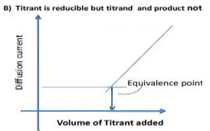  M5:  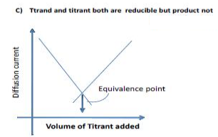 |  | M2: Reducible species in beaker, concentration decreases at it reacts, no change in activity after equivalence point, example Pb²⁺ against SO₄²⁻  M4: Reducible species in burette, concentration low until equivalence point, then increases, no change in activity after equivalence point, example SO₄²⁻ against Pb²⁺  M6: Reducible species in burette and beaker, concentration decreases until equivalence point due to decrease in concentration of titrand, then increases due to increase in concentration of titrant, example titration of Pb²⁺ against Cr₂O₇²⁻  Any 2 of M2, M4, M5  [5]
8. |  | (a) |  | M1: amperometric measures current vs volume at constant potential  M2: potentiometric measures potential vs volume at constant current
 |  | (b) |  | In potentiometric titrations, a graph of ΔE/ΔV against V is more useful than a graph of E against V. Explain why, and sketch the shape of a graph of ΔE/ΔV against V.  M3: point of maximum gradient is easier to see on an ΔE/ΔV vs Vol graph  M4: clear spike either up or down  M5: y-axis dE/dV and x-axis Vol  [5]

TOTAL 85 MARKS

