REVISION NOTES FOR CHEM 124 EXAM

1. **Qualitative Analysis of Cations and Anions**

You will be expected to sue simple reagents to identify the following cations: Li+, Na+, K+, Be2+, Mg2+, Ca2+, Sr2+, Ba2+, Cr3+, Fe2+, Co2+, Ni2+, Cu2+, Zn2+, H+, NH4+ and the following anions: Cl-, Br-, I-, OH-, NO3-, CO32-, SO32- and SO42-

1. **Identifying cations with sodium hydroxide solution**

* Precipitate formed with Be2+, Mg2+ and all d-block cations (eg Mg2+ + 2OH- 🡪 Mg(OH)2), faint precipitate with Ca2+
* NH4+ may give detectable pungent smell due to NH3 (NH4+ + OH- 🡪 NH3 + H2O)
* Be(OH)2, Cr(OH)3 and Zn(OH)2 are amphoteric so dissolve in excess NaOH (eg Zn(OH)2 + 2OH- 🡪 Zn(OH)42-)
* d-block hydroxides are all coloured except Zn(OH)2

1. **Identifying cations with sodium carbonate solution**

* Precipitate formed with all cations except Li+, Na+, K+, H+ and NH4+ (eg Mg2+ + CO32- 🡪 MgCO3)
* Bubbles/fizzing may be observed with H+ (2H+ + CO32- 🡪 CO2 + H2O)
* d-block hydroxides are all coloured except ZnCO3

1. **Identifying anions with nitric acid and silver nitrate solution**

* If HNO3 added first, white precipitate formed with Cl- and SO42-, cream precipitate with Br- and yellow precipitate with I- (eg Ag+ + I- 🡪 AgI)

1. **Identifying anions with barium chloride solution and hydrochloric acid**

* If BaCl2 added first, white precipitate formed with CO32-, SO32- and SO42- (eg Ba2+ + CO32- 🡪 BaCO3); if HCl then added, BaSO3 and BaCO3 dissolve with fizzing/bubbling due to SO2 and CO2 respectively; SO2 has a strong smell but CO2 is odourless (eg BaCO3 + 2HCl 🡪 BaCl2 + CO2 + H2O)
* If HCl added first, only SO42- gives precipitate when BaCl2 is added

1. **Identifying anions with ammonium chloride solution**

* Pungent smell due to NH3 with OH- (NH4+ + OH- 🡪 NH3 + H2O)

1. **Determining the order of a reaction with respect to a particular reactant using the initial rates method**

* Measure the initial rate of reaction at various different concentrations
* the initial rate is measured as 1/time taken; “time taken” is the time taken for the reaction to reach a fixed point
* the concentration is usually varied by diluting the solution with water; the concentration of the diluted solution can be calculated from: original concentration x (volume of solution before dilution/volume of solution after dilution)
* a rate-concentration graph needs to be plotted; it can have one of the following shapes:



First order second order zero order

* first order: rate is directly proportional to concentration (graph is straight line through origin)
* second order: rate increases faster than concentration (graph is curved line through the origin with steadily increasing gradient
* zero order: rate is independent of concentration (graph is horizontal line)

1. **Determining the order of a reaction with respect to a particular reactant using the continuous monitoring method**

* A single reaction is monitored over time
* The concentration of a single reactant is monitored at regular time intervals; this usually involves withdrawing a sample, quenching and titrating
* A concentration-time graph is plotted

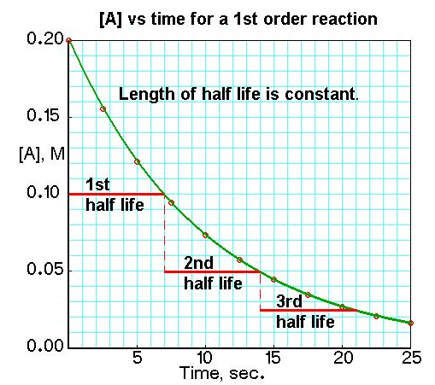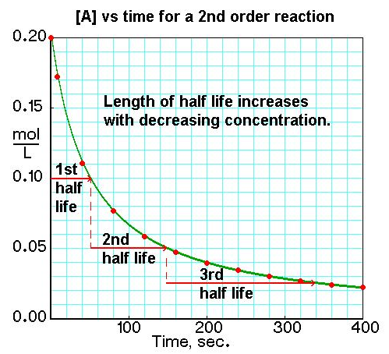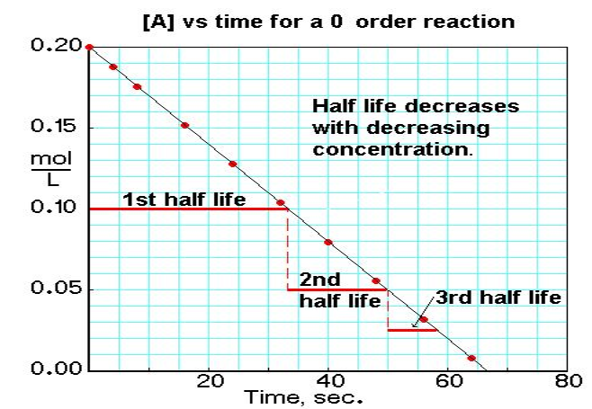

* First order: constant half-life
* Second order: half-life increases with decreasing concentration
* Zero order: straight line/half-life decreases with decreasing concentration

1. **Determining the activation energy for a reaction**

* Measure the initial rate of reaction at various different temperatures
* the initial rate is measured as 1/time taken; “time taken” is the time taken for the reaction to reach a fixed point
* a graph of log (1/time taken) against 1/T (K-1) will give a straight line with gradient Ea/R, so Ea = -R x gradient

1. **Identifying organic molecules**

|  |  |  |
| --- | --- | --- |
| **Test** | **Positive result if** | **Confirms presence of** |
| Add bromine water | Bromine water decolorises | Alkenes |
| Add K2Cr2O7 and H2SO4 | Solution turns from orange to brown or green | Primary alcohols or secondary alcohols or aldehydes |
| Fehling’s solution | Orange precipitate seen | Aldehydes |
| Tollen’s reagent | Silver mirror seen | Aldehydes |
| 2,4-DNPH | Orange precipitate seen | Aldehydes or ketones |
| Combustion | Smoky flame | Aromatic ring |
| Pink phenolphthalein  Add NaOH until just pink again and warm | Decolorises  Decolorises again | Carboxylic acid or ester  Ester |
| Add yellow bromothymol blue | Turns blue | Amines |

* Identity of aldehydes and ketones can be confirmed by reacting with 2.4-DNPH, purifying the precipitate, testing its melting point and comparing the melting point to those of known derivatives
* Non-polar molecules such as hydrocarbons are insoluble in water irrespective of chain length; molecules with -OH, -NH2, -COOH or ionic groups are soluble; the more of these groups on the molecule, the higher the solubility; long hydrocarbon chains or rings significantly reduce solubility, even if molecules have one of the above functional groups; the longer the hydrocarbon chain, the lower the solubility (eg ethanol highly soluble but hexan-1-ol sparingly soluble)