|  |
| --- |
| **UNIT 11**  **FURTHER ORGANIC CHEMISTRY**  **teacher version**    www.chemguide.co.uk    **Contents**   1. Alcohols (alkanols) 2. Carboxylic acids (alkanoic acids) and Alkanoates 3. Amines and Amino Acids 4. Addition and Condensation Polymers 5. Introduction to Biochemistry 6. Soaps and Soapless Detergents 7. Separating, Purifying and Identifying Organic Compounds   **Key words**: alkanol (alcohol), fermentation, hydration, distillation, distillate, primary alcohol, secondary alcohol, tertiary alcohol, alkanoic acid (carboxylic acid), alkanoate (carboxylate), ester, alkoxide, condensation, hydrolysis, amine, amino acid, peptide, polymer, monomer, co-polymer, plastic, thermoplastic, thermosetting plastic, resin, polyester, polyamide, fat, oil, triglyceride, fatty acid, glycerol, hydrogenation, carbohydrate, monosaccharide, disaccharide, polysaccharide, protein, Fehling’s solution, Benedict’s solution, Biuret solution, soap, saponification, soapless detergent, hydrophilic, hydrophobic, recrystallisation, chromatography  Units which must be completed before this unit can be attempted:  **Unit 1 – Atomic Structure and the Periodic Table**  **Unit 2 – Particles, Structure and Bonding**  **Unit 3 – Amount of Substance**  **Unit 4 – Introduction to Physical Chemistry**  **Unit 5 – Acids, Bases and Salts**  **Unit 6 – Redox Reactions**  **Unit 7 – Introduction to Organic Chemistry**  **Unit 8 – Solubility and Precipitation Reactions**  **Unit 9 – Metals and their Compounds**  **Estimated Teaching Time: 14 hours** |

**UNIT 11 SUMMARY AND SYLLABUS REFERENCE**

|  |  |
| --- | --- |
| **Lesson** | **Title and Syllabus Reference** |
| **1** | **Structure and Physical Properties of Alcohols**  ***CA11i.i alkanols – structure****;* ***CA11i.ii alkanols – physical properties*** *(including those due to intermolecular hydrogen bonding);* ***ISA13 organic and inorganic compounds*** *(alkanols (methanol, ethanol, propanol) - functional groups, properties and uses of organic compounds)* |
| **2** | **Preparation of Ethanol**  ***CA11i.i alkanols- sources*** *(*laboratory preparation including hydration of alkenes, industrial and local production of ethanol including alcoholic beverages, harmful impurities and methods of purification should be mentioned*),* ***ISA13 organic and inorganic compounds*** *(alkanols (methanol, ethanol) - functional groups, properties and uses of organic compounds)* |
| **3** | **Chemical Properties of Alcohols I**  ***CA11i.ii alkanols - classification*** *(*primary, secondary and tertiary alkanols)*;* ***CA11i.iv alkanols – chemical properties*** *(*reaction with Na, conc. H2SO4, I2/NaOH*);* ***ISA13 organic and inorganic compounds*** *(*alkanols (methanol, ethanol, propanol), alkanoic acids – first two members - functional groups, properties and uses of organic compounds*)* |
| **4** | **Chemical Properties of Alcohols II – Oxidation**  ***CA11i.iv alkanols – chemical properties*** *(*oxidation by KMnO4, K2Cr2O7, I2/NaOH*);* ***CA11ji alkanoic acids – sources****;* ***ISA13 organic and inorganic compounds*** *(alkanols (methanol, ethanol) - functional groups, properties and uses of organic compounds)* |
| **5** | **Carboxylic Acids and Alkanoate Salts**  ***CA11aii nomenclature and functional groups*** *(systematic nomenclature of alkanoic acids and alkanoates (salts));* ***CA11ji alkanoic acids - sources, nomenclature and structure****;* ***CA11jii alkanoic acids - physical properties*** *(including those due to intermolecular hydrogen bonding);* ***CA11jiii alkanoic acids - chemical properties*** *(acid properties only: i.e. reactions with H2O, NaOH, NaHCO3),* ***CA11jiv alkanoic acids - laboratory test*** *(reaction with NaHCO3);* ***CA11jv alkanoic acids - uses and properties*** *(uses and properties of ethanoic and phenylmethanoic (benzoic) acids as examples of aliphatic and aromatic acids respectively)* ***CA13cv characteristic test tube reactions of the functional group in alkanoic acids****;* ***CC6h alkanoic acids*** *(recognition of mono and dioic acids);* ***ISA4.3 ionic and covalent compounds*** *(IUPAC names of common compounds);* ***ISA13******organic and inorganic compounds*** *(alkanols (methanol, ethanol, propanol), alkanoic acids (first two members) - functional groups, properties and uses of organic compounds);* ***ISA13.2 neutralization*** *(equations representing neutralization reactions)* |
| **6** | **Esters – Preparation and Reactions**  ***CA11aii nomenclature - functional groups*** *(systematic nomenclature of alkanoates (esters))* ***CA11i.iv alkanols - chemical properties*** *(reaction with alkanoic acids (esterification));* ***CA11i.v alkanols - laboratory test****,* ***CA11ki alkanoates - sources, nomenclature and structure*** *(preparation of alkyl alkanoates (esters) from alkanoic acids);* ***CA11kii alkanoates - physical properties****;* ***CA11kiii alkanoates - chemical properties*** *(hydrolysis of esters (mechanism not required));* ***CA13cv characteristic test tube reactions of the functional groups in the following simple organic compounds: alkenes, alkanols, alkanoic acids****;* ***ISA4.3 ionic and covalent compounds*** *(IUPAC names of common compounds); ISA13 organic and inorganic compounds (alkanols (methanol, ethanol, propanol), alkanoic acids (first two members), alkanoates (first two members) - functional groups, properties and uses of organic compounds);* ***ISA13.2 neutralization and esterification*** *(differences between neutralization and esterification, equations representing esterification reactions)* |
| **7** | **Qualitative Analysis - Identification of Organic Functional Groups**  ***CA11i.v alkanols - laboratory test; CA13cv characteristic test tube reactions of the functional groups in the following simple organic compounds: alkenes, alkanols, alkanoic acids*** |

|  |  |
| --- | --- |
| **Lesson** | **Title and Syllabus Reference** |
| **8** | **Amines and Amino Acids**  ***CA11aii nomenclature - functional groups*** *(systematic nomenclature of amines); CA11m amino acids (difunctional nature of amino acids);* ***ISA4.3 ionic and covalent compounds*** *(IUPAC names of common compounds)* |
| **9** | **Addition Polymers and Plastics**  ***CA11ni natural and synthetic polymers – definitions*** *(polymerisation, addition and condensation polymers, plastics and resins, thermoplastic and thermosetting polymers);* ***CA11nii important properties of polymers****;* ***CA11niv synthetic polymers*** *(classification and preparation based on the monomers and co-polymers);* ***ISA13.3 petrochemicals*** *(uses of petrochemicals such as plastics)* |
| **10** | **Condensation Polymers**  ***CA11ni natural and synthetic polymers – definitions*** *(polymerisation, condensation polymers);* ***CA11nii important properties of polymers****;* ***CA11niv synthetic polymers*** *(classification and preparation based on the monomers and co-polymers);* ***CC6g alkanols*** *(recognition of the structures of mono- and diols);* ***CC6h alkanoic*** *acids (recognition of mono and dioic acids)* |
| **11** | **Biochemistry: Lipids and Carbohydrates**  ***CA11l fats and oils: sources, physical and chemical properties*** *(alkanoates (esters), hardening of oils);* ***CA11niii natural polymers - carbohydrates: formulae, properties and uses*** *(classification as monosaccharides, disaccharides and polysaccharides, reducing and non-reducing sugars using glucose, fructose, sucrose/maltose and starch/cellulose as examples, hydrolysis of sucrose and starch);* ***CA13cv characteristic test tube reactions of the functional groups in sugars (using Fehling’s and Benedict’s solutions only) and starch (iodine test only); ISA13 organic and inorganic compounds*** *(fats and oils - functional groups, properties and uses)* |
| **12** | **Biochemistry: Proteins; Food Tests**  ***CA11niii natural polymers - proteins*** *(*as polymers of amino acid molecules linked by peptide or amide linkage, hydrolysis, uses in living systems*);* ***CA13cv c*haracteristic test tube reactions of the functional groups in sugars (using Fehling’s and Benedict’s solutions only), starch (iodine test only) and proteins (using the Ninhydrin test, Xanthoproteic test, Biuret test and Millon’s test only)** |
| **13** | **Soaps and Soapless Detergents**  ***CA11l fats and oils: sources, physical and chemical properties*** *(saponification, detergents as soapless detergents, comparison of soapless detergents with soapy detergents and their action on soft water and hard water);* ***ISA13 organic and inorganic compounds*** *(fats and oils - functional groups, properties and uses)* |
| **14** | **Separation, Purification and Analysis of Organic Compounds**  ***CA4aiii chemical equations*** *(calculations involving formulae and equations will be required);* ***CA11b separation and purification*** *(methods to be discussed should include: distillation, crystallisation, drying, chromatography);* ***CA11c determination of empirical and molecular formulae and molecular structures of organic compounds****;* ***CA13aiii General Skills and Principles – Recrystallisation*** |
| **15** | **Unit 11 Revision and Summary** |

**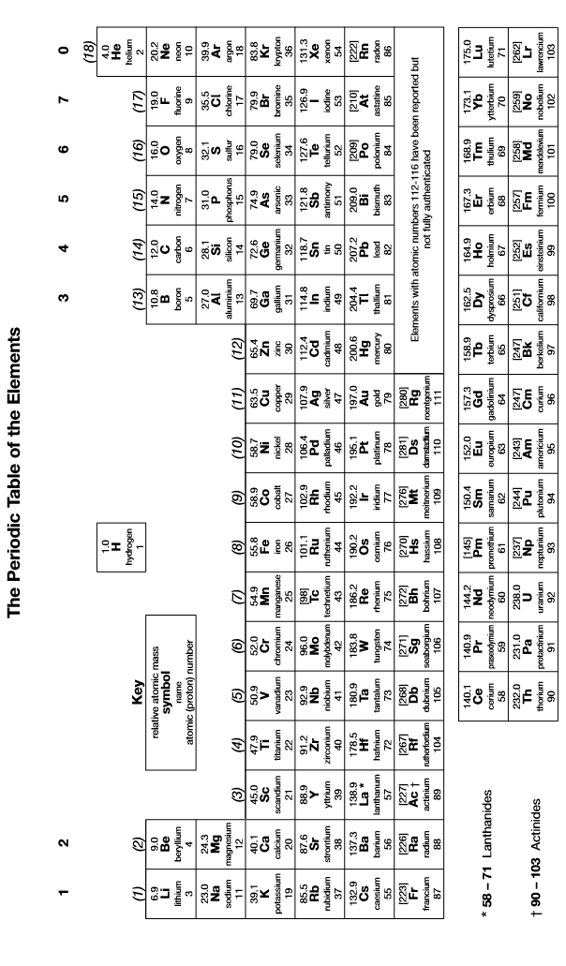**

***Lesson 1 – What are alcohols?***

1. **Alcohols (alkanols)**
2. **Physical Properties of Alcohols**

|  |
| --- |
| **Summary Activity 1.1: What are alcohols?**   * Name, and draw the structures of, the first three members of the homologous series of alcohols * Draw and name one branched aliphatic alcohol and one alicyclic alcohol * What is hydrogen bonding? Why can alcohols form hydrogen bonds? * What properties of alcohols are likely to result from their ability to form hydrogen bonds? * How many alcoholic drinks can you think of? How are they made? * Are there any other uses of alcohols that you are aware of? |
| * Methanol (CH3OH), ethanol (CH3CH2OH), propan-1-ol (CH3CH2CH2OH) (allow displayed or skeletal formula, allow propan-2-ol as third member)   , ,   * Eg  (methylpropane-1-ol); eg  (cyclobutanol) * Intermolecular attraction between a δ+ve H atom on one molecule and an electronegative atom on an adjacent molecule; alcohols can form hydrogen bonds because the H attached to the O has a partial positive charge and is strongly attracted to the O atom on adjacent molecules * Alcohols have a higher boiling point than other molecules of similar size; alcohols are likely to be soluble in water * Beer, wine, cider, whisky, gin etc; they are made by fermenting sugar * Disinfectants, solvents (students are not expected to know) |

* **Alcohols** (also known as **alkanols**) are saturated molecules containing an –OH group; examples of simple alcohols are methanol and ethanol
* Aliphatic alcohols have the general formula CnH2nO
* The H atom in the O-H bond can form hydrogen bonds with other alcohol molecules and with water:

|  |  |
| --- | --- |
| Hydrogen bond between a water molecule and an ethanol molecule: | Hydrogen bond between two ethanol molecules: |
|  |  |
| [www.sites.google.com](http://www.sites.google.com) | [www.chemistry.stackexchange.com](http://www.chemistry.stackexchange.com) |

* As a result of hydrogen bonding between alcohol molecules, alcohols have stronger intermolecular forces between them, and hence higher boiling points, than other molecules of similar size (eg the boiling point of methanol, which contains 18 electrons, is 65 oC, but the boiling point of ethane, which also contains 18 electrons, is -89 oC)
* As a result of hydrogen bonding between alcohol and water molecules, many alcohols mix well with water
* As you ascend the homologous series of alcohols, the number of electrons in the molecule increases, so the Van der Waal’s forces between the molecules get stronger than the boiling point increases (eg the boiling point of methanol is 65 oC but the boiling point of ethanol is 78 oC)
* As you ascend the homologous series of alcohols, the length of the hydrocarbon section of the molecule (the alkyl group) increases; this part of the molecule cannot form hydrogen bonds and it limits the ability of the alcohol to form hydrogen bonds with water; the longer the chain, the more it disrupts the hydrogen bonds with water molecules and the lower the solubility of the alcohol (eg ethanol is highly soluble in water but hexan-1-ol is only sparingly soluble)
* Because alcohols have a non-polar hydrocarbon chain as well as an -OH group, they often mix readily with non-polar substances as well; this means that many alcohols can mix well with both water and non-polar substances; **as a result, alcohols (especially ethanol) make very good solvents**
* Alcohols are toxic; most humans, however, have the ability to break ethanol down; as a result most humans can tolerate moderate quantities of ethanol; even small quantities, however, affect the nervous system and can cause both physical and mental impairment (being drunk); **ethanol is widely used in alcoholic drinks**; the human body is not able to break down any of the other alcohols and as a result these alcohols are considered more highly toxic
* Some alcohols contain more than one -OH group; these are known as diols (if they have two -OH groups) or polyols (if they have many -OH groups); they are very important in biochemistry and industry
* two important examples are:

|  |  |  |
| --- | --- | --- |
| Name | Structure | Uses |
| ethan-1,2-diol |  | Added to water to lower the freezing point and prevent freezing; it is also known as antifreeze |
| propan-1,2,3-triol |  | Also known as glycerol; this is produced by breaking down fats and can be used as a source of energy |

* diols and polyols have high water solubility due to the large number of OH groups which can form hydrogen bonds with water

|  |
| --- |
| **Image result for test iconTest your knowledge 1.2: Explaining the physical properties and uses of alcohols**   1. Explain why ethanol has a higher boiling point than butane 2. Explain why ethanol is soluble in water but butane is not 3. Explain why ethanol has a lower boiling point than butan-1-ol 4. Explain why ethanol is more soluble in water than butan-1-ol 5. State two uses of ethanol |
| 1. Ethanol can form hydrogen bonds between molecules; butane cannot 2. Ethanol can form hydrogen bonds with water, butane cannot 3. Butan-1-ol has more electrons per molecule, so more/stronger Van der Waal’s forces 4. Butan-1-ol has a longer alkyl chain (C3H7-) which disrupts the hydrogen bonding in water 5. Solvents, alcoholic drinks |

***Lesson 2 – How is ethanol made?***

1. **Preparation of Alcohols**

|  |
| --- |
| **Summary Activity 2.1: Distillation and fractional distillation**   * What is fractional distillation used for and how does it work? * What types of substances are best separated by fractional distillation? |
| * Separation of components in a mixture using differences in their boiling point; mixture is boiled and then components rise up the fractionating column; as they do so they cool down; substances with higher boiling points condense first and can be separated out * Fractional distillation is effective at separating miscible liquids or gases with different boiling points |

* Much of the ethanol in the world is produced by decomposing glucose in a process called **fermentation**:

C6H12O6 🡪 2C2H5OH + 2CO2

Successful fermentation requires

* the presence of yeast, which acts as a catalyst for the reaction
* a temperature of 35 – 55 oC
* the absence of air
* Fermentation has several advantages of other methods of producing ethanol:
* it is a low-technology process, which means it can be used anywhere
* it does not use much energy
* it uses sugar cane or other fruit/vegetables as a raw material, which is a renewable resource
* the other ingredients in the raw materials can give make drinks with pleasant tastes
* There are also some disadvantages associated with the fermentation process:
* it is a batch process, which means that once the reaction has finished the vessel needs to be emptied before the reaction can be started again
* it is a relatively slow process
* it does not produce pure ethanol
* Throughout the world, alcoholic drinks are produced on a large scale (industrially) and on a small scale (locally) by fermentation; there are two main risks associated with locally-brewed alcohol:
* methanol is a very toxic substance produced in small quantities during fermentation; in low-concentration alcohols such as beer or wine, it is not present in harmful levels; in spirits, however, methanol levels can be dangerous if care is not taken to remove the methanol before drinking
* the water used in the process may be contaminated with harmful bacteria; this can happen if the water used is of poor quality or if sanitation practices are poor
* During the production of spirits such as whisky and gin, the fermented mixture is **distilled** in order to make the ethanol more concentrated:
* **distillation** is the separation of two substances using differences in their boiling points; it is similar to fractional distillation but it does not use a fractionating column); the substance with the lower boiling point boils first and can be separated condensed, and collected; this separated liquid is called the **distillate**
* ethanol boils at a lower temperature (78 oC) than water (100 oC) and so when a mixture of ethanol and water is heated, the ethanol will boil first; the resulting distillate is thus more concentrated in ethanol than the original mixture
* distillation can also be used to separate methanol from ethanol; methanol boils at a lower temperature (65 oC) than ethanol so the methanol will boil first, so it is possible to remove much of the methanol by discarding the first 2 – 3% of the distillate produced
* a simple distillation apparatus uses a piece of equipment known as a **condenser**; it can be drawn as follows:

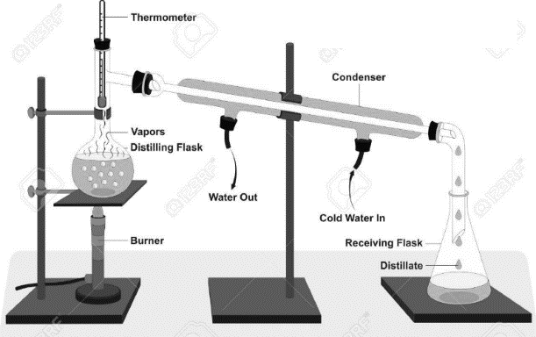 [www.123RF.com](http://www.123RF.com)

|  |
| --- |
| **Image result for test iconTest your knowledge 2.2: Understanding fermentation**   1. Write an equation to show the fermentation of glucose into ethanol; use your equation to explain why alcoholic drinks are often fizzy 2. Describe the conditions needed for fermentation 3. State two advantages and two disadvantages of fermentation and a method of making ethanol 4. Describe how pure alcohol can be separated from the other products and impurities after fermentation 5. Explain the main dangers with drinking home-brewed spirits and explain how these dangers can be avoided |
| 1. C6H12O6 🡪 2C2H5OH + 2CO2; CO2 produced which is a gas 2. 35 – 55 oC, yeast, no oxygen 3. Adv: cheap, low technology, low energy, uses renewable raw material; Disadv: slow, batch process, doesn’t make pure ethanol 4. By distillation; mixture is boiled; ethanol boils before water and can be separated, condensed and collected 5. Presence of methanol (discard first 2 – 3% of distillate); contaminated water (use treated water and hygienic conditions |

|  |
| --- |
| **Summary Activity 2.3: Classifying organic reactions**   * What is an addition reaction? Give one example * What is a substitution reaction? Give one example * What do you think is meant by the term “elimination reaction”? |
| * A reaction in which one or more atoms are added to an organic molecule but none are removed * A reaction in which one or more atoms on an organic molecule are replaced by others * A reaction in which one or more atoms are removed from an organic molecule and not replaced |

* Pure ethanol can also be produced industrially by the **hydration** of ethene:

C2H4 + H2OC2H5OH

Hydration is an example of an **addition** reaction; successful hydration requires

* A temperature of 300 oC
* a pressure of 6 MPa (60 atm)
* a catalyst (concentrated H3PO4)
* Hydration has a number of advantages over fermentation as a method of producing ethanol:
* it is a relatively fast process
* it is a continuous flow process, which means that ethene can be entered into the vessel continuously and the reaction never has to be stopped
* it produces pure ethanol
* it can also produce other alcohols, depending on the alkene used; propene, for example, can be used to make propan-1-ol and propan-2-ol
* There are some disadvantages associated with hydration as a method of producing ethanol:
* it requires fairly high technology
* it uses a lot of energy
* the ethene used comes from crude oil, which is a non-renewable resource
* Some alcohols can be produced in the laboratory by hydration; the most common example of this is cyclohexanol, which can be produced from cyclohexene:

C6H10 + H2O 🡪 C6H11OH

|  |
| --- |
| **Image result for test iconTest your knowledge 2.4: Understanding hydration**   1. Write an equation to show how ethanol is produced from ethene and state the conditions used when this reaction is carried out industrially 2. State two advantages and two disadvantages associated with producing ethanol by hydration rather than by fermentation 3. Suggest the starting materials necessary to produce butan-1-ol by hydration; explain why butan-1-ol is not the only product of this reaction and identify the other product |
| 1. C2H4 + H2OC2H5OH; 300 oC, 60 atm, conc. H3PO4 2. Adv: faster, continuous, makes purer ethanol; disadv: high cost, high technology; raw material not renewable 3. But-1-ene and H2O; addition of H2O to unsymmetrical alkene like but-1-ene gives two products; the other product is butan-2-ol |

***Lesson 3 – What are the chemical properties of alcohols?***

1. **Classification of Alcohols**

* Alcohols can be divided into three classes: primary, secondary and tertiary
* **Primary alcohols** are those in which the carbon attached to the OH is attached to 0 or 1 other carbon atom; in other words, they are molecules in which the functional group is at the end of the chain:
* Eg propan-1-ol
* Secondary alcohols are those in which the carbon attached to the OH is attached to 2 other carbon atoms; in other words, they are molecules in which the functional group is not at the end of the chain:
* Eg propan-2-ol
* Tertiary alcohols are those in which the carbon atom attached to the OH is attached to 3 other carbon atoms; in other words, they are molecules in which the functional group is attached to a carbon which also has a branch attached to it:
* Eg methypropan-2-ol

|  |
| --- |
| **Image result for test iconTest your knowledge 3.1: Classifying alcohols**  Classify the following alcohols as primary, secondary or tertiary:  (a) methanol (b) ethanol (c) butan-1-ol (d) butan-2-ol  (e) methylpropan-1-ol (f) 2-methylbutan-1-ol (g) 3-methylbutan-1-ol (h) 2-methylbutan-2-ol  (i) 3-methylbutan-2-ol (j) dimethylpropanol |
| (a) primary; (b) primary; (c) primary; (d) secondary; (e) primary; (f) primary; (g) primary; (h) tertiary; (i) secondary; (j) primary |

1. **Reaction of alcohols with sodium**

* Sodium reacts violently with water to make sodium hydroxide and hydrogen:

2Na + 2H2O 🡪 2NaOH + H2

* this reaction is a redox reaction (the Na is oxidised from 0 to +1 and the H is reduced from +1 to 0)
* bubbles are given off
* the gas can be confirmed as hydrogen if it burns with a squeaky pop
* Sodium reacts with alcohols in a very similar way:

2Na + 2CH3CH2OH 🡪 2CH3CH2ONa + H2

* this reaction is a redox reaction (the Na is oxidised from 0 to +1 and the H is reduced from +1 to 0)
* the organic product is called an **alkoxide**; in this case the product is sodium ethoxide; methanol would produce sodium methoxide
* this reaction is less vigorous than the reaction between sodium and water and can be carried out in the laboratory
* the gas can be confirmed as hydrogen if it burns with a squeaky pop

1. **Dehydration of alcohols**

* It is possible to remove water from alcohols to give alkenes:

Eg CH3CH2CH2OH 🡪 CH3CH=CH2 + H2O

propan-1-ol 🡪 propene

* this reaction is the reverse of hydration
* it is known as an **elimination** reaction as it involves atoms being lost but not replaced
* the alcohol should be heated at 180oC with concentrated H2SO4
* The H which is lost comes from a carbon atom which is adjacent to the carbon atom attached to the OH group; in some cases, this can lead to more than one product:
* Eg when butan-2-ol undergoes elimination, two different products can be formed depending on which H atom is lost:



|  |
| --- |
| **Image result for test iconTest your knowledge 3.2: Understanding simple reactions of alcohols**   1. Write an equation to show the reaction of propan-1-ol with sodium. Show clearly the structure of the organic product. 2. Draw and name the organic product(s) when the following alcohols are dehydrated; if two products are possible, draw and name them both:   (i) butan-1-ol (ii) butan-2-ol (iii) 3-methylbutan-1-ol (iv) 2-methylbutan-2-ol (v) dimethylpropanol |
| 1. 2CH3CH2CH2OH + 2Na 🡪 2CH3CH2CH2ONa + H2 2. (i) CH3CH2CH=CH2 (but-1-ene) only; (ii) CH3CH2CH=CH2 (but-1-ene) and CH3CH=CHCH3 (but-2-ene) (cis or trans); (iii) (CH3)2CHCH=CH2 (3-methylbut-1-ene) only; (iv) (CH3)2C=CHCH3 (2-methylbut-2-ene) or CH2=C(CH3)CH2CH3 (2-methylbut-1-ene); (v) cannot be dehydrated – no products possible |

1. **The iodoform reaction**

* Some alcohols give a very distinctive reaction with iodine (I2) in the presence of aqueous sodium hydroxide (NaOH); they form a pale yellow precipitate of triiodomethane (CHI3), also known as iodoform; this reaction is known as the iodoform reaction and the equation for it is complex
* Any alcohol which contains a methyl group and at least one H atom on the carbon atom attached to the OH can give the iodoform reaction; ie any alcohol with the following feature:

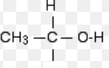

* examples of alcohols which undergo the iodoform reaction include ethanol, propan-2-ol and butan-2-ol
* examples of alcohols which do not undergo the iodoform reaction include methanol, propan-1-ol and butan-1-ol
* the iodoform reaction is a very useful test in organic chemistry for identifying this group

|  |
| --- |
| **Image result for test iconTest your knowledge 3.3: Using the iodoform reaction to identify alcohols**  For each of the following alcohols, state whether they will give a pale yellow precipitate in the presence of I2 and NaOH:  (a) methanol (b) ethanol (c) butan-1-ol (d) butan-2-ol  (e) methylpropan-1-ol (f) 2-methylbutan-1-ol (g) 3-methylbutan-1-ol (h) 2-methylbutan-2-ol  (i) 3-methylbutan-2-ol (j) dimethylpropanol |
| (a) no; (b) yes; (c) no; (d) yes; (e) no; (f) no; (g) no; (h) no; (i) yes; (j) no |

***Lesson 4 – How can we oxidise alcohols?***

1. **Oxidation of alcohols**

* Oxidation in organic chemistry can be regarded as the addition of oxygen or the removal of hydrogen; as the full equations are quite complex, the oxidising agent is often represented by the symbol [O]
* If a **primary alcohol** is mixed with an oxidising agent, two hydrogen atoms will be removed and an **aldehyde** will be formed:

Eg CH3CH2OH + [O] 🡪 CH3CHO + H2O



Ethanol 🡪 Ethanal

* an aldehyde is a molecule containing the following group



(Note: you do not need to know the structure of aldehydes for the WASSCE exam)

* if enough oxidising agent is present, and additional oxygen atom can be added to the group and a **carboxylic acid (or alkanoic acid)** will be formed:

Eg CH3CHO + [O] 🡪 CH3COOH



Ethanal 🡪 Ethanoic acid

* a carboxylic acid is a molecule containing the following group:



* the overall equation for the oxidation of a primary alcohol to a carboxylic acid is:

**R-CH2OH + 2[O] 🡪 R-COOH + H2O (R = any alkyl group)**

Eg CH3CH2OH + 2[O] 🡪 CH3COOH + H2O

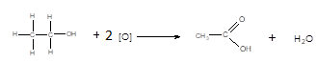

Ethanol 🡪 ethanoic acid

the organic molecule loses two hydrogen atoms and gains one oxygen atom

* If a **secondary alcohol** is mixed with an oxidising agent, two hydrogen atoms will be removed and a **ketone** will be formed:

Eg CH3CH(OH)CH3 + [O] 🡪 CH3COCH3 + H2O



Propan-2-ol 🡪 propanone

* A ketone is a molecule containing the following group:

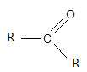(R = any alkyl group)

(Note: you do not need to know the structure of aldehydes for the WASSCE exam)

* Ketones cannot be oxidised further into carboxylic acids; it is therefore not possible to make a ketone from a secondary alcohol
* **Tertiary alcohols are not readily oxidised** since they do not have available H atoms to give up
* The oxidising agent most widely used in organic chemistry is potassium dichromate (VI) (K2Cr2O7) in dilute sulphuric acid (H2SO4); this mixture is known as acidified potassium dichromate; it reacts as follows:

Cr2O72-(aq) + 14H+(aq) + 6e 🡪 2Cr3+(aq) + 7H2O(l)

* the Cr2O72-(aq) ion is orange and the Cr3+ ion is green; this reduction process is accompanied by a colour change from orange to green
* primary and secondary alcohols turn acidified potassium dichromate from orange to green; tertiary alcohols do not
* Another oxidising agent often used in organic chemistry is potassium manganate(VII) (KMnO4) in dilute sulphuric acid (H2SO4); this mixture is known as acidified potassium permanganate; it reacts as follows:

MnO4-(aq) + 8H+(aq) + 5e 🡪 Mn3+(aq) + 4H2O(l)

* the MnO4-(aq) ion is purple and the Mn2+ ion is colourless; this reduction process is accompanied by a colour change from purple to colourless (ie the KMnO4 is decolorised)
* primary and secondary alcohols decolorise acidified potassium permanganate; tertiary alcohols do not
* The iodoform reaction is also an oxidation reaction; the secondary alcohol is oxidised before the precipitate is formed
* The oxidation reactions of alcohols can be summarised as follows:



|  |
| --- |
| Image result for test icon**Test your knowledge 4.1: Understanding the oxidation of alcohols**   1. For each of the following alcohols, state whether they will turn acidified potassium dichromate from orange to green   (i) methanol (ii) ethanol (iii) butan-1-ol (iv) butan-2-ol (v) methylpropan-1-ol  (vi) 2-methylbutan-1-ol (vii) 3-methylbutan-1-ol (viii) 2-methylbutan-2-ol (ix) 3-methylbutan-2-ol  (x) dimethylpropanol  (b) State which of the alcohols in (a) can be converted into carboxylic acids by acidified potassium dichromate; for those which can, write an equation for the oxidation reaction showing clearly the structure of the organic product |
| 1. (i) yes; (ii) yes; (iii) yes; (iv) yes; (v) yes; (vi) yes; (vii) yes; (viii) no; (ix) yes; (x) yes (2-methylbutan-2-ol is a tertiary alcohol; the others are primary or secondary) 2. methanol, ethanol, butan-1-ol, methylpropan-1-ol, 2-methylbutan-1-ol, 3-methylbutan-1-ol and dimethylpropanol (these are primary alcohols)   CH3OH + 2[O] 🡪 HCOOH + H2O; CH3CH2OH + 2[O] 🡪 CH3COOH + H2O; CH3CH2CH2CH2OH + 2[O] 🡪 CH3CH2CH2COOH + H2O; (CH3)2CHCH2OH + 2[O] 🡪 (CH3)2CHCOOH + H2O; CH3CH2CH(CH3)CH2OH + 2[O] 🡪 CH3CH2CH(CH3)COOH + H2O; (CH3)2CHCH2CH2OH + 2[O] 🡪 (CH3)2CHCH2COOH + H2O; (CH3)3CCH2OH + 2[O] 🡪 (CH3)3COOH + H2O (allow displayed formulae) |

***Lesson 5 – What are carboxylic acids?***

**b) Carboxylic acids (alkanoic acids) and alkanoates**

1. **Introduction to carboxylic acids**

* Carboxylic acids (also known as alkanoic acids) contain the following functional group:



* Carboxylic acids are named using the ending “-anoic acid”; the functional group always comes at the end of the molecule, so it does not need to be numbered; examples are:

methanoic acid ethanoic acid butanoic acid

 **** 

* Aliphatic carboxylic acids have the general formula C2H2nO2, but alicyclic and aromatic carboxylic acids are also common; examples of aromatic carboxylic acids include:

|  |  |  |
| --- | --- | --- |
| structure | Name | Uses |
|  | Commonly known as benzoic acid | antibacterial agent |
|  | Commonly known as salicylic acid | treats dry skin  used to make aspirin |

* It is also possible to have a carboxylic acid group at both ends of the molecule; these molecules are known as dicarboxylate acids; eg hexanedioic acid HOOC(CH2)2COOH or ethanedioic acid HOOCCOOH; these are used to make fabrics such as polyester
* Ethanoic acid, made by oxidising ethanol, is the main component of vinegar; this is the reason wine and other alcohol drinks can start to taste like vinegar if left to stand in air; vinegar is used in food flavouring and as a preservative; it is also used as a cleaning agent
* Carboxylic acids can be formed by the oxidation of primary alcohols using acidified potassium dichromate (VI) or acidified potassium manganate (VII)
* Carboxylic acids can form hydrogen bonds with water and with each other:

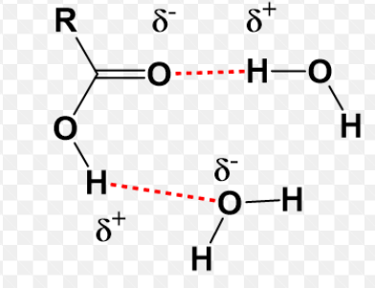 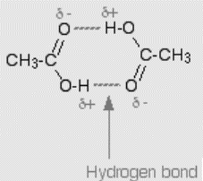

[www.wou.edu](http://www.wou.edu) [www.chemguide.co.uk](http://www.chemguide.co.uk)

* most carboxylic acids with relatively short chains are highly soluble in water; carboxylic acids with long hydrocarbon chains and aromatic carboxylic acids such as benzoic acid are much less soluble
* carboxylic acids have relatively high boiling points compared with other molecules of similar size (ethanoic acid has 32 electrons and boils at 118 oC; butane has 34 electrons and boils at -1 oC)

|  |
| --- |
| Image result for test icon**Test your knowledge 5.1: Introducing carboxylic acids**   1. Name, and draw the structure of, the carboxylic acids formed by the oxidation of:   (i) propan-1-ol (ii) methylpropan-1-ol (iii) 2-methylbutan-1-ol  (iv) 3-methylbutan-1-ol (v) dimethylpropanol (vi) ethan-1,2-diol   1. Explain why ethanoic acid is highly soluble in water but benzoic acid is not 2. Suggest a use for: (i) ethanoic acid (ii) benzoic acid (iii) ethanedioic acid |
| 1. (i) Propanoic acid - CH3CH2COOH; (ii) methylpropanoic acid - CH3CH(CH3)COOH; (iii) 2-methylbutanoic acid - CH3CH2CH(CH3)COOH; (iv) 3-methylbutanoic acid - (CH3)2CHCH2COOH; (v) dimethylpropanoic acid - (CH3)3COOH (allowed displayed formulae) 2. Ethanoic acid can form hydrogen bonds with water; the aromatic ring in benzoic acid disrupts the hydrogen bonding between water molecules so does not mix well with water 3. (i) Preserving food; (ii) preventing bacterial infection; (iii) making polyesters |

1. **Acidic properties of carboxylic acids**

|  |
| --- |
| **Summary Activity 5.2: Reactions of acids**   * What is the difference between a strong acid and a weak acid? Give one example of each. * Write equations for the reactions between HCl and H2O, HCl and NaOH and HCl and NaHCO3; what is the name given to these types of reaction? * What is salt hydrolysis? Give one example of a basic salt |
| * Strong acid completely dissociates in water; eg HCl or HNO or HSO ; weak acid only slightly dissociates in water, eg CH3 COOH or any carboxylic acid * HCl 🡪 H+ + Cl-; HCl + NaOH 🡪 NaCl + H2O; HCl + NaHCO3 🡪 NaCl + CO2 + H2O; these are acid-base or neutralisation reactions * Salt hydrolysis is the reaction of an anion or cation in a salt with water to give H+ or OH- ions; salts of weak acids react with water to give OH- and salts of weak bases react with water to give H+; example of a basic salt would be any salt of a weak acid, eg CH3COONa |

* The properties and reactions of acids, bases and salts were covered extensively in Unit 5 – Acids, Bases and Salts; carboxylic acids behave as typical examples of weak acids:
* they partially dissociate in water:

CH3COOHCH3COO- + H+

* they react with NaOH to give a salt and water:

CH3COOH + NaOH 🡪 CH3COONa + H2O

* they react with Na2CO3 and NaHCO3 to give a salt, water and carbon dioxide:

CH3COOH + NaHCO3 🡪 CH3COONa + H2O + CO2

* Carboxylic acids therefore evolve CO2 when mixed with NaHCO3; this is a useful laboratory test for a carboxylic acid; they also turn blue litmus paper red
* Most acid-base indicators used in titrations are carboxylic acids; if carboxylic acid and the carboxylate salt are different colours the acid can be used as an indicator; these coloured organic acids can also be used as dyes
* the salt produced from a carboxylic acid is called a **carboxylate (or alkanoate) salt:**
* they contain the following group:

(cation can be any metal ion)

* they are named with the cation first and then the suffix -anoate

 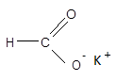 

sodium ethanoate potassium methanoate sodium butanoate

* Like most ionic compounds, carboxylate salts are generally soluble in water; they are often soluble even if the carboxylic acid from which they are made is not:
* eg benzoic acid is sparingly soluble in water but sodium benzoate is highly soluble
* As salts of weak acids, carboxylate salts undergo salt hydrolysis; the carboxylate ion reacts with water to produce OH- ions:
* Eg CH3COO- + H2OCH3COOH + OH-
* as a result, solutions of carboxylate salts are generally basic with a pH of 8 – 10
* Carboxylate salts can be readily converted back into the carboxylic acid in the presence of a stronger acid such as HCl:
* Eg C6H5COONa + HCl 🡪 C6H5COOH + NaCl (sodium benzoate 🡪 benzoic acid)
* this is an example of an acid-salt reaction

|  |
| --- |
| Image result for test icon**Test your knowledge 5.3: Describing acid-base reactions of carboxylic acids**   1. Write equations for the following reactions: 2. propanoic acid with sodium hydroxide 3. butanoic acid with sodium hydrogencarbonate 4. methanoic acid with water 5. Describe a simple chemical test for a carboxylic acid 6. Write equations for the following reactions: 7. sodium ethanoate with water 8. potassium propanoate with hydrochloric acid |
| 1. (i) CH3CH2COOH + NaOH 🡪 CH3CH2COONa + H2O; (ii) CH3CH2CH2COOH + NaHCO3 🡪 CH3CH2CH2COONa + CO2 + H2O; (iii) HCOOHH+ + HCOO- 2. Add NaHCO3; bubbles will be seen 3. (i) CH3COONa + H2OCH3COOH + NaOH; (ii) CH3CH2COONa + HClCH3CH2COOH + NaCl |

***Lesson 6 – What are esters and how are they made?***

1. **Esterification and ester hydrolysis**

* If a carboxylic acid is heated with an alcohol with concentrated H2SO4, an **ester** is formed:

carboxylic acid + alcoholester + H2O

R1-COOH + R2OHR1-COOR2 + H2O (R1 and R2 are alkyl groups)

* this reaction is known as **esterification**
* esterifcation is an example of a **condensation** reaction; this is a reaction in which two or more organic molecules join together to form a single large molecule, and in so doing give off a small molecule such as HCl or H2O
* Esters are molecules containing the following group: ; eg 
* Esters are named using an **alkyl** prefix to indicate the group attached to the single O (ie the alkyl group from the alcohol) and the suffix **–anoate** to indicate the group attached to both oxygen atoms (ie the alkyl group from the carboxylic acid:
* Egis methyl methanoate; the methyl indicates the number of carbons in the chain attached to the single O (ie 1), and the methanoate indicates the number of carbons in the chain attached to both O atoms (ie 1); this ester is made from methanol and methanoic acid
* Eg is propyl ethanoate; this ester is made from propan-1-ol and ethanoic acid
* Examples of esterification reactions include:









 

* Esters (such as ethyl ethanoate) and carboxylate salts (such as sodium ethanoate) are both examples of alkanoates, which are compounds derived from carboxylic acids; esters are made when carboxylic acids react with alcohols (esterification); carboxylate salts are made when carboxylic acids react with bases (neutralisation)
* Esterification is a reversible reaction; the reaction typically reaches an equilibrium in which approximately 70% of the carboxylic acid and alcohol have been converted into the ester; in the reverse reaction, an ester can be heated with water in the presence the of the same catalyst (concentrated H2SO4) to produce a carboxylic acid and an alcohol; this reaction is known as **ester hydrolysis:**

R1-COOR2 + H2OR1-COOH + R2OH

* Eg ethyl ethanoate + H2Oethanoic acid + ethanol



* Eg methyl propanoate + H2Opropanoic acid + methanol



* Eg propyl methanoate + H2Omethanoic acid + propan-1-ol



* Esters have sweet, often fruity smells and are often used in food flavourings
* All alcohols react with carboxylic acids to make esters; even tertiary alcohols; the presence of an ester can be detected by its pleasant, fruity smell, and this can therefore be used as a **chemical test for alcohols**; all alcohols give a fruity smell when heated with ethanoic acid with a few drops of concentrated sulphuric acid
* Ester hydrolysis, like esterification, is reversible and typically reaches equilibrium with only approximately 30% of the ester hydrolysed; esters can also be hydrolysed irreversibly in alkaline conditions to produce a carboxylate salt and an alcohol: R1-COOR2 + NaOHR1-COO-Na+ + R2OH
* Eg ethyl ethanoate + NaOH(aq) 🡪 sodium ethanoate + ethanol



* Eg methyl propanoate + NaOH(aq) 🡪 sodium propanoate + methanol



* Eg propyl methanoate + NaOH(aq) 🡪 sodium methanoate + propan-1-ol



* Alkaline hydrolysis is not readily reversible, so results in a better yield of the alcohol and carboxylate salt than acid hydrolysis of the same ester

|  |
| --- |
| Image result for test icon**Test your knowledge 6.1: Understanding esterification and ester hydrolysis**   1. Write equations for the following reactions and name the organic product in each case: 2. propanoic acid with methanol 3. ethanoic acid with butan-1-ol 4. methanoic acid with propan-1-ol 5. Describe a simple chemical test for an alcohol 6. Write equations for the following reactions and name the organic products in each case: 7. Ethyl ethanoate with water and concentrated H2SO4   (ii) Methyl propanoate with water and concentrated H2SO4  (iii) Ethyl propanoate with sodium hydroxide  (iv) propyl ethanoate with potassium hydroxide |
| 1. (i) CH3CH2COOH + CH3OHCH3CH2COOCH3 + H2O (methyl propanoate); (ii) CH3COOH + CH3CH2CH2CH2OHCH3COOCH2CH2CH2CH3 + H2O (butyl methanoate); (iii) HCOOH + CH3CH2CH2OHHCOOCH2CH2CH3 + H2O (propyl methanoate) 2. Add some ethanoic acid and a few drops of concentrated sulphuric acid and heat; a fruity smell should be detectable 3. CH3COOCH2CH3 + H2OCH3COOH + CH3CH2OH (ethanoic acid and ethanol); CH3CH2COOCH3 + H2OCH3CH2COOH + CH3OH (propanoic acid and methanol); CH3CH2COOCH2CH3 + NaOH 🡪 CH3CH2COONa + CH3CH2OH (sodium propanoate and ethanol); CH3COOCH2CH2CH3 + KOH 🡪 CH3COOK + CH3CH2CH2OH (potassium ethanoate and propan-1-ol) |

***Lesson 7 – How can we identify simple organic functional groups?***

|  |
| --- |
| **Summary Activity 7.1: Tests for functional groups in organic compounds**   * What is the chemical test for an alkene? * What is the chemical test for a carboxylic acid (alkanoic acid)? * What is the chemical test for an alcohol (alkanol)? |
| * Decolorises bromine water * Fizzes with NaHCO3 * Gives a fruity smell when warmed with ethanoic acid and concentrated sulphuric acid |

* Alkenes undergo an addition reaction with bromine; this reaction causes the orange colour of the bromine to disappear (see Unit 7 – Introduction to Organic Chemistry); this reaction is used as the simple chemical test for an alkene
* Carboxylic acids react with carbonates to give carbon dioxide; the bubbles/fizzing can be clearly seen; this reaction is used as the simple chemical test for a carboxylic acid (it works for any acid)
* Alcohols react with carboxylic acids to make esters, which have a fruity smell; this reaction can be used as the simple chemical test for an alcohol; it can also be used as a test for carboxylic acids
* Primary and secondary alcohols can be distinguished from tertiary alcohols because they are reducing agents; they decolorised acidified potassium manganate (VII) and they turn acidified potassium dichromate (VI) from orange to green; alkenes also decolorise potassium manganate (VII) as they undergo hydroxyoxidation
* Molecules containing the CH3CH(OH)- can be identified using the iodoform reaction

|  |
| --- |
| cid:ii_jepnvfe00_1621fa54a497745d **Practical 7.2: Observe the characteristic test tube reactions of alkenes, carboxylic acids and alcohols**  **Caution – wear disposable gloves for this experiment and dispose of all chemicals in a waste bottle provided**  You are provided with three liquid organic compounds - ethanol, one is ethanoic acid and one is cyclohexene   1. Pour 2 cm3 of each organic liquid into different test tubes; add 2 cm3 of bromine water into each test tube; place a bung on each test tube and shake the mixture well; record your observations 2. Pour 2 cm3 of each organic liquid into different test tubes; add 10 drops of acidified KMnO4 into each test tube; place a bung on each test tube and shake the mixture well; record your observations 3. Pour 2 cm3 of each organic liquid into different test tubes; add 10 drops of acidified K2Cr2O7 into each test tube; place a bung on each test tube and shake the mixture well; record your observations 4. Pour 1 cm3 of each organic liquid into different test tubes; add 1.5 cm of I2 solution into each test tube and then add NaOH dropwise until the brown colour disappears; shake the mixture well and record your observations 5. Pour 2 cm3 of each organic liquid into different test tubes; add one spatula of NaHCO3 into each test tube; shake the mixture well; record your observations 6. Pour 2 cm3 of ethanol and 2 cm3 of ethanoic acid into the same boiling tube; add 10 drops of concentrated H2SO4 and leave the mixture in a beaker of hot water for 10 minutes; then smell the mixture and record your observations 7. Record your observations in the following table:     **What is the chemical test for an alkene in the laboratory?**  **What is the chemical test for a carboxylic acid in the laboratory?**  **Why is the iodoform test not a good general test for an alcohol in the laboratory?**  **Why is the acidified potassium dichromate test not a good general test for an alcohol in the laboratory?**  **What is the best general test for an alcohol in the laboratory?** |

|  |
| --- |
| Equipment needed per group: 15 test tubes, one boiling tube, two test tube racks, access to cyclohexene, ethanol and ethanoic acid, each with its own dropping pipette (20 cm3 per group), access to; Br2 water, 0.02 moldm-3 KMnO4 in 1 moldm-3 H2SO4, 0.02 moldm-3 K2Cr2O7 in 1 moldm-3 H2SO4, 0.5 moldm-3 I2 in 2.5 moldm KI, 2 moldm-3 NaOH, each with its own dropping pipette (10 cm3 per group) access to concentrated H2SO4 with dropping pipette (1 cm3 per group), access to NaHCO3 with spatula (1 g per group), access to hot water (kettle or water bath)   * These chemicals are hazardous; provide a waste bottle for disposal of the chemicals and then incinerate in line with Ministry guidelines      * For alkene: decolorises bromine water * For carboxylic acid: effervesces with NaHCO3 * I2/NaOH only works for alcohols with -CH(CH3)OH group * Acidified K2Cr2O7 only works for primary and secondary alcohols * For alcohol: warm with ethanoic acid and concentrated H2SO4 – fruity smell produced |
| Cannot do this experiment? Watch these videos: [***https://www.onlinemathlearning.com/alkane-alkene-tests.html***](https://www.onlinemathlearning.com/alkane-alkene-tests.html)  <https://www.youtube.com/watch?v=iOeDDme-Tl0> | |

***Lesson 8 – What are amines and what are their properties?***

**c) Amines and Amino Acids**

1. **Amines**

* Amines are molecules containing a N atom connected to H atoms and at least one alkyl group by three single bonds; examples of amines include:

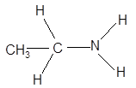 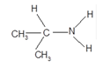  

primary amine primary amine secondary amine tertiary amine

* If the N atom is attached to two H atoms (and one alkyl group), it is a primary amine; if the N atom is attached to one H atom (and two alkyl groups, it is a secondary amine; if the N atom is attached to no H atoms (and three alkyl groups) it is a tertiary amine
* There are a number of ways to name amines:
* unbranched primary amines in which the NH2 group is at the end of the chain are usually named using the alkyl prefix followed by -amine:

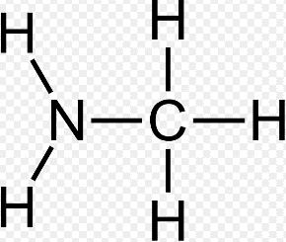 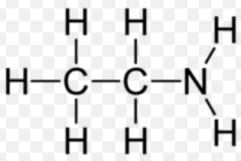 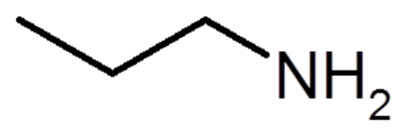

methylamine ethylamine propylamine

* simple unbranched secondary and tertiary amines are also named using alkyl prefixes followed by -amine

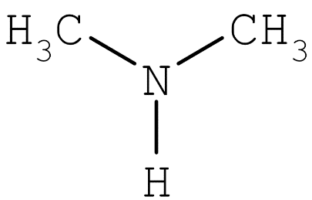 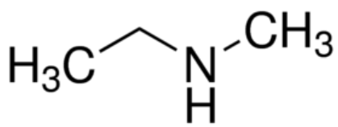 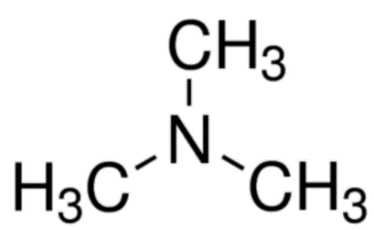

dimethylamine methylethylamine trimethylamine

* primary amines which are not at the end of the chain and diamines are more commonly named using an

-amino prefix:

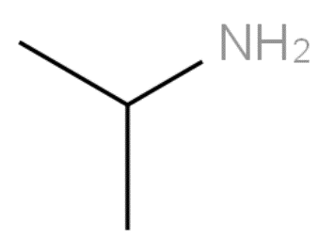 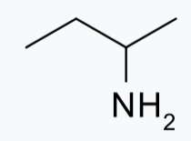 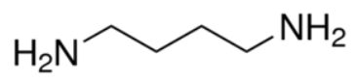

2-aminopropane 2-aminobutane 1,4-diaminobutane

* more complex branched amines are also named using the -amino prefix; additional alkyl groups on secondary amines can be identified using the N-prefix to indicate the position of the alkyl group; there are many alternative ways to name complex amines:

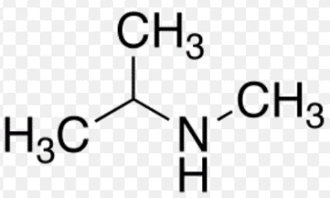

Eg N-methyl, 2-aminopropane

* The physical properties of amines are very similar to those of alcohols; because they can form hydrogen bonds, amines with short alkyl chains are often soluble in water and they have similar boiling points to alcohols
* Amines behave as weak bases in a very similar manner to ammonia (NH3):

NH3 + H2ONH4+ + OH- CH3NH2 + H2OCH3NH3+ + OH-

NH3 + HCl 🡪NH4Cl CH3NH2 + HCl 🡪CH3NH3Cl

* Some acid-base indicators used in titrations are amines; if the amine and the alkylammonium salt are different colours the amine can be used as an indicator; these coloured organic bases can also be used as dyes
* Primary and secondary amines can undergo a reversible condensation reaction with carboxylic acids similar to esterification:

Eg 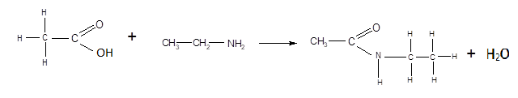

* the resulting product is an example of an **amide**
* the functional group linking the two molecules together is known as an amide or peptide link:



1. **Amino Acids**

* Amino acids are molecules which contain a carboxylic acid group and an amine group; they are named as if they are carboxylic acids, with the amine group added as an amino prefix:

 

2-aminopropanoic acid 2-aminoethanoic acid

(commonly known as alanine) (commonly known as glycine)

* Amino acids occur widely in nature and are very useful molecules in biochemistry; naturally occurring amino acids have the following general formula:



* there is a central carbon atom attached to a hydrogen, a carboxylic acid group, an amine group and an alkyl group
* Amino acids display most of the characteristic properties of carboxylic acids as well as most of the characteristic properties of amines (they are known as bifunctional molecules):
* amino acids react with alkalis to make carboxylate salts (like carboxylic acids)

eg CH3CH(NH2)COOH + NaOH 🡪 CH3CH(NH2)COONa + H2O

* amino acids react with alcohols to make esters (like carboxylic acids)

eg CH3CH(NH2)COOH + CH3OHCH3CH(NH2)COOCH3 + H2O

* amino acids react with amines to make amides (like carboxylic acids)

eg CH3CH(NH2)COOH + CH3NH2CH3CH(NH2)CONHCH3 + H2O

* amino acids react with acids to make salts (like amines)

eg CH3CH(NH2)COOH + HClCH3CH(NH3Cl)COOH + H2O

* amino acids react with carboxylic acids to make amides (like amines)

eg CH3CH(NH2)COOH + HClCH3CH(NHCOCH3)COOH + H2O

* Because amino acids can react with both acids and bases, they can be described as amphoteric (see Unit 5 – Acids, Bases and Salts)
* Because amino acids contain -COOH and -NH2 groups which can react with each other, amino acids can undergo condensation reactions with themselves:



* the resulting molecule contains a peptide link is called a **dipeptide** (because it is made from two amino acid molecules)

|  |
| --- |
| Image result for test icon**Test your knowledge 8.1: Introducing amines and amino acids**   1. Name the following amines: 2. (ii) (CH3CH2)2NH (iii) 3. Write equations to show the reaction between: 4. Methylamine and ethanoic acid 5. Ethylamine and propanoic acid 6. Propylamine and methanoic acid 7. State the name of the group present in the organic products of the reactions in (b) 8. Name the following molecule: CH3CH2CH(NH2)COOH 9. Write equations for the reactions of CH3CH2CH(NH2)COOH with: 10. HCl 11. NaOH 12. Itself to form a dipeptide |

|  |
| --- |
| 1. (i) Butylamine (or 1-aminobutane); (ii) diethylamine (or N-ethyl,aminoethane); (iii) 2-aminopropane 2. (i) CH3NH2 + CH3COOH CH3CONHCH3 + H2O; (ii) CH3CH2NH2 + CH3CH2COOH CH3CH2CONHCH2CH3 + H2O; (iii) CH3CH2CH2NH2 + HCOOH HCONHCH2CH2CH3 + H2O 3. Amide or peptide 4. 2-aminobutanoic acid 5. (i) CH3CH2CH(NH2)COOH + HCl 🡪 CH3CH2CH(NH3Cl)COOH; (ii) CH3CH2CH(NH2)COOH + NaOH 🡪 CH3CH2CH(NH2)COONa + H2O; (iii) 2CH3CH2CH(NH2)COOH CH3CH2CH(NH2)CONHCH(C2H5)COOH + H2O |

***Lesson 9 – What are polymers and plastics and how are they made?***

**d) Polymers**

|  |
| --- |
| **Summary Activity 9.1: Addition and condensation reactions**   * What is an addition reaction? Give one example. * What is a condensation reaction? Give one example. * Explain why alkenes can undergo addition reactions |
| * Joining of two molecules without loss of any atoms (eg C2H4 + Br2 🡪 C2H4Br2 or any reaction between an alkene and a halogen, halogen halide or H2O) * Joining or two organic molecules accompanied by the loss of a small molecule (eg CH3COOH + CH3OH 🡪 CH3COOCH3 + H2O or CH3COOH + CH3NH2 🡪 CH3CONHCH3 + H2O or any reaction between a carboxylic acid and an alcohol to make an ester or between a carboxylic acid and an amine to make an amide) * Alkenes are unsaturated, which means atoms can be added by breaking the C=C bond without have to remove any atoms |

* **Polymers** are long molecules made by the joining together of many smaller molecules; the name polymer means “many parts” in Greek
* The small molecules which join together to make a polymer are called **monomers**; the process by which monomers join together to make a single long molecule is called **polymerisation**
* Most polymers are man-made and are therefore known as **synthetic polymers**; some polymers occur naturally and are known as **natural polymers**
* There are two types of polymerisation reaction – addition polymerisation which makes **addition polymers**, and condensation polymerisation which makes **condensation polymers**

1. **Addition Polymers**

* Addition polymerisation involves the joining together of monomers by an addition reaction, which means that no atoms are lost when the monomers join together
* The most common type of addition polymerisation involves the joining together of alkenes to make polyalkenes:



* This process requires a high pressure and a suitable catalyst; the product of this addition process is a very long hydrocarbon chain and is an example of an addition polymer; different alkenes join together to make different addition polymers with different properties; the polymer is named after the alkene which was used to make it:

 

ethene poly(ethene) propene poly(propene)

 

but-1-ene poly(but-1-ene) but-2-ene poly(but-2-ene)



methylpropene poly(2-methylpropene)

* Addition polymers have long non-polar carbon chains which give them a number of characteristic properties:
* since the hydrocarbon chains are often very long, the Van der Waal's forces between the chains are often very strong and the polymers have relatively high melting and boiling points; since most polymers contain chains of different lengths, the Van der Waal's forces are of variable strength and these polymers tend to melt gradually over a range of temperatures rather than sharply at a fixed temperature
* since the chains are non-polar, addition polymers are insoluble in water; they are generally unreactive
* their low reactivity means that they are not easily decomposed in nature and as a result have a very long lifetime; such substances are said to be **non-biodegradable**, and constitute an environmental hazard as they are very persistent in nature and thus difficult to dispose of
* Most addition polymers are made from just one monomer; they are therefore called **homopolymers;** addition polymers made from the combination of different alkene monomers do not have a single repeat unit; these are known as **co-polymers**
* Most alkenes are made by cracking fractions of crude oil; all plastics made from these alkenes are therefore classified as **petrochemicals**
* Most addition polymers are converted into **plastics**, many of which are in everyday use; a plastic is a material which can be shaped by applying heat or pressure; almost all plastics contain addition polymers, usually polyalkenes; plastics can be classified as **thermoplastics** or **thermosetting plastics**, depending on how they respond to heating:
* thermoplastics can be repeatedly softened by heating and hardened by cooling

thermoplastics only have Van der Waal’s forces between the polymer molecules together; on heating, the polymer molecules vibrate faster and the plastic can be reshaped; on cooling, the structure sets in place until it is heated again; the structure is characterised by one or two-dimensional polymers with no links between the different chains

* thermosetting plastics are originally soft but are hardened irreversibly on heating

during the initial heating, permanent covalent bonds are formed between the polymer molecules which hold the polymer molecules rigidly in place, even after cooling; the structure is characterised by cross-links between the polymer chains:

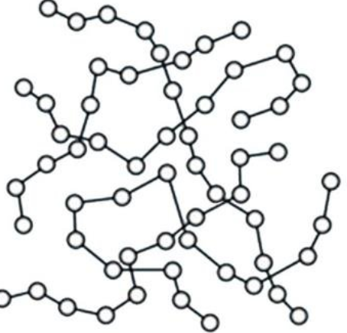 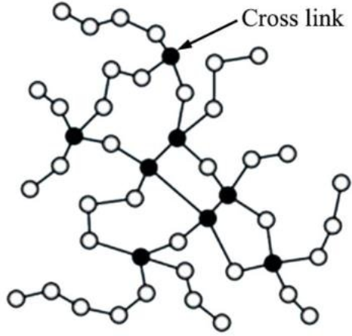

thermoplastic thermosetting plastic

[www.researchgate.net](http://www.researchgate.net)

* The properties of addition polymers results in their widespread use as inert plastic materials - they are very useful as insulators, as packaging and in making containers; common addition polymers include:
* polystyrene (made from styrene) is used in packaging and insulation
* polyvinylchloride (PVC) (made from vinyl chloride) is used to make waterproof clothing
* polyethene is used to make plastic bags and food containers
* polypropene is used to make pens, guttering and pipes
* A solid or viscous liquid raw material which can be made into a polymer or plastic is called a **resin**; some resins are monomers and are converted into polymers; some resins are already polymers and are converted into useful plastics

|  |
| --- |
| Image result for test icon**Test your knowledge 9.2: Describing addition polymers**   1. Explain the meaning of the term “polymer” 2. Draw the structure of polychloroethene, showing three repeating units 3. Draw and name the monomer which could be used to make the polymer below; hence name the polymer      1. (i) Explain what is meant by the term “plastic”   (ii) Explain the difference between thermoplastics and thermosetting plastics and explain how their different structures cause the different properties   1. Explain the main environmental problem associated with addition polymers 2. What is meant by the term “resin”? |
| 1. A large molecule formed by the joining together of many small molecules 3. , tetrafluoroethene, polytetrafluoroethene (PTFE) 4. A material which can be shaped by the action of heat of pressure; thermoplastics can reversibly soften when heated and harden when cooled, as the polymer chains are held together by Van der Waal’s forces only; thermosetting plastics are initially soft but become irreversibly hard when heated, as the heating process cases covalent bonds to form between the polymer chains which fix them in place 5. They are non-biodegradable, which means that it is difficult to get rid of them as they cannot be broken down naturally 6. a solid or viscous liquid which can be converted into a polymer or plastic |

***Lesson 10 – What are polyesters and polyamides and how are they made?***

**(ii) Condensation Polymers**

* If a carboxylic acid is heated with an alcohol in the presence of concentrated sulphuric acid, an ester is made and a water molecule is lost; this is an example of a condensation reaction:

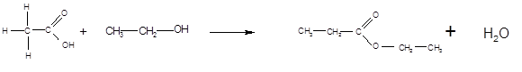

ethanoic acid + ethanol 🡪 ethyl ethanoate + H2O

* It follows that if a dicarboxylic acid is reacted with a diol, then the -COOH group at each end of the dicarboxylic acid should join to an -OH group, and the -OH group at each end of the diol should join to a -COOH group; it should therefore be possible for all the molecules to link together and form a polymer:
* Eg consider the molecules benzene-1,4-dicarboxylic acid and ethan-1,2-diol



benzene-1,4-dicarboxylic acid ethan-1,2-diol

* these two compounds can link together to form a polymer, and water is given off:



* this process can continue indefinitely:



* the resulting polymer can be represented by the following repeating unit:



* the trade name for this polymer is terylene; it is used in fire resistant clothing
* the monomer units are linked together by the ester group:



* Polymers which consist of monomer units linked by an ester group are called **polyesters**; they are an important type of condensation polymer
* Another example of condensation polymerisation to make a polyester is the reaction between ethanedioic acid and propan-1,2-diol

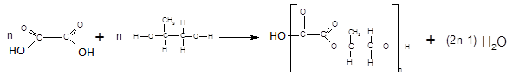

* Carboxylic acids also react with amines to form amides in another example of a condensation reaction:



propanoic acid + ethylamineN-ethylpropanamide + H2O

* It follows that if a dicarboxylic acid is reacted with a diamine, the -COOH group at each end of the dicarboxylic acid with join to an -NH2 group, and the -NH2 group at each end of the diamine will join to a -COOH group; it should therefore be possible for each of the molecules to join together and form a polymer:
* Eg consider the molecules hexanedioic acid and 1,6-diaminohexane



* these two compounds can link together to form a polymer, and water is given off:



* the resulting polymer can be represented by the following repeating unit:



* the trade name for the above polymer is nylon-66; it is used in clothing
* the monomers are linked together by the amide, or peptide link:



* Polymers containing monomer units linked by an amide or peptide group are therefore known as **polyamides**
* Another example of condensation polymerisation to make a polyamide is:

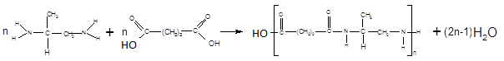

* Condensation polymers (polyesters, polyamides and proteins) consist of long chains which include polar bonds (C-O and C-N); this gives condensation polymers certain characteristic properties
* the strength of the intermolecular forces between the different chains in polyamides is enhanced by the presence of hydrogen bonding; polyamides are therefore often very strong
* the ester and amide links can be broken during hydrolysis reactions and this will break down the polymer structure; condensation polymers are hence **biodegradable**, and so constitute a smaller environmental hazard than addition polymers; hydrolysis can take place either in acidic or in alkaline conditions
* the biodegradability of condensation polymers may compromise their effectiveness, since physical and chemical durability is one of the reasons for their widespread use; a balance must be struck between practical durability and long-term biodegradability
* Polyamides and polyesters are both used largely in high-strength synthetic fibres:
* polyesters are used as wool and cotton substitutes in clothing (esp jumpers, T-shirts, shirts etc) and also in carpets and rugs; bullet-proof vests and some flame-retardant clothing are made from polyesters
* polyamides are more elastic and used in underwear, fishing nets and other synthetic fibres
* Condensation polymers are usually made by joining together different monomers; they are therefore usually called heteropolymers

|  |
| --- |
| Image result for test icon**Test your knowledge 10.1: Describing condensation polymers**   1. Explain why polyesters and polyamides are known as “condensation polymers” 2. Draw the structure of the polymer formed by mixing pentanedioic acid with 1,5-diaminopentane; what type of polymer is this? 3. Draw the structure of the polymer formed by mixing pentanedioic acid with ethan-1,2-diol; what type of polymer is this? 4. State the main use for polyesters and polyamides and explain why they are useful for this purpose 5. Explain the main environmental advantage of condensation polymers over addition polymers 6. Explain the difference between a homopolymer and a co-polymer 7. What is the difference between a synthetic polymer and a natural polymer? |

|  |
| --- |
| 1. They are formed by joining monomers together; each time a new organic molecule joins the chain, a small molecule is lost 2. ; condensation polymer (polyamide) 3. ; condensation polymer (polyester) 4. Used in making fibres for clothes and fabrics; they are very strong and can be elastic 5. Condensation polymers are biodegradable; they are broken down naturally by acids and alkalis, so they do not linger in the environment 6. A homopolymer is made from a single monomer (eg polyethene or most other addition polymers); a co-polymer is made from more than one monomer 7. A synthetic polymer is man-made; a natural polymer is naturally occurring |

***Lesson 11 – What is the chemical composition of food that we eat?***

**e) Introduction to Biochemistry**

* Biochemistry is the study of the chemistry of living organisms; many chemical reactions occur in the human body and in other organisms which are essential for survival

**(i) Fats, oils, fatty acids and glycerol**

* Fats and oils are naturally occurring esters made from long chain carboxylic acids (called fatty acids) and glycerol (propan-1,2,3-triol); each -OH group on the glycerol combines with a fatty acid in an esterification reaction to make a triester often known as a triglyceride:

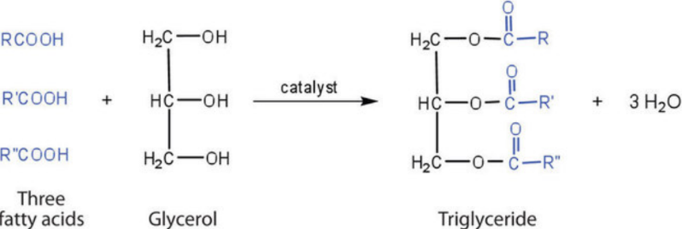

[www.chem.libretexts.org](http://www.chem.libretexts.org)

* a typical example of a triglyceride is shown below:

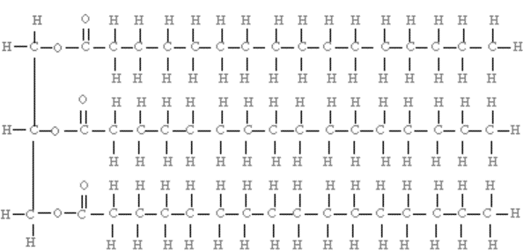

* Whether the triglyceride is solid at room temperature (ie a fat) or liquid at room temperature (ie an oil) depends on the structure of the fatty acids used to make the triglyceride:

|  |  |
| --- | --- |
|  |  |
| If the triglyceride is made from fatty acids with saturated hydrocarbon chains, the chains are reasonably straight; this allows the fat molecules to form strong Van der Waal’s forces with each other, increasing the melting point and making the triglyceride a solid at room temperature (ie a fat) | If the triglyceride is made from fatty acids with unsaturated hydrocarbon chains (especially cis isomers), the chains are not straight; this prevents the fat molecules from forming strong Van der Waal’s forces with each other, decreasing the melting point and making the triglyceride a liquid at room temperature (ie an oil) |

* It is possible to convert unsaturated fats into saturated fats artificially; this has the effect of hardening them and often making them solids at room temperature:
* The process is known as “hydrogenation”; the unsaturated fat is reacted with hydrogen at high pressure with a nickel catalyst (see Unit 9 – Metals and their Compounds)
* the hydrogen is added across the double bond, making the molecule saturated
* this straightens out the triglyceride, so it forms stronger Van der Waal’s forces and becomes harder
* this is how sunflower oil is converted into margarine
* Many organisms have the ability to combine glycerol and fatty acids together to make fats and oils; fat is important for the protection of organs and to keep warm; it also a useful energy store
* Usually, humans do not need to make fat as it is part of a normal diet; humans and some other organisms generally need to break down triglycerides into fatty acids and glycerol (ie the reverse reaction) using an enzyme called lipase:

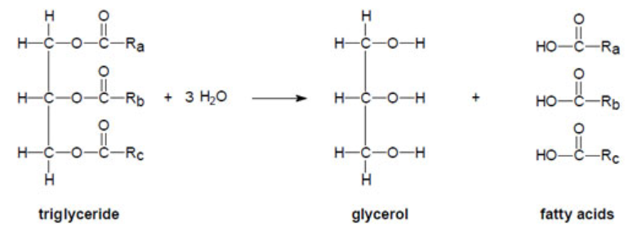

* this reaction is an important example of ester hydrolysis in biochemistry
* this reaction takes place when food is digested
* The hydrolysis of triglycerides by the human body is important because both glycerol and fatty acids are important nutrients:
* glycerol isused by the body to make glucose for respiration (which is why fats are a good source of energy)
* fatty acids are used to make cell membranes (which is why fats are essential for healthy tissue growth)
* the human body can store fat until it is needed (but it is important not to store too much fat)

|  |
| --- |
| Image result for test icon**Test your knowledge 11.1: Understanding fats, oils and how we digest them**   1. Explain what is meant by a triglyceride 2. Explain the difference between the structure of a fat (like margarine) and the structure of an oil (like sunflower oil) 3. Explain how sunflower oil can be converted into margarine 4. Explain what happens when fat broken down in the digestive system and explain why this process is important |
| 1. An ester made by combining glycerol with three fatty acid molecules 2. Fats contain mostly saturated fatty acids which are straight; this makes the Van der Waal’s forces stronger, causing the triglyceride to be solid at room temperature; oils contain mostly cis-unsaturated fatty acids which are bent; this makes the Van der Waal’s forces weaker, causing the triglyceride to be liquid at room temperature 3. By adding hydrogen with a nickel catalyst; the hydrogen adds across the C=C bond which straightens the fatty acid chains 4. Triglycerides are hydrolysed by lipase into fatty acids (which are used to build cell membanes) and glycerol (which is used as an energy source |

1. **Carbohydrates**

* Carbohydrates are molecules with the general formula Cx(H2O)y; carbohydrates can be classified as **monosaccharides**, **disaccharides** and **oligosaccharides** (collectively known as **sugars**) and **polysaccharides**, depending on the complexity of the molecule
* The simplest carbohydrates are monosaccharides, which contain a single ring of 5 or 6 carbon atoms; the most common monosaccharides are **glucose** and **fructose**, both of which have the molecular formula C6H12O6:

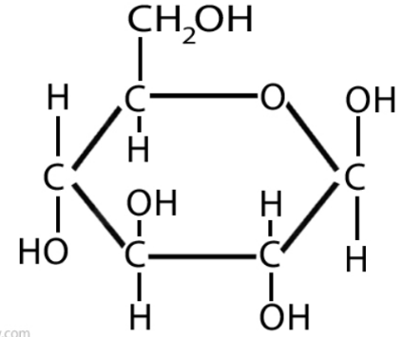 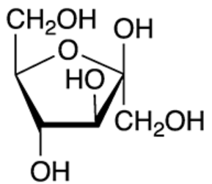

Glucose (C6H12O6) Fructose (C6H12O6)

* Glucose and fructose are made naturally by plants
* glucose can be converted directly into energy by both animals and plants in an exothermic reaction known as respiration: C6H12O6 + 6O2 🡪 6CO2 + 6H2O; fructose can also be converted into energy
* respiration of monosaccharides is the main way in which most organisms generate energy
* Monosaccharides can join together in a condensation reaction to form a disaccharide; the most common disaccharides are **sucrose** and **maltose**:
* a glucose molecule can combine with a fructose molecule to make a molecule called sucrose:

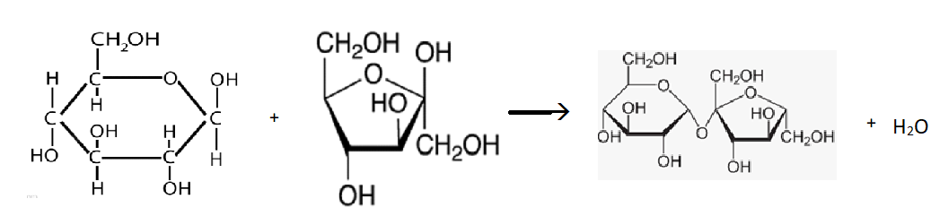

glucose + fructose 🡪 sucrose (C12H22O11) + H2O

* two glucose molecules can combine with each other to make a molecule called maltose:

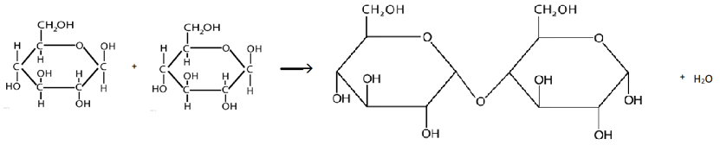

glucose + glucose 🡪 maltose (C12H22O11) + H2O

* These condensation reactions can also result in the formation of larger molecules; chains of 3 – 9 monosaccharides are known as oligosaccharides; chains of more than 9 monosaccharides are known as polysaccharides; common examples of polysaccharides are **starch**, **cellulose** and **glycogen**:
* Starch is a polysaccharide made by plants as an efficient way of storing glucose
* Cellulose is a polysaccharide made by plants to provide structural support (cell walls)
* Glycogen is a polysaccharide made by animals as an efficient way of storing glucose and fructose
* Polysaccharides are good examples of naturally occurring polymers
* Most animals can only convert monosaccharides directly into energy; most animals also have the ability to break down starch, glycogen and most disaccharides and oligosaccharides into monosaccharides using an enzyme called amylase; these reactions are the reverse of condensation and are further examples of hydrolysis:
* the hydrolysis of sucrose produces glucose and fructose
* the hydrolysis of maltose produces glucose
* the hydrolysis of starch and glycogen produces mainly glucose
* the above reactions all take place during the digestion of food
* Most animals do not have the ability to break down cellulose; cellulose remains important in nutrition as a source of fibre
* All monosaccharides and some disaccharides can be readily oxidised in the presence of a mild oxidising agent; these are known as reducing sugars; sugars which are not readily oxidised are known as non-reducing sugars:
* glucose, fructose and maltose are all reducing sugars
* sucrose is a nonreducing sugar
* The presence of reducing sugars can be detected using Fehling’s solution or Benedict’s solution; both contain a mild oxidising agent (Cu2+ ions) and they are both therefore blue in colour (see Unit 9 – Metals and their Compounds); when warmed with a reducing sugar, the Cu2+ is reduced to Cu2O (copper (I) oxide) which appears as an orange precipitate; reducing sugars therefore give an orange precipitate when warmed with Benedict’s solution or Fehling’s solution
* The presence of starch can be confirmed by adding iodine; starch and iodine form a complex with a distinct blue-black colour; any substance which gives a blue-black colour on addition of iodine must therefore contain starch

|  |
| --- |
| Image result for test icon**Test your knowledge 11.2: Understanding carbohydrates**   1. Explain, giving one example in each case, the meaning of: (i) a monosaccharide; (ii) a disaccharide; (iii) a polysaccharide 2. How do plants store excess glucose? How do animals store excess glucose? 3. Describe what happens when polysaccharides are broken down in the digestive system and explain why this is useful 4. Give one example of a reducing sugar and one example of a non-reducing sugar 5. Describe a simple chemical test for reducing sugars 6. Describe a simple chemical test for starch |
| 1. (i) a carbohydrate consisting of a single ring of carbon and oxygen; (ii) a carbohydrate consisting of two monosaccharides joined together by condensation (iii) a carbohydrate consisting of many monosaccharides joined together by condensation 2. Plants store glucose by converting it into starch; animals store excess glucose by converting it into glycogen 3. The polysaccharides are hydrolysed by amylase and broken down into monosaccharides which can be absorbed into the blood and converted into energy 4. Reducing: glucose, fructose, maltose; non-reducing: sucrose 5. Reducing sugars will turn Benedict’s solution from blue to orange if heated gently for a few minutes 6. Starch will turn iodine solution from orange to blue-black |

***Lesson 12 – How can we test for the presence of different nutrients in food?***

1. **Amino acids and proteins**

* Amino acids are very important in biochemistry; there are 20 naturally occurring amino acids; the two simplest are glycine and alanine; each amino acid has its own three-letter and one-letter symbol:



Glycine (Gly) (G) Alanine (Ala) (A) Valine (Val) (V)

* The -COOH group on one molecule can undergo a condensation reaction with an -NH2 group on another molecule to form a dipeptide; this process can continue further until a long chain of amino acids is formed, called a **polypeptide**
* When one or more polypeptides are arranged in a particular way, a **protein** is formed; a protein is a naturally occurring polypeptide or combination of polypeptides; proteins are natural polymers composed entirely of amino acids:

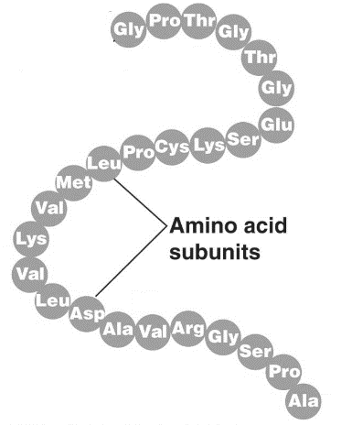

A typical protein ([www.socratic.org](http://www.socratic.org))

* Proteins are essential for life; they are the main structural component of most types of body tissue, such as muscle; they are also the main component of enzymes and antibodies
* Protein (from plants and animals) is an important part of the human diet; the human body is able to break down proteins into amino acids using an enzyme called protease; this is a hydrolysis reaction and is a key part of human digestion; the body then uses the amino acids produced by protein hydrolysis to make the proteins it needs; proteins are made by DNA in human cells
* There are a number of ways to test for amino acids and proteins:
* **Biuret reagent** can be used to test for the presence of a peptide link in solution; Biuret reagent is blue (due to the presence of Cu2+ ions) but it turns purple when added to a solution containing a substance with a peptide link (as the Cu2+ forms a complex with the N atom)
* **ninhydrin** can be used to test for any molecule containing a primary amine group (-NH2); the colourless ninhydrin solution turns purple or deep blue in the presence of a primary amine group; all primary amines, all amino acids except proline, and many proteins give a positive ninhydrin test
* two amino acids (tyrosine and tryptophan) give a yellow colour in the presence of concentrated nitric acid; since most common proteins contain tyrosine, it can be used as a test for a protein; this reaction is called the **xanthoproteic test**
* The amino acid tyrosine contains a benzene ring with an -OH group attached to it; this group will give a red-brown colour on warming with **Millon’s reagent** (which is colourless)

|  |
| --- |
| Image result for test icon**Test your knowledge 12.1: Understanding proteins**   1. Explain what is meant by a protein 2. Explain what happens when proteins are broken down in the digestive system and explain why this is useful 3. Describe four different tests for proteins and explain any differences in what they are tests for |
| 1. A naturally occurring polymer made up of one or more long chains of amino acids, joined by condensation 2. Proteins are hydrolysed by protease and broken down into amino acids; the body can use its DNA to convert these amino acids into other useful proteins which it needs 3. Biuret (blue 🡪 purple; any molecule with a peptide link); ninhydrin (colourless 🡪 purple; any molecule containing -NH2); xanthoproteic (colourless 🡪 yellow; tyrosine or tryptophan or any protein containing them); Millon (colourless 🡪 red; any molecule containing a benzene ring with an -OH group on it) |

|  |
| --- |
| cid:ii_jepnvfe00_1621fa54a497745d **Practical 12.2: Test for protein, starch and reducing sugars in food**  You are provided with three foods – apple, biscuit and egg; you must test each food to determine whether they contain sugar, starch and protein   1. Take half of a simple biscuit and grind it to a powder in a mortar and pestle 2. Pour the ground biscuit into a 100 cm3 beaker and add 10 cm3 of distilled water; stir the mixture well for several minutes in order to dissolve as many of the nutrients as possible into the water 3. Filter the mixture into another 100 cm3 beaker using a funnel and filter paper 4. Divide the filtered mixture by pouring it into three different test tubes, with approximately equal amounts in each 5. To the first test tube add 2 cm3 of Biuret solution; record your observations 6. To the second test tube add 2 cm3 of Benedict’s solution and then place the test tube in a water bath for five minutes; record your observations 7. To the third test tube add 2 cm3 of iodine solution; record your observations 8. Clean out the mortar and pestle, beakers and funnel thoroughly and repeat steps 1 – 7 using one quarter of an apple 9. Repeat steps 2 – 7 using egg white from one egg (you do not need to grind the egg!) 10. Complete the following table: |
| Equipment needed per group: a biscuit, an apple and an egg; one mortar, one pestle, one stirring rod, one funnel, three pieces of filter paper, two 100 cm3 beakers, nine test tubes, one test tube rack, access to a hot water bath (a 250 cm3 beaker half-full of boiling water is sufficient), access to Benedict’s solution with dropping pipette; access to Biuret reagent with dropping pipette, access to 0.5 M iodine solution with dropping pipette (10 cm3 per group)   * the biscuit should turn iodine solution from brown to blue-black (if this test doesn’t work, try adding the iodine solution directly onto the biscuit – a blue-black colour will be visible) * the biscuit and the apple should turn Benedict’s solution from brown to orange * the egg should turn Biuret solution from blue to purple |
| Cannot do this experiment? Watch it here: [www.youtube.com/watch?v=sLP8dcnWnJg](http://www.youtube.com/watch?v=sLP8dcnWnJg) |

***Lesson 13 – What is soap and how is it made?***

|  |
| --- |
| **Summary Activity 13.1: Miscibility of organic compounds in water**   * What types of organic compound are generally the most soluble in water? * What types of organic compounds are generally the least soluble in water? * What types of organic compound are generally the most and least soluble in non-polar solvents? * How might you design a molecule which could mix with water and non-polar solvents? |
| * compounds with ionic groups (eg -COO-); also groups which can hydrogen bond (eg -OH, -COOH and -NH2) * compounds with long hydrocarbon chains or aromatic rings * compounds with long hydrocarbon chains or aromatic rings (which are least soluble in water) are generally the most soluble in non-polar solvents; compounds with ionic groups and hydrogen bonds (which are most soluble in water) are generally the least soluble in non-polar solvents * the molecule needs an ionic group AND a long hydrocarbon chain |

**f) Soaps and Soapless Detergents**

* A detergent is a substance which is added to water to improve its cleaning properties; most oils and fats do not mix with water and so water is not effective at removing them; a detergent is a substance which helps oil and water mix and hence helps water remove oil and grease from materials such as fabrics and cooking utensils
* Detergents are generally long molecules or ions which have a “hydrophilic” end, usually a carboxylate or other ionic group, which attracts water molecules, and a “hydrophobic” end, usually a long hydrocarbon chain or aromatic ring, which attracts oil/grease molecules; detergents can therefore bind simultaneously with water and grease, causing them to mix:

**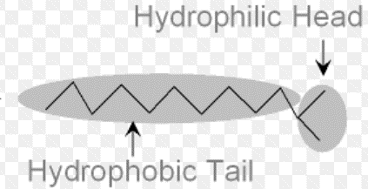**

* The most common type of detergent is **soap**; soap is the sodium salt of a fatty acid; the long hydrocarbon chain acts as the hydrophobic end and the carboxylate group acts as the hydrophilic end:

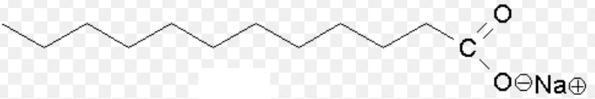

* Soap is made by the alkaline hydrolysis of triglycerides:

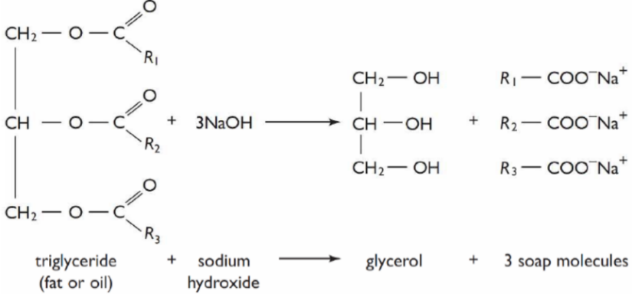

* this reaction is known as **saponification**; glycerol is a by-product of the reaction
* it is an important example of ester hydrolysis
* The main disadvantage of soap as a detergent is that it can form insoluble ionic compounds with some of the cations present in hard water (eg Mg2+ and Ca2+) (see Unit 8 – Solubility and Precipitation Reactions); these precipitation reactions remove the soap anions from solution and prevent them from acting as an effective detergent: Ca2+(aq) + C17H35COO-(aq) 🡪 Ca(C17H35COO)2(s); soap is therefore more effective in soft water than in hard water
* Some detergents have been developed which do not form precipitates in hard water; these are not made from triglycerides but are synthesised from hydrocarbons and other products of crude oil; these products are known as **soapless detergents**; they are often more soluble in water than soap and hence clean more efficiently
* Most soapless detergents consists of long hydrocarbon chains or an aromatic ring with a hydrophilic sulphonate group – HSO3Na at the end; they work in the same way as soaps:

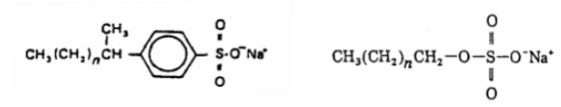

* Disadvantages of soapless detergents are that they are often non-biodegradable and so can pollute water supplies; they are also not made from a renew some people are also allergic to soapless detergents; the main advantages of soapless detergents are that they work more efficiently, especially in hard water

|  |
| --- |
| Image result for test icon**Test your knowledge 13.2: Understanding soaps and soapless detergents**   1. Draw the structure of a typical soap and a typical soapless detergent 2. Explain how soaps and soapless detergents improve the cleaning properties of water 3. Describe how soap is manufactured 4. State two advantages of soapless detergents over soaps 5. State two advantages of soaps over soapless detergents |
| 1. soap: any long chain hydrocarbon with a COO-Na+ at one end; soapless detergent: any long chain hydrocarbon or aromatic hydrocarbon with a OSO3-Na+ at one end   eg (soap);(soapless detergent)   1. hydrocarbon chain is hydrophobic and attracts oil and grease molecules; anionic end is hydrophilic and attracts water; hence the oil and water will mix 2. alkaline hydrolysis of triglycerides (saponification); fat or oil is heated with sodium hydroxide 3. they are more water soluble so less of it is needed for efficient cleaning; they work well in hard water 4. they are more biodegradable; they are made from a renewable resource |

***Lesson 14 – How can we isolate, purify and analyse organic compounds?***

**g) Separating, purifying and analysing compounds**

* The deliberate use of chemical reactions to make new substances is called **synthesis**; after synthesising new materials, it is necessary to **separate** them from the rest of the reaction mixture; it is also frequently necessary to **purify** them and to **test their purity**

|  |
| --- |
| **Summary Activity 14.1: Separation Techniques**   * What is filtration? When is filtration an effective separation technique? Can you think of a preparation you have carried out in which the desired product is separated from the reaction mixture by filtration? * What is distillation? When is distillation an effective separation technique? Can you think of any substances which are separated by distillation? * What is crystallisation? When is crystallisation an effective separation technique? Can you think of a preparation you have carried out in which the desired product is separated from the reaction mixture by crystallisation? |
| * Using a funnel and filter paper to separate an insoluble solid from a liquid; it only works when the solid is insoluble in the liquid; most insoluble salts (eg BaSO4) can be separated by filtration * Using a condenser to separate two miscible liquids with different boiling points; it only works when the two liquids have significantly different boiling points; ethanol and water, ethanol and methanol, the components of air and the fractions of crude oil are all separated by distillation * Separating a solid from a soluble solvent by evaporating off most of the solvent and then cooling the mixture down; most solids are less soluble at lower temperatures; it is an efffective separation technique for removing a non-volatile soluble solid from a solution; most soluble salts such as CuSO4 or (NH4)2SO4 are separated from water by crystallisation |

**(i) Separation Techniques**

* **Filtration** is the separation of an insoluble solid from a liquid, using a funnel and filter paper; the solid remains in the filter paper and is called the **residue**; the liquid passes through the filter paper and can be collected in a beaker or flask below; it is called the **filtrate**

Filtration can be used in organic and inorganic chemistry to remove a solid from a solution, or to remove a solution from a solid:

* when an insoluble salt such as BaSO4 is prepared using a precipitation reaction, it can be separated from the mixture by filtration; the residue is collected and purified
* when a soluble salt such as CuSO4 is prepared by reacting an acid with an insoluble base (CuO); the excess base can be removed from the reaction mixture by filtration; the filtrate is collected
* **Distillation** is the separation of two miscible liquids using differences in their boiling points; the mixture is heated until the mixture with the lower boiling point boils; this vapour is separated, condensed and collected in a separate vessel; it is known as the **distillate**
* during the preparation of high-alcohol drinks such as whisky, the ethanol can be removed from the reaction mixture after fermentation by distillation; ethanol has a lower boiling point than water, so will boil first and can be collected as the distillate
* methanol can also be removed from ethanol by distillation; if the mixture is heated, methanol will boil first; it will condense in the condenser and it can be collected and discarded, leaving pure ethanol as the residue
* **Crystallisation** is the separation of a soluble solid from an aqueous solution of the solid; most, but not all, of the water should be removed by heating the solution; the solution should then be left to cool; the water will continue to evaporate and the solid will separate out as crystals, partly because there is less water to dissolve in and partly because the solubility of the solid is lower at lower temperatures
* when soluble salts such as CuSO4 or (NH4)2SO4 are prepared during neutralisation reactions, they are in aqueous solution; the mixture is heated until 75% of the water has evaporated, and then allowed to cool; the salt will crystallise and can be collected
* **Chromatography** is the separation of two liquids or gases using the different speeds at which they travel along paper (thin layer chromatography) or through a narrow tunnel (gas chromatography); thin layer chromatography is very useful for separating different pigments in synthetic or natural inks; gas chromatography can be used to separate any mixture of volatile liquids
* Chromatography is mainly used to separate the different components of a mixture during **analysis**; the different components can be first separated and then identified; it works only with small quantities and is not a good way of separating a desired product from a reaction mixture; filtration, distillation or crystallisation should be used for this purpose

**(ii) Purification Techniques**

* The simplest purification technique is **drying**; drying is a very useful way of removing small quantities of water or ethanol from a solid sample; there are three ways to achieve drying:
* squeeze the solid sample inside some filter paper; most of the water will be absorbed into the paper, leaving a drier solid behind
* place the solid in an open container in an oven at a relatively low temperature (not so hot that the solid melts); after a few minutes, most of the remaining water will have evaporated off, leaving a dry solid
* place the solid in a desiccator (drier); desiccators contain chemical drying agents, usually hygroscopic or deliquescent substances (see Unit 5 – Acids, Bases and Salts); these drying agents will remove much of the water form the solid, leaving it dry
* A more sophisticated purification technique is **recrystallisation**; recrystallisation is a good way to remove most solid impurities from a solid sample; recrystallisation only works if a solvent exists in which the solid is highly soluble when hot but not very soluble when cold; most solids are recrystallised using either water or ethanol
* The solid should first be dissolved in the minimum possible quantity of hot solvent
* once dissolved, the hot solution should be filtered to remove insoluble impurities
* the filtrate should then be allowed to cool down and then placed in an ice bath; most of the solid should crystallise out again due to the lower temperature
* the mixture should then be filtered again to remove the excess solvent, along with any impurities which do not recrystallise
* the residue should be collected and dried to remove any remaining solvent

|  |
| --- |
| Image result for test icon**Test your knowledge 14.2: Understanding separation and purification techniques**   1. Describe how to isolate pure sand from a mixture of sand and water 2. Describe how to isolate pure water from a mixture of salt and water 3. Describe how to isolate pure salt from a mixture of salt and water 4. Aspirin is soluble in hot water but not in cold water; suggest how a sample of aspirin prepared in the laboratory could be purified |
| 1. Filter the mixture; the sand is the residue and can be collected; it should be dried in filter paper and then left to dry further in an oven 2. Heat the mixture in a distillation apparatus; collect the water in a beaker below the end of the condenser 3. Heat the mixture gently in an evaporating dish until 75% of the water has evaporated; then allow the mixture to cool until crystals form; use a spatula to collect the crystals, dry them in filter paper and then leave them in an oven for a short time to dry further 4. Dissolve the aspirin in a small quantity of hot water; filter the mixture whilst hot, cool down the distillate and then place the beaker in an ice bath; filter the cold mixture; dry the residue in filter paper and leave to dry further in an oven at low temperature |

**(iii) Analytical Techniques**

* There are a large number of techniques available for analysing substances in order to identify them (qualitative analysis) or to determine how much of them is present (quantitative analysis)
* Many anions, cations, gases and organic functional groups can be identified by simple chemical tests, which have been covered throughout this course (see Unit 5 – Acids, Bases and Salts, Unit 6 – Redox Reactions, Unit 7 – Introduction to Organic Chemistry, Unit 8 – Solubility and Precipitation Reactions, Unit 9 – Metals and their Compounds); most analytical chemists, however, use a much wider variety of analytical techniques than just simple tests; in this section a few additional techniques will be discussed, particularly regarding the identification of unknown organic compounds
* The **molecular mass** of an organic compound can be determined in two ways:
* using the ideal gas equation; by vaporising an organic substance in a container of fixed known volume at standard pressure, and weighing the mass of gas present, it is possible to determine its molecular mass:

PV = nRT and n = $\frac{m}{m_{r}}$ so PV = $\frac{mRT}{m_{r}}$ so **mr =** ; the mass must be entered in kg and the molecular mass will be calculated in kgmol-1

|  |
| --- |
| Worked example:  A vaporised organic compound at 100 kPa and 298 K in a 200 cm3 container was found to have a mass of 0.37 g. What is the molecular mass of the gas?  Answer:  m = 0.37 g = 3.7 x 10-4 kg; R = 8.31, T = 298, P = 100,000, V = 200 x 10-6 so mr = 0.0458 kgmol- 1 = **46 gmol-1** |

* using a technique called mass spectrometry
* Once the molecular mass is known, the **molecular formula** of an organic compound (containing only C, H and O) can be determined; this is usually done by completely burning a known mass of the substance and measuring the mass of carbon dioxide and water produced:
* the mass of carbon present will be 12/44 of the mass of carbon dioxide produced
* the mass of hydrogen present will be 2/18 of the mass of water produced
* any remaining mass must be oxygen

|  |
| --- |
| Worked example:  1.0 g of an organic compound with a molecular mass of 46 was completely burned in oxygen; 1.91 g of carbon dioxide and 1.17 g of water were produced. What is the molecular formula of the compound?  Answer:  Mass of carbon in 1.0 g of compound = 12/44 x 1.91 = 0.52 g (proportion of C = 0.52/1)  Mass of hydrogen in 1.0 g of compound = 2/18 x 1.17 = 0.13 g (proportion of H = 0.13/1)  Mass of oxygen in 1.0 g of compound = 1.0 – 0.52 – 0.13 = 0.35 g (proportion of O = 0.35/1)  If the molecular mass is 46, then:  0.52/1 x 46 = 24 must come from C; 24/12 = 2 so two C atoms present  0.13/1 x 46 = 6 must come from H; 6/1 = 6 so 6 H atoms present  0.35/1 x 46 = 16 must come from O; 16/16 = 1 so 1 O atom present  **So the molecular formula is C2H6O** |

* the molecular formula can also be determined using an advanced form of mass spectrometry
* The detailed molecular structure of the compound can be determined using combination of mass spectrometry, gas chromatography and various types of **spectroscopy**; spectroscopy is the analysis of a substance based on how it absorbs or emits radiation (see Unit 1 – Atomic Structure and the Periodic Table)

|  |
| --- |
| Image result for test icon**Test your knowledge 14.3: Determining the molecular formula of an organic compound**   1. A sample of an organic compound was vaporised at 373 K at 100 kPa; at this temperature and pressure the mass of gas occupying a volume of 100 cm3 was 0.194 g   In a separate experiment, 1.00 g of the same organic compound was found to produce 1.47 g of CO2 and 0.60 g of H2O  Deduce the molecular mass and hence the molecular formula of the organic compound   1. A sample of an organic compound was vaporised at 373 K at 100 kPa; at this temperature and pressure the mass of gas occupying a volume of 100 cm3 was 0.304 g   In a separate experiment, 1.00 g of the same organic compound was found to produce 2.81 g of CO2 and 0.574 g of H2O  Deduce the molecular mass and hence the molecular formula of the organic compound |
| 1. mr = 0.060 kgmol-1 = 60 gmol-1; moles in 1.00 g = 1/60 = 0.0167; mass of C = 12/44 x 1.47 = 0.40; moles of C = .40/12 = 0.033; 0.033/0.0167 = 2 so 2 C atoms; mass of H = 2/18 x 0.6 = 0.0667; moles of H = 0.0667/1 = 0.0667; 0.0667/0.0167 = 4 so 4 H atoms; 2 x 12 + 4 x 1 = 28; remainder of mr = 60 – 28 = 32 comes from O so 32/16 = 2 O atoms so molecular formula = C2H4O2 2. mr = = 0.094 kgmol-1 = 94 gmol-1; moles in 1.00 g = 1/94 = 0.0106; mass of C = 12/44 x 2.81 = 0.766; moles of C = .766/12 = 0.063; 0.063/0.0106 = 6 so 6 C atoms; mass of H = 2/18 x 0.574 = 0.0638; moles of H = 0.0667/1 = 0.0638; 0.0638/0.0106 = 6 so 6 H atoms; 6 x 12 + 6 x 1 = 78; remainder of mr = 94 – 78 = 16 comes from O so 16/16 = 1 O atom so molecular formula = C6H6O |

***Lesson 15 – What have I learned about further organic chemistry?***

|  |
| --- |
| Image result for test icon  **15.1 END-OF-UNIT QUIZ**  **UNIT 11 – FURTHER ORGANIC CHEMISTRY**   1. Explain why alcohols and carboxylic acids have relatively high boiling points and are usually soluble in water 2. (a) Describe how alcohol is made from sugar   (b) State the main risk of drinking home-brewed spirits and describe how this risk can be minimised   1. Consider the following alcohols: propan-2-ol, butan-1-ol, methylpropan-1-ol, methylpropan-2-ol 2. Classify each alcohol as primary, secondary or tertiary: 3. State which alcohols would give a yellow precipitate with I2 and NaOH 4. State which alcohols would give turn acidified potassium dichromate green or brown 5. State which alcohols can be converted into carboxylic acids and draw the structure of the carboxylic acid formed in each case 6. Write equations to show what happens when propan-1-ol is reacted with: 7. concentrated sulphuric acid (with heat) 8. sodium 9. ethanoic acid in the presence of sulphuric acid 10. Write equations to show what happens when propanoic acid is reacted with: 11. sodium hydroxide 12. sodium carbonate 13. methanol in the presence of sulphuric acid 14. Identify the products of the hydrolysis of propyl methanoate 15. In acidic conditions 16. In alkaline conditions 17. Name the following amines: 18. CH3CH2NH2 19. CH3CH(NH2)CH3 20. (CH3)2NH 21. Explain the meaning of the terms “addition polymer”, “condensation polymer” and “co-polymer” 22. Draw the repeating unit of the polymer formed from: 23. propene 24. butanedioic acid and ethan-1,2-diol 25. 2-aminopropanoic acid 26. Describe the structure of a lipid. State in general terms the products of the hydrolysis of lipids 27. Explain the difference between monosaccharides, disaccharides and polysaccharides and give one example of each 28. Describe the structure of proteins 29. Describe a simple laboratory test for: 30. a reducing sugar 31. starch 32. protein 33. Explain the difference between a soap and a soapless detergent. Explain how they work and give one advantage and one disadvantage of each. 34. Suggest how a sample of aspirin could be purified in the laboratory. |

|  |
| --- |
| 1. Hydrogen bonding between molecules causes stronger intermolecular forces and higher boiling point; hydrogen bonding with water molecules causes miscibility with water 2. (a) by fermentation; 35 – 55 oC, no oxygen, yeast, C6H12O6 🡪 2C2H5OH + 2CO2   (b) presence of methanol; discard first 5% of distillate during distillation   1. (a) butan-1-ol and methylpropan-1-ol are primary; propan-2-ol is secondary; methylpropan-2-ol is tertiary   (b) propan-2-ol  (c) propan-2-ol, butan-1-ol and methylpropan-1-ol  (d) butan-1-ol CH3CH2CH2COOH, methylpropan-1-ol CH3CH(CH3)COOH   1. (a) CH3CH2CH2OH 🡪 CH3CH=CH2 + H2O   (b) 2CH3CH2CH2OH + 2Na 🡪 2CH3CH2CH2ONa + H2  (c) CH3CH2CH2OH + CH3COOHCH3COOCH2CH2CH3 + H2O   1. (a) CH3CH2COOH + NaOH 🡪 CH3CH2COONa + H2O   (b) 2CH3CH2COOH + Na2CO3 🡪 2CH3CH2COONa + CO2 + H2O  (c) CH3CH2COOH + CH3OHCH3CH2COOCH3 + H2O   1. (a) propan-1-ol and methanoic acid   (b) propan-1-ol and sodium methanoate (or any methanoate)   1. (a) ethylamine or aminoethane   (b) 2-aminopropane  (c) dimethylamine or N-methylaminomethane   1. Addition polymer: made when monomers join together in an addition reaction (ie no small molecule is lost); condensation polymer: made when monomers join together in a condensation reaction (ie a small molecule is lost); co-polymer: do not consist of a single repeating unit (usually addition polymers) 2. (a) -CH2CH(CH3)- (also allow displayed or skeletal)   (b) -OCH2CH2OOC(CH2)2CO- (also allow displayed or skeletal)  (c) -NHCH(CH3)CO-   1. Trimester; glycerol joined to three fatty acid molecules by ester links; hydrolysis of lips gives fatty acids and glycerol 2. monosaccharides consist of a single C-O ring (glucose, fructose); disaccharides consist of two adjoining C-O rings (sucrose, maltose), polysaccharides consist of many adjoining C-O rings (eg starch, glycogen, cellulose) 3. one or more chains of amino acids joined together with an amide (peptide) link as a result of a condensation reaction 4. (a) Benedict’s or Fehling’s solution – blue solution becomes orange precipitate   (b) iodine – blue-black complex formed  (c) Biuret’s – blue solution turns purple   1. Soap – salt of fatty acid; soapless detergent – sulphonate salt of aromatic or long-chain hydrocarbon; both have a hydrophilic end which binds to water and a hydrophobic end which binds to grease; soap is carbon-neutral and biodegradable; soapless detergents are more effective in hard water 2. Recrystallisation - dissolve in minimum quantity of hot water; filter hot; cool distillate in ice bath; filter cold; wash residue in a little cold water; dry |