UNIT 7

INTRODUCTION TO ORGANIC CHEMISTRY

Answers

Lesson 1 – What are organic molecules?

Test your knowledge 1.1: Classifying simple organic molecules
- (i) alkene; unbranched aliphatic  hydrocarbon | (ii) alcohol; unbranched aliphatic | (iii) bromoalkene; branched aliphatic
(iv) cycloalkane; branched alicyclic hydrocarbon | (v) alkyne; unbranched aliphatic  Hydrocarbon | (vi) cycloalcohol; unbranched alicyclic
(vii) alkene; branched aliphatic hydrocarbon | (viii) cyclochloroalkane; branched alicyclic | (ix) alkane; branched aliphatic hydrocarbon

Lesson 2 – How can we draw and write organic molecules?

Test your knowledge 2.1: Drawing simple organic molecules
(a) | (i) CH₃CH₂CH₂CH₃  or 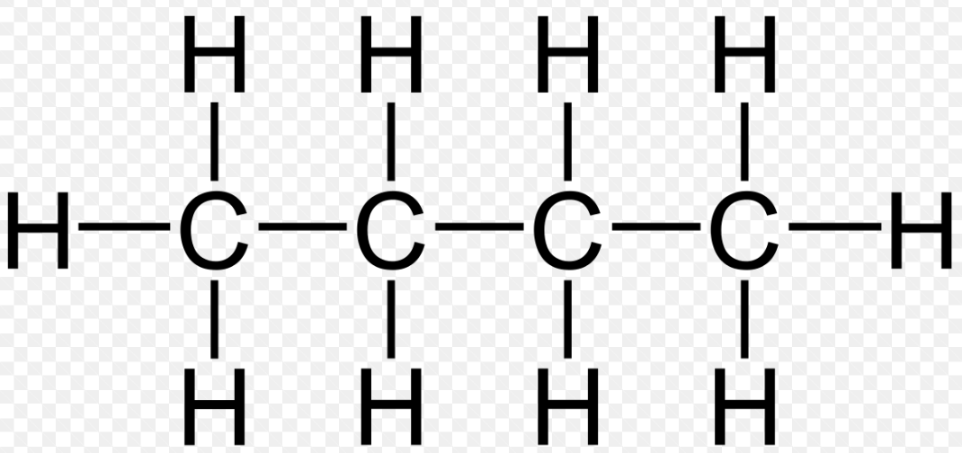 | (ii)  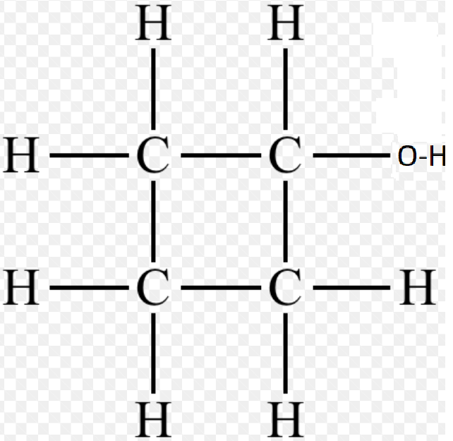 | (iii) (CH)₃CHCH₂ or  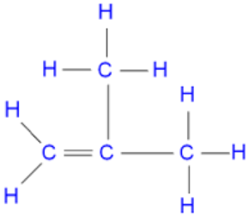 | (iv) CH₃CH₂CCH or CH₃CCCH₃  or 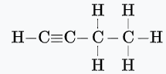or  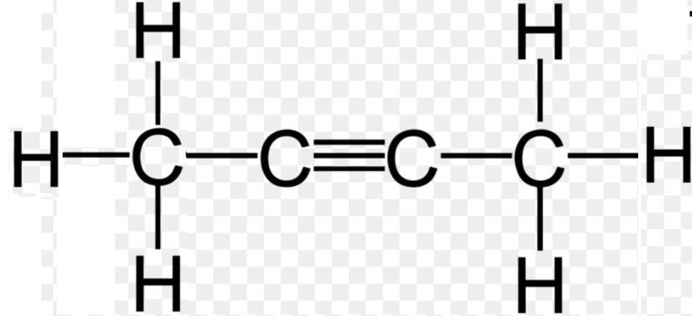
(v) (CH₃)₂CHCH₂Br or (CH₃)₃CBr or 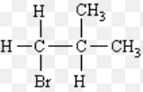 or 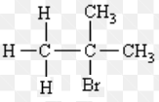
Note – there are other correct answers to (a) (i) – (v) using combinations of displayed and skeletal formulae
(b) (i) C₄H₁₀, C₂H₅; (ii) C₄H₈O, C₄H₈O; (iii) C₄H₈, CH₂; (iv) C₄H₆, C₂H₃; (v) C₄H₉Br, C₄H₉Br
(c) five possible alcohols:
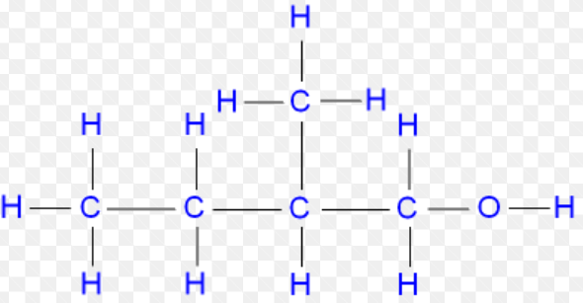 CH₃CH₂CH(CH₃)CH₂OH 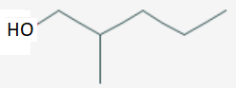
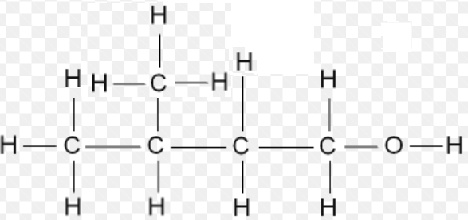 (CH₃)₂CHCH_{2C}CH₂OH 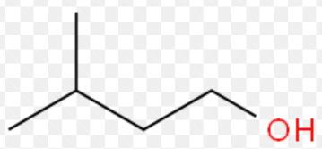
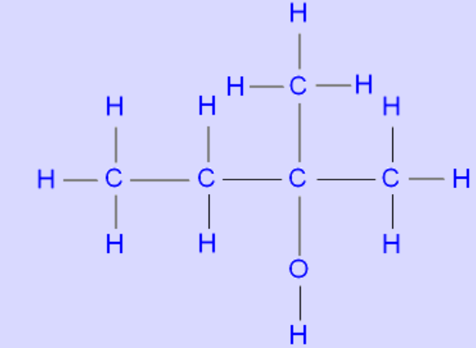 (CH₃)₂C(OH)CH₂CH₃ 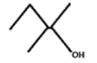
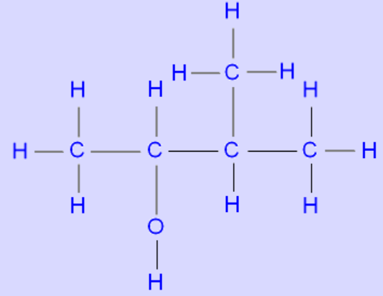 CH₃CH(OH)CH(CH₃)₂ 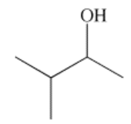
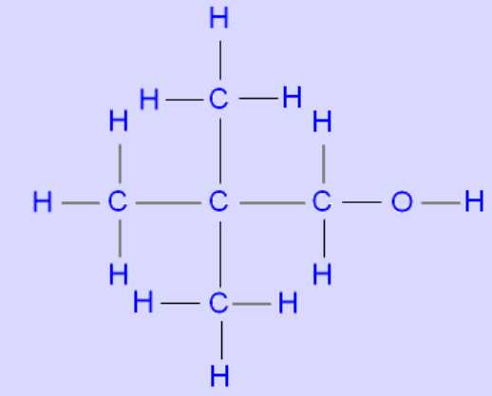 (CH₃)₃CCH₂OH 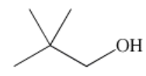
Molecular formula: C₅H₁₂O; empirical formula: C₅H₁₂O
(d) (i) C_{n}H_{2n-2}; (ii) C_{n}H_{2n}O

Lesson 3 – How do we name organic compounds?

Test your knowledge 3.1: Naming simple organic molecules
- (i) pent-1-ene; (ii) but-2-yne; (iii) 1-bromopropane; (iv) chloroethane; (v) 3-chloropentane; (vi) pentan-3-ol
- (i) 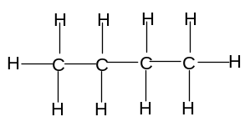; (ii) 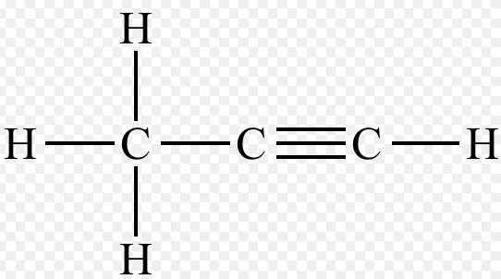; (iii) 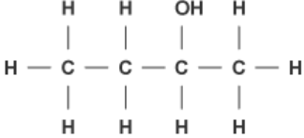
(iv) 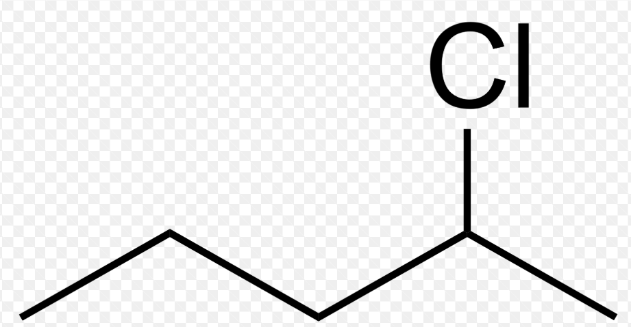; (v) CH₃I; (vi) CH₃CH₂CH₂OH
Note: any correct displayed, structural or skeletal formula is acceptable

Lesson 4 – How do we name more complex organic compounds?

Test your knowledge 4.1: Naming more complex organic molecules
- (i) propan-1,3-diol; (ii) 1-bromo,1-chloroethane; (iii) 2-methylpent-1-ene; (iv) 3-methylpentan-2-ol;
(v) 4-methylpent-1-yne; (vi) 2,2,4-trimethylpentane; (vii) cyclopentene; (viii) 1,3-dimethylcyclobutane; (ix) 1-iodo,2-methylcyclopropane
- (i) HO-CH₂-CH₂-OH; (ii) BrCH₂CHBrCH₃; (iii) (CH₃)₂CHCH(OH)CH₂CH₃; (iv) (CH₃)₂CHCH₂CH₂OH;
(v) CH₂=CH(CH₃)CH₂CH₃; (vi) 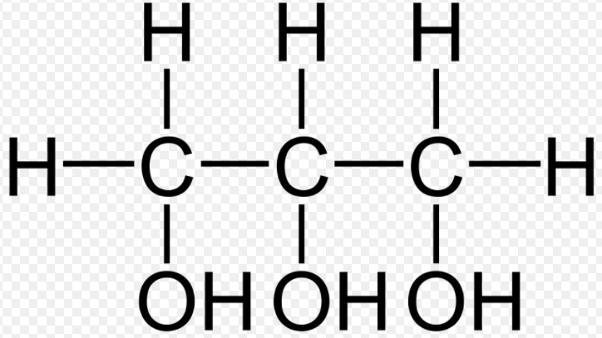; (vii) 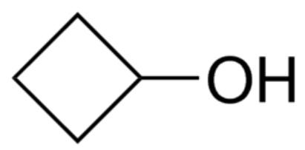; (viii) 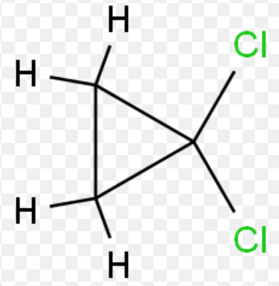;
(ix) 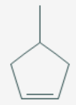
Note: displayed or structural or skeletal or any correct combination is acceptable

Lesson 5 – How can we predict, recognise and classify isomers?

Summary Activity 5.1: What are isomers?
- 2; 1-chloropropane (CH₃CH₂CH₂Cl) and 2-chloropropane (CH₃CHClCH₃); in 1-chloropropane the Cl is attached to C₁ but in 2-chloropropane the Cl is attached to C₂
- 4; but-1-ene (CH₃CH₂CH=CH₂), but-2-ene (CH₃CH=CHCH₃), methylpropene ((CH₃)₂CH=CH₂), cyclobutane (□); but-1-ene and but-2-ene are different because the functional group is on a different position; methylpropene is different from but-1-ene and but-2-ene because it is branched; cyclobutane is different because it does not have a C=C bond

Test your knowledge 5.2: Recognising structural isomerism
- CHCl₂CCH₃ (1,1-dichloropropane) and CH₂ClCH₂Cl (1,2-dichloropropane); positional isomerism
- (i) CH₃(CH₂)₂CH=CH₂; (ii) CH₃CH=CHCH₂CH₃ (pent-2-ene); (iii) either CH₂=C(CH₃)CH₂CH₃ (2-methylbut-1-ene) or (CH₃)₂C=CHCH₃ (2-methylbut-2-ene) or (CH₃)₂CHCH=CH₂ (3-methylbut-1-ene); (iv) Either cyclopentane or methylcyclobutane or 1,1-dimethylcyclopropane or 1,2-dimethylcyclopropane
(either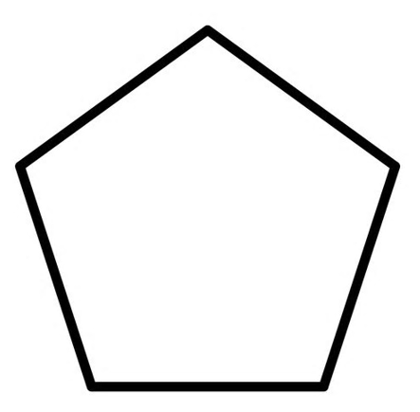or 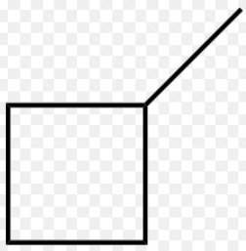 or 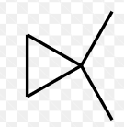 or 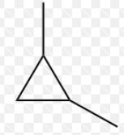)
- Four: CH₃CH₂CH₂CH₂OH (butan-1-ol), CH₃CH(OH)CH₂CH₃ (butan-2-ol), (CH₃)₂CHCH₂OH (methylpropan-1-ol), (CH₃)₃COH (methylpropan-2-ol)
- Butane, as it has a larger surface area, so stronger Van der Waal’s forces between the molecules
Extension 5.3: Further structural isomerism
- CH₃(CH₂)₂CH=CH₂ (pent-1-ene), CH₃CH=CHCH₂CH₃ (pent-2-ene); CH₂=C(CH₃)CH₂CH₃ (2-methylbut-1-ene), (CH₃)₂C=CHCH₃ (2-methylbut-2-ene), (CH₃)₂CHCH=CH₂ (3-methylbut-1-ene)
- CH₃(CH₂)₃CH₂OH (pentan-1-ol); CH₃CH(OH)CH₂CH₂CH₃ (pentan-2-ol); CH₃CH₂CH(OH)CH₂CH₃ (pentan-3-ol); (CH₃)₂CHCH₂CH₂OH (3-methylbutan-1-ol); (CH₃)₂CHCH(OH)CH₃ (3-methylbutan-2-ol) (CH₃)₂C(OH)CH₂CH₃ (2-methylbutan-2-ol); CH₃CH₂CH(CH₃)CH₂OH (2-methylbutan-1-ol); (CH₃)₃CCH₂OH (dimethylpropanol)

Lesson 6 – What are stereoisomers?

 Activity 6.1: Why can single bonds rotate and why can double bonds not rotate?
Equipment needed per group: 4 pieces of scrap paper and 3 sharp pencils
The students should notice that if two pieces of paper are connected by only one pencil, it is possible to rotate them both independently; if the pieces of paper are connected by two pencils a few cm apart, however, it is no longer possible to rotate one piece of paper without rotating the other

Test your knowledge 6.2: Geometrical isomerism
- A and B can be cyclopentane, methylcyclobutane, 1,1-dimethylcyclopropane or 1,2-dimethylcyclopropene; E and F are cis pent-2-ene and trans pent-2-ene; D is pent-1-ene; C is either 2-methylbut-1-ene or 3-methylbut-1-ene or 2-methylbut-2-ene
- 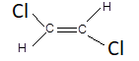(trans 1,2-dichloroethene)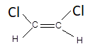(cis 1,2-dichloroethene); 1,1-dichloroethene does not have two different groups attached to the C atoms in the C=C bond (one C has 2 Cl atoms and the other has 2 H atoms); 1,2-dichloroethane has single bonds only, so has free rotation around all bonds

Lesson 7 – What is crude oil and why is it useful?

Summary Activity 7.1: Why do different hydrocarbons have different boiling points?
- Van der Waal’s forces (intermolecular forces)
- Larger molecules mean more/stronger Van der Waal’s forces, as more electrons and more surface area mean more temporary and induced dipoles
- They increase as the molecule gets larger, so more electrons/greater surface area means more temporary and induced dipoles
- Smaller surface area, so weaker Van der Waal’s forces

Test your knowledge 7.2: Processing crude oil
- (i) a mixture of hydrocarbons with similar boiling points; (ii) column is hotter at the bottom than at the top; vaporised hydrocarbon molecules rise up the column; molecules cool down; larger molecules with higher boiling points condense first and are collected nearer the bottom of the column; smaller molecules with lower boiling points condense later and are collected nearer the top of the column; (iii) any five from liquefied petroleum gas – gas for camping and cooking; petrol – fuel for cars; naphtha – petrochemicals; kerosene – fuel for aeroplanes; diesel – fuel for lorries and central heating; mineral oil – lubrication and petrochemicals; fuel oil – fuel for ships; wax – candles and grease; bitumen – road surfacing
- (i) C₁₀H₂₂ → C₈H₁₈ + C₂H₄ or C₁₀H₂₂ → C₆H₁₄ + C₄H₈ or any balanced equation producing one alkane and one alkene; (ii) C₁₂H₂₆ → C₈H₁₈ + 2C₂H₄ or C₁₂H₂₆ → C₆H₁₄ + C₂H₄ + C₄H₈ or any balanced equation producing one alkane and two alkenes; (iii) C₆H₁₄ → C₆H₁₂ + H₂
- Cracking produces higher value, higher demand alkanes and alkenes; reforming produces

Lesson 8 – why are alkanes useful?

Summary Activity 8.1: Exothermic reactions
- A reaction in which chemical potential energy is converted into heat energy (causing the temperature to rise)
- They are useful because the heat energy released can be used for heating, to make electricity or to power vehicles
- All reactions have an activation energy (energy needed to break bonds in the reactants); sometimes heat or a spark is needed to make sure that the reactants have this energy
- “fuel” is a substance which can be used to create useful energy; “combustion” is the reaction of a substance with oxygen

Test your knowledge 8.2: Alkanes as fuels
- (i) C₇H₁₆ + 11O₂ → 7CO₂ + 8H₂O; (ii) C₄H₁₀ + 4.5O₂ → 4CO + 5H₂O; (iii) C₆H₁₄ + 3.5O₂ → 6C + 7H₂O
- Any three from: CO – formed when hydrocarbons burn in limited oxygen; C – formed when hydrocarbons burn in very limited oxygen; hydrocarbons – formed when hydrocarbons vaporise and escape before having a chance to burn; SO₂ – formed when S impurities in petrol burn as the fuel burns; NO – formed when N₂ in the air reacts with O₂ at high temperature or in the presence of a spark’
- A number showing how resistant a fuel is to knocking, on a scale in which heptane is 0 and 2,2,4-trimethylpentane is 100

Lesson 9 – What are the typical reactions of alkanes, alkenes and alkynes?

Test your knowledge 9.1: Simple reactions of hydrocarbons
- ethane: C₂H₄ + H₂ → C₂H₆ or C₂H₅X + H₂ → C₂H₆ + HX (X = any halogen); ethene: C₂H₆O → C₂H₄ + H₂O; ethyne: CaC₂ + 2H₂O → C₂H₂ + Ca(OH)₂
- addition: organic molecule gains atoms without losing any, eg C₂H₄ + H₂ → C₂H₆; substitution: replacement of one atom or group of atoms on an organic molecule with another, eg C₂H₅X + H₂ → C₂H₆ + HX; elimination: loss of atoms from an organic molecule without replacement, eg C₂H₆O → C₂H₄ + H₂O
- add bromine: ethene will decolorise it but alkane will not; or add KMnO₄: alkene will decolorise it but ethane will not
- Add silver nitrate and ammonia solution; ethyne will give a yellow-white precipitate but ethene will not
- (i) CH₃CH₂Cl (or any isomer of C₂H₄Cl₂ or C₂H₃Cl₃ or C₂H₂Cl₄ or C₂HCl₅ or C₂Cl₆) (substitution); (ii) CH₃CHBrCH₃ or CH₃CH₂Br (addition) (iii) CH₃CH₂CH(OH)CH₂OH (hydroxyoxidation); (iv) CH₂=CHCl (addition)

Lesson 10 – What are aromatic compounds?

Test your knowledge 10.1: Benzene
- Ring of six carbon atoms; all C-C bonds intermediate between single and double bonds as p-electrons delocalised; each carbon also bonded to one hydrogen, C₆H₆
- (i) C₆H₆ + Cl₂ → C₆H₅Cl + HCl; (ii) C₆H₆ + 3Cl₂ → C₆H₆Cl₆
- Delocalised electrons makes structure stable; substitution reactions preserve the delocalised structure but addition reactions break it; substitution therefore preferred
- To make polystyrene; to increase octane number of petrol, to make pharmaceuticals
- Contains a benzene ring

Lesson 11 – What have I learned about Organic Chemistry?

11.1 END-OF-TOPIC QUIZ

UNIT 7 – INTRODUCTION TO ORGANIC CHEMISTRY
- (i) eg (CH₃)CHCH₃ (or any branched alkane); (ii) CH₂=CHCH₃ (or any unbranched alkene); (iii) 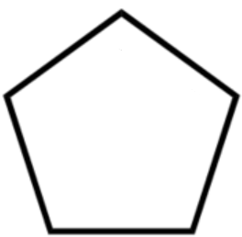 (or any unbranched cycloalkane); (iv) 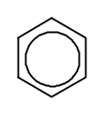
- (i) (CH₃)₂CHCH₂CH₃; (ii) CH₃CH=CHCH₂CH₃; (iii) (CH₃)₂CHCH₂CH₂OH; (iv) CH₂BrCHBrCH₃; (v) 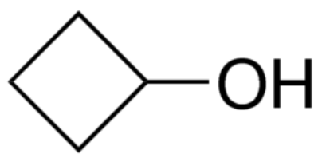
- 1,1-dimethylcyclopentane; (ii) propan-1-ol; (iii) methylbut-2-ene; (iv) 2-bromomethylpropane; (v) chlorocyclopropane
- CH₃CH₂CH₂OH (propan-1-ol) and CH₃CH(OH)CH₃ (propan-2-ol)
- (i) CH₃CH₂CH₂CH=CH₂ and CH₃CH₂CH=CHCH₃, or two from (CH₃)₂C=CHCH₃ and (CH₃)₂CHCH=CH₂ and CH₃CH₂C(CH₃)=CH₂; (ii) any of the five alkenes with cyclopentane, methylcyclobutane, 1,1-dimethylcyclopropane or 1,2-dimethylcyclopropane; (iii) one of the unbranched alkenes and one of the branched alkenes; (iv) 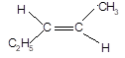 and 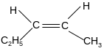
- methane, ethane, propane; boiling point increases due to more electrons per molecule and larger surface area leading to stronger Van der Waal’s forces between molecules
- column is hotter at the bottom than at the top; vaporised hydrocarbon molecules rise up the column; molecules cool down; larger molecules with higher boiling points condense first and are collected nearer the bottom of the column; smaller molecules with lower boiling points condense later and are collected nearer the top of the column
- eg C₈H₁₈ → C₆H₁₄ + C₂H₄ or any balanced combination of one alkane and one or more alkenes
- C₆H₁₄ → C₆H₁₂ + H₂
- Any three from: liquefied petroleum gas – gas for camping and cooking; petrol – fuel for cars; naphtha – petrochemicals; kerosene – fuel for aeroplanes; diesel – fuel for lorries and central heating; mineral oil – lubrication and petrochemicals; fuel oil – fuel for ships; wax – candles and grease; bitumen – road surfacing
- (i) C₅H₁₂ + 8O₂ → 5CO₂ + 6H₂O; (ii) CH₄ + 1.5O₂ → CO + 2H₂O or CH₄ + O₂ → C + 2H₂O
- S present naturally in crude oil and most fractions; when fuel is burned, S burns to five SO₂; it is an acidic gas and dissolves in water to form acid rain
- Add bromine to both; pent-1-ene will decolorise but cyclopentane will not (or use KMnO₄)
- CH₃CH₂CH₂CHBrCH₃ and CH₃CH₂CH₂CH₂CH₂Br
- Delocalised ring is stable; addition reactions break the delocalised ring so are not favoured; substitution reactions do not break the ring so are preferred

