2.2.3 Exercise 2 - MASS SPECTRA OF ELEMENTS
In a mass spectrum, the atoms of an element are ionised and the ions are then detected according to their relative mass (their mass/charge ratio, m/z).
Most elements have different isotopes so more than one peak is seen in their mass spectrum.
The mass spectra of elements can be used to:
- Determine relative isotopic masses accurately
- Calculate relative atomic masses
- Identify elements

Use the following spectra to estimate the abundance of each isotope, and hence calculate the relative atomic mass of the element and deduce its identity.

a)
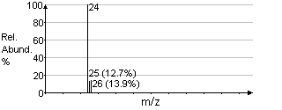

b)
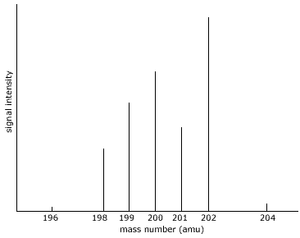
c)
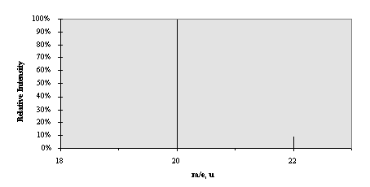

d)
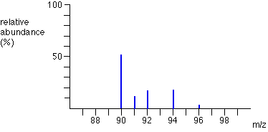

Give two scenarios in which you might want to identify unknown elements by mass spectrometry.

