A-LEVEL CHEMISTRY

PAPER 1
PRACTICE PAPER 10

Answer all questions
Max 105 marks
2 hours

Name ……………………………………………………………..

Mark ……../105 ……....% Grade ………

1. Steel rods are cleaned before they are painted. The rods are cleaned by passing them through a bath of dilute sulfuric acid. This process produces large quantities of iron(II) sulfate.
(a) Write an equation for the reaction between iron and dilute sulfuric acid.
........................................................................................................................
(1)
(b) State one chemical hazard in this process and suggest an appropriate safety precaution for this hazard.
Hazard ...........................................................................................................
Precaution .....................................................................................................
(2)
(Total 3 marks)

2. Lead(II) chromate(VI) is a bright yellow solid and is almost insoluble in water. It is the pigment in the yellow paint that has been used for road markings.
(a) Lead(II) chromate(VI) can be prepared by mixing solutions of sodium chromate(VI) and lead(II) nitrate.
Write an equation for this reaction.
........................................................................................................................
(1)
(b) Suggest one advantage of the low solubility of lead(II) chromate(VI) when it was used in the paint for road markings.
........................................................................................................................
........................................................................................................................
(1)
(c) Lead(II) chromate(VI) does not react with oxidising agents.
Suggest one advantage of this property of lead(II) chromate(VI) when it was used in the paint for road markings.
........................................................................................................................
........................................................................................................................
(1)
(d) Lead(II) chromate(VI) was used to give a bright yellow colour to some types of foodstuffs.
Suggest one reason why this use is now illegal.
........................................................................................................................
(1)
(Total 4 marks)

3. | 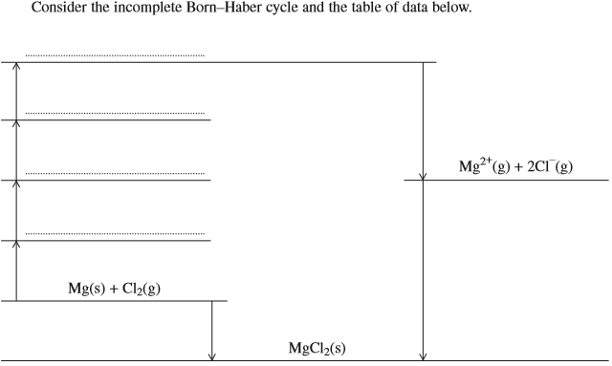  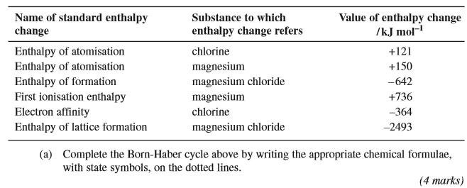
 | 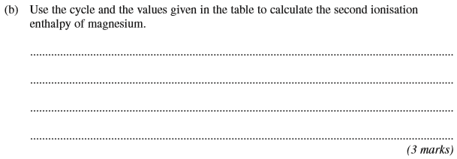
 | 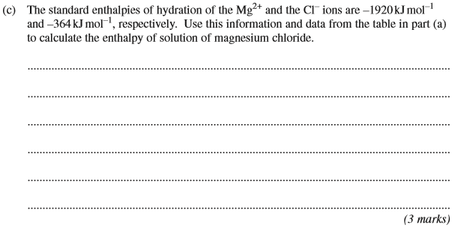
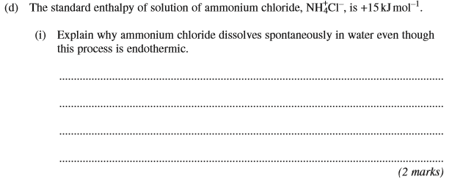
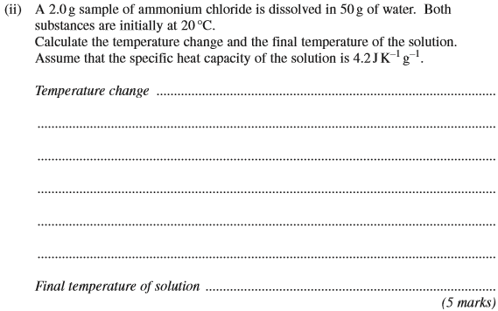
(Total 17 marks)

4. | 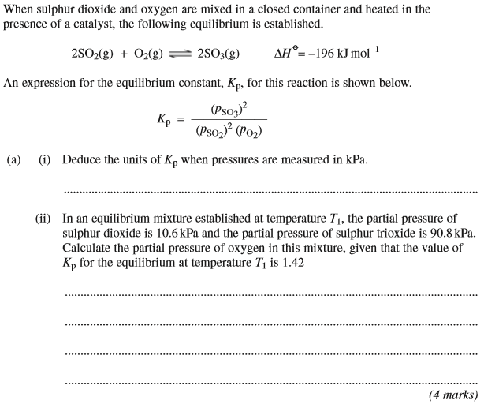

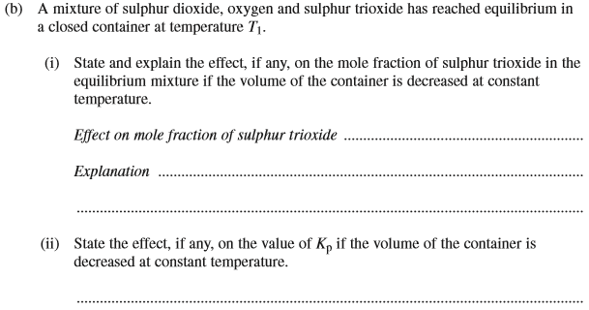
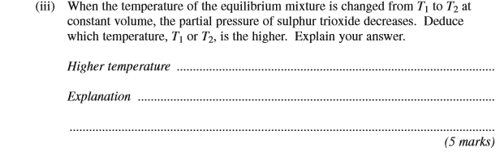
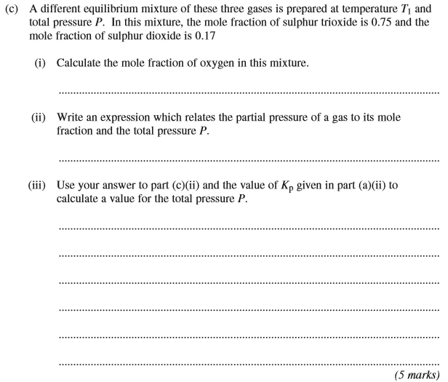
(Total 14 marks)

5. | 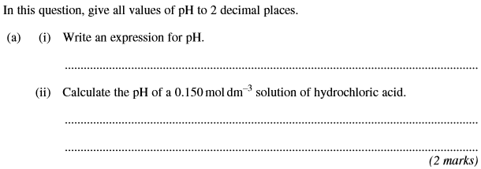
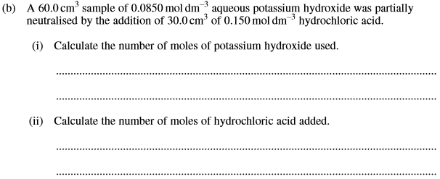
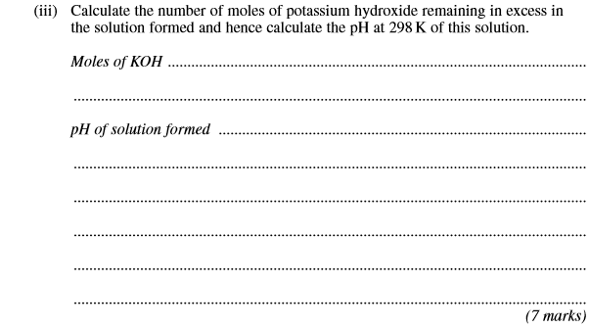
(Total 9 marks)

6. A solution of chlorine in water is acidic. Swimming pool managers maintain pool water at a constant pH by using a buffer. They do so by adding sodium hydrogencarbonate and sodium carbonate.
(a) Hydrogen carbonate ions (HCO₃⁻) act as a weak acid in aqueous solution. Write an equation for this equilibrium.
........................................................................................................................
........................................................................................................................
........................................................................................................................
(1)

(b) Use the equation in part (a) to explain how a solution containing sodium hydrogencarbonate and sodium carbonate can act as a buffer when small amounts of acid or small amounts of alkali are added.
........................................................................................................................
........................................................................................................................
........................................................................................................................
........................................................................................................................
........................................................................................................................
........................................................................................................................
........................................................................................................................
........................................................................................................................
(3)
(Total 4 marks)

7. Indicators and pH curves can be used to determine the end point in a titration.
(a) The pH curves labelled J, K, L and M for combinations of different acids and bases are shown below. All solutions have a concentration of 0.1 mol dm^{–3}.
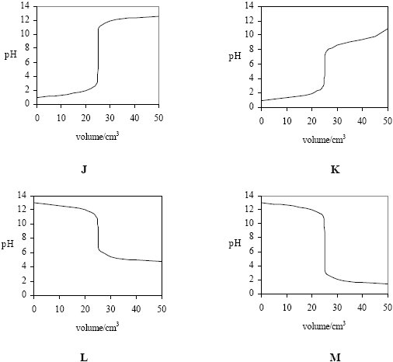

(i) Select from J, K, L and M the curve produced by the addition of
ammonia to 25 cm³ of hydrochloric acid .............................................
ethanoic acid to 25 cm³ of sodium hydroxide ......................................
sodium hydroxide to 25 cm³ of hydrochloric acid ................................
(ii) A table of acid–base indicators and the pH ranges over which they change colour is shown below.

Indicator pH range
Thymol blue 1.2 – 2.8
Bromophenol blue 3.0 – 4.6
Methyl red 4.2 – 6.3
Cresolphthalein 8.2 – 9.8
Thymolphthalein 9.3 – 10.5
Select from the list above an indicator which could be used in the titration which produces curve J but not in the titration which produces curve K.
.............................................................................................................
(4)
(b) The acid dissociation constant, K_{a}, for the weak acid, ethanoic acid, has a value of 1.74 × 10^{–5} mol dm^{–3} at 25 °C.
K_{a} = 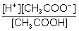
(i) Write an expression for the term pH.
.............................................................................................................
(ii) Calculate the pH of a 0.15 mol dm^{–3} solution of ethanoic acid. Give your answer to
2 decimal places.
.............................................................................................................
.............................................................................................................
.............................................................................................................
.............................................................................................................
(4)
(Total 8 marks)

8. | 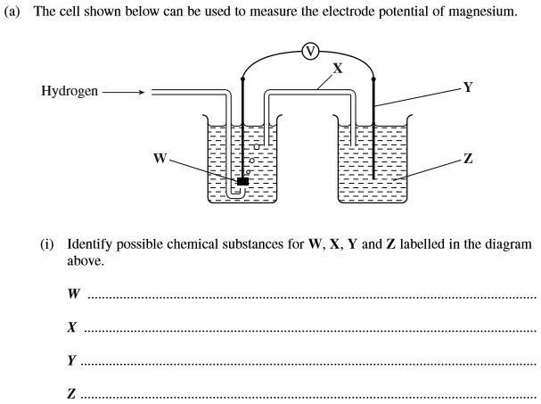  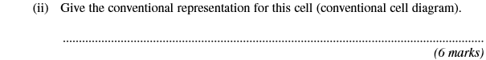

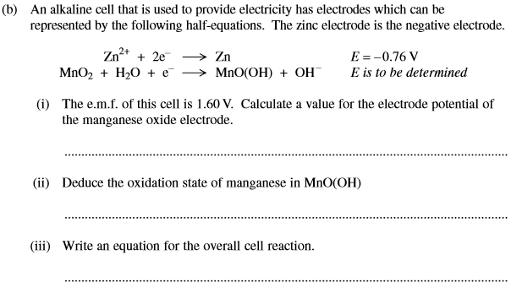
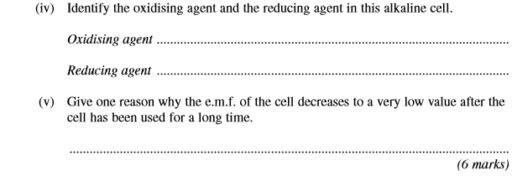
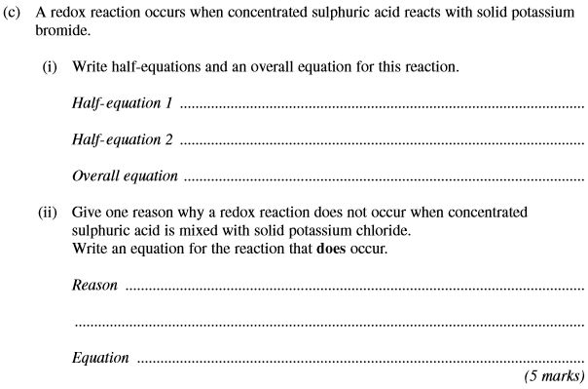
(Total 17 marks)

9. (a) State what is meant by each of the following terms.
(i) Ligand ...................................................................................…………
.............................................................................................................
(ii) Complex ion ........................................................................................
.............................................................................................................
(iii) Co-ordination number ...........................................................…………
.............................................................................................................
(3)
(b) Using complex ions formed by Co²⁺ with ligands selected from H₂O, NH₃, Cl–, and EDTA^{4–}, give an equation for each of the following.
(i) A ligand substitution reaction which occurs with no change in either the co-ordination number or in the charge on the complex ion.
.............................................................................................................
(ii) A ligand substitution reaction which occurs with both a change in the co-ordination number and in the charge on the complex ion.
.............................................................................................................
(iii) A ligand substitution reaction which occurs with no change in the co-ordination number but a change in the charge on the complex ion.
.............................................................................................................
(iv) A ligand substitution reaction in which there is a large change in entropy.
.............................................................................................................
(8)

(c) An aqueous solution of iron(II) sulphate is a pale-green colour. When aqueous sodium hydroxide is added to this solution a green precipitate is formed. On standing in air, the green precipitate slowly turns brown.
(i) Give the formula of the complex ion responsible for the pale-green colour.
.............................................................................................................
(ii) Give the formula of the green precipitate.
.............................................................................................................
(iii) Suggest an explanation for the change in the colour of the precipitate.
.............................................................................................................
.............................................................................................................
(4)
(Total 15 marks)

10. (a) State the electron configuration of a Ti(III) ion and that of a Ti(IV) ion. Explain, in terms of electron configurations and electron transitions, why Ti(III) compounds are usually coloured but Ti(IV) compounds are colourless.
......................................................................................................................
......................................................................................................................
......................................................................................................................
......................................................................................................................
......................................................................................................................
......................................................................................................................
......................................................................................................................
......................................................................................................................
(5)
(b) Transition metal ions and their complexes can often be identified from their colours.
For each of the following, identify a complex ion responsible for the colour of the aqueous solution. Restrict your answers to complexes formed from the elements Fe, Co and Cu.
A deep blue solution formed in an excess of concentrated aqueous ammonia.
A yellow–green solution formed in an excess of concentrated hydrochloric acid.
......................................................................................................................
......................................................................................................................
......................................................................................................................
(2)
(c) An experiment is carried out to investigate the rate of the autocatalysed reaction between aqueous potassium manganate(VII) and ethanedioate ions in an excess of dilute sulfuric acid. When these reagents are mixed together, the colour of the reaction mixture gradually fades. The concentration of the manganate(VII) ions is recorded at different times using a spectrometer. The temperature of the reaction mixture is constant.
(i) Give two reasons why the use of a spectrometer is the most appropriate method for measuring the concentration of the coloured ions in this experiment.
.............................................................................................................
.............................................................................................................
.............................................................................................................
.............................................................................................................
(2)
(ii) Sketch a curve to show how you would expect the concentration of manganate(VII) ions to change with time until the colour has faded because the concentration has reached a very low value. Explain the shape of the curve.
.............................................................................................................
.............................................................................................................
.............................................................................................................
.............................................................................................................
.............................................................................................................
.............................................................................................................
.............................................................................................................
.............................................................................................................
.............................................................................................................
.............................................................................................................
.............................................................................................................
.............................................................................................................
.............................................................................................................
.............................................................................................................
(5)
(Total 14 marks)

