A-LEVEL CHEMISTRY

PAPER 1
PRACTICE PAPER 11

Answer all questions
Max 105 marks
2 hours

Name ……………………………………………………………..

Mark ……../105 ……....% Grade ………

1. | ……………………………………………………………………………………………………………………………………………………………………………  ……………………………………………………………………………………………………………………………………………………………………………  ……………………………………………………………………………………………………………………………………………………………………………  ……………………………………………………………………………………………………………………………………………………………………………  ……………………………………………………………………………………………………………………………………………………………………………  ……………………………………………………………………………………………………………………………………………………………………………  ……………………………………………………………………………………………………………………………………………………………………………  ……………………………………………………………………………………………………………………………………………………………………………  ……………………………………………………………………………………………………………………………………………………………………………  ……………………………………………………………………………………………………………………………………………………………………………

……………………………………………………………………………………………………………………………………………………………………………

……………………………………………………………………………………………………………………………………………………………………………

……………………………………………………………………………………………………………………………………………………………………………

……………………………………………………………………………………………………………………………………………………………………………

……………………………………………………………………………………………………………………………………………………………………………

……………………………………………………………………………………………………………………………………………………………………………

……………………………………………………………………………………………………………………………………………………………………………

……………………………………………………………………………………………………………………………………………………………………………
(Total 15 marks)
2. | ……………………………………………………………………………………………………………………………………………………………………………  ……………………………………………………………………………………………………………………………………………………………………………  ……………………………………………………………………………………………………………………………………………………………………………  ……………………………………………………………………………………………………………………………………………………………………………  ……………………………………………………………………………………………………………………………………………………………………………  ……………………………………………………………………………………………………………………………………………………………………………  (Total 6 marks)
3. | 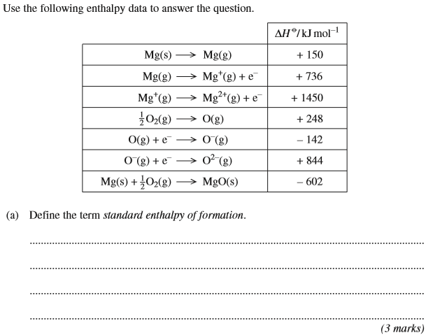
 | 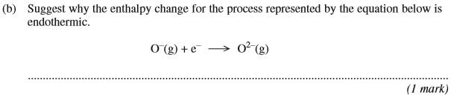
 | 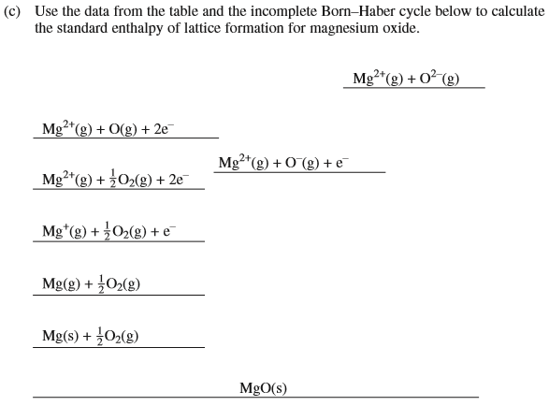
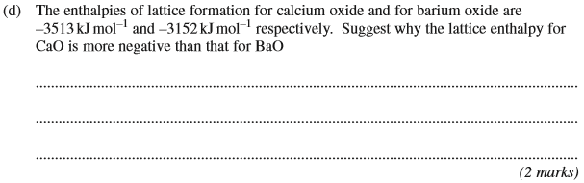
(Total 9 marks)

4. | 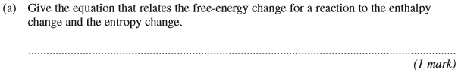
 | 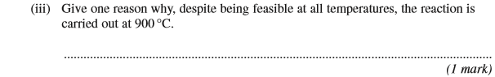

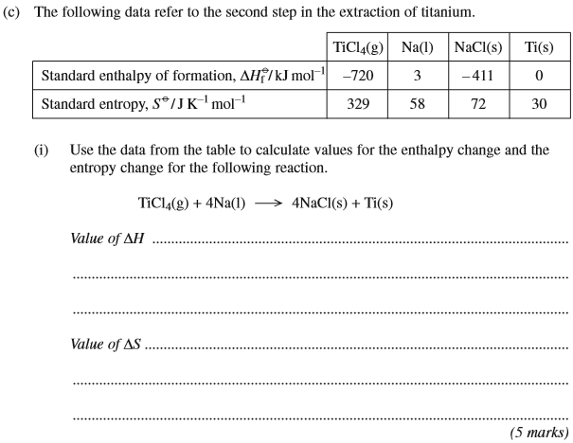
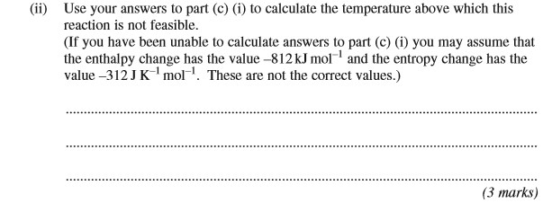
(Total 15 marks)

5. | 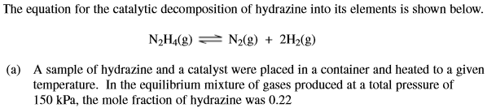  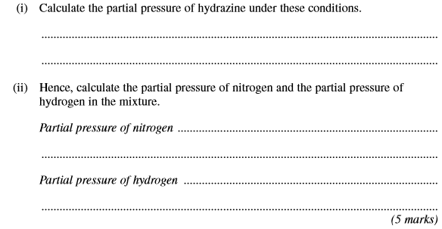
 | 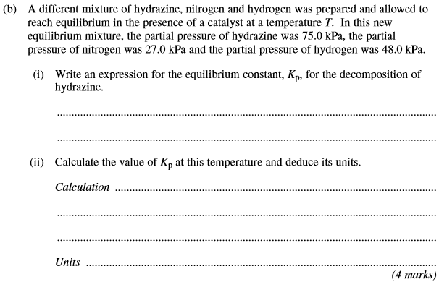
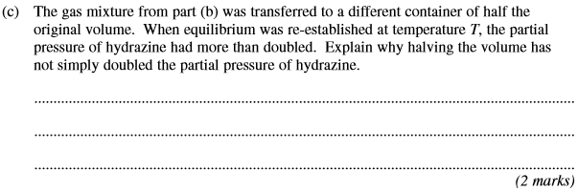
(Total 11 marks)

6. | 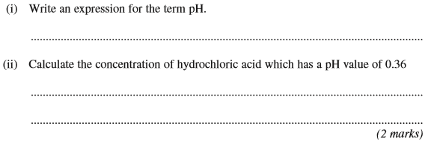  (Total 2 marks)
7. The value of the acid dissociation constant, K_{a}, for ethanoic acid is 1.74 × 10^{–5} mol dm^{–3} at 298 K.
(a) (i) Write an expression for K_{a} for ethanoic acid.
.............................................................................................................
(ii) Calculate the pH at 298 K of a 0.220 mol dm^{–3} solution of ethanoic acid.
.............................................................................................................
.............................................................................................................
.............................................................................................................
.............................................................................................................
.............................................................................................................
.............................................................................................................
(5)

(b) A sample of the 0.220 mol dm^{–3} solution of ethanoic acid was titrated against sodium hydroxide solution.
(i) Calculate the volume of a 0.150 mol dm^{–3} solution of sodium hydroxide required to neutralise 25.0 cm³ of the ethanoic acid solution.
.............................................................................................................
.............................................................................................................
.............................................................................................................
.............................................................................................................
(ii) From the list below, select the best indicator for this titration and explain your choice.
Name of indicator pH range
bromophenol blue 3.0 – 4.6
methyl red 4.2 – 6.3
bromothymol blue 6.0 – 7.6
thymol blue 8.0 – 9.6
Indicator ..............................................................................................
Explanation .........................................................................................
.............................................................................................................
.............................................................................................................
(5)
(c) A buffer solution is formed when 2.00 g of sodium hydroxide are added to 1.00 dm³ of a 0.220 mol dm^{–3} solution of ethanoic acid.
Calculate the pH at 298 K of this buffer solution.
......................................................................................................................
......................................................................................................................
......................................................................................................................
......................................................................................................................
......................................................................................................................
......................................................................................................................
......................................................................................................................
(6)
(Total 16 marks)

8. Copper, in the form of nanoparticles of copper(II) hexacyanoferrate(II), has recently been investigated as an efficient method of storing electrical energy in a rechargeable cell.
(a) Solar cells generate an electric current from sunlight. These cells are often used to provide electrical energy for illuminated road signs.
Explain why rechargeable cells are connected to these solar cells.
........................................................................................................................
........................................................................................................................
........................................................................................................................
........................................................................................................................
(2)
(b) Suggest one reason why many waste disposal centres contain a separate section for cells and batteries.
........................................................................................................................
........................................................................................................................
........................................................................................................................
(1)
(Total 3 marks)

9. | 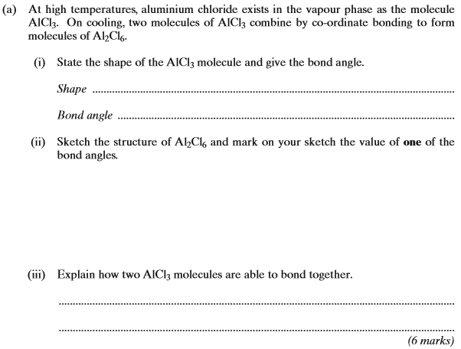
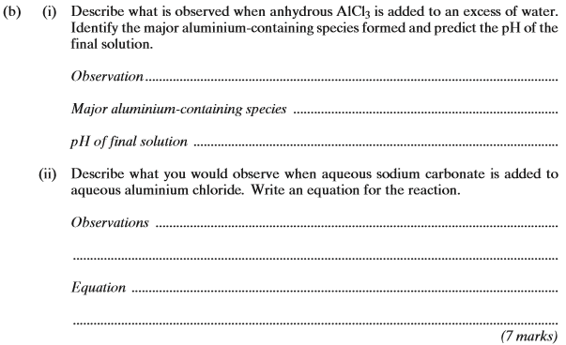
(Total 13 marks)

10. (a) State what is meant by the term homogeneous as applied to a catalyst.
......................................................................................................................
(1)
(b) (i) State what is meant by the term autocatalysis.
.............................................................................................................
.............................................................................................................
(ii) Identify the species which acts as an autocatalyst in the reaction between ethanedioate ions and manganate(VII) ions in acidic solution.
.............................................................................................................
(2)

(c) When petrol is burned in a car engine, carbon monoxide, carbon dioxide, oxides of nitrogen and water are produced. Catalytic converters are used as part of car exhaust systems so that the emission of toxic gases is greatly reduced.
(i) Write an equation for a reaction which occurs in a catalytic converter between two of the toxic gases. Identify the reducing agent in this reaction.
Equation ..............................................................................................
.............................................................................................................
Reducing agent ...................................................................................
(ii) Identify a transition metal used in catalytic converters and state how the converter is constructed to maximise the effect of the catalyst.
Transition metal ...................................................................................
How effect is maximised ......................................................................
.............................................................................................................
(5)
(Total 8 marks)

11. A student carried out an experiment to find the mass of FeSO₄.7H₂O in an impure sample, X.
The student recorded the mass of X. This sample was dissolved in water and made up to 250 cm³ of solution.
The student found that, after an excess of acid had been added, 25.0 cm³ of this solution reacted with 21.3 cm³ of a 0.0150 mol dm^{–3} solution of K₂Cr₂O₇
(a) Use this information to calculate a value for the mass of FeSO₄.7H₂O in the sample of X.
........................................................................................................................
........................................................................................................................
........................................................................................................................
........................................................................................................................
........................................................................................................................
........................................................................................................................
........................................................................................................................
........................................................................................................................
........................................................................................................................
........................................................................................................................
........................................................................................................................
........................................................................................................................
(5)

(b) The student found that the calculated mass of FeSO₄.7H₂O was greater than the actual mass of the sample that had been weighed out. The student realised that this could be due to the nature of the impurity.
Suggest one property of an impurity that would cause the calculated mass of FeSO₄.7H₂O in X to be greater than the actual mass of X.
Explain your answer.
........................................................................................................................
........................................................................................................................
........................................................................................................................
........................................................................................................................
(2)
(Total 7 marks)

