A-LEVEL CHEMISTRY

PAPER 1
PRACTICE PAPER 12

Answer all questions
Max 105 marks
2 hours

Name ……………………………………………………………..

Mark ……../105 ……....% Grade ………

1. | 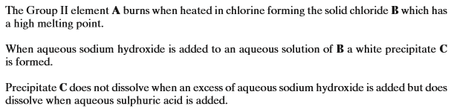  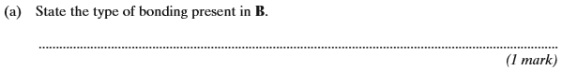
 | 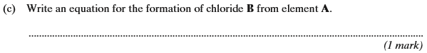
 | 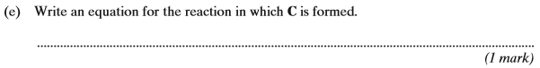
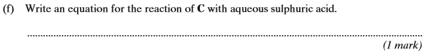
(Total 6 marks)

2. | 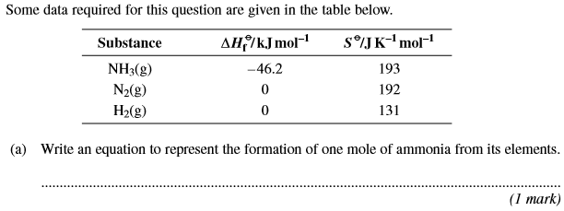
 | 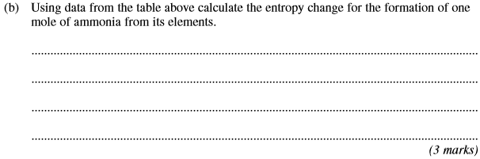
 | 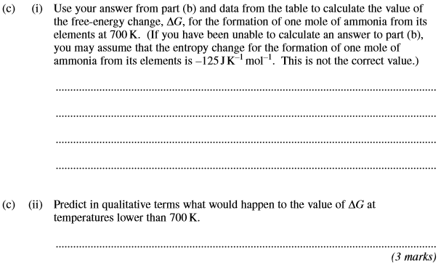
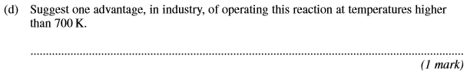
(Total 8 marks)

3. | 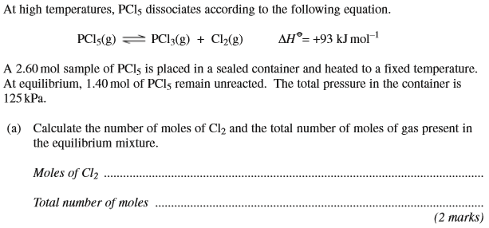
 | 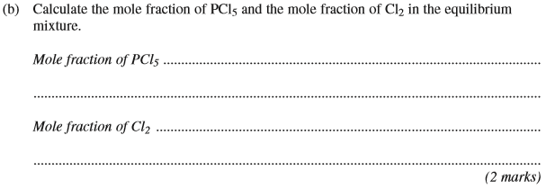
 | 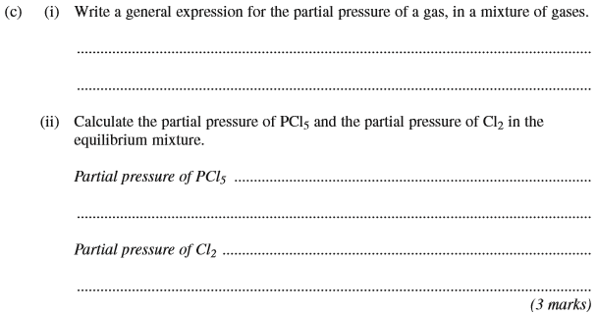
 | 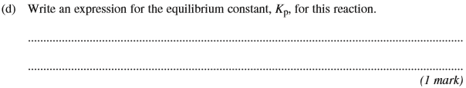
 | 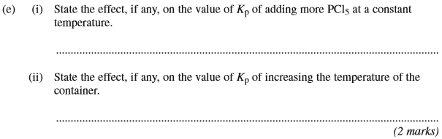
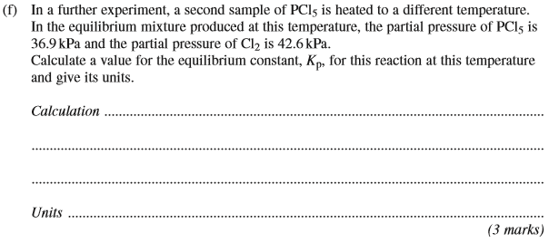
(Total 13 marks)

4. | 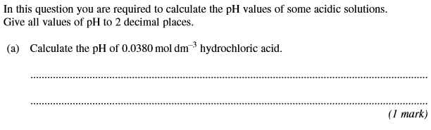
 | 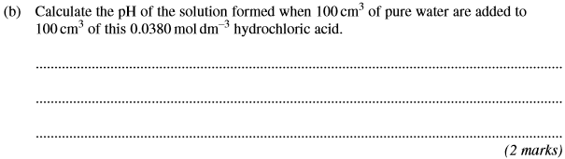
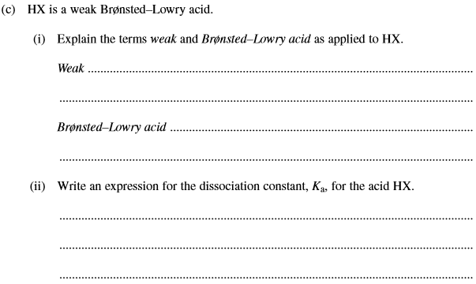
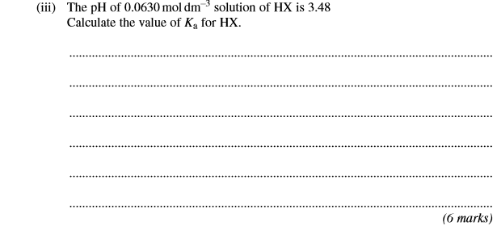
 | 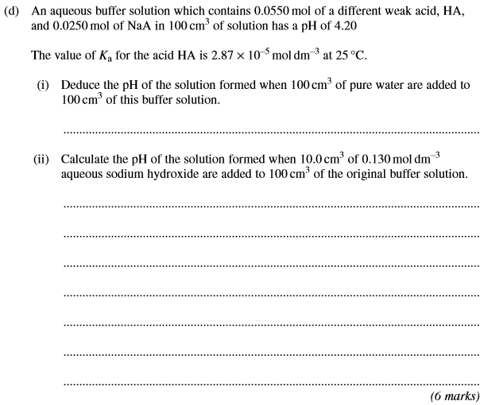
5. | 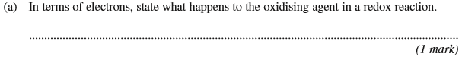
 | 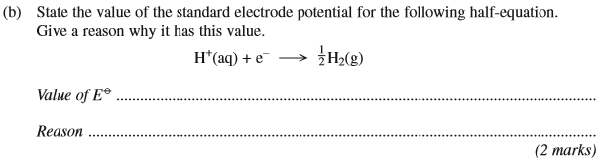
 | 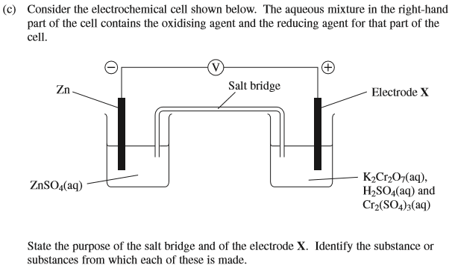
 | 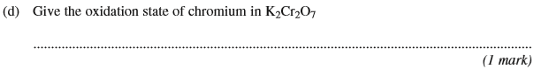
 | 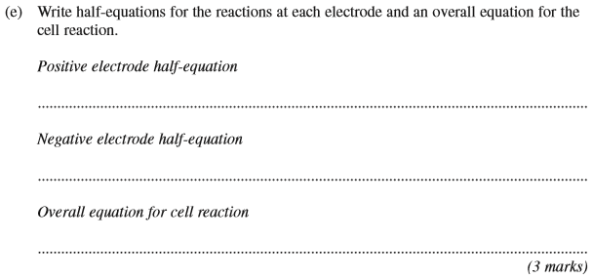
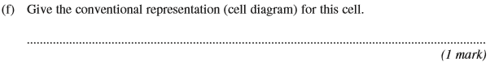
(Total 12 marks)

6. | 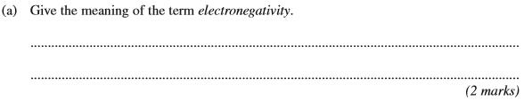
 | 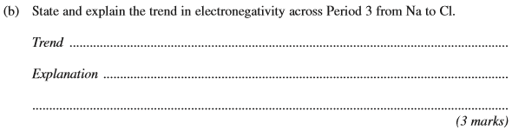
 | 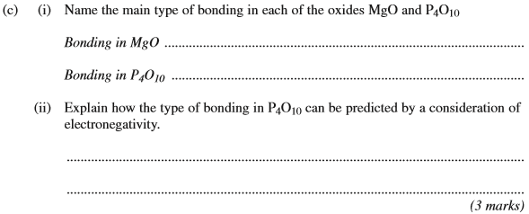
 | 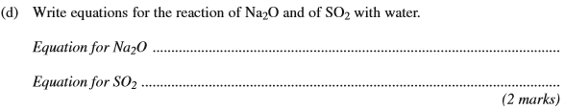
 | 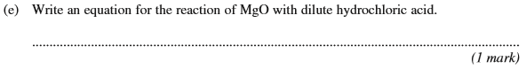
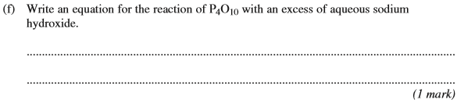
(Total 12 marks)

7. | 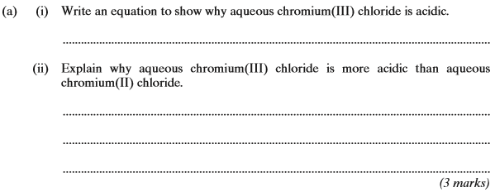
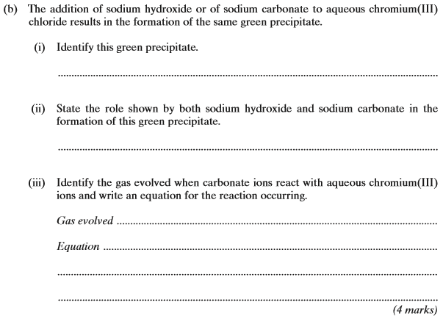
(Total 7 marks)

8. | 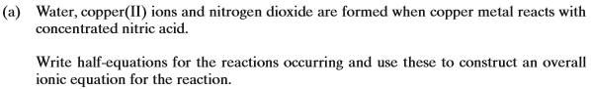  …………………………………………………………………………………………………………………………………………………………………………...  …………………………………………………………………………………………………………………………………………………………………………...  …………………………………………………………………………………………………………………………………………………………………………...  …………………………………………………………………………………………………………………………………………………………………………...  (3 marks)

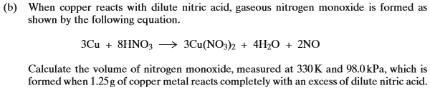

…………………………………………………………………………………………………………………………………………………………………………...

…………………………………………………………………………………………………………………………………………………………………………...

…………………………………………………………………………………………………………………………………………………………………………...

…………………………………………………………………………………………………………………………………………………………………………...

…………………………………………………………………………………………………………………………………………………………………………...

…………………………………………………………………………………………………………………………………………………………………………...

…………………………………………………………………………………………………………………………………………………………………………...
(6 marks)
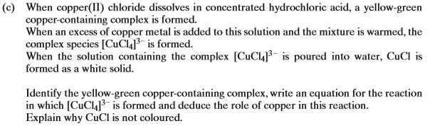

…………………………………………………………………………………………………………………………………………………………………………...

…………………………………………………………………………………………………………………………………………………………………………...

…………………………………………………………………………………………………………………………………………………………………………...

…………………………………………………………………………………………………………………………………………………………………………...

…………………………………………………………………………………………………………………………………………………………………………...

…………………………………………………………………………………………………………………………………………………………………………...

…………………………………………………………………………………………………………………………………………………………………………...
(6 marks)
(Total 15 marks)

9. | (a) | Separate solutions of CuSO₄(aq) and Cu(NO₃)₂(aq) can be distinguished by using a suitable reagent in test-tube reactions.  Identify a suitable reagent, describe what you would observe and write equations for any reactions that occur.  ……………………………………………………………………………………………………………………………………………………………….  ……………………………………………………………………………………………………………………………………………………………….  ……………………………………………………………………………………………………………………………………………………………….  ……………………………………………………………………………………………………………………………………………………………….  (4 marks)
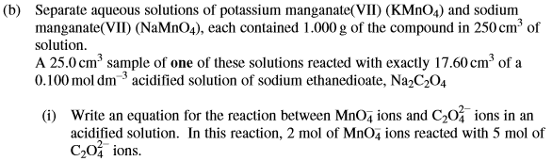

……………………………………………………………………………………………………………………………………………………………….

……………………………………………………………………………………………………………………………………………………………….

……………………………………………………………………………………………………………………………………………………………….

……………………………………………………………………………………………………………………………………………………………….

……………………………………………………………………………………………………………………………………………………………….

……………………………………………………………………………………………………………………………………………………………….
(6 marks)
(Total 10 marks)

10. | (a) | (2 marks)
 | (b) | ……………………………………………………………………………………………………………………………………………………………….  ……………………………………………………………………………………………………………………………………………………………….  ……………………………………………………………………………………………………………………………………………………………….  ……………………………………………………………………………………………………………………………………………………………….  ……………………………………………………………………………………………………………………………………………………………….  ……………………………………………………………………………………………………………………………………………………………….  ……………………………………………………………………………………………………………………………………………………………….  ……………………………………………………………………………………………………………………………………………………………….  (5 marks)  (Total 7 marks)

