A-LEVEL CHEMISTRY

PAPER 1
PRACTICE PAPER 15

Answer all questions
Max 105 marks
2 hours

Name ……………………………………………………………..

Mark ……../105 ……....% Grade ………

1. | (a) | 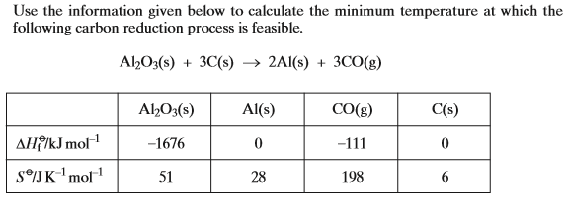  ………………………………………………………………………………………………………………………………………………………………………  ………………………………………………………………………………………………………………………………………………………………………  ………………………………………………………………………………………………………………………………………………………………………  ………………………………………………………………………………………………………………………………………………………………………  ………………………………………………………………………………………………………………………………………………………………………  ………………………………………………………………………………………………………………………………………………………………………  ………………………………………………………………………………………………………………………………………………………………………  ………………………………………………………………………………………………………………………………………………………………………  ………………………………………………………………………………………………………………………………………………………………………  (8 marks)
 | (b) | ………………………………………………………………………………………………………………………………………………………………………  ………………………………………………………………………………………………………………………………………………………………………  ………………………………………………………………………………………………………………………………………………………………………  ………………………………………………………………………………………………………………………………………………………………………  ………………………………………………………………………………………………………………………………………………………………………  ………………………………………………………………………………………………………………………………………………………………………  (3 marks)  (Total 11 marks)
2. | 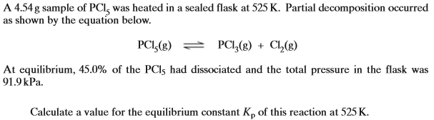  ………………………………………………………………………………………………………………………………………………………………………  ………………………………………………………………………………………………………………………………………………………………………  ………………………………………………………………………………………………………………………………………………………………………  ………………………………………………………………………………………………………………………………………………………………………  ………………………………………………………………………………………………………………………………………………………………………  ………………………………………………………………………………………………………………………………………………………………………  ………………………………………………………………………………………………………………………………………………………………………  ………………………………………………………………………………………………………………………………………………………………………  ………………………………………………………………………………………………………………………………………………………………………  ………………………………………………………………………………………………………………………………………………………………………  ………………………………………………………………………………………………………………………………………………………………………  ………………………………………………………………………………………………………………………………………………………………………  (Total 9 marks)
3. | 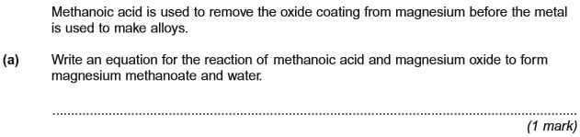
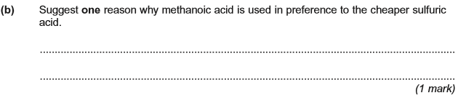
(Total 2 marks)

4. | 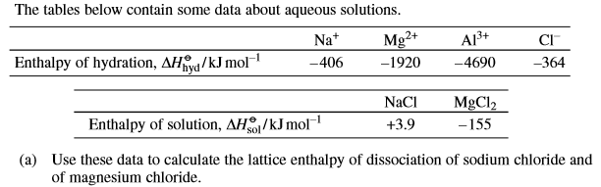  ………………………………………………………………………………………………………………………………………………………………………  ………………………………………………………………………………………………………………………………………………………………………  ………………………………………………………………………………………………………………………………………………………………………  (3 marks)

………………………………………………………………………………………………………………………………………………………………………

………………………………………………………………………………………………………………………………………………………………………

………………………………………………………………………………………………………………………………………………………………………
(2 marks)

………………………………………………………………………………………………………………………………………………………………………

………………………………………………………………………………………………………………………………………………………………………

………………………………………………………………………………………………………………………………………………………………………
(2 marks)
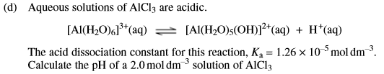

………………………………………………………………………………………………………………………………………………………………………

………………………………………………………………………………………………………………………………………………………………………

………………………………………………………………………………………………………………………………………………………………………

………………………………………………………………………………………………………………………………………………………………………
(4 marks)
(Total 11 marks)
5. | 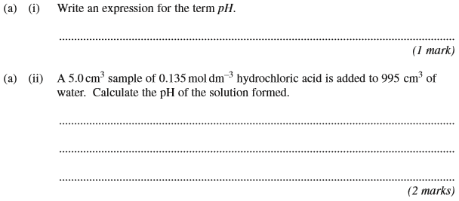
 | 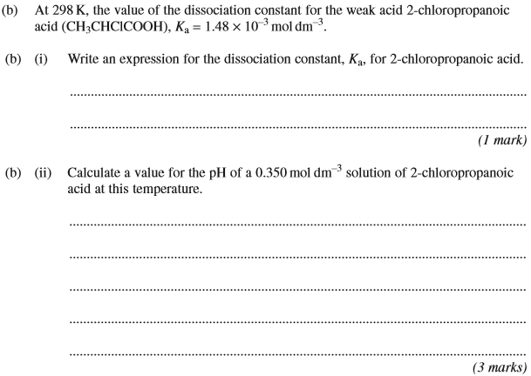
 | 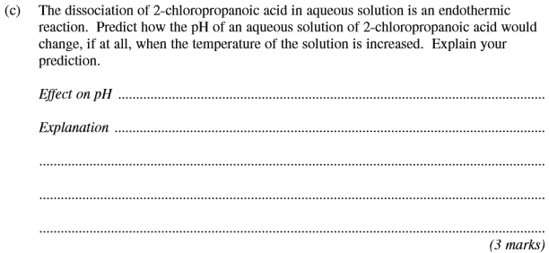
 | (Total 13 marks)
6. | ………………………………………………………………………………………………………………………………………………………………………………  ………………………………………………………………………………………………………………………………………………………………………………  ………………………………………………………………………………………………………………………………………………………………………………  ………………………………………………………………………………………………………………………………………………………………………………  ………………………………………………………………………………………………………………………………………………………………………………  ………………………………………………………………………………………………………………………………………………………………………………  ………………………………………………………………………………………………………………………………………………………………………………  (5 marks)

………………………………………………………………………………………………………………………………………………………………………………

………………………………………………………………………………………………………………………………………………………………………………

………………………………………………………………………………………………………………………………………………………………………………
(2 marks)

………………………………………………………………………………………………………………………………………………………………………………

………………………………………………………………………………………………………………………………………………………………………………

………………………………………………………………………………………………………………………………………………………………………………

………………………………………………………………………………………………………………………………………………………………………………

………………………………………………………………………………………………………………………………………………………………………………

………………………………………………………………………………………………………………………………………………………………………………

………………………………………………………………………………………………………………………………………………………………………………
(6 marks)

………………………………………………………………………………………………………………………………………………………………………………

………………………………………………………………………………………………………………………………………………………………………………

………………………………………………………………………………………………………………………………………………………………………………

………………………………………………………………………………………………………………………………………………………………………………
(4 marks)
(Total 17 marks)

7. | ………………………………………………………………………………………………………………………………………………………………………………  ………………………………………………………………………………………………………………………………………………………………………………  ………………………………………………………………………………………………………………………………………………………………………………  ………………………………………………………………………………………………………………………………………………………………………………  (2 marks)

………………………………………………………………………………………………………………………………………………………………………………

………………………………………………………………………………………………………………………………………………………………………………

………………………………………………………………………………………………………………………………………………………………………………

………………………………………………………………………………………………………………………………………………………………………………

………………………………………………………………………………………………………………………………………………………………………………

………………………………………………………………………………………………………………………………………………………………………………
(3 marks)
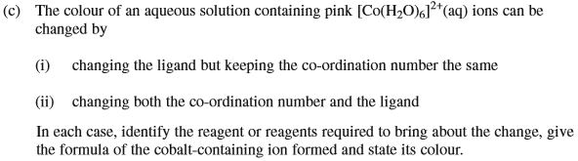

(i)…………………………………………………………………………………………………………………………………………………………………………..

………………………………………………………………………………………………………………………………………………………………………………

………………………………………………………………………………………………………………………………………………………………………………

………………………………………………………………………………………………………………………………………………………………………………

………………………………………………………………………………………………………………………………………………………………………………

(ii)………………………………………………………………………………………………………………………………………………………………………….

………………………………………………………………………………………………………………………………………………………………………………

………………………………………………………………………………………………………………………………………………………………………………

………………………………………………………………………………………………………………………………………………………………………………

………………………………………………………………………………………………………………………………………………………………………………
(6 marks)
(Total 11 marks)

8. | ………………………………………………………………………………………………………………………………………………………………………………  ………………………………………………………………………………………………………………………………………………………………………………  ………………………………………………………………………………………………………………………………………………………………………………  ………………………………………………………………………………………………………………………………………………………………………………  ………………………………………………………………………………………………………………………………………………………………………………  ………………………………………………………………………………………………………………………………………………………………………………  (5 marks)
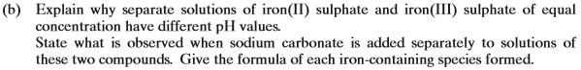

………………………………………………………………………………………………………………………………………………………………………………

………………………………………………………………………………………………………………………………………………………………………………

………………………………………………………………………………………………………………………………………………………………………………

………………………………………………………………………………………………………………………………………………………………………………

………………………………………………………………………………………………………………………………………………………………………………

………………………………………………………………………………………………………………………………………………………………………………

………………………………………………………………………………………………………………………………………………………………………………

………………………………………………………………………………………………………………………………………………………………………………

………………………………………………………………………………………………………………………………………………………………………………

………………………………………………………………………………………………………………………………………………………………………………

………………………………………………………………………………………………………………………………………………………………………………

………………………………………………………………………………………………………………………………………………………………………………
(9 marks)
(Total 14 marks)

9. | ………………………………………………………………………………………………………………………………………………………………………………  ………………………………………………………………………………………………………………………………………………………………………………  ………………………………………………………………………………………………………………………………………………………………………………  ………………………………………………………………………………………………………………………………………………………………………………  ………………………………………………………………………………………………………………………………………………………………………………  ………………………………………………………………………………………………………………………………………………………………………………  ………………………………………………………………………………………………………………………………………………………………………………  ………………………………………………………………………………………………………………………………………………………………………………  ………………………………………………………………………………………………………………………………………………………………………………  ………………………………………………………………………………………………………………………………………………………………………………  (Total 11 marks)

10. | ………………………………………………………………………………………………………………………………………………………………………………  ………………………………………………………………………………………………………………………………………………………………………………  ………………………………………………………………………………………………………………………………………………………………………………  ………………………………………………………………………………………………………………………………………………………………………………  ………………………………………………………………………………………………………………………………………………………………………………  ………………………………………………………………………………………………………………………………………………………………………………  ………………………………………………………………………………………………………………………………………………………………………………  ………………………………………………………………………………………………………………………………………………………………………………  (Total 6 marks)

