A-LEVEL CHEMISTRY

PAPER 1
PRACTICE PAPER 16

Answer all questions
Max 105 marks
2 hours

Name ……………………………………………………………..

Mark ……../105 ……....% Grade ………

1. | 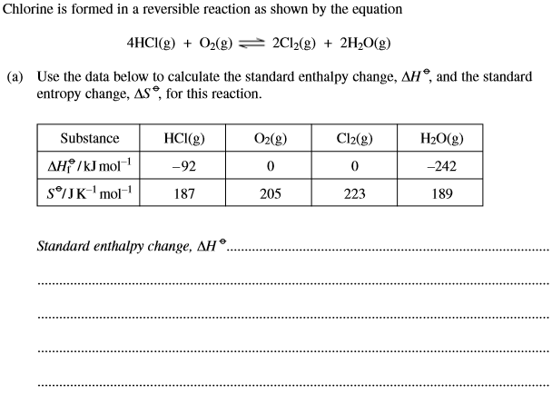
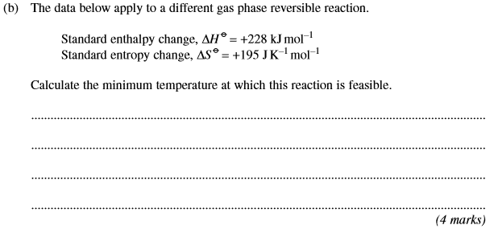
(Total 10 marks)
2. | 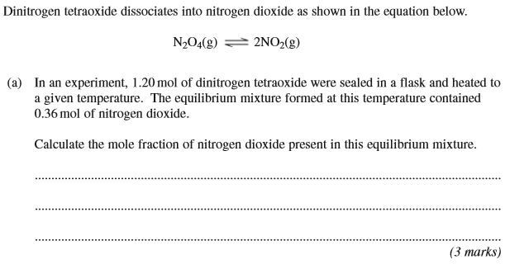
 | 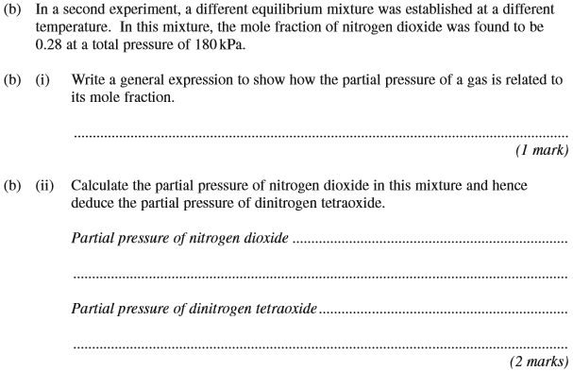
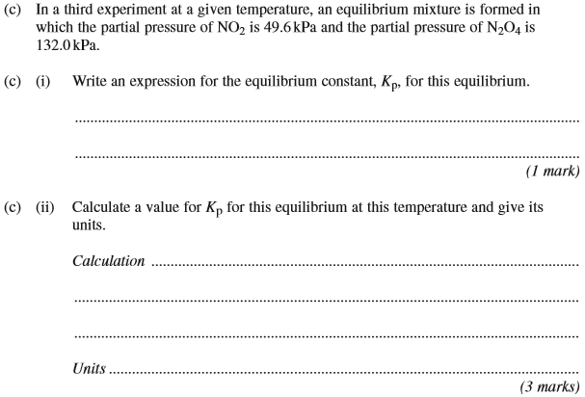
(Total 10 marks)

3. | 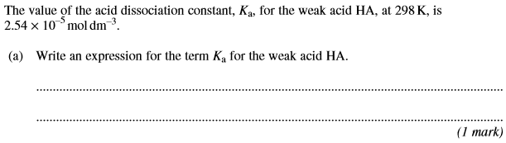
 | 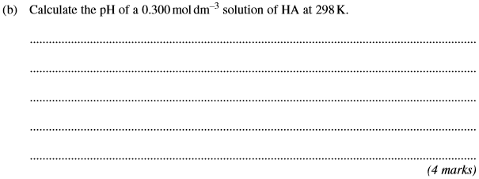
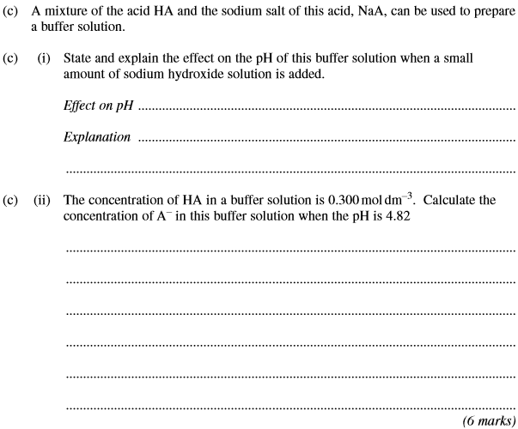
(Total 11 marks)

4. | 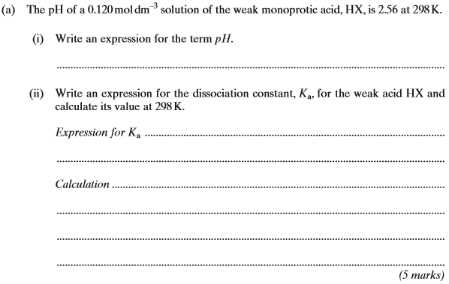
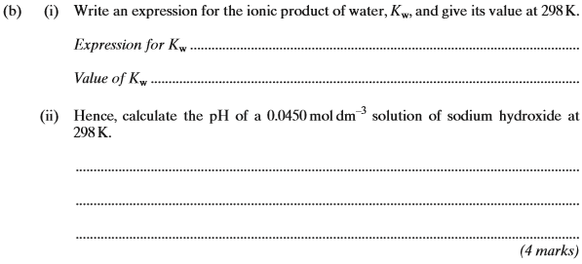
(Total 9 marks)

5. | 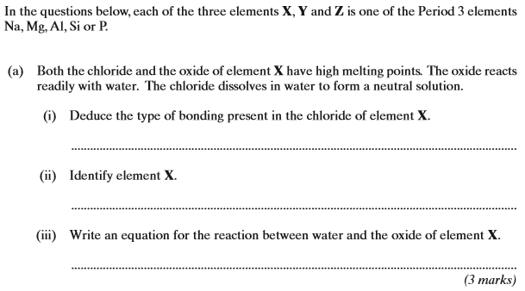
 | 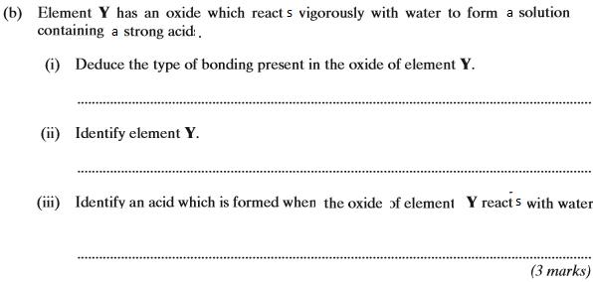
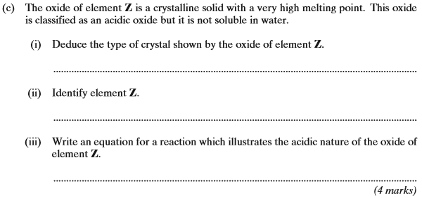
(Total 10 marks)

6. | 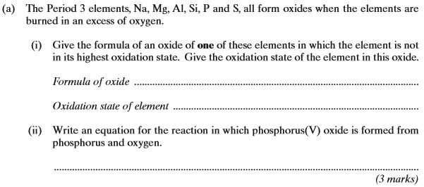
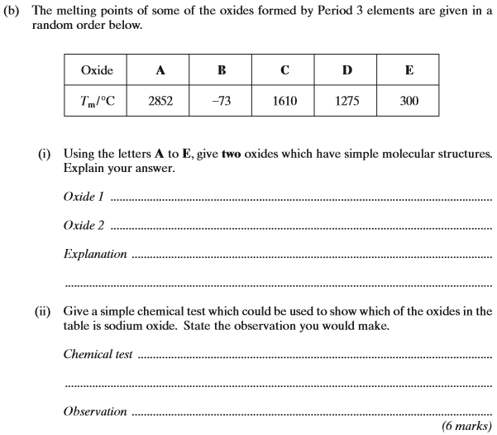
(Total 9 marks)

7. | 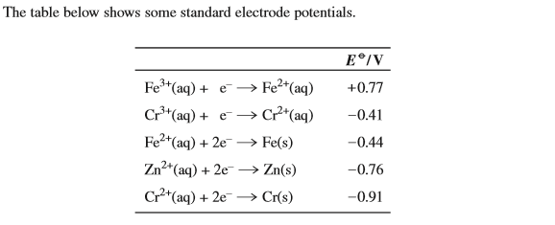  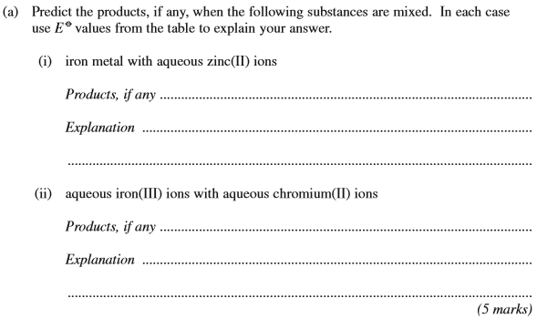
 | 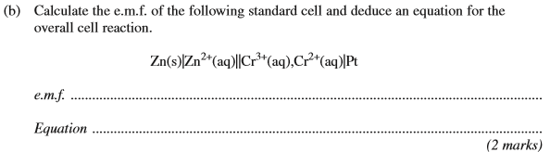
 | 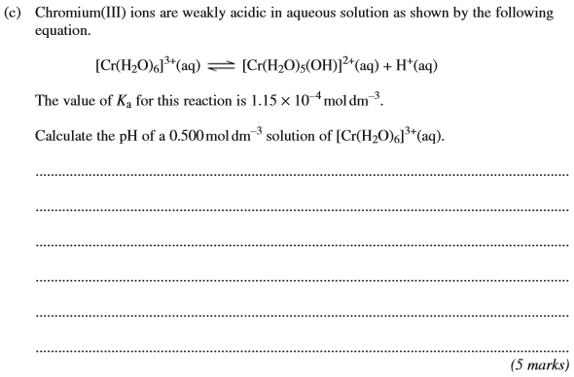
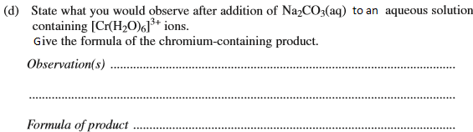
(3 marks)
(Total 15 marks)

8. | 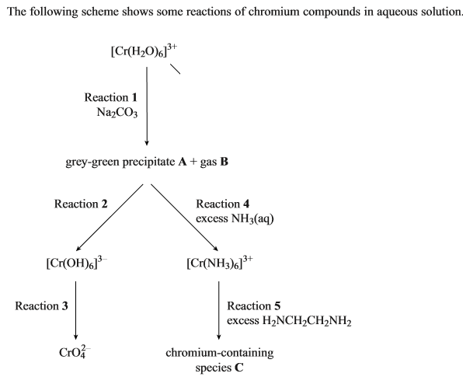  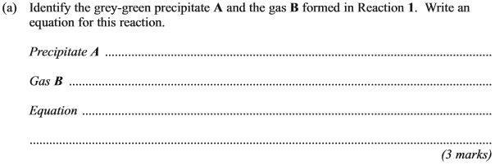
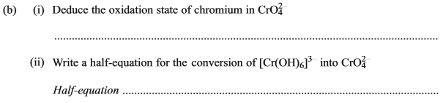
(2 marks)
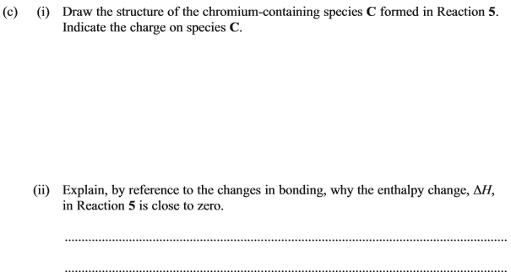
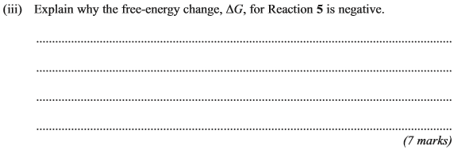
(Total 12 marks)

9. | …………………………………………………………………………………………………………………………………………………………………………...  …………………………………………………………………………………………………………………………………………………………………………...  …………………………………………………………………………………………………………………………………………………………………………...  …………………………………………………………………………………………………………………………………………………………………………...  …………………………………………………………………………………………………………………………………………………………………………...  …………………………………………………………………………………………………………………………………………………………………………...  …………………………………………………………………………………………………………………………………………………………………………...  (Total 6 marks)
10. | (Total 4 marks)

11. | ……………………………………………………………………………………………………………………………………………………………………………  ……………………………………………………………………………………………………………………………………………………………………………  ……………………………………………………………………………………………………………………………………………………………………………  ……………………………………………………………………………………………………………………………………………………………………………  ……………………………………………………………………………………………………………………………………………………………………………  ……………………………………………………………………………………………………………………………………………………………………………  ……………………………………………………………………………………………………………………………………………………………………………  ……………………………………………………………………………………………………………………………………………………………………………  ……………………………………………………………………………………………………………………………………………………………………………  ……………………………………………………………………………………………………………………………………………………………………………  ……………………………………………………………………………………………………………………………………………………………………………  ……………………………………………………………………………………………………………………………………………………………………………  (Total 9 marks)

