A-LEVEL PAPER 1 PP1 MS

1.
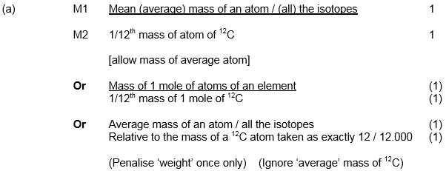
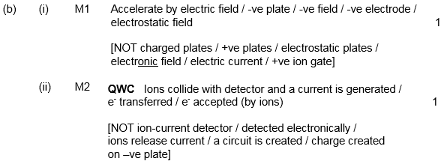
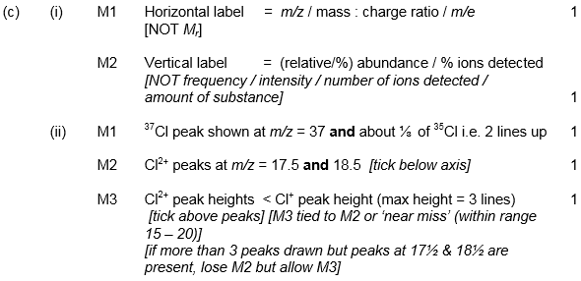 [9]

2.
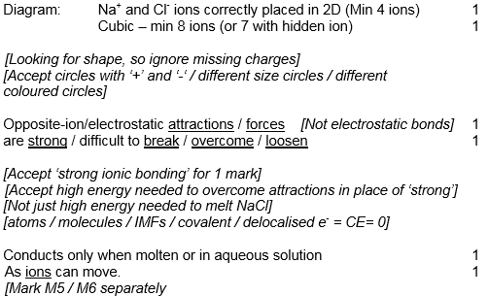 [6]

3.
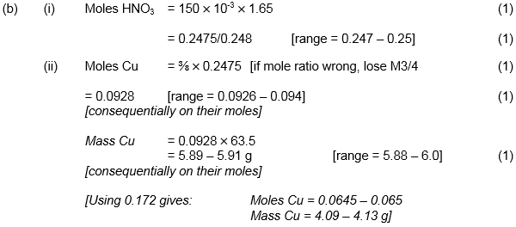 [6]

4. (a) ∆H = Σ(∆H_{f} products) - Σ(∆H_{f} reactants)
Allow correct cycle
1
/= +34 - +90
= -56 kJ mol^{–1}
Ignore no units, penalise incorrect units
1
(b) ∆S = Σ(S products) - Σ(S reactants)
1
/= 240 - (205 +211/2)
= -70.5 J K^{–1} mol^{–1} / -0.0705 kJ K^{–1} mol^{–1}
Ignore no units, penalise incorrect units
Allow -70 to -71/-.070 to -.071
1

(c) T = ∆H/∆S / T = (Ans to part(a) ×1000)/ans to part(b)
Mark consequentially on answers to parts (a) and (b)
1
/= -56/(-70.5 ÷ 1000)
= 794 K (789 to 800 K)
Must have correct units
Ignore signs; allow + or – and –ve temps
1
(d) Temperatures exceed this value
1
(e) N₂ + O₂ → 2NO
Allow multiples
1
(f) there is no change in the number of moles (of gases)
Can only score these marks if the equation in (e) has equal number of moles on each side
Numbers, if stated must match equation
1
So entropy/disorder stays (approximately) constant / entropy/disorder change is
very small / ∆S=0 / T∆S=0
1
[10]

5. (a) Hydrogen bonding (1)
between H₂O and NH₃ (1)

(b) (i) NH₃ + H₂O NH₄⁺ + OH– (1)
(ii) Ammonia is weak base (1)
NOT partially ionised
Equilibrium to left or incomplete reaction (1)
3
(c) A proton donor (1)
1
(d) Buffer solution: A solution which resists change in pH (1)
when small amounts of acid or base added or on dilution (1)
Reagent: NH₄Cl (1)
Allow a correct strong acid
3
(e) (i) K_{a} = [H⁺] [A–] / [HA] (1)
= [H⁺] [0.125 × 4] (1) / 1.00
[H⁺] = 1.70 × 10^{–5} / 0.125 × 4 = 3.40 × 10^{–5} (1)
pH = –log₁₀ [H⁺] = 4.47 (1)
Allow pH conseq to [H⁺] if 2 place decimals given
(ii) H⁺ + CH₃COO– → CH₃COOH (1)
5
[14]

6. (a) Over time / after storage meter does not give accurate readings
Do not allow ‘to get an accurate reading’ or ‘reading drifts’ on its own.
Allow ‘temperature variations affect readings’.
1

(b) Any five from:
Ignore references to the use of the pipette, the filling of the burette and the calibration of the pH meter.
• Measure pH (of the acid)
• Add alkali in known small portions
Allow 1 – 2cm³.
• Stir mixture
• Measure pH (after each addition)
• Repeat until alkali in excess
Allow 27 – 50cm³.
• Add in smaller increments near endpoint
Allow 0.1 – 0.5cm³.
To score full marks, the sequence must follow a logical order.
5 max
[6]

7. (a) Zn(s) → Zn²⁺(aq) + 2e⁻
If equations reversed, allow M1 only.
1
Cu²⁺(aq) + 2e⁻ → Cu(s)
Ignore state symbols.
1
(b) Moles of copper(II) reacted = (100 / 1000) × 0.5 = 0.05
1
Moles of zinc reacted = 0.05
1
Mass of zinc lost = 0.05 × 65.4 = 3.27 g
Correct final answer without working scores M3 only.
1
(c) Allow cell to discharge until [Cu²⁺] is 0.5
Alternative: Allow cell to discharge completely.
1
Confirmed by colorimetric measurement or other suitable method
Solution colourless or use of chemical test to determine absence of copper(II)
1
Weigh the Zn electrode before and after the experiment
Weigh Zn electrodes before and after and halve the mass change.
1
[8]

8. (a) (i) Ionic lattice / solid / giant ionic
CE = 0/2 if molecules / IMFs / atoms / metallic
1
Strong (electrostatic) forces/attraction between ions
Allow strong ionic bonds for M2 only
Allow lot of energy to break ionic bonds
1
(ii) Molecular/molecules
1
Weak dipole-dipole and/or van der Waals forces between molecules
QoL
Type of force must be mentioned
1

(b) P₄O₁₀ bigger molecule/has larger surface area than SO₂
Allow M_{r} of P₄O₁₀ greater than for SO₂
If P₄O₁₀ macromolecule/ionic, CE = 0/2
1
van der Waals forces between molecules stronger
Allow stronger IMF
1
(c) Na₂O + H₂O 2Na⁺ + 2OH–
Allow 2NaOH
1
14
Allow 12–14
1
P₄O₁₀ + 6H₂O 4H₃PO₄
Allow ions
1
0
Allow –1 to +2
1
(d) 6Na₂O + P₄O₁₀ 4Na₃PO₄
Allow ionic
Allow correct formula of product with atoms in any order
1
[11]

9. (a) 1s² 2s² 2p⁶ 3s² 3p⁶ 3d¹⁰
allow [He] 2s² . or [Ne] 3s².or [Ar]3d¹⁰
1
d sub-shell / shell / orbitals / sub-level full (or not partially full)
can only score M2 if d¹⁰ in M1 correct
allow ‘full d orbital’ if d¹⁰ in M1
do not allow d block
1
(b) atom or ion or transition metal bonded to / surrounded by
one or more ligands
Allow Lewis base instead of ligand
1
by co–ordinate / dative (covalent) bonds / donation of
an electron pair
can only score M2 if M1 correct
1
(c) H₂ / hydrogen
do not allow H
1
no lone / spare / non-bonded pair of electrons
only score M2 if M1 correct or give ‘H’ in M1
1
(d) (i) +2 or 2+ or Pd²⁺ or II or +II or II+ or two or two plus
1
(ii) tetrahedral
these shapes can be in any order
1
square planar
allow phonetic spelling e.g. tetrahydral
1
[9]

10. (a) Reaction 1
General principles in marking this question
Square brackets are not essential
Penalise charges on individual ligands rather than on the whole complex
Reagent and species can be extracted from the equation
Ignore conditions such as dilute, concentrated, excess
Reagent must be a compound NOT just an ion
Equations must start from [Cu(H₂O)₆ ]²⁺ except in part (b)
Mark reagent, species and equation independently
ammonia (NH₃) (solution) / NaOH
1
[Cu(H₂O)₆]²⁺ + 2NH₃ → [Cu(H₂O)₄(OH)₂] + 2NH₄⁺ /
[Cu(H₂O)₆]²⁺ + 2OH⁻ → [Cu(H₂O)₄(OH)₂] + 2H₂O
Do not allow OH– for reagent
Product 1, balanced equation 1
Allow either equation for ammonia
2
(b) Reaction 2
Ammonia (conc / xs)
1
[Cu(H₂O)₄(OH)₂] + 4NH₃ → [Cu(H₂O)₂(NH₃)₄]²⁺ + 2H₂O + 2OH⁻
Product 1, balanced equation 1
Note that the equation must start from the hydroxide [Cu(H₂O)₄(OH)₂]
2
(c) Reaction 3
Na₂CO₃ / any identified soluble carbonate / NaHCO₃
Do not allow NaCO₃ or any insoluble carbonate but mark on
1
[Cu(H₂O)₆]²⁺ + CO₃²⁻ → CuCO₃ + 6H₂O
OR [Cu(H₂O)₆]²⁺ + Na₂CO₃ → CuCO₃ + 6H₂O + 2Na⁺
OR 2[Cu(H₂O)₆]²⁺ + 2CO₃²⁻ → Cu(OH)₂.CuCO₃ + 11H₂O + CO₂
OR with NaHCO₃
[Cu(H₂O)₆]²⁺ + HCO₃⁻ → CuCO₃ + 6H₂O + H⁺
Product 1, balanced equation 1
2
(d) Reaction 4
HCl (conc / xs) / NaCl
Allow any identified soluble chloride
1
[Cu(H₂O)₆]²⁺ + 4Cl⁻ → [CuCl₄]²⁻ + 6H₂O
Product 1, balanced equation 1
2
[12]

11. | (a)
 | (b)
 | (c)
 | (d) | (i)
 |  | (ii) | Both = 1 mark
 | (e)
 | (f)
 | (g)
 | (h)
 | (i)
 | (j) | [14]

