A-LEVEL CHEMISTRY

PAPER 1
PRACTICE PAPER 3

Answer all questions
Max 105 marks
2 hours

Name ……………………………………………………………..

Mark ……../105 ……....% Grade ………

1. | 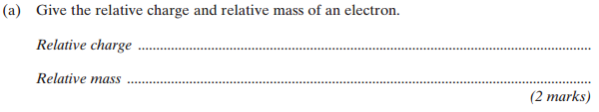
 | 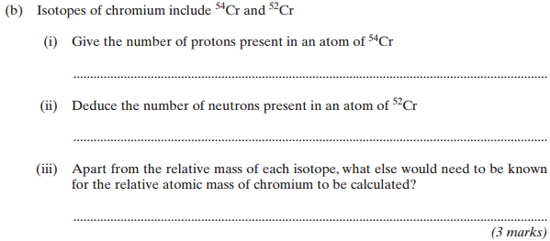
 | (c) | 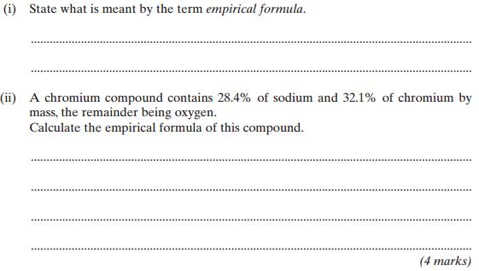  (Total 9 marks)
2. | 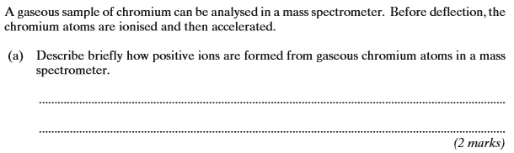
 | 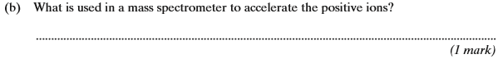
 | (c) | 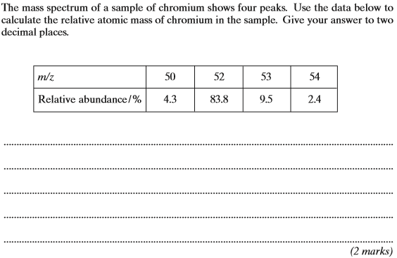  (Total 5 marks)
3. | 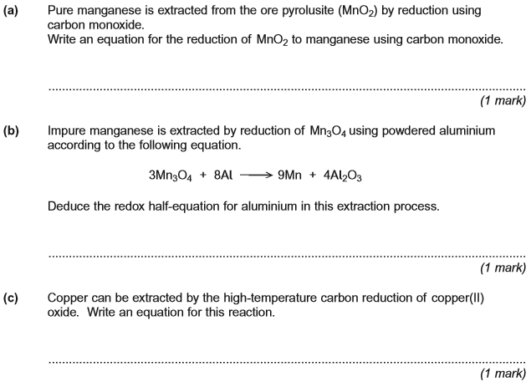
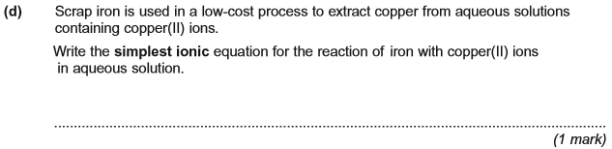
(Total 4 marks)

4. (a) Define the term lattice enthalpy of dissociation.
........................................................................................................................
........................................................................................................................
........................................................................................................................
........................................................................................................................
(2)
(b) Lattice enthalpy can be calculated theoretically using a perfect ionic model.
Explain the meaning of the term perfect ionic model.
........................................................................................................................
........................................................................................................................
........................................................................................................................
(1)
(c) Suggest two properties of ions that influence the value of a lattice enthalpy calculated using a perfect ionic model.
Property 1 .....................................................................................................
........................................................................................................................
Property 2 ......................................................................................................
........................................................................................................................
(2)

(d) Use the data in the table to calculate a value for the lattice enthalpy of dissociation for silver chloride.

 | Enthalpy change | Value / kJ mol ⁻¹
 | Enthalpy of atomisation for silver | +289
 | First ionisation energy for silver | +732
 | Enthalpy of atomisation for chlorine | +121
 | Electron affinity for chlorine | −364
 | Enthalpy of formation for silver chloride | −127

........................................................................................................................
........................................................................................................................
........................................................................................................................
........................................................................................................................
........................................................................................................................
........................................................................................................................
........................................................................................................................
........................................................................................................................
........................................................................................................................
........................................................................................................................
........................................................................................................................
(3)
(e) Predict whether the magnitude of the lattice enthalpy of dissociation that you have calculated in part (d) will be less than, equal to or greater than the value that is obtained from a perfect ionic model. Explain your answer.
Prediction compared with ionic model ..........................................................
Explanation .....................................................................................................
........................................................................................................................
........................................................................................................................
(2)
(Total 10 marks)

5. Buffer solutions are important in biological systems and in industry to maintain almost constant pH values.
(a) In the human body, one important buffer system in blood involves the hydrogencarbonate ion, , and carbonic acid, H₂CO₃, which is formed when carbon dioxide dissolves in water.
(i) Use the following equation to explain how this buffer maintains a constant pH of 7.41 even if a small amount of acid enters the bloodstream.
H₂CO₃(aq) H⁺(aq) + (aq)
.............................................................................................................
.............................................................................................................
.............................................................................................................
(ii) In a sample of blood with a pH of 7.41, the concentration of (aq) ions is 2.50 × 10^{–2} mol dm^{–3} and the concentration of H₂CO₃(aq) is 1.25 × 10^{–3} mol dm^{–3}.
Calculate a value for the acid dissociation constant, K_{a}, for carbonic acid at this temperature.
.............................................................................................................
.............................................................................................................
.............................................................................................................
.............................................................................................................
(5)

(b) In industry, the pH of a solution used to dye cloth must be controlled or else the colour varies.
A solution of dye in a beaker is buffered by the presence of ethanoic acid and sodium ethanoate. In the solution, the concentration of ethanoic acid is 0.15 mol dm^{–3} and the concentration of sodium ethanoate is 0.10 mol dm^{–3}. The value of K_{a} for ethanoic acid is 1.74 × 10^{–5} mol dm^{–3} at 298 K.
(i) A 10.0 cm³ portion of 1.00 mol dm^{–3} hydrochloric acid is added to 1000 cm³ of this buffered solution.
Calculate the number of moles of hydrochloric acid added.
.............................................................................................................
(ii) Calculate the number of moles of ethanoic acid and the number of moles of sodium ethanoate in the solution after addition of the hydrochloric acid.
Mol of ethanoic acid after addition ......................................................
.............................................................................................................
Mol of sodium ethanoate after addition ..............................................
.............................................................................................................
(iii) Hence calculate the pH of this new solution. Give your answer to 2 decimal places.
.............................................................................................................
.............................................................................................................
.............................................................................................................
(6)
(Total 11 marks)

6. The electrons transferred in redox reactions can be used by electrochemical cells to provide energy.
Some electrode half-equations and their standard electrode potentials are shown in the table below.

Half-equation | E^{ο}/V
Cr₂O₇^{2–}(aq) + 14H⁺(aq) + 6e– → 2Cr³⁺(aq) + 7H₂O(l) | +1.33
Fe³⁺(aq) + e– → Fe²⁺(aq) | +0.77
2H⁺(aq) + 2e– → H₂(g) | 0.00
Fe²⁺(aq) + 2e– → Fe(s) | –0.44
Li⁺(aq) + e– → Li(s) | –3.04

(a) Describe a standard hydrogen electrode.
......................................................................................................................
......................................................................................................................
......................................................................................................................
......................................................................................................................
......................................................................................................................
......................................................................................................................
......................................................................................................................
(4)
(b) A conventional representation of a lithium cell is given below.
This cell has an e.m.f. of +2.91 V
Li(s) | Li⁺(aq) || Li⁺(aq) | MnO₂(s) , LiMnO₂(s) | Pt(s)
Write a half-equation for the reaction that occurs at the positive electrode of this cell.
Calculate the standard electrode potential of this positive electrode.
......................................................................................................................
......................................................................................................................
......................................................................................................................
......................................................................................................................
......................................................................................................................
......................................................................................................................
(2)
(c) Suggest what reactions occur, if any, when hydrogen gas is bubbled into a solution containing a mixture of iron(II) and iron(III) ions. Explain your answer.
......................................................................................................................
......................................................................................................................
......................................................................................................................
......................................................................................................................
(2)
(d) A solution of iron(II) sulfate was prepared by dissolving 10.00 g of FeSO₄.7H₂O
(M_{r} = 277.9) in water and making up to 250 cm³ of solution. The solution was left to stand, exposed to air, and some of the iron(II) ions became oxidised to iron(III) ions. A 25.0 cm³ sample of the partially oxidised solution required 23.70 cm³ of 0.0100 mol dm^{–3} potassium dichromate(VI) solution for complete reaction in the presence of an excess of dilute sulfuric acid.
Calculate the percentage of iron(II) ions that had been oxidised by the air.
......................................................................................................................
......................................................................................................................
......................................................................................................................
......................................................................................................................
......................................................................................................................
......................................................................................................................
......................................................................................................................
......................................................................................................................
......................................................................................................................
......................................................................................................................
......................................................................................................................
......................................................................................................................
(6)
(Total 14 marks)

7. Hydrogen–oxygen fuel cells are used to provide electrical energy for electric motors in vehicles.
(a) In a hydrogen–oxygen fuel cell, a current is generated that can be used to drive an electric motor.
(i) Deduce half-equations for the electrode reactions in a hydrogen–oxygen fuel cell.
Half-equation 1 .....................................................................................
Half-equation 2 .....................................................................................
(2)
(ii) Use these half-equations to explain how an electric current can be generated.
...............................................................................................................
...............................................................................................................
...............................................................................................................
...............................................................................................................
(2)
(b) Explain why a fuel cell does not need to be recharged.
........................................................................................................................
........................................................................................................................
........................................................................................................................
(1)
(c) To provide energy for a vehicle, hydrogen can be used either in a fuel cell or in an internal combustion engine.
Suggest the main advantage of using hydrogen in a fuel cell rather than in an internal combustion engine.
........................................................................................................................
........................................................................................................................
........................................................................................................................
(1)
(d) Identify one major hazard associated with the use of a hydrogen–oxygen fuel cell in a vehicle.
........................................................................................................................
........................................................................................................................
(1)
(Total 7 marks)

8. (a) P and Q are oxides of Period 3 elements.
Oxide P is a solid with a high melting point. It does not conduct electricity when solid but does conduct when molten or when dissolved in water. Oxide P reacts with water forming a solution with a high pH.
Oxide Q is a colourless gas at room temperature. It dissolves in water to give a solution with a low pH.
(i) Identify P. State the type of bonding present in P and explain its electrical conductivity. Write an equation for the reaction of P with water.
……………………………………………………………………………………………………
……………………………………………………………………………………………………
……………………………………………………………………………………………………
……………………………………………………………………………………………………
……………………………………………………………………………………………………
(ii) Identify Q. State the type of bonding present in Q and explain why it is a gas at room temperature. Write an equation for the reaction of Q with water.
……………………………………………………………………………………………………
……………………………………………………………………………………………………
……………………………………………………………………………………………………
……………………………………………………………………………………………………
……………………………………………………………………………………………………
(9)
(b) R is a hydroxide of a Period 3 element. It is insoluble in water but dissolves in both aqueous sodium hydroxide and aqueous sulphuric acid.
(i) Give the name used to describe this behaviour of the hydroxide.
……………………………………………………………………………………………………
(ii) Write equations for the reactions occurring.
……………………………………………………………………………………………………
……………………………………………………………………………………………………
(iii) Suggest why R is insoluble in water.
……………………………………………………………………………………………………
……………………………………………………………………………………………………
……………………………………………………………………………………………………
(6)
(Total 15 marks)
9. Transition metals form complex ions. Using actual examples of complex ions formed by transition metal ions, give the formula of
• a linear complex ion,
• a tetrahedral complex ion and
• an octahedral complex ion formed by using a bidentate ligand.
…………………………………………………………………………………………………………………
…………………………………………………………………………………………………………………
…………………………………………………………………………………………………………………
…………………………………………………………………………………………………………………
(Total 4 marks)

10. An acidified solution of potassium manganate(VII) was reacted with a sample of sodium ethanedioate at a constant temperature of 60 °C. The concentration of the manganate(VII) ions in the reaction mixture was determined at different times using a spectrometer to measure the light absorbed.
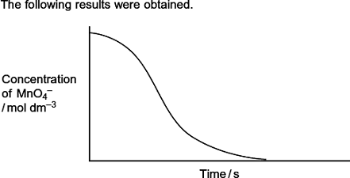
(a) Write an equation for the reaction between manganate(VII) ions and ethanedioate ions in acidic solution.
........................................................................................................................
........................................................................................................................
........................................................................................................................
(2)
(b) By considering the properties of the reactants and products, state why it is possible to use a spectrometer to measure the concentration of the manganate(VII) ions in this reaction mixture.
........................................................................................................................
........................................................................................................................
........................................................................................................................
(2)

(c) This reaction is autocatalysed. Give the meaning of the term autocatalyst.
Explain how the above curve indicates clearly that the reaction is autocatalysed.
Meaning of autocatalyst ................................................................................
........................................................................................................................
Explanation ....................................................................................................
........................................................................................................................
........................................................................................................................
........................................................................................................................
(3)
(d) Identify the autocatalyst in this reaction.
........................................................................................................................
(1)
(e) Write two equations to show how the autocatalyst is involved in this reaction.
Equation 1 ......................................................................................................
Equation 2 ......................................................................................................
(2)
(Total 10 marks)

11. Iron(II) sulfate is used to kill weeds in garden lawns. It is a by-product of the manufacture of steel.
When a lawn is treated with iron(II) sulfate, the iron(II) ions are oxidised to form iron(III) ions.
Iron(III) ions are acidic in aqueous solution as shown by the following equation.
[Fe(H₂O)₆]³⁺(aq) [Fe(H₂O)₅(OH)]²⁺(aq) + H⁺(aq)
In an experiment, a calibrated pH meter was used to measure the pH of an iron(III) salt in solution. At 20 °C the pH of a 0.100 mol dm^{–3} solution of iron(III) sulfate was found to be 1.62.
(a) Explain briefly why a pH meter should be calibrated before use.
........................................................................................................................
........................................................................................................................
(1)
(b) Write an expression for the equilibrium constant, K_{a}, for the dissociation of iron(III) ions in aqueous solution.
........................................................................................................................
........................................................................................................................
(1)

(c) Use your answer from part (b) to calculate the value of K_{a} for this reaction at 20 °C.
Give your answer to the appropriate precision. Show your working.
........................................................................................................................
........................................................................................................................
........................................................................................................................
........................................................................................................................
........................................................................................................................
........................................................................................................................
(4)
(d) Name the substance that is most likely to oxidise the iron(II) ions when iron(II) sulfate is used as a weed killer.
........................................................................................................................
(1)
(e) Suggest a value for the pH of a 0.100 mol dm^{–3} solution of iron(II) sulfate.
........................................................................................................................
(1)
(Total 8 marks)

12.
 | (a) | ……………………………………………………………………………………………………………………………………………………………………...  ……………………………………………………………………………………………………………………………………………………………………...  ……………………………………………………………………………………………………………………………………………………………………...  ……………………………………………………………………………………………………………………………………………………………………...
 | (b) | ……………………………………………………………………………………………………………………………………………………………………...  ……………………………………………………………………………………………………………………………………………………………………...  ……………………………………………………………………………………………………………………………………………………………………...  ……………………………………………………………………………………………………………………………………………………………………...  ……………………………………………………………………………………………………………………………………………………………………...  ……………………………………………………………………………………………………………………………………………………………………...  ……………………………………………………………………………………………………………………………………………………………………...  ……………………………………………………………………………………………………………………………………………………………………...  ……………………………………………………………………………………………………………………………………………………………………...  ……………………………………………………………………………………………………………………………………………………………………...  ……………………………………………………………………………………………………………………………………………………………………...

 | (c) | ……………………………………………………………………………………………………………………………………………………………………...  ……………………………………………………………………………………………………………………………………………………………………...  ……………………………………………………………………………………………………………………………………………………………………...  ……………………………………………………………………………………………………………………………………………………………………...
 | (d) | ……………………………………………………………………………………………………………………………………………………………………...  ……………………………………………………………………………………………………………………………………………………………………...  ……………………………………………………………………………………………………………………………………………………………………...  (Total 8 marks)

