A-LEVEL CHEMISTRY

PAPER 1
PRACTICE PAPER 5

Answer all questions
Max 105 marks
2 hours

Name ……………………………………………………………..

Mark ……../105 ……....% Grade ………

1. | 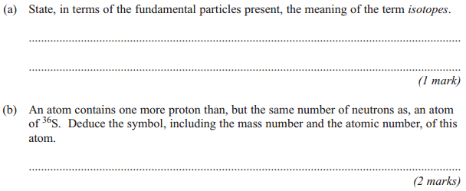
 | 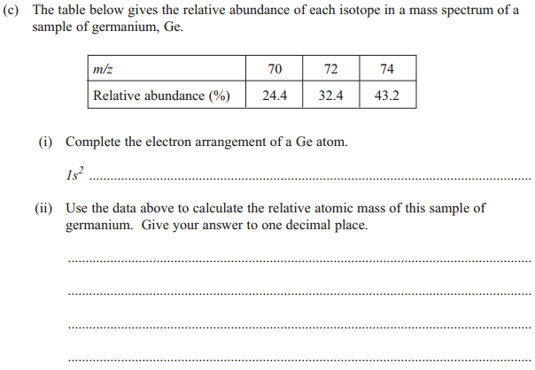
 | (iii) | (Total 8 marks)
2. | 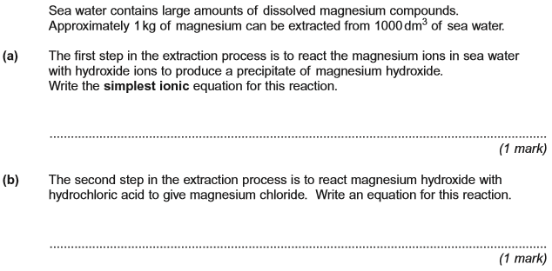
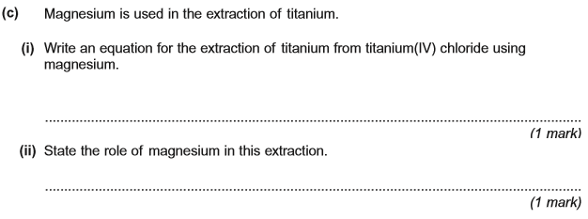
(Total 4 marks)

3. | 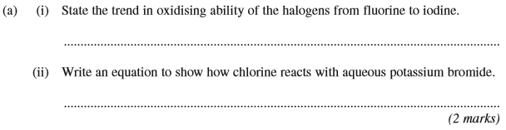
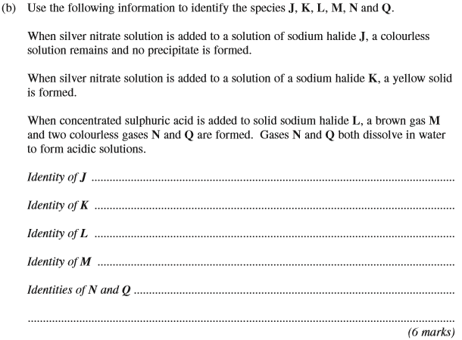
(Total 8 marks)

4. The following table shows some enthalpy change and entropy change data.

 |  | ΔH / kJ mol^{–1} | ΔS / J K^{–1} mol^{–1}
 | AgCl(s) Ag⁺(g) + Cl–(g) | +905
 | AgCl(s) Ag⁺(aq) + Cl–(aq) | +77 | +33
 | AgF(s) Ag⁺(aq) + F–(aq) | –15 | to be calculated
 | Ag⁺(g) Ag⁺(aq) | –464
(a) Define the term enthalpy of hydration of an ion.
........................................................................................................................
........................................................................................................................
........................................................................................................................
........................................................................................................................
(2)

(b) Use data from the table to calculate a value for the enthalpy of hydration of the chloride ion.
........................................................................................................................
........................................................................................................................
........................................................................................................................
........................................................................................................................
(2)
(c) Suggest why hydration of the chloride ion is an exothermic process.
........................................................................................................................
........................................................................................................................
........................................................................................................................
........................................................................................................................
(2)
(d) Silver chloride is insoluble in water at room temperature.
Use data from the table to calculate the temperature at which the dissolving of silver chloride in water becomes feasible.
Comment on the significance of this temperature value.
Calculation of temperature .............................................................................
........................................................................................................................
........................................................................................................................
Significance of temperature value ..................................................................
........................................................................................................................
........................................................................................................................
(4)
(e) When silver fluoride dissolves in water at 25 °C, the free-energy change is –9 kJ mol^{–1}.
Use this information and data from the table to calculate a value, with units, for the entropy change when silver fluoride dissolves in water at 25 °C.
........................................................................................................................
........................................................................................................................
........................................................................................................................
........................................................................................................................
.....................................................................................................................
(3)
(Total 13 marks)

5. This question is about the pH of several solutions.
Give all values of pH to 2 decimal places.
(a) (i) Write an expression for pH.
.............................................................................................................
(1)
(ii) Calculate the pH of 0.154 mol dm^{–3} hydrochloric acid.
.............................................................................................................
.............................................................................................................
(1)
(iii) Calculate the pH of the solution formed when 10.0 cm³ of 0.154 mol dm^{–3} hydrochloric acid are added to 990 cm³ of water.
.............................................................................................................
.............................................................................................................
.............................................................................................................
.............................................................................................................
(2)
(b) The acid dissociation constant, K_{a}, for the weak acid HX has the value
4.83 × 10^{–5} mol dm^{–3} at 25 °C.
A solution of HX has a pH of 2.48
Calculate the concentration of HX in the solution.
......................................................................................................................
......................................................................................................................
......................................................................................................................
......................................................................................................................
......................................................................................................................
......................................................................................................................
(4)

(c) Explain why the pH of an acidic buffer solution remains almost constant despite the addition of a small amount of sodium hydroxide.
......................................................................................................................
......................................................................................................................
......................................................................................................................
......................................................................................................................
(2)
(d) The acid dissociation constant, K_{a}, for the weak acid HY has the value
1.35 × 10^{–5} mol dm^{–3} at 25 °C.
A buffer solution was prepared by dissolving 0.0236 mol of the salt NaY in
50.0 cm³ of a 0.428 mol dm^{–3} solution of the weak acid HY
(i) Calculate the pH of this buffer solution.
.............................................................................................................
.............................................................................................................
.............................................................................................................
.............................................................................................................
.............................................................................................................
.............................................................................................................
.............................................................................................................
(4)
(ii) A 5.00 × 10^{–4} mol sample of sodium hydroxide was added to this buffer solution.
Calculate the pH of the buffer solution after the sodium hydroxide was added.
.............................................................................................................
.............................................................................................................
.............................................................................................................
.............................................................................................................
.............................................................................................................
.............................................................................................................
.............................................................................................................
.............................................................................................................
.............................................................................................................
(4)
(Total 18 marks)
6. Where appropriate, use the standard electrode potential data in the table below to answer the questions which follow.

 |  |  |  |  |  |  | E^{ο}/V
Zn²⁺(aq) | + | 2e– | → | Zn(s) |  |  | –0.76
V³⁺(aq) | + | e– | → | V²⁺(aq) |  |  | –0.26
+ 2H⁺(aq) | + | 2e⁻ | → |  | + | H₂O(l) | +0.17
VO²⁺(aq) +2H⁺(aq) | + | e– | → | V³⁺(aq) | + | H₂O(l) | +0.34
Fe³⁺(aq) | + | e– | → | Fe²⁺(aq) |  |  | +0.77
+ 2H⁺(aq) | + | e– | → | VO²⁺(aq) | + | H₂O(l) | +1.00
Cl₂(aq) | + | 2e– | → | 2Cl–(aq) |  |  | +1.36

(a) From the table above select the species which is the most powerful reducing agent.
......................................................................................................................
(1)
(b) From the table above select
(i) a species which, in acidic solution, will reduce to VO²⁺(aq) but will not reduce VO²⁺(aq) to V³⁺(aq),
.............................................................................................................
(ii) a species which, in acidic solution, will oxidise VO²⁺(aq) to .
.............................................................................................................
(2)
(c) The cell represented below was set up under standard conditions.
Pt|Fe²⁺(aq), Fe³⁺(aq)||Tl³⁺(aq),Tl⁺(aq)|Pt Cell e.m.f. = + 0.48 V
(i) Deduce the standard electrode potential for the following half-reaction.
Tl³⁺(aq) + 2e– → Tl⁺(aq)
.............................................................................................................
.............................................................................................................
(ii) Write an equation for the spontaneous cell reaction.
.............................................................................................................
(3)

(d) After acidification, 25.0 cm³ of a solution of hydrogen peroxide reacted exactly with
16.2 cm³ of a 0.0200 mol dm^{–3} solution of potassium manganate(VII). The overall equation for the reaction is given below.
+ 6H⁺ + 5H₂O₂ → 2Mn²⁺ + 8H₂O + 5O₂
(i) Use the equation for this reaction to determine the concentration, in g dm^{–3}, of the hydrogen peroxide solution.
.............................................................................................................
.............................................................................................................
.............................................................................................................
.............................................................................................................
.............................................................................................................
.............................................................................................................
(ii) Calculate the maximum volume of oxygen, measured at a pressure of 98 kPa and a temperature of 298 K, which would be evolved in this reaction.
.............................................................................................................
.............................................................................................................
.............................................................................................................
.............................................................................................................
.............................................................................................................
(8)
(Total 14 marks)

7. This question is about copper chemistry.
(a) Aqueous copper(II) ions [Cu(H₂O)₆]²⁺(aq) are blue.
(i) With reference to electrons, explain why aqueous copper(II) ions are blue.
.............................................................................................................
.............................................................................................................
.............................................................................................................
.............................................................................................................
.............................................................................................................
.............................................................................................................
(3)
(ii) By reference to aqueous copper(II) ions, state the meaning of each of the three terms in the equation ΔE = hv.
.............................................................................................................
.............................................................................................................
.............................................................................................................
.............................................................................................................
.............................................................................................................
.............................................................................................................
(3)
(iii) Write an equation for the reaction, in aqueous solution, between [Cu(H₂O)₆]²⁺ and an excess of chloride ions.
State the shape of the complex produced and explain why the shape differs from that of the [Cu(H₂O)₆]²⁺ ion.
.............................................................................................................
.............................................................................................................
.............................................................................................................
.............................................................................................................
.............................................................................................................
.............................................................................................................
(3)

(b) Draw the structure of the ethanedioate ion (C₂O₄^{2–}).
Explain how this ion is able to act as a ligand.

......................................................................................................................
......................................................................................................................
......................................................................................................................
......................................................................................................................
......................................................................................................................
(2)
(c) When a dilute aqueous solution containing ethanedioate ions is added to a solution containing aqueous copper(II) ions, a substitution reaction occurs. In this reaction four water molecules are replaced and a new complex is formed.
(i) Write an ionic equation for the reaction. Give the co-ordination number of the complex formed and name its shape.
.............................................................................................................
.............................................................................................................
.............................................................................................................
.............................................................................................................
.............................................................................................................
.............................................................................................................
(4)
(ii) In the complex formed, the two water molecules are opposite each other.
Draw a diagram to show how the ethanedioate ions are bonded to a copper ion and give a value for one of the O–Cu–O bond angles. You are not required to show the water molecules.

(2)
(Total 17 marks)
8. Transition metal compounds have a range of applications as catalysts.
(a) State the general property of transition metals that allows the vanadium in vanadium(V) oxide to act as a catalyst in the Contact Process.
........................................................................................................................
(1)
(b) Write two equations to show how vanadium(V) oxide acts as a catalyst in the Contact Process.
Equation 1
........................................................................................................................
Equation 2
........................................................................................................................
(2)
(c) In the Contact Process, vanadium(V) oxide acts as a heterogeneous catalyst.
(i) Give the meaning of the term heterogeneous.
...............................................................................................................
...............................................................................................................
...............................................................................................................
(1)
(ii) Give one reason why impurities in the reactants can cause problems in processes that use heterogeneous catalysts.
...............................................................................................................
...............................................................................................................
...............................................................................................................
(1)

(d) The oxidation of C₂O₄²⁻ ions by MnO₄⁻ ions in acidic solution is an example of a reaction that is autocatalysed.
(i) Give the meaning of the term autocatalysed.
...............................................................................................................
...............................................................................................................
...............................................................................................................
(1)
(ii) Identify the autocatalyst in this reaction.
...............................................................................................................
(1)

(iii) Write two equations to show how the autocatalyst is involved in this oxidation of C₂O₄²⁻ ions.
Equation 1
...............................................................................................................
Equation 2
...............................................................................................................
(2)
(Total 9 marks)

9.
 | (a)
 | (b)
 | (c)
 | (d)
 | (e)
 | (f)
 | (g)
 | (h)
 | (i)
 | (j) | (Total 14 marks)

