A-LEVEL CHEMISTRY

PAPER 1
PRACTICE PAPER 7

Answer all questions
Max 105 marks
2 hours

Name ……………………………………………………………..

Mark ……../105 ……....% Grade ………

1. (a) Vanadium(V) oxide is used as a heterogeneous catalyst in the Contact Process.
Explain what is meant by the terms heterogeneous and catalyst and state, in general terms, how a catalyst works.
State the essential feature of vanadium chemistry which enables vanadium(V) oxide to function as a catalyst and, by means of equations, suggest how it might be involved in the Contact Process.
…………………………………………………………………………………………………………….
…………………………………………………………………………………………………………….
…………………………………………………………………………………………………………….
…………………………………………………………………………………………………………….
…………………………………………………………………………………………………………….
…………………………………………………………………………………………………………….
…………………………………………………………………………………………………………….
(7)
(b) The following method was used to determine the percentage by mass of vanadium in a sample of ammonium vanadate(V).
A solution was made up by dissolving 0.160 g of ammonium vanadate(V) in dilute sulphuric acid. The ammonium vanadate(V) formed ions in this solution. When an excess of zinc was added to this solution, the ions were reduced to V²⁺ ions and the zinc was oxidised to Zn²⁺ ions.
After the unreacted zinc had been removed, the solution was titrated against a 0.0200 mol dm^{–3} solution of potassium manganate(VII). In the titration, 38.5 cm³ of potassium manganate(VII) solution were required to oxidise all vanadium(II) ions to vanadium(V) ions.
Using half-equations, construct an overall equation for the reduction of to V²⁺ by zinc in acidic solution.
Calculate the percentage by mass of vanadium in the sample of ammonium vanadate(V).
…………………………………………………………………………………………………………….
…………………………………………………………………………………………………………….
…………………………………………………………………………………………………………….
…………………………………………………………………………………………………………….
…………………………………………………………………………………………………………….
…………………………………………………………………………………………………………….
…………………………………………………………………………………………………………….
(8)
(Total 15 marks)
2. For many years, swimming pool water has been treated with chlorine gas. The chlorine is added to kill any harmful bacteria unintentionally introduced by swimmers. Pool managers are required to check that the chlorine concentration is high enough to kill the bacteria without being a health hazard to the swimmers.
When chlorine reacts with water in the absence of sunlight, the chlorine is both oxidised and reduced and an equilibrium is established.
(a) Write an equation for this equilibrium.
For each chlorine-containing species in the equation, write the oxidation state of chlorine below the species.
........................................................................................................................
........................................................................................................................
........................................................................................................................
........................................................................................................................
........................................................................................................................
(2)
(b) The pool manager maintains the water at a pH slightly greater than 7.0
Explain how this affects the equilibrium established when chlorine is added to water.
........................................................................................................................
........................................................................................................................
........................................................................................................................
........................................................................................................................
........................................................................................................................
(2)
(c) Explain why chlorine is used to kill bacteria in swimming pools, even though chlorine is toxic.
........................................................................................................................
........................................................................................................................
........................................................................................................................
........................................................................................................................
........................................................................................................................
(2)
(Total 6 marks)

3. A Born–Haber cycle for the formation of calcium sulphide is shown below. The cycle includes enthalpy changes for all Steps except Step F. (The cycle is not drawn to scale.)
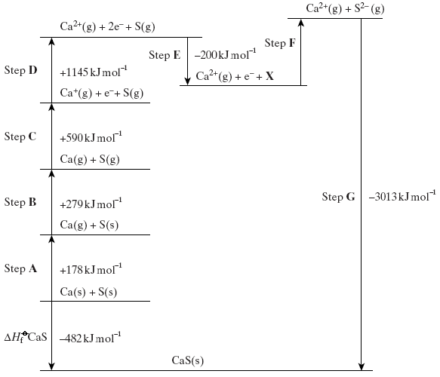
(a) Give the full electronic arrangement of the ion S^{2–}
......................................................................................................................
(1)
(b) Identify the species X formed in Step E.
......................................................................................................................
(1)
(c) Suggest why Step F is an endothermic process.
......................................................................................................................
......................................................................................................................
(2)

(d) Name the enthalpy change for each of the following steps.
(i) Step B .................................................................................................
(ii) Step D .................................................................................................
(iii) Step F ..................................................................................................
(3)
(e) Explain why the enthalpy change for Step D is larger than that for Step C.
......................................................................................................................
......................................................................................................................
(2)
(f) Use the data shown in the cycle to calculate a value for the enthalpy change for Step F.
......................................................................................................................
......................................................................................................................
......................................................................................................................
(2)
(Total 11 marks)

4. Use the data in the table below to answer the questions which follow.

Substance | Fe₂O₃(s) | Fe(s) | C(s) | CO(g) | CO₂(g)
ΔH_{f}/ kJ mol^{–1} | –824.2 | 0 | 0 | –110.5 | –393.5
S/ J K^{–1} mol^{–1} | 87.4 | 27.3 | 5.7 | 197.6 | 213.6

(a) The following equation shows one of the reactions which can occur in the extraction of iron.
Fe₂O₃(s) + 3CO(g) → 2Fe(s) + 3CO₂(g)
(i) Calculate the standard enthalpy change and the standard entropy change for this reaction.
Standard enthalpy change ..................................................................
.............................................................................................................
.............................................................................................................
.............................................................................................................
.............................................................................................................
Standard entropy change ....................................................................
.............................................................................................................
.............................................................................................................
.............................................................................................................
(ii) Explain why this reaction is feasible at all temperatures.
.............................................................................................................
.............................................................................................................
.............................................................................................................
(9)
(b) The reaction shown by the following equation can also occur in the extraction of iron.
Fe₂O₃(s) + 3C(s) → 2Fe(s) + 3CO(g) ΔH = +492.7 kJ mol^{–1}
The standard entropy change, ΔS, for this reaction is +542.6 J K^{–1} mol^{–1}
Use this information to calculate the temperature at which this reaction becomes feasible.
......................................................................................................................
......................................................................................................................
......................................................................................................................
(3)
(c) Calculate the temperature at which the standard free-energy change, ΔG has the same value for the reactions in parts (a) and (b).
......................................................................................................................
......................................................................................................................
......................................................................................................................
......................................................................................................................
(3)
(Total 15 marks)

5. In this question, give all values of pH to 2 decimal places.
(a) (i) Write an expression for the term pH.
.............................................................................................................
(1)
(ii) Calculate the concentration, in mol dm^{–3}, of an aqueous solution of sulfuric acid that has a pH of 0.25
.............................................................................................................
.............................................................................................................
.............................................................................................................
.............................................................................................................
(2)

(b) A student carried out a titration by adding an aqueous solution of sodium hydroxide from a burette to an aqueous solution of ethanoic acid. The end-point was reached when 22.60 cm³ of the sodium hydroxide solution had been added to 25.00 cm³ of 0.410 mol dm^{–3} ethanoic acid.
(i) Write an equation for the reaction between sodium hydroxide and ethanoic acid.
.............................................................................................................
(1)
(ii) Calculate the concentration, in mol dm^{–3}, of the sodium hydroxide solution used.
.............................................................................................................
.............................................................................................................
.............................................................................................................
.............................................................................................................
(2)
(iii) A list of indicators is shown below.

Indicator pH range
thymol blue 1.2–2.8
bromophenol blue 3.0–4.6
litmus 5.0–8.0
cresol purple 7.6–9.2

Select from the list the most suitable indicator for the end-point of this titration.
.............................................................................................................
(1)
(iv) Suggest why the concentration of sodium hydroxide in a solution slowly decreases when left open to air.
.............................................................................................................
.............................................................................................................
(1)

(c) At 298 K, the value of the acid dissociation constant, K_{a}, for ethanoic acid in aqueous solution is 1.74 × 10^{–5} mol dm^{–3}
(i) Write an expression for the acid dissociation constant, K_{a}, for ethanoic acid.
.............................................................................................................
.............................................................................................................
(1)
(ii) Calculate the pH of 0.410 mol dm^{–3} ethanoic acid at this temperature.
.............................................................................................................
.............................................................................................................
.............................................................................................................
.............................................................................................................
(3)
(iii) Calculate the pH of the buffer solution formed when 10.00 cm³ of 0.100 mol dm^{–3} potassium hydroxide are added to 25.00 cm³ of 0.410 mol dm^{–3} ethanoic acid.
.............................................................................................................
.............................................................................................................
.............................................................................................................
.............................................................................................................
.............................................................................................................
.............................................................................................................
.............................................................................................................
.............................................................................................................
.............................................................................................................
.............................................................................................................
.............................................................................................................
(6)
(Total 18 marks)

6. The diagram below shows a cell that can be used to measure the standard electrode potential for the half-reaction Fe³⁺(aq) + e– Fe²⁺(aq). In this cell, the electrode on the right-hand side is positive.
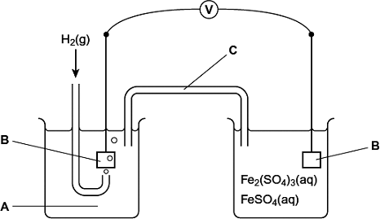
(a) Identify solution A and give its concentration. State the other essential conditions for the operation of the standard electrode that forms the left-hand side of the cell.
Solution A .......................................................................................................
Conditions ......................................................................................................
........................................................................................................................
........................................................................................................................
(3)
(b) Identify the material from which electrodes B are made. Give two reasons why this material is suitable for its purpose.
Material ..........................................................................................................
Reason 1 .......................................................................................................
........................................................................................................................
Reason 2 .......................................................................................................
........................................................................................................................
(3)

(c) Identify a solution that could be used in C to complete the circuit. Give two reasons why this solution is suitable for its purpose.
Solution ..........................................................................................................
Reason 1 .......................................................................................................
........................................................................................................................
Reason 2 .......................................................................................................
........................................................................................................................
(3)
(d) Write the conventional representation for this cell.
........................................................................................................................
(1)
(e) The voltmeter V shown in the diagram of the cell was replaced by an ammeter.
(i) Write an equation for the overall cell reaction that would occur.
...............................................................................................................
...............................................................................................................
...............................................................................................................
(1)
(ii) Explain why the ammeter reading would fall to zero after a time.
...............................................................................................................
...............................................................................................................
(1)
(Total 12 marks)

7. Large blocks of magnesium are bolted onto the hulls of iron ships in an attempt to prevent the iron being converted into iron(II), one of the steps in the rusting process.
Use the data below, where appropriate, to answer the questions which follow.
E/ V
Mg²⁺(aq) + 2e– Mg(s) –2.37
Fe²⁺(aq) + 2e– Fe(s) –0.44
O₂(g) + 2H₂O(l) + 4e– 4OH–(aq) +0.40
(a) Calculate the e.m.f. of the cell represented by Mg(s)|Mg²⁺(aq)||Fe²⁺(aq)|Fe(s) under standard conditions. Write a half-equation for the reaction occurring at the negative electrode of this cell when a current is drawn.
Cell e.m.f. ....................................................................................................
Half-equation ................................................................................................
......................................................................................................................
(2)
(b) Deduce how the e.m.f. of the cell Mg(s)|Mg²⁺(aq)||Fe²⁺(aq)|Fe(s) changes when the concentration of Mg²⁺ is decreased. Explain your answer.
Change in e.m.f. ..........................................................................................
Explanation ..................................................................................................
......................................................................................................................
(3)
(c) Calculate a value for the e.m.f. of the cell represented by
Pt(s)|OH–(aq)|O₂(g)||Fe²⁺(aq)|Fe(s) and use it to explain why iron corrodes when in contact with water which contains dissolved oxygen.
Cell e.m.f. ....................................................................................................
Explanation ..................................................................................................
......................................................................................................................
(2)
(Total 7 marks)

8. (a) Give one example of a bidentate ligand.
......................................................................................................................
(1)
(b) Give one example of a linear complex ion formed by a transition metal.
......................................................................................................................
(1)

(c) Write an equation for a substitution reaction in which the complete replacement of ligands in a complex ion occurs with a change in both the co-ordination number and the overall charge of the complex ion.
......................................................................................................................
(2)
(d) Write an equation for a substitution reaction in which the complete replacement of ligands in a complex ion occurs without a change in either the co-ordination number or the overall charge of the complex ion.
......................................................................................................................
(2)
(e) When a solution containing [Co(H₂O)₆]²⁺ ions is treated with a solution containing EDTA^{4–} ions, a more stable complex is formed. Write an equation for this reaction and explain why the complex is more stable.
Equation ......................................................................................................
Explanation ..................................................................................................
......................................................................................................................
(3)
(Total 9 marks)

9. The concentration of iron(III) ions in a dilute solution can be determined by visible spectrometry. The absorption of light of a particular frequency by solutions of iron(III) sulfate of different concentrations was measured. The results are shown in the table below.

 | Percentage  absorbance | Concentration of iron(III)  sulfate / mol dm^{–3}
 | 1.0 | 7.5 ×10^{–3}
 | 2.5 | 14.0 ×10^{–3}
 | 5.0 | 27.5 ×10^{–3}
 | 7.0 | 37.5 ×10^{–3}
 | 10.0 | 54.0 ×10^{–3}
 | 12.0 | 65.0 ×10^{–3}

(a) Use these results to plot a graph of percentage absorbance (y-axis) against concentration of iron(III) sulfate on the grid below.
Draw a straight line of best fit.
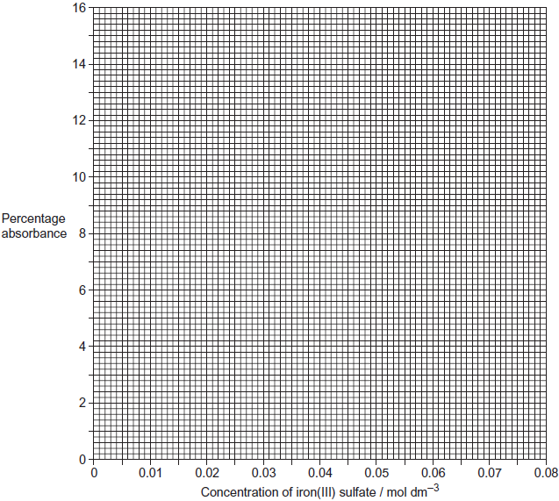
(2)
(b) Use your graph to determine the concentration of an iron(III) sulfate solution that has a percentage absorbance of 14.0%.
........................................................................................................................
(1)
(Total 3 marks)

10.
 | (a) | ……………………………………………………………………………………………………………………………………………………………………  ……………………………………………………………………………………………………………………………………………………………………  ……………………………………………………………………………………………………………………………………………………………………
 | (b) | ……………………………………………………………………………………………………………………………………………………………………  ……………………………………………………………………………………………………………………………………………………………………  ……………………………………………………………………………………………………………………………………………………………………  ……………………………………………………………………………………………………………………………………………………………………  ……………………………………………………………………………………………………………………………………………………………………  ……………………………………………………………………………………………………………………………………………………………………  ……………………………………………………………………………………………………………………………………………………………………  ……………………………………………………………………………………………………………………………………………………………………  ……………………………………………………………………………………………………………………………………………………………………  ……………………………………………………………………………………………………………………………………………………………………
 | (c) | ……………………………………………………………………………………………………………………………………………………………………  ……………………………………………………………………………………………………………………………………………………………………  ……………………………………………………………………………………………………………………………………………………………………  ……………………………………………………………………………………………………………………………………………………………………
 | (d) | ……………………………………………………………………………………………………………………………………………………………………  ……………………………………………………………………………………………………………………………………………………………………  ……………………………………………………………………………………………………………………………………………………………………  ……………………………………………………………………………………………………………………………………………………………………

