A-LEVEL CHEMISTRY

PAPER 2
PRACTICE PAPER 10

Answer all questions
Max 105 marks
2 hours

Name ……………………………………………………………..

Mark ……../105 ……....% Grade ………

1. | ……………………………………………………………………………………………………………………………………………………………………………  ……………………………………………………………………………………………………………………………………………………………………………  ……………………………………………………………………………………………………………………………………………………………………………  (3 marks)
……………………………………………………………………………………………………………………………………………………………………………

……………………………………………………………………………………………………………………………………………………………………………

……………………………………………………………………………………………………………………………………………………………………………

……………………………………………………………………………………………………………………………………………………………………………
(2 marks)
(Total 5 marks)

2. | 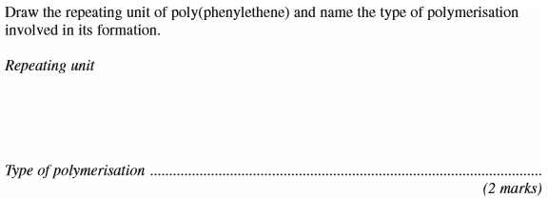  (Total 2 marks)

3. | 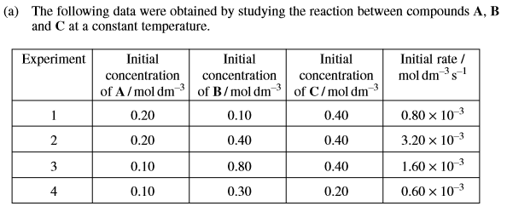  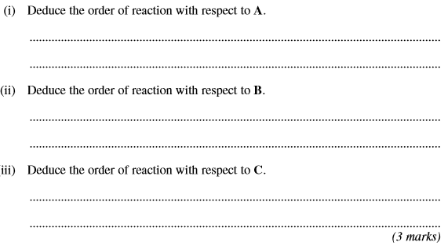
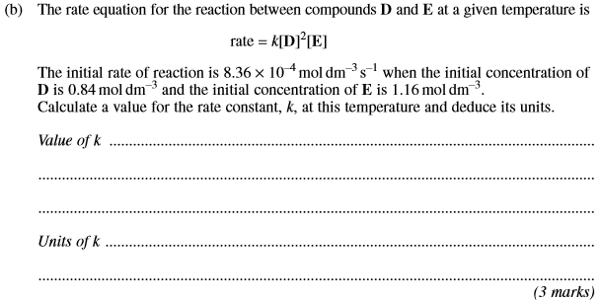
(Total 6 marks)

4. | ……………………………………………………………………………………………………………………………………………………………………………  ……………………………………………………………………………………………………………………………………………………………………………  ……………………………………………………………………………………………………………………………………………………………………………  (4 marks)

……………………………………………………………………………………………………………………………………………………………………………

……………………………………………………………………………………………………………………………………………………………………………

……………………………………………………………………………………………………………………………………………………………………………
(7 marks)

……………………………………………………………………………………………………………………………………………………………………………

……………………………………………………………………………………………………………………………………………………………………………

……………………………………………………………………………………………………………………………………………………………………………
(7 marks)
(Total 18 marks)
5. | 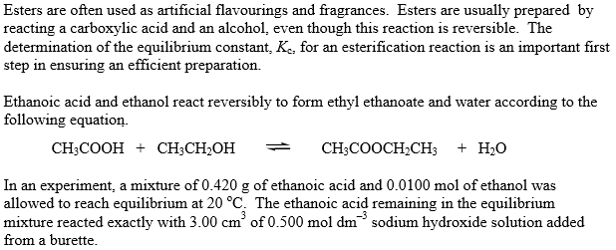
 | (a) | 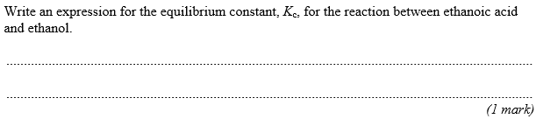
 | (b) | 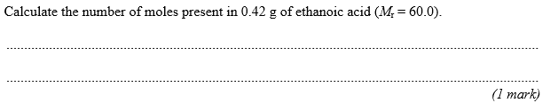
 | (c) | 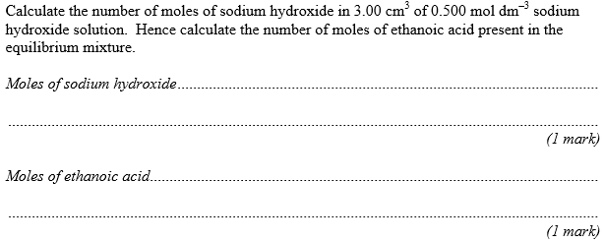
 | (d) | 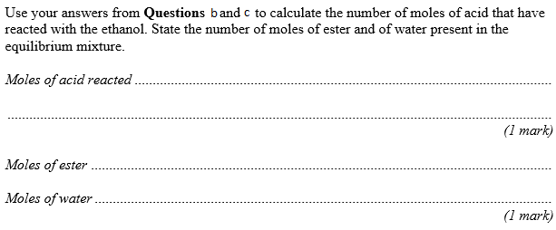
 | (e) | 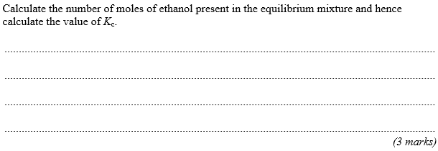
 | (f) | 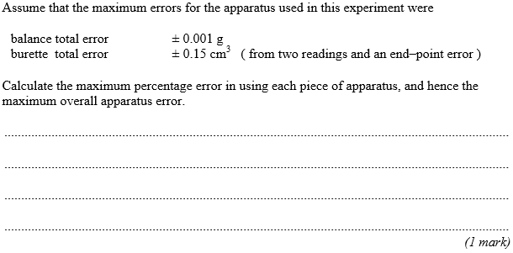
 | (g) | 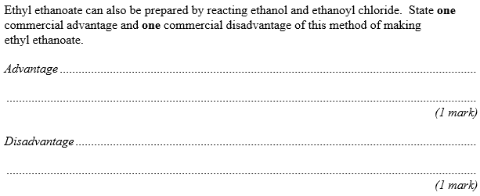
 | (h) | 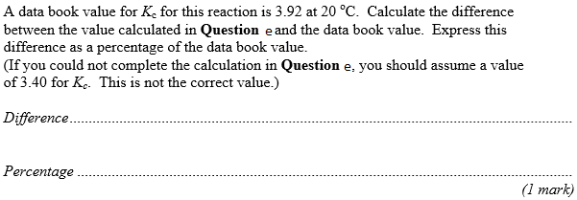
 | (i) | 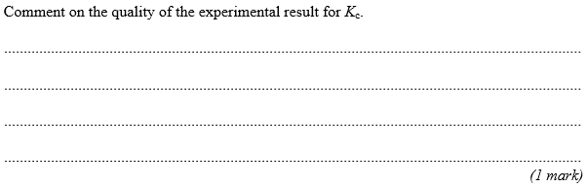
 | (j) | 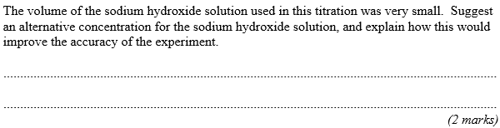
 | (k) | 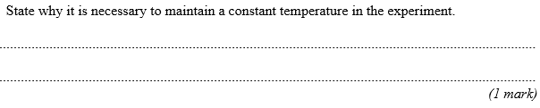
 | (l) | 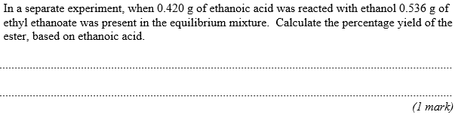
 | (m) | 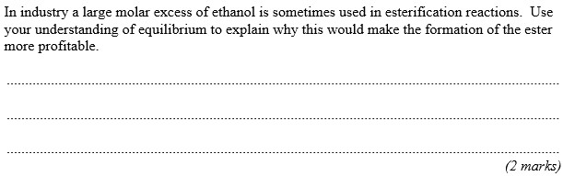
 | (n) | 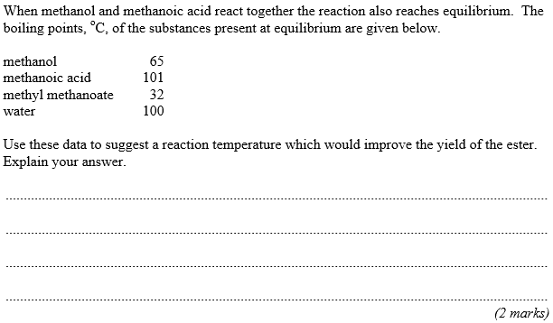  (Total 22 marks)

6. | 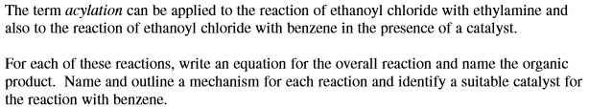  ……………………………………………………………………………………………………………………………………………………………………………  ……………………………………………………………………………………………………………………………………………………………………………  ……………………………………………………………………………………………………………………………………………………………………………  ……………………………………………………………………………………………………………………………………………………………………………  ……………………………………………………………………………………………………………………………………………………………………………  ……………………………………………………………………………………………………………………………………………………………………………  ……………………………………………………………………………………………………………………………………………………………………………  ……………………………………………………………………………………………………………………………………………………………………………  ……………………………………………………………………………………………………………………………………………………………………………  ……………………………………………………………………………………………………………………………………………………………………………  ……………………………………………………………………………………………………………………………………………………………………………  ……………………………………………………………………………………………………………………………………………………………………………  ……………………………………………………………………………………………………………………………………………………………………………  ……………………………………………………………………………………………………………………………………………………………………………  ……………………………………………………………………………………………………………………………………………………………………………  ……………………………………………………………………………………………………………………………………………………………………………  ……………………………………………………………………………………………………………………………………………………………………………  ……………………………………………………………………………………………………………………………………………………………………………  ……………………………………………………………………………………………………………………………………………………………………………  ……………………………………………………………………………………………………………………………………………………………………………  ……………………………………………………………………………………………………………………………………………………………………………  ……………………………………………………………………………………………………………………………………………………………………………  (Total 15 marks)
7. | 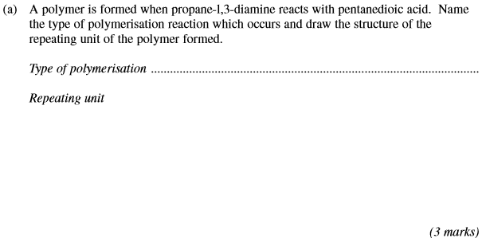
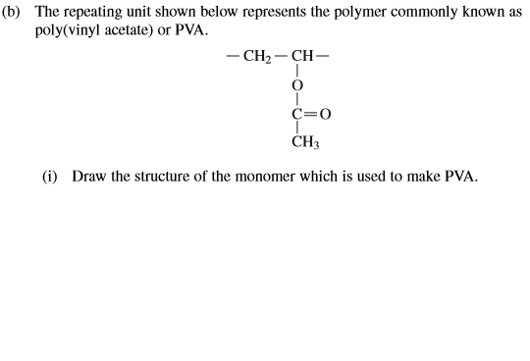
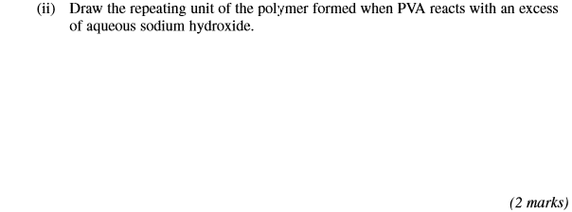
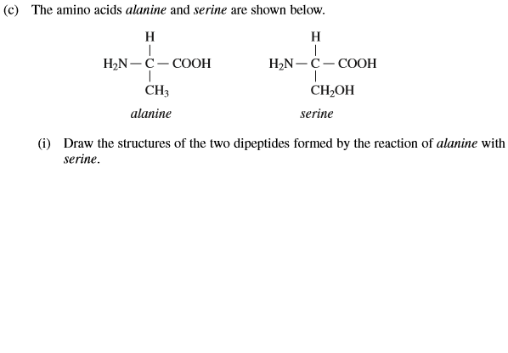
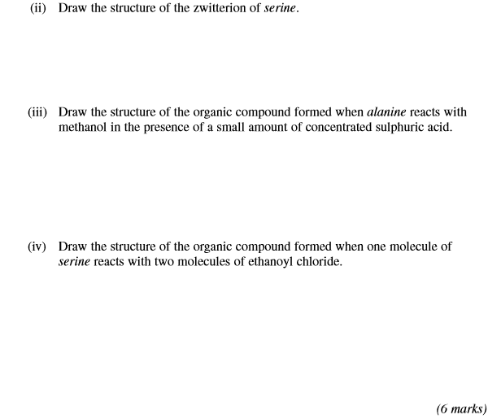
(Total 11 marks)
8. | 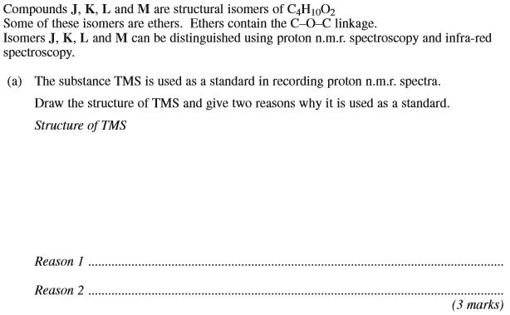
 | 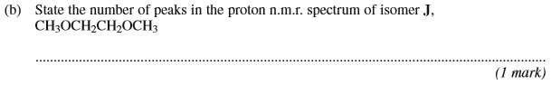
 | 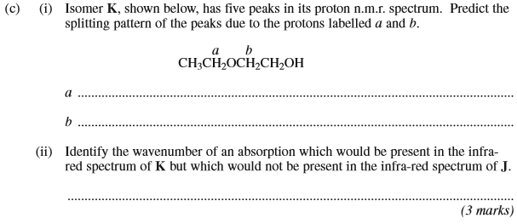
 | 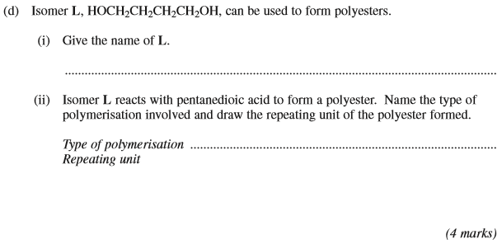

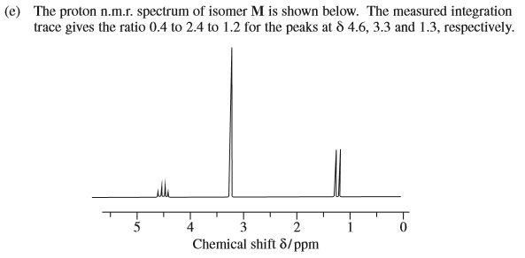
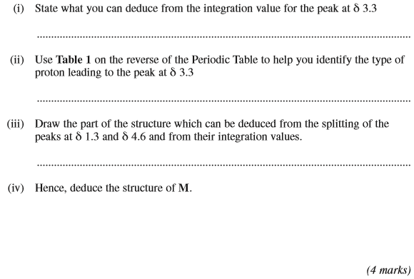
(Total 15 marks)

9. | 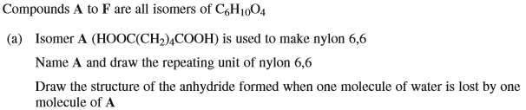
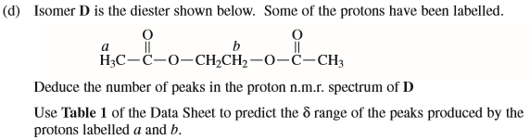

……………………………………………………………………………………………………………………………………………………………………………

……………………………………………………………………………………………………………………………………………………………………………

……………………………………………………………………………………………………………………………………………………………………………

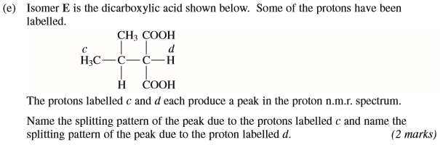

……………………………………………………………………………………………………………………………………………………………………………

……………………………………………………………………………………………………………………………………………………………………………

……………………………………………………………………………………………………………………………………………………………………………
(Total 11 marks)

