A-LEVEL PAPER 2 PP10 MS

1.
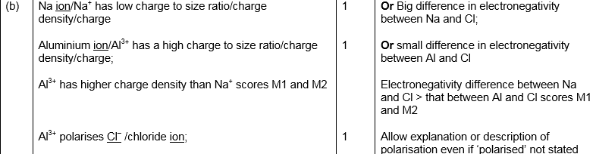
[5]

2. | 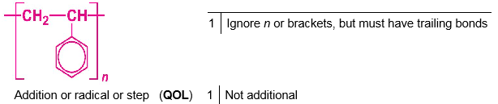  [2]
3.
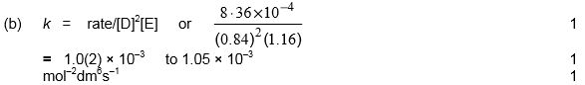
[6]

4. | 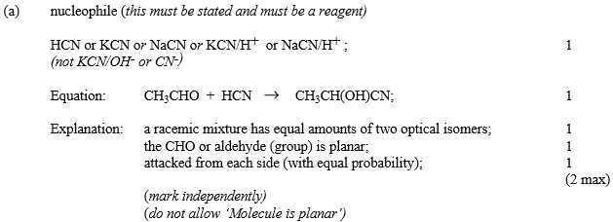
 | 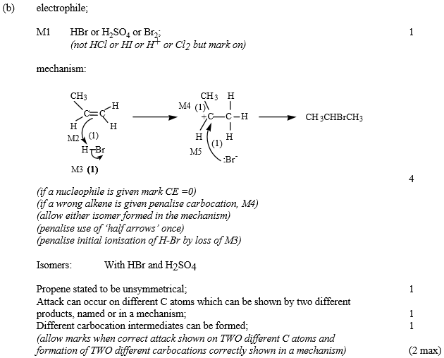

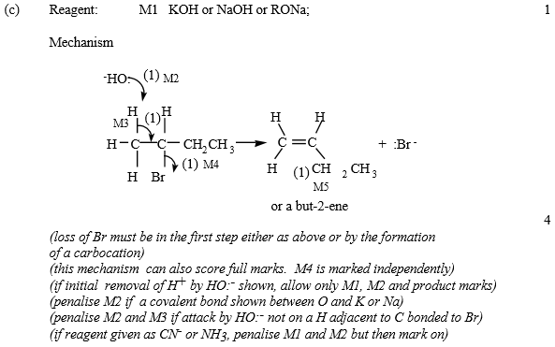
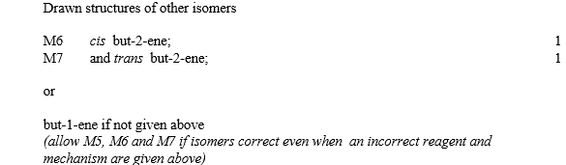
[18]

5. | (a)
 | (b)
 | (c)
 | (d)
 | (e) | 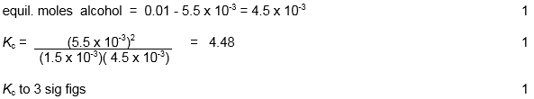
 | (f)
 | (g)
 | (h)
 | (i)
 | (j)
 | (k)
 | (l)
 | (m)
 | (n) | [22]
6. | 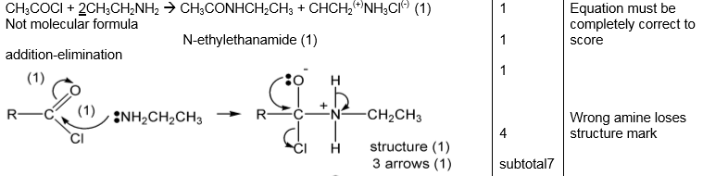  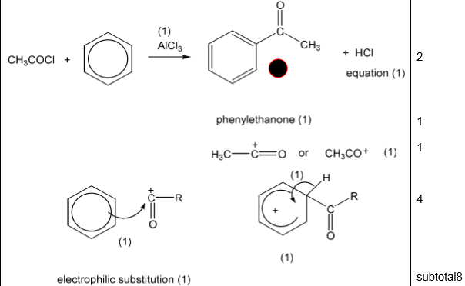  [15]
7. | 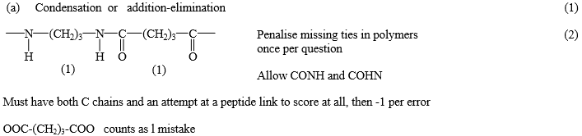
 | 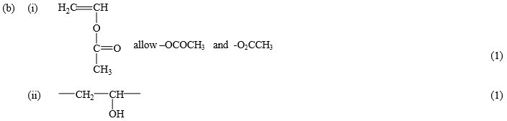
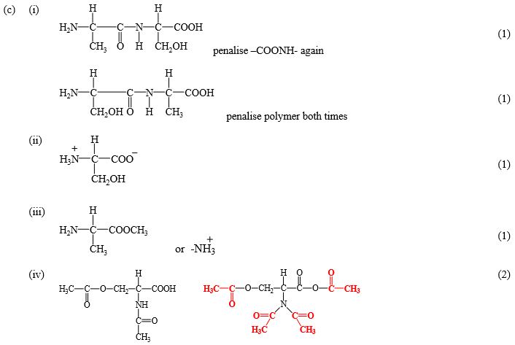
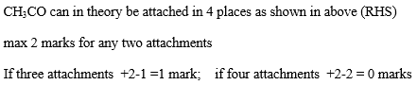
[11]

8. | 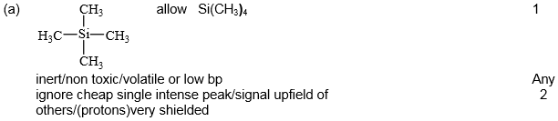
 | 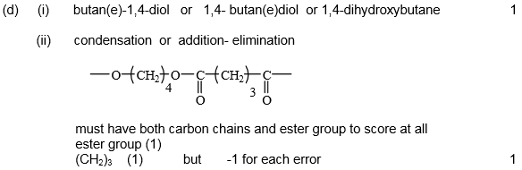
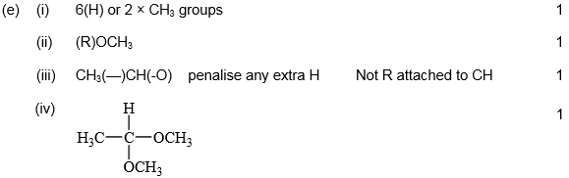
[15]

9. | 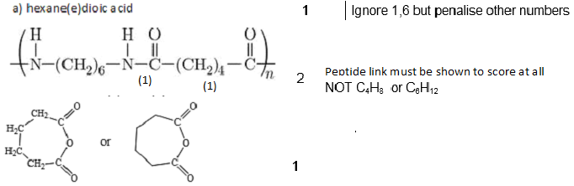
 | 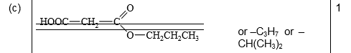
 | 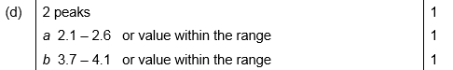
 | [11]

