A-LEVEL CHEMISTRY

PAPER 2
PRACTICE PAPER 11

Answer all questions
Max 105 marks
2 hours

Name ……………………………………………………………..

Mark ……../105 ……....% Grade ………

1. | 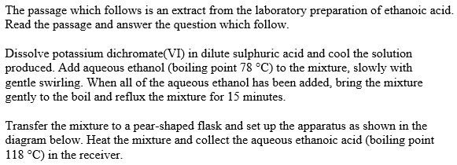  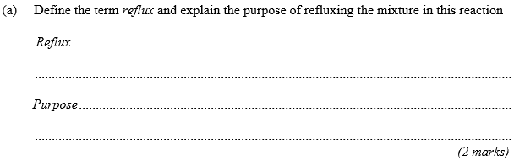
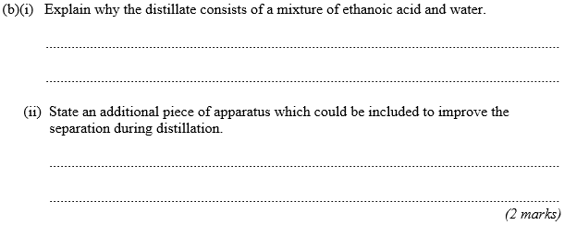
(Total 4 marks)

2. | 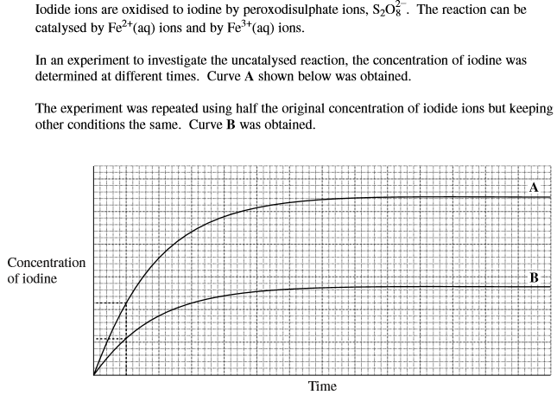  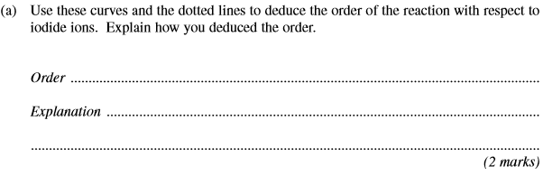
 | 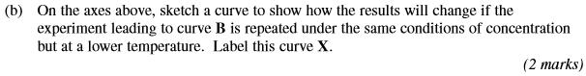
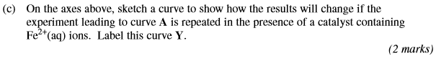
(Total 6 marks)

3. | (Total 3 marks)
4. | (a) | Name of organic product: ………………………………………………………………………………………………………………  (5 marks)
 | (b) | ……………………………………………………………………………………………………………………………………………………………………  ……………………………………………………………………………………………………………………………………………………………………  ……………………………………………………………………………………………………………………………………………………………………  ……………………………………………………………………………………………………………………………………………………………………  (2 marks)

 | (c) | ……………………………………………………………………………………………………………………………………………………………………  ……………………………………………………………………………………………………………………………………………………………………  ……………………………………………………………………………………………………………………………………………………………………  ……………………………………………………………………………………………………………………………………………………………………  (4 marks)  (Total 11 marks)
5. | 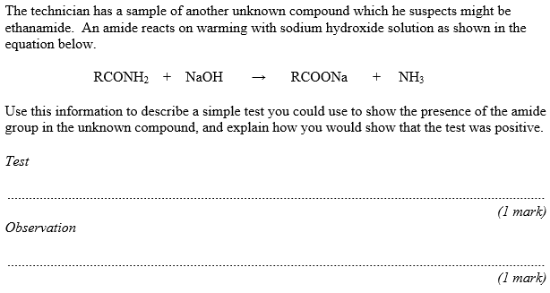  (2 marks)  (Total 2 marks)

6. | 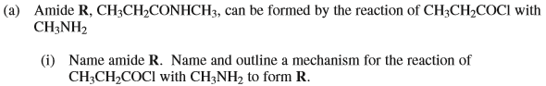  Name of R: ……………………………………………………………………………….  Name of mechanism: ……………………………………………………………….  Mechanism:  (7 marks)
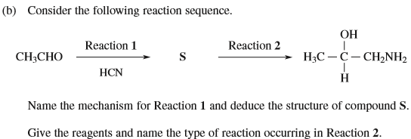

Name of mechanism: ………………………………………………………

Structure of S:

Reagents: …………………………………………………………………………..

Type of reaction: ………………………………………………………………
(4 marks)
(Total 11 marks)

7. | (Total 4 marks)
8. | 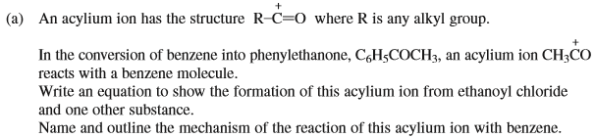  Equation: ……………………………………………………………………………………………………………………………………………………………..  Name of mechanism: …………………………………………………………………………………………………………………………………………..  Mechanism:  (6 marks)
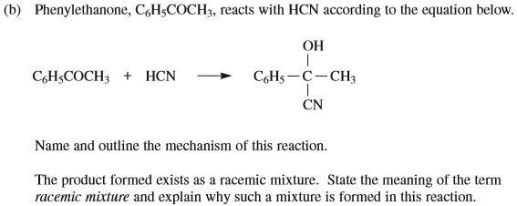

Name of mechanism: …………………………………………………………………………………………………………………………………………..

Mechanism:

……………………………………………………………………………………………………………………………………………………………………………...

……………………………………………………………………………………………………………………………………………………………………………...

……………………………………………………………………………………………………………………………………………………………………………...

……………………………………………………………………………………………………………………………………………………………………………...

……………………………………………………………………………………………………………………………………………………………………………...
(8 marks)
(Total 14 marks)

9. | 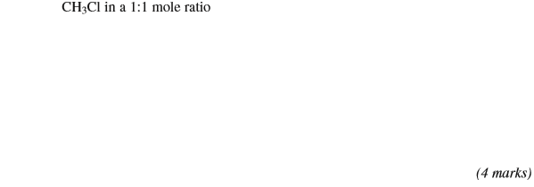
 | 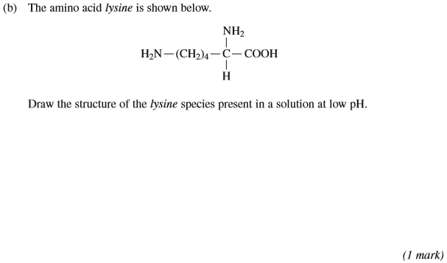
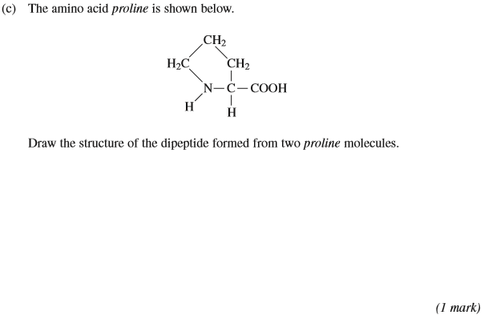
(Total 6 marks)

10. | 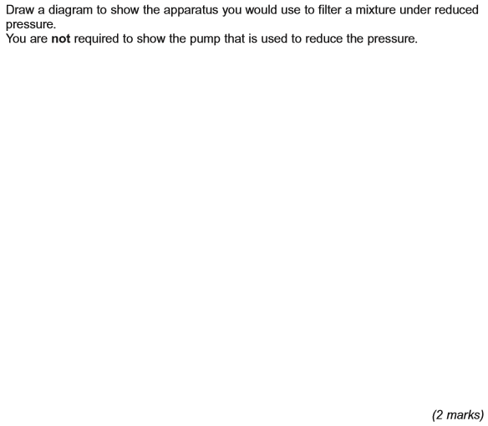  (Total 2 marks)

11. | 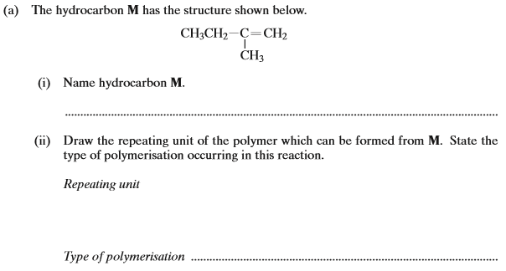
 | (iii) | (4 marks)
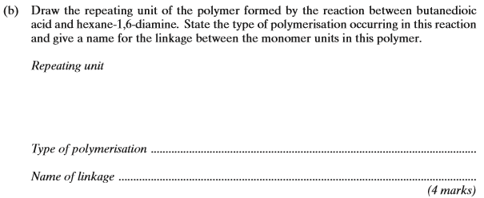
(Total 8 marks)

12. | 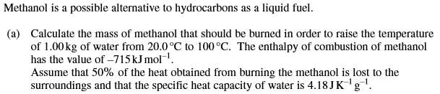  ………………………………………………………………………………………………………………………………………………………………………………  ………………………………………………………………………………………………………………………………………………………………………………  ………………………………………………………………………………………………………………………………………………………………………………  ………………………………………………………………………………………………………………………………………………………………………………  ………………………………………………………………………………………………………………………………………………………………………………  (5 marks)
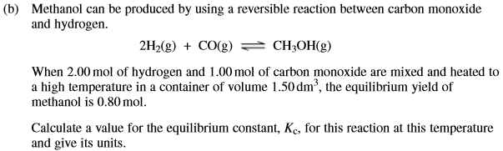

………………………………………………………………………………………………………………………………………………………………………………

………………………………………………………………………………………………………………………………………………………………………………

………………………………………………………………………………………………………………………………………………………………………………

………………………………………………………………………………………………………………………………………………………………………………

………………………………………………………………………………………………………………………………………………………………………………

………………………………………………………………………………………………………………………………………………………………………………

………………………………………………………………………………………………………………………………………………………………………………
(7 marks)

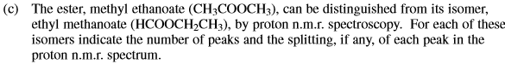

………………………………………………………………………………………………………………………………………………………………………………

………………………………………………………………………………………………………………………………………………………………………………

………………………………………………………………………………………………………………………………………………………………………………

………………………………………………………………………………………………………………………………………………………………………………

………………………………………………………………………………………………………………………………………………………………………………
(5 marks)
(Total 17 marks)

13. | 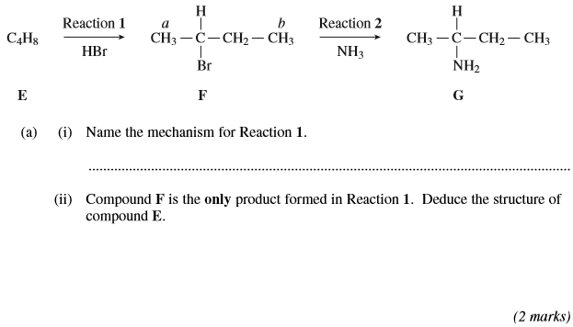
 | 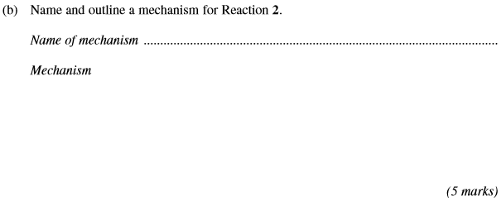
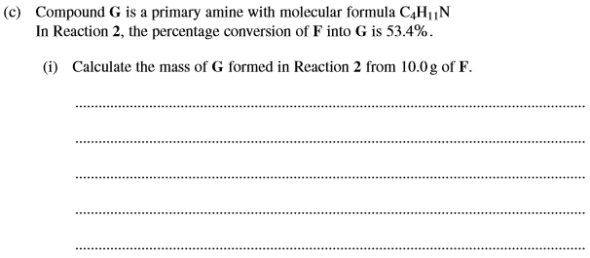
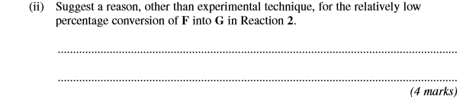
 | 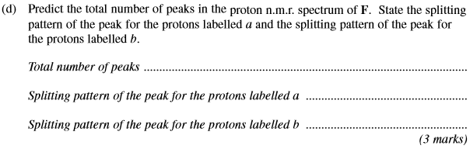
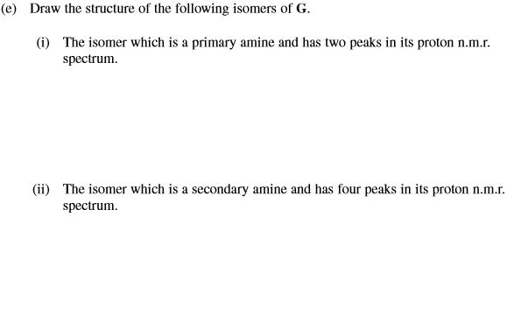
(Total 17 marks)

