A-LEVEL CHEMISTRY

PAPER 2
PRACTICE PAPER 12

Answer all questions
Max 105 marks
2 hours

Name ……………………………………………………………..

Mark ……../105 ……....% Grade ………

1. | 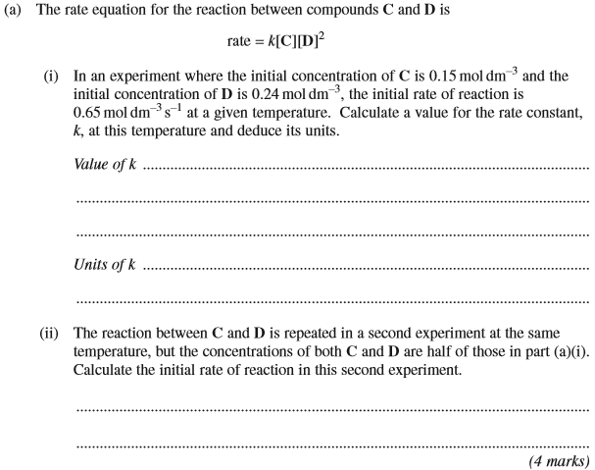
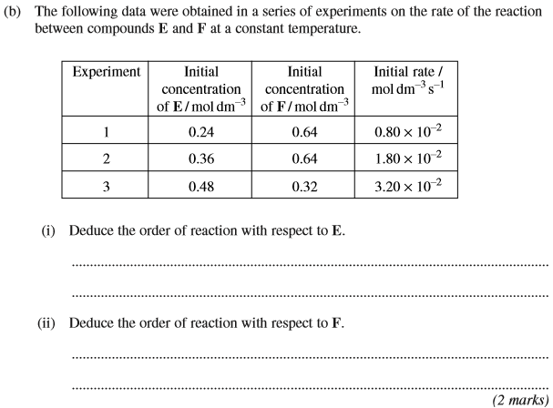
(Total 6 marks)
2. | 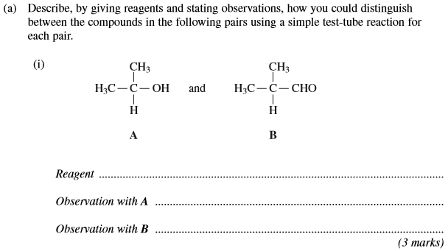  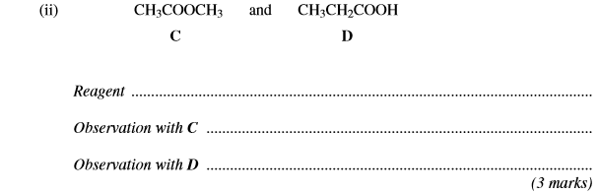
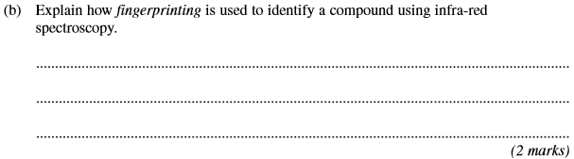
(Total 8 marks)

3. | 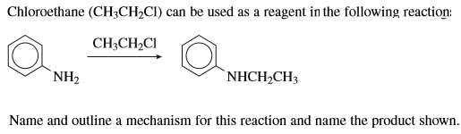  Name of mechanism:………………………………………………………………………………………………………..  Mechanism:  Name of product:………………………………………………………………………………………………………………..  (Total 6 marks)
4. | ……………………………………………………………………………………………………………………………………………………………………………  ……………………………………………………………………………………………………………………………………………………………………………  ……………………………………………………………………………………………………………………………………………………………………………  (2 marks)
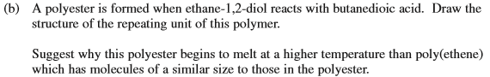

……………………………………………………………………………………………………………………………………………………………………………

……………………………………………………………………………………………………………………………………………………………………………
(4 marks)

(4 marks)
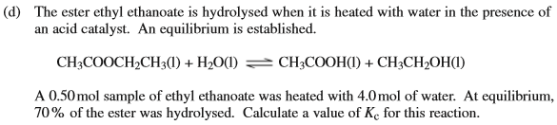

……………………………………………………………………………………………………………………………………………………………………………

……………………………………………………………………………………………………………………………………………………………………………

……………………………………………………………………………………………………………………………………………………………………………

……………………………………………………………………………………………………………………………………………………………………………

……………………………………………………………………………………………………………………………………………………………………………
(5 marks)
(Total 15 marks)

5. | 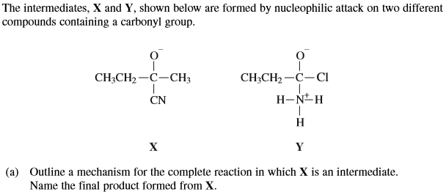  Mechanism:  Final product formed from X:………………………………………………………………………….  (5 marks)

Mechanism:

Name of mechanism:
Final product formed from X:………………………………………………………………………….
(6 marks)
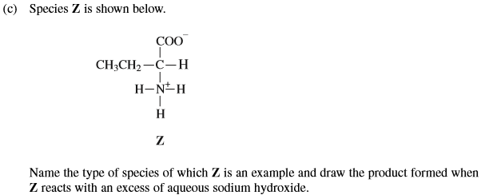

……………………………………………………………………………………………………………………………………………………………………………
(2 marks)
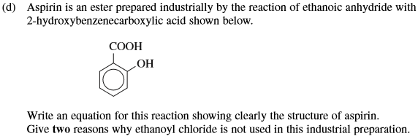

……………………………………………………………………………………………………………………………………………………………………………

……………………………………………………………………………………………………………………………………………………………………………

……………………………………………………………………………………………………………………………………………………………………………
(5 marks)
(Total 18 marks)
6. | 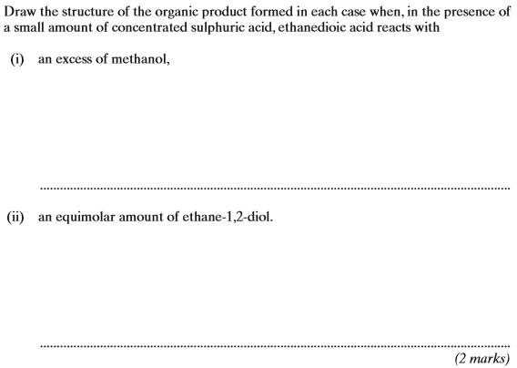  (Total 2 marks)
7. | 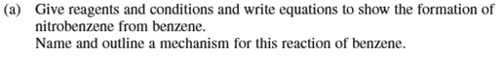  ……………………………………………………………………………………………………………………………………………………………………………  ……………………………………………………………………………………………………………………………………………………………………………  ……………………………………………………………………………………………………………………………………………………………………………  (8 marks)

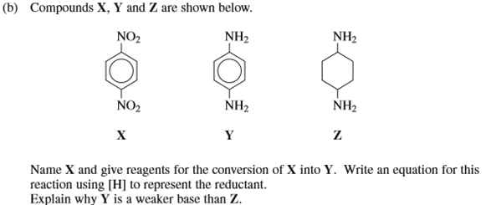

……………………………………………………………………………………………………………………………………………………………………………

……………………………………………………………………………………………………………………………………………………………………………

……………………………………………………………………………………………………………………………………………………………………………
(6 marks)

(2 marks)
(Total 16 marks)

8. | 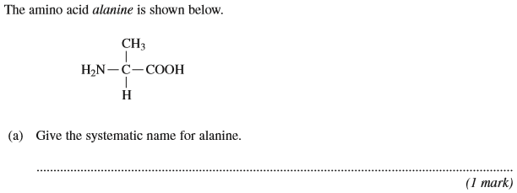
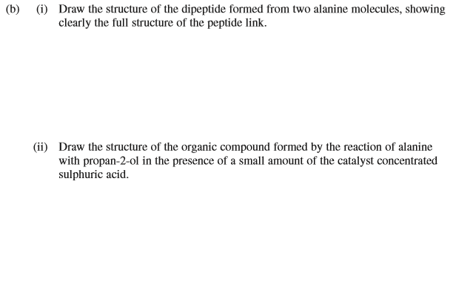
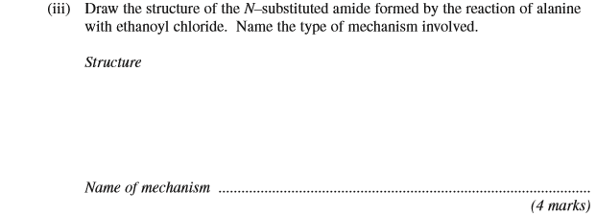
(Total 5 marks)

9. | 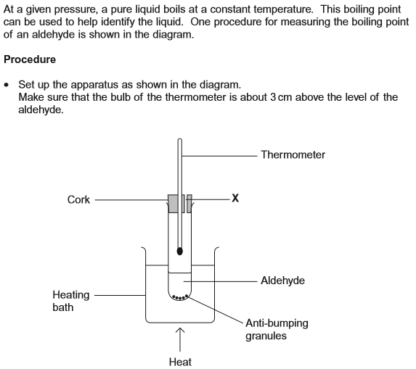  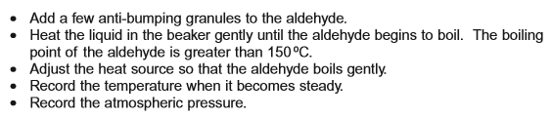  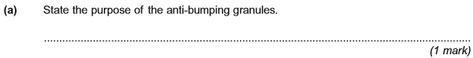
 | 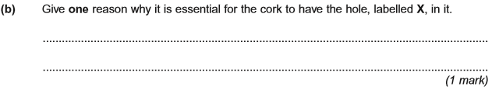
 | 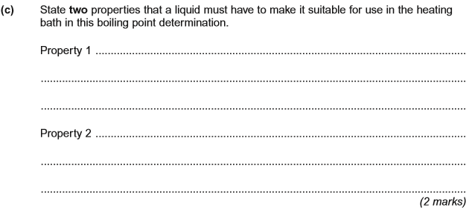
 | 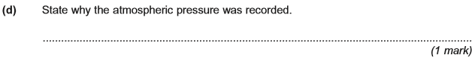
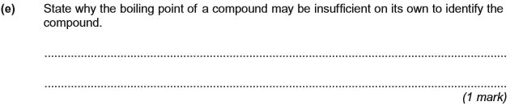
(Total 6 marks)

10. | 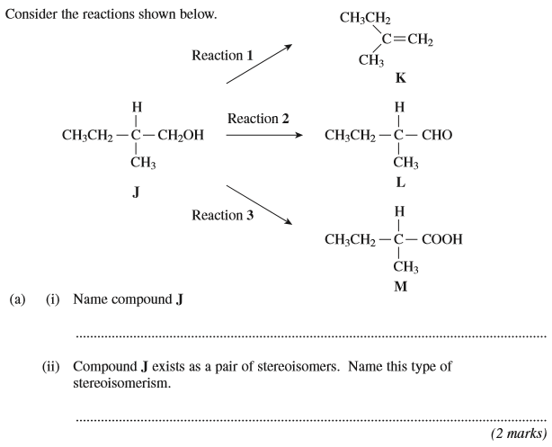
 | 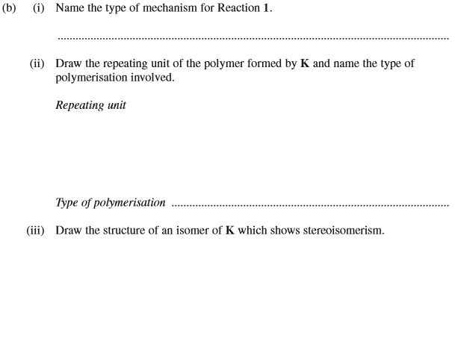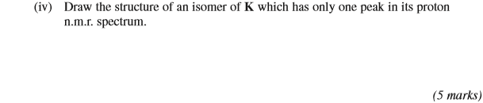
 | 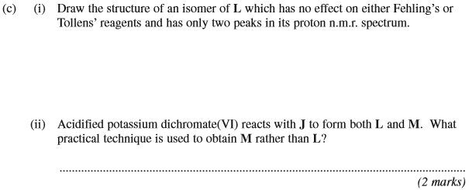

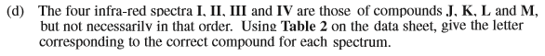
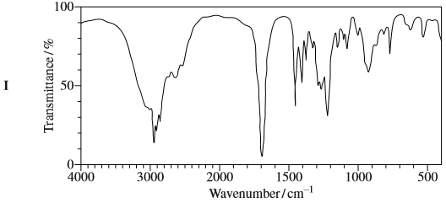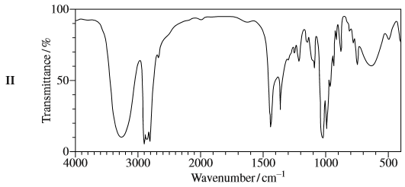
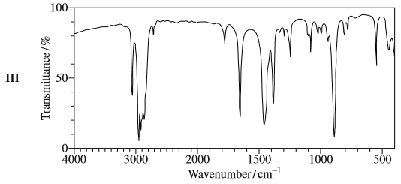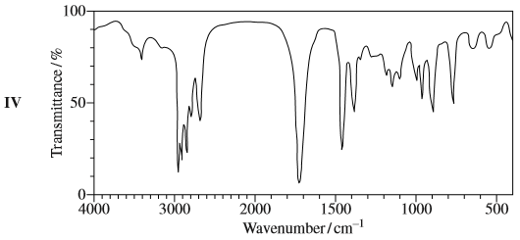

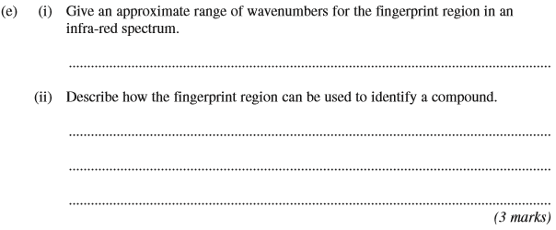
(Total 16 marks)

11. | 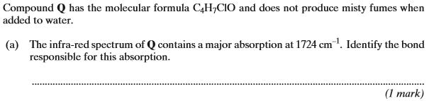
 | 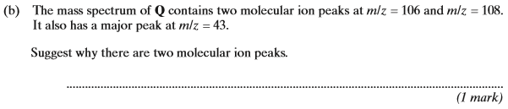
 | 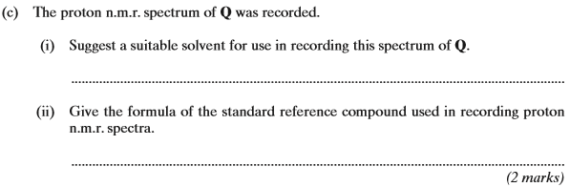
 | 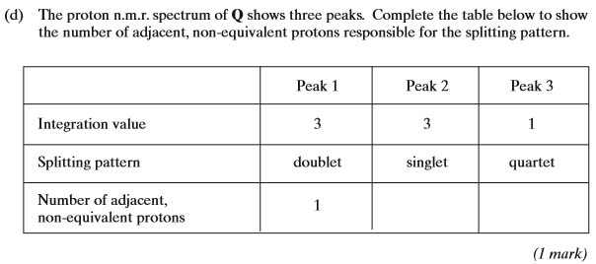
 | 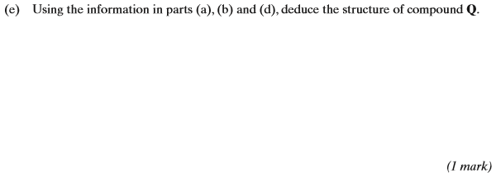
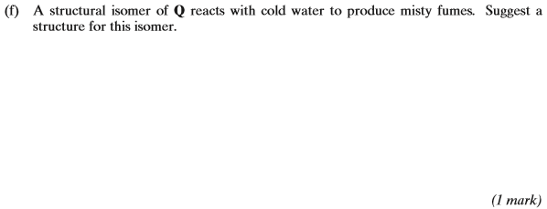
(Total 7 marks)

