A-LEVEL PAPER 2 PP2 MS

Organic points
(1) Curly arrows: must show movement of a pair of electrons,
i.e. from bond to atom or from lp to atom / space
e.g.
(2) Structures
penalise sticks (i.e. 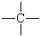) once per paper
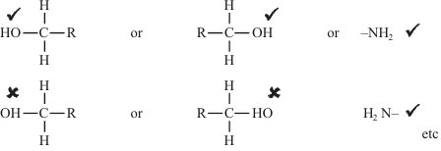
Penalise once per paper
allow CH₃– or –CH₃ or or CH₃
or H₃C–

1.
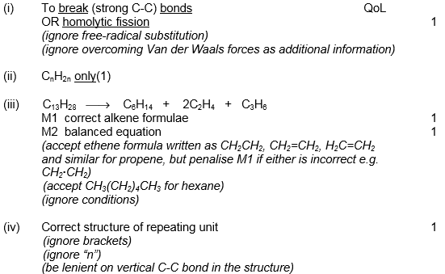 [5]

2.
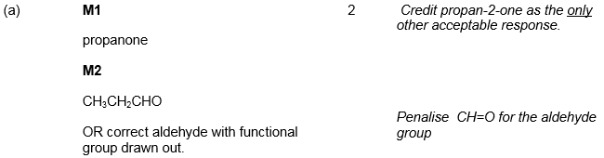
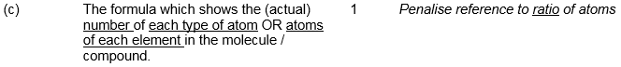
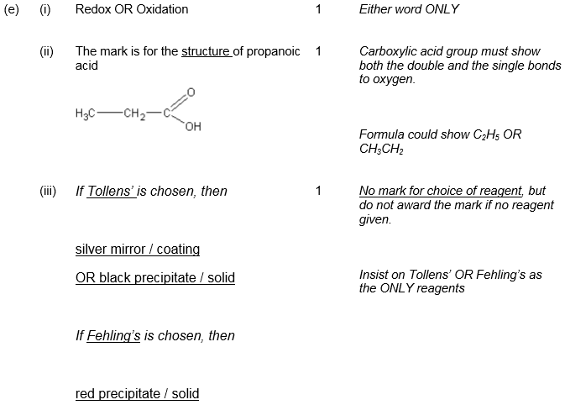
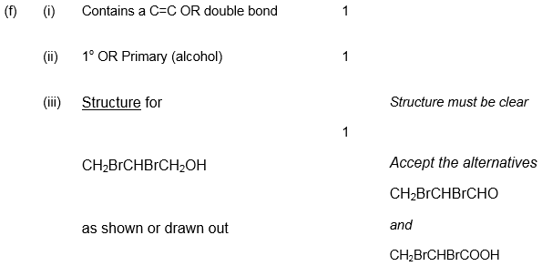 [12]
3.
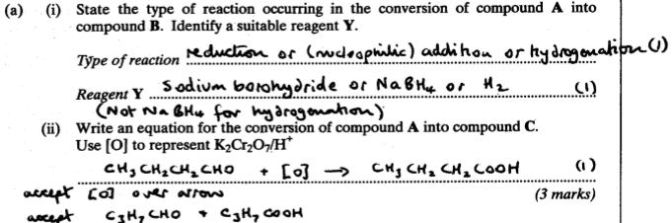
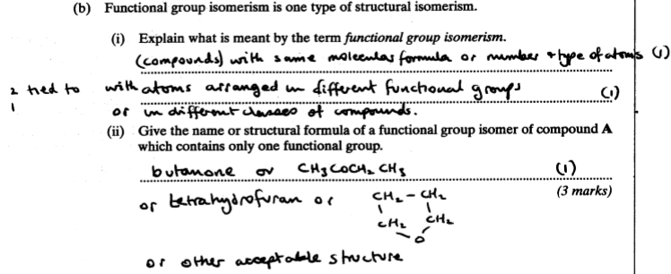
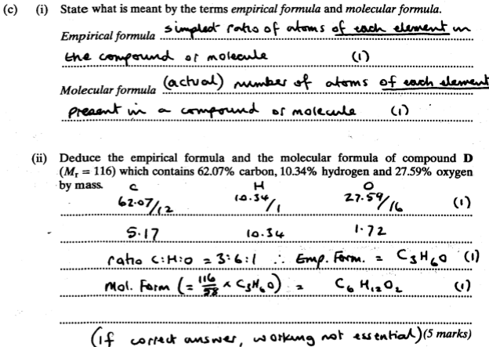 [11]

4. (a) (nucleophilic) addition-elimination
1
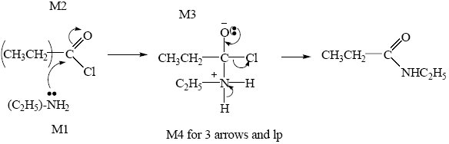
4
N-ethylpropanamide
minus on NH₂ loses M1
M2 not allowed independent of M1, but allow M1 for correct attack on C+
+C=O loses M2
only allow M4 after correct or very close M3
lose M4 for Cl– removing H⁺ in mechanism, but ignore HCl as a product
Not N-ethylpropaneamide
1

(b) CH₃CN or ethan(e)nitrile or ethanonitrile
not ethanitrile
but allow correct formula with ethanitrile
1
for each step wrong or no reagent loses condition mark
contradiction loses mark
1
Step 1 Cl₂
uv or above 300 °C
wrong or no reagent loses condition mark
1
Step 2 KCN
1
aq and alcoholic (both needed)
allow uv light/(sun)light/uv radiation
1
Step 3 H₂/Ni or LiAlH₄ or Na/C₂H₅OH
not CN– but mark on
NOT HCN or KCN + acid, and this loses condition mark
NOT NaBH₄
Sn/HCl (forms aldehyde!)
ignore conditions
1
[12]

5. (a) Sn / HCl OR Fe / HCl not conc H₂SO₄ nor any HNO₃
Ignore subsequent use of NaOH
Ignore reference to Sn as a catalyst with the acid
Allow H₂ (Ni / Pt) but penalise wrong metal
But NOT NaBH₄ LiAlH₄ Na / C₂H₅OH
1
Equation must use molecular formulae
C₆H₄N₂O₄ + 12 [H]
12[H] and 4H₂O without correct molecular formula scores 1 out of 2
1
→C₆H₈N₂ + 4H₂O
Allow .... + 6H₂ if H₂ / Ni used
Allow −CONH− or −COHN− or −C₆H₄−
1
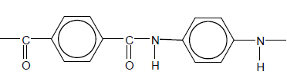
Mark two halves separately: lose 1 each for
• error in diamine part
• error in diacid part
• error in peptide link
• missing trailing bonds at one or both ends
• either or both of H or OH on ends
Ignore n
2

(b) CH₂
1
In benzene 120°
1
In cyclohexane 109° 28’ or 109½°
Allow 108° - 110°
If only one angle stated without correct qualification, no mark awarded
1
[8]

6. (a) (i) 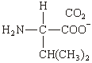 (1)
ignore Na⁺ unless covalently bonded
(ii) 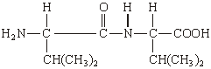 (1)
must be dipeptide, not polymer nor anhydride
allow –CONH– or –COHN–
allow zwitterion
(iii) hydrogen bonding (1)
QL
Allow with dipole-dipole or v derWaals, but not dipole-dipole etc alone
3
(b) (i) Type of polymerisation: addition(al) (1)
Repeating unit: 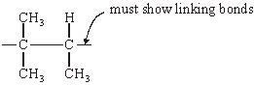 (1)
not multiples
allow n
(ii) CH₃CH=CHCH₂CH₃ (1) C₂H₅
(iii)
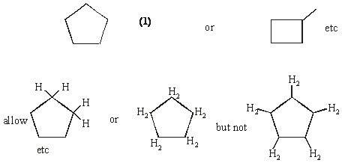
4
[7]

7. (a) CH₃COCl + AlCl₃ CH₃CO⁺ + AlCl₄–
Allow RHS as 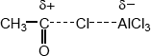
Allow + on C or O in equation but + must be on C in mechanism below
Ignore curly arrows in equation even if wrong.
1
AlCl₄– + H⁺ AlCl₃ + HCl
1
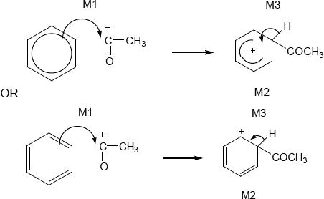
• M1 arrow from within hexagon
to C or to + on C
• + must be on C of RCO in mechanism
• + in intermediate not too close to C1
• gap in horseshoe must be centred approximately around C1
• M3 arrow into hexagon unless Kekule
• allow M3 arrow independent of M2 structure
• ignore base removing H for M3
• NO mark for name of mechanism
3
Phenylethanone ignore 1 in name, penalise other numbers
Note: this is the sixth marking point in (a)
1
(b) M1 about electrons
methyl group has (positive) inductive effect OR increases electron density on
benzene ring OR pushes electrons OR is electron releasing
Ignore reference to delocalisation
1
M2 about attraction
electrophile attracted more
or benzene ring better nucleophile
Allow intermediate ion stabilised
M2 only awarded after correct or close M1
1
[8]

8. (a) Benzene-1,2-dicarboxylic acid
Allow 1,2-benzenedicarboxylic acid
1
(b)
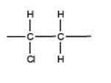
Must show all bonds including trailing bonds
Ignore n
1
(c) (i) 2 C₂H₅OH
NB Two ethanols
1
H₂O
but only one water
1
(ii) 6 or six
1
(iii)
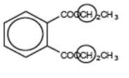
Ignore overlap with O to the left or H to the
right, but must only include this one carbon.
either or allow both (as they are identical)
1
(d) (i) Rate = k[DEP]
Must have brackets but can be ( )
1
(ii) Any two of
• experiment repeated/continued over a long period
• repeated by independent body/other scientists/avoiding
bias
• investigate breakdown products
• results made public
Not just repetition
Ignore animal testing
2 max
[9]

9. (a) X contains > C=O (1)
if X and Y reversed lose this mark but allow remaining max 6/7
X is CH₃CH₂COOH (1)
Y is CH₃CH₂CH₂OH (1)
A is 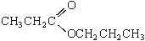 (1)
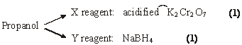
Conc H₂SO₄ : catalyst (1)
7
(b)
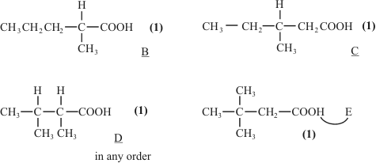
4
(c) 3.1 – 3.9 (1)
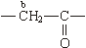 2.1 – 2.6 (1)
a: quartet (1) 3 adjacent H (1)
b: triplet (1) 2 adjacent H (1)
6
(d) 3269 cm^{–1} OH alcohol (1)
G is 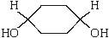 (1)
2
Notes
(a) first mark for C=O stated or shown in X
Ignore wrong names
Y CH₃CH₂CH₂OH
allow C₃H₇ in A if Y correct or vice versa
Allow (1) for A if correct conseq to wrong X and Y
other oxidising agents: acidified KMnO₄; Tollens; Fehlings
other reducing agents: LiAlH₄; Na/ethanol; Ni/H₂; Zn or Sn or Fe/HCl
(b) give (1) for carboxylic acid stated or COOH shown in each suggestion
(1) for correct E
any 2 out of 3 for B, C or D
allow C₃H₇ for either the B or D shown on the mark scheme
i.e. a correct structure labelled B, C or D or E will gain 2.
(c) protons a – quartet must be correct to score 3 adjacent H mark. Same for b
(d) allow (1) for any OH (alcohol) shown correctly in any structure – ignore extra functional groups. Structure must be completely correct to gain second mark
[19]
10. | (a)
 | (b)
 | (c)
 | (d)
 | (e)
 | (f)
 | (g)
 | (h)
 | (i)
 | (j) | [14]

