A-LEVEL CHEMISTRY

PAPER 2
PRACTICE PAPER 3

Answer all questions
Max 105 marks
2 hours

Name ……………………………………………………………..

Mark ……../105 ……....% Grade ………

1. | 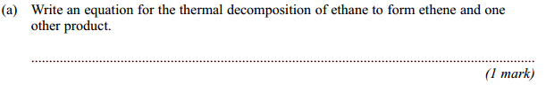
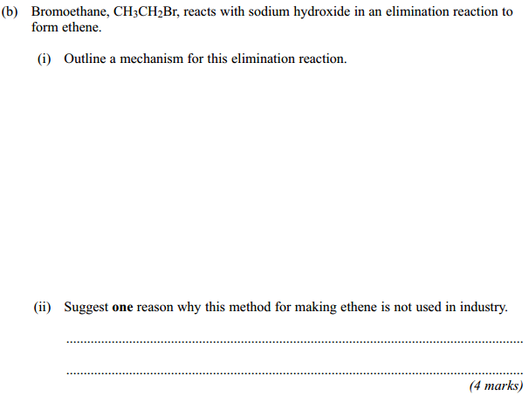
(Total 5 marks)

2. | 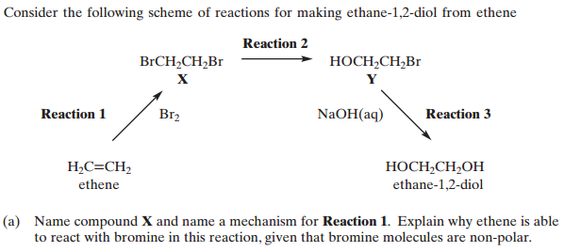  ……………………………………………………………………………………………………………………………………………………………………………...  ………………………………………………………………………………………………………………………………………………………………………………  ……………………………………………………………………………………………………………………………………………………………………………...  ………………………………………………………………………………………………………………………………………………………………………………  (4)

……………………………………………………………………………………………………………………………………………………………………………...

………………………………………………………………………………………………………………………………………………………………………………

……………………………………………………………………………………………………………………………………………………………………………...

………………………………………………………………………………………………………………………………………………………………………………

(4)
(Total 8 marks)

3. | 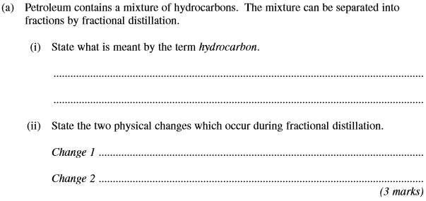
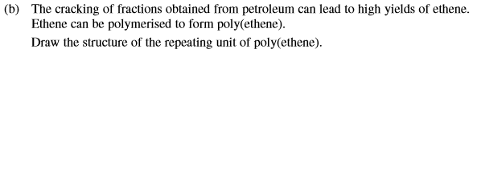
(1)
(Total 4 marks)

4. This question involves the use of kinetic data to calculate the order of a reaction and also a value for a rate constant.
(a) The data in this table were obtained in a series of experiments on the rate of the reaction between compounds E and F at a constant temperature.

 | Experiment | Initial concentration  of E / mol dm ⁻³ | Initial concentration  of F / mol dm ⁻³ | Initial rate of reaction  / mol dm⁻³ s⁻¹
 | 1 | 0.15 | 0.24 | 0.42 × 10⁻³
 | 2 | 0.45 | 0.24 | 3.78 × 10⁻³
 | 3 | 0.90 | 0.12 | 7.56 × 10⁻³

(i) Deduce the order of reaction with respect to E.
...............................................................................................................
(Space for working) ...............................................................................
...............................................................................................................
...............................................................................................................
(1)
(ii) Deduce the order of reaction with respect to F.
...............................................................................................................
(Space for working) ...............................................................................
...............................................................................................................
...............................................................................................................
(1)

(b) The data in the following table were obtained in two experiments on the rate of the reaction between compounds G and H at a constant temperature.

 | Experiment | Initial concentration  of G / mol dm⁻³ | Initial concentration  of H / mol dm⁻³ | Initial rate of reaction  / mol dm⁻³ s⁻¹
 | 4 | 3.8 × 10⁻² | 2.6 × 10⁻² | 8.6 × 10⁻⁴
 | 5 | 6.3 × 10⁻² | 7.5 × 10⁻² | To be calculated

The rate equation for this reaction is
rate = k[G]²[H]
(i) Use the data from Experiment 4 to calculate a value for the rate constant k at this temperature. Deduce the units of k.
Calculation ............................................................................................
...............................................................................................................
...............................................................................................................
...............................................................................................................
Units ......................................................................................................
...............................................................................................................
(3)
(ii) Calculate a value for the initial rate of reaction in Experiment 5.
...............................................................................................................
...............................................................................................................
(1)
(Total 6 marks)

5. Butenedioic acid, HOOCCH=CHCOOH, occurs as two stereoisomers. One of the isomers readily forms the acid anhydride C₄H₂O₃ when warmed.
(a) Identify one electrophile which will react with butenedioic acid and outline a mechanism for this reaction.

(4)
(b) Describe and explain the appearance of the proton n.m.r. spectrum of butenedioic acid.

(3)
(Total 7 marks)
6. Kevlar is a polymer used in protective clothing.
The repeating unit within the polymer chains of Kevlar is shown.
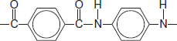
(a) Name the strongest type of interaction between polymer chains of Kevlar.
........................................................................................................................
(1)
(Total 1 mark)

7. This question is about some isomers of C₅H₈O₂
(a) Compound H is a cyclic ester that can be prepared as shown.
On the structure of H, two of the carbon atoms are labelled.

 | HOCH₂CH₂CH₂CH₂COCl | 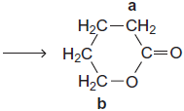 | + HCL
H
(i) Name and outline a mechanism for this reaction.
Use Table C on the Data Sheet to give the ¹³C n.m.r. δ value for the carbon atom labelled a and the δ value for the carbon atom labelled b.
...............................................................................................................
...............................................................................................................
...............................................................................................................
...............................................................................................................
...............................................................................................................
...............................................................................................................
...............................................................................................................
...............................................................................................................
...............................................................................................................
...............................................................................................................
...............................................................................................................
...............................................................................................................
...............................................................................................................
...............................................................................................................
...............................................................................................................
...............................................................................................................
(7)

(ii) HOCH₂CH₂CH₂CH₂COCl can also react to form a polyester in a mechanism similar to that in part (i).
Draw the repeating unit of the polyester and name the type of polymerisation involved.
...............................................................................................................
...............................................................................................................
...............................................................................................................
...............................................................................................................
...............................................................................................................
(2)
(b) State how you could distinguish between compounds J and K by a simple test-tube reaction.
State how you could distinguish between J and K by giving the number of peaks in the ¹H n.m.r. spectrum of each compound.

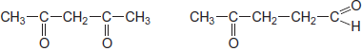
J K

........................................................................................................................
........................................................................................................................
........................................................................................................................
........................................................................................................................
........................................................................................................................
........................................................................................................................
........................................................................................................................
........................................................................................................................
(5)

(c) Draw the structure of each of the following isomers of C₅H₈O₂
Label each structure you draw with the correct letter L, M, N, P or Q.
L is methyl 2-methylpropenoate.

M is an ester that shows E-Z stereoisomerism.

N is a carboxylic acid with a branched carbon chain and does not show stereoisomerism.

P is an optically active carboxylic acid.

Q is a cyclic compound that contains a ketone group and has only two peaks in its ¹H n.m.r. spectrum.

(5)
(Total 19 marks)

8. The structures of the amino acids alanine and glycine are shown below.
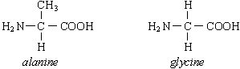
(a) Give the systematic name for alanine.
......................................................................................................................
(1)

(b) Alanine exists as a pair of stereoisomers.
(i) Explain the meaning of the term stereoisomers.
.............................................................................................................
.............................................................................................................
.............................................................................................................
(ii) State how you could distinguish between the stereoisomers.
.............................................................................................................
.............................................................................................................
.............................................................................................................
(4)
(c) Give the structural formula of the species formed by glycine at pH 14.

(1)
(d) When two amino acids react together, a dipeptide is formed. Give the structural formulae of the two dipeptides which are formed when alanine and glycine react together.
Dipeptide 1

Dipeptide 2

(2)

(e) Give the structural formula of the organic compound formed when glycine reacts with methanol in the presence of a small amount of concentrated sulphuric acid.

(1)
(Total 9 marks)

9. N.m.r. spectroscopy can be used to study the structures of organic compounds.
(a) Compound J was studied using ¹H n.m.r. spectroscopy.
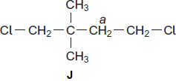
(i) Identify a solvent in which J can be dissolved before obtaining its ¹H n.m.r. spectrum.
...............................................................................................................
(1)
(ii) Give the number of peaks in the ¹H n.m.r. spectrum of J.
...............................................................................................................
(1)
(iii) Give the splitting pattern of the protons labelled a.
...............................................................................................................
(1)
(iv) Give the IUPAC name of J.
...............................................................................................................
(1)

(b) Compound K was studied using ¹³C n.m.r. spectroscopy.
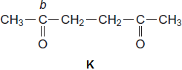
(i) Give the number of peaks in the ¹³C n.m.r. spectrum of K.
...............................................................................................................
(1)
(ii) Use Table 3 on the Data Sheet to suggest a δ value of the peak for the carbon labelled b.
...............................................................................................................
(1)
(iii) Give the IUPAC name of K.
...............................................................................................................
(1)
(Total 7 marks)

10. The N-substituted amide C₆H₁₃NO can be formed from but−2−ene in a three-step synthesis.
H₃CCHCHCH₃ 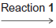 C₄H₉Br 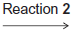 C₄H₁₁N 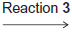 C₆H₁₃NO
For each reaction
• state a reagent
• give the structure of the product
• name the mechanism of the reaction.
Detailed mechanisms are not required.
.................................................................................................................................
.................................................................................................................................
.................................................................................................................................
.................................................................................................................................
.................................................................................................................................
.................................................................................................................................
.................................................................................................................................
.................................................................................................................................
.................................................................................................................................
(Total 9 marks)

11. (a) The infra-red spectrum of compound A, C₃H₆O₂, is shown below.
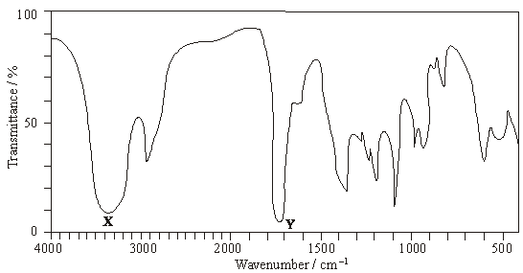
Identify the functional groups which cause the absorptions labelled X and Y.
X …………………………………………………………….
Y …………………………………………………………….
Using this information draw the structures of the three possible structural isomers for A.

Label as A the structure which represents a pair of optical isomers.
(6)

(b) Draw the structures of the three branched-chain alkenes with molecular formula C₅H₁₀

Draw the structures of the three dibromoalkanes, C₅H₁₀Br₂, formed when these three alkenes react with bromine.

One of these dibromoalkanes has only three peaks in its proton n.m.r. spectrum. Deduce the integration ratio and the splitting patterns of these three peaks.
…………………………………………………………………………………………………………….
…………………………………………………………………………………………………………….
…………………………………………………………………………………………………………….
…………………………………………………………………………………………………………….
(10)
(Total 16 marks)

12.
 | (a)
 | (b)
 | (c)
 | (d)
 | (e) | (Total 14 marks)

