A-LEVEL PAPER 2 PP3 MS

1.
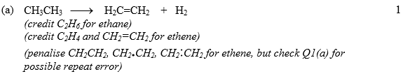
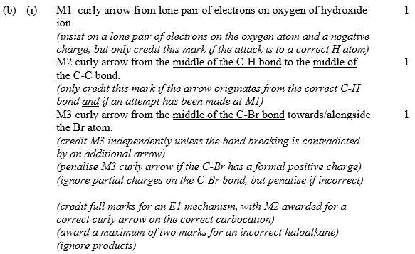
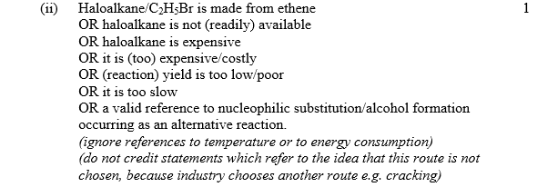 [5]

2.
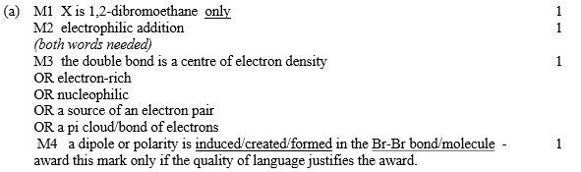
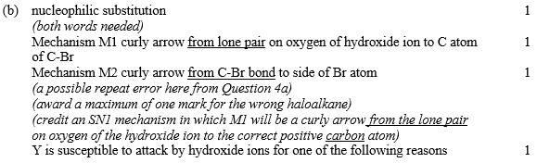 [8]

3.
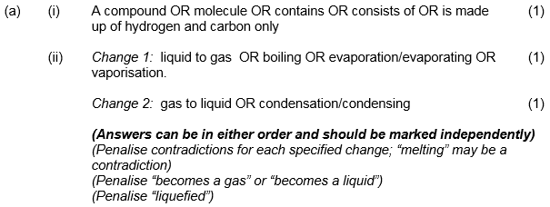
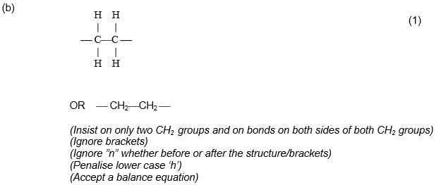[4]

4. (a) (i) 2 or two or second or [E]²
1
(ii) 1 or one or first or [F]¹ or [F]
1

(b) (i) k = 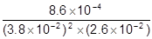
mark is for insertion of numbers into a correctly rearranged rate equ , k = etc.
AE (−1) for copying numbers wrongly or swapping two numbers.
1
= 22.9 (Allow 22.9 − 24 after correct rounding)
1
mol⁻²dm⁺⁶ s^{&8722;1}
Any order.
1
(ii) 6.8(2) × 10⁻³ (mol dm^{&8722;3}s⁻¹)
OR if their k is wrong, award the mark consequentially
a quick check can be achieved by using
their answer = 2.9768 × 10⁻⁴ Allow 2.9 − 3.1 × 10⁻⁴ for the mark
their k
Allow 6.8 × 10⁻³ to 6.9 × 10⁻³
Ignore units.
1
[6]

5. (a) Br₂ / HBr / H₂SO₄ / H⁺ / Br⁺ / NO₂⁺ (Mark M1)
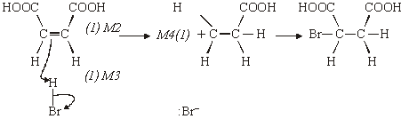

NB If electrophile H⁺ / Br⁺ / NO₂⁺ allow M1, M2 and M4
If the acid is incorrect, M2 and M3 can still be scored
Allow M4 consequentially if repeat error from part (a)
4
(b) M1 Two peaks
1
M2 No splitting or singlets
1
M3 (Two) non-equivalent protons or two proton environments
1
M4 No adjacent protons
1
M5 Same area under the two peaks or same relative intensity
1
NB Doublet could score M1 and M3 or M5 (Max 2)
More than two peaks CE = 0
Apply the “list principle” to incorrect answers if more
than 3 given
Max 3
[7]

6. (a) Hydrogen bond(ing)
Allow H bonding.
Penalise mention of any other type of bond.
1
[1]

7. (a) (i) (nucleophilic) addition-elimination
Not electrophilic addition-elimination
Ignore esterification
1
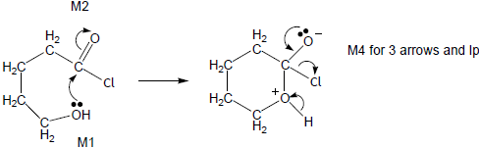
M3 for structure
• If wrong nucleophile used or O–H broken in first step, can only score M2.
• M2 not allowed independent of M1, but allow M1 for correct attack on C+
• + rather than δ+ on C=O loses M2.
• If Cl lost with C=O breaking lose M2.
• M3 for correct structure with charges but lone pair on O is part of M4.
• Only allow M4 after correct / very close M3.
• Ignore HCl shown as a product.
4
a 20-50 (ppm) or single value or range entirely within this range
If values not specified as a or b then assume first is a.
1
b 50-90 (ppm) or single value or range entirely within this range
1
(ii)
Must have trailing bonds, but ignore n.
1
OR –OCH₂CH₂CH₂CH₂CO– OR –CH₂CH₂CH₂CH₂COO–
Allow
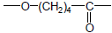
but not - C₄H₈₋
one unit only
Condensation
1

(b)

 |  | Tollens’ | Fehling’s / Benedicts | Acidified potassium dichromate

Penalise wrong formula for Tollens or missing acid with potassium dichromate but mark on.
1

 | J | No reaction / no  (visible) change /  no silver mirror | No reaction / no  (visible) change /  stays blue / no red  ppt | No reaction / no  (visible) change / stays  orange / does not turn  green

Ignore ‘clear’, ‘nothing’.
Penalise wrong starting colour for dichromate.
1

 | K | Silver mirror /  grey ppt | Red ppt  (allow brick red or  red-orange) | (orange) turns green

1
J Two (peaks)
Allow trough, peak, spike.
1
K Four (peaks)
Ignore details of splitting.
If values not specified as J or K then assume first is J.
1
(c) If all the structures are unlabelled, assume that the first drawn ester is L, the second ester is M; the first drawn acid is N, the second P. The cyclic compound should be obvious.
L
ester
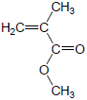
OR H₂C=C(CH₃)COOCH₃
All C₅H₈O₂ L to P must have C=C.
Allow CH₃−.
Allow -CO₂CH₃ etc.
Allow CH₂C(CH₃)COOCH₃.
1

M
ester
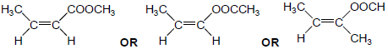
CH₃CH=CHCOOCH₃ CH₃CH=CHOOCCH₃ CH₃CH=C(CH₃)OOCH
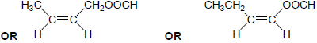
CH₃CH=CHCH₂OOCH CH₃CH₂CH=CHOOCH
Allow either E–Z isomer.
Allow CH₃− or C₂H₅₋ but not CH₂CH₃−.
Allow CH₃CHCHCOOCH₃ etc.
1
N
acid
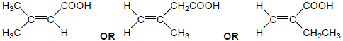
(CH₃)₂C=CHCOOH H₂C=C(CH₃)CH₂COOH H₂C=C(COOH)CH₂CH₃
Allow CH₃− or C₂H₅₋ but not CH₂CH₃−.
Allow −CO₂H.
Not cyclic isomers.
Not the optically active isomer.
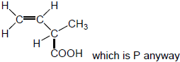
Allow (CH₃)₂CCHCOOH etc.
1
P
acid
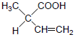
Allow −CO₂H.
CH₃CH(COOH)CH=CH₂
Allow CH₃CH(CO₂H)CHCH₂ or
CH₃CH(CO₂H)C₂H₃.
1

Q
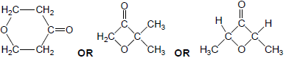
Not cyclic esters.
1
[19]
8. (a) 2-amino(e) propanoic acid (1)
1
(b) (i) molecules with same structure / structural formula (1)
but with bonds (atoms or groups) arranged differently in
space (3D) (1)
(ii) Plane polarised light (1)
Rotated (equally) in opposite directions (1)
4
(c) 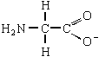 (1)
allow H₂NCH₂COO–
Penalise NH₂‑ and OH‑ once per paper
but CH₃– is allowed
1
(d) 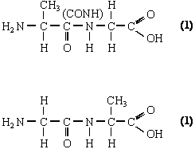
Not anhydrides; not repeating units
2

(e) 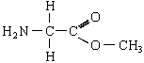 (1)
or H₂NCH₂COOCH₃
1
[9]

9. (a) (i) CDCl₃ or CD₂Cl₂ or C₆D₆ or CCl₄
Not D₂O Allow CD₃Cl
1
(ii) 4 or four
1
(iii) Triplet or 3 or three
1
(iv) 1,4-dichloro-2,2-dimethylbutane
Do not penalise different or missing punctuation or extra spaces.
Spelling must be exact and order of letters and numbers as here.
1

(b) (i) 3 or three
1
(ii) 190-220 (cm⁻¹)
Allow a single number within the range.
OR a smaller range entirely within this range.
1
(iii) hexane-2,5-dione
Do not penalise different or missing punctuation or extra spaces.
Spelling must be exact and order of letters and numbers as here.
NB so must have middle e
1
[7]

10. Step 1
HBr
In any step, if wrong reagent or extra wrong reagent, can only score mechanism mark,but if AlCl₃ added in Step 3, lose M7 but can score M8 & M9
M1
1
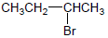
M2
1
electrophilic addition
If 1-bromobutane structure given for M2 then 1-aminobutane structure for M5, penalise M2 and M5 but mark M8 consequentially
M3
1
Step 2
NH₃
M4
1
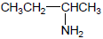
If 1-bromobutane structure given for M2 then 2-aminobutane structure for M5, penalise M2, M5 and M8
M5
1
nucleophilic substitution
If 2-bromobutane structure given for M2 then 1-aminobutane structure, penalise M5 and M8
M6
1

Step 3
CH₃COCl or (CH₃CO)₂O
Allow C₂H₅ for CH₃CH₂
M7
1
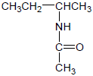
M8
1

(nucleophilic) addition-elimination
Not allow (electrophilic) addition-elimination
M9
1
[9]

11. (a) X (O–H) (alcohols)
penalise acid or missing “alcohol”
1
Y C=O
allow carbonyl
1
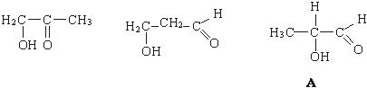
NOT acid
4

(b)
Allow conseq dibromocompounds following incorrect unbranched alkenes
NOT allow dibromocompound consequent on a duplicate alkene
NOT allow monobromocompounds if HBr added
3
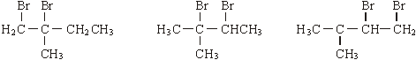
3
6:3:1 either next to correct structure or to none
1
Allow a mark for identifying correct dibromocompound with three peaks
even if integration ratio is wrong
1
if 6:3:1 missing or wrong, no marks for splitting
Only award a mark for splitting if it is clear which integration number it
refers to
6 singlet or drawn
1
3 doublet or drawn
1
1 quartet/quadruplet or drawn
1
(max 10 marks)
[16]

4.
 | (d)
 | (e) | [14]

