A-LEVEL CHEMISTRY

PAPER 2
PRACTICE PAPER 4

Answer all questions
Max 105 marks
2 hours

Name ……………………………………………………………..

Mark ……../105 ……....% Grade ………

1. | 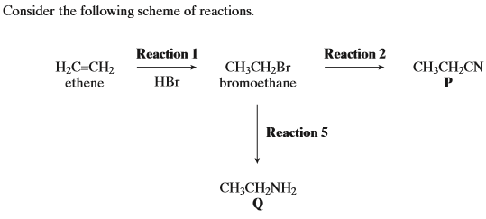
 | 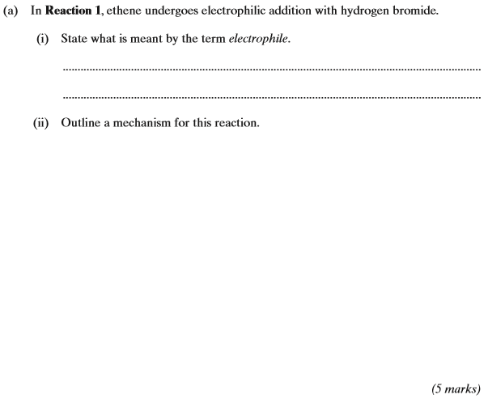
 | (b) | 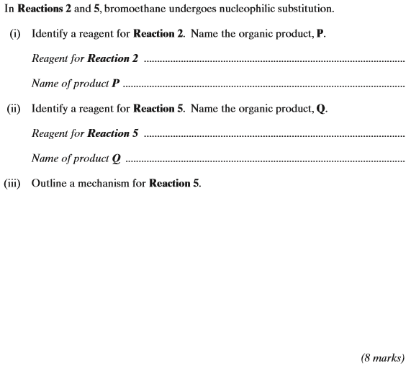  (Total 13 marks)
2. | 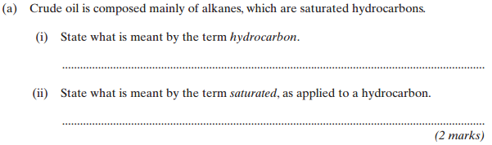
 | (b) | (3)  (Total 5 marks)
3. | 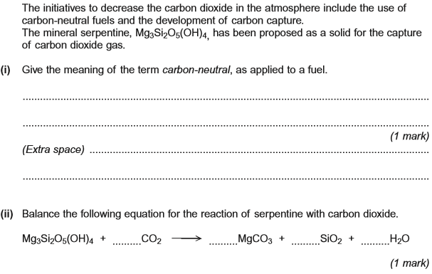  (Total 2 marks)
4. The initial rate of the reaction between two gases P and Q was measured in a series of experiments at a constant temperature. The following rate equation was determined.
rate = k[P]²[Q]
(a) Complete the table of data below for the reaction between P and Q.

Experiment | Initial [P] /mol dm^{–3} | Initial [Q] /mol dm^{–3} | Initial rate /mol dm^{–3} s^{–1}
1 | 0.20 | 0.30 | 1.8 = 10^{–3}
2 | 0.40 | 0.60
3 | 0.60 |  | 5.4 = 10^{–3}
4 |  | 0.90 | 12.2 = 10^{–3}
(Space for working) .......................................................................................
........................................................................................................................
........................................................................................................................
........................................................................................................................
........................................................................................................................
(3)

(b) Use the data from Experiment 1 to calculate a value for the rate constant k and deduce its units.
Calculation .....................................................................................................
........................................................................................................................
........................................................................................................................
........................................................................................................................
........................................................................................................................
Units ...............................................................................................................
........................................................................................................................
(3)
(c) Consider the graphs E, F, G and H below.
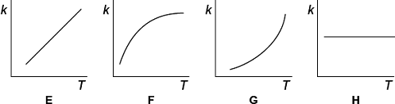
Write in the box below the letter of the graph that shows how the rate constant k varies with temperature.
(1)
(Total 7 marks)

5. Consider the reaction sequence shown below.
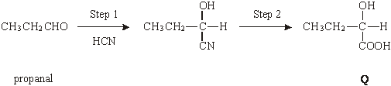
(a) Name and outline a mechanism for the reaction in Step 1.
Name of mechanism ....................................................................................
Mechanism

(5)

(b) (i) Name compound Q formed in Step 2.
.............................................................................................................
(ii) Two stereoisomers are formed by the dehydration of Q. Give the structures of these two isomers and name the type of stereoisomerism shown.
Structures of isomers

Type of stereoisomerism ..............................................................................
(4)

(c) An isomer of Q which has the structure shown below is polymerised to form the biodegradeable polymer known as PHB.
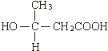
(i) Draw the repeating unit of the polymer PHB.

(ii) Suggest a reason why the polymer is biodegradeable.
.............................................................................................................
.............................................................................................................
(2)
(d) The amino acid R is shown below.
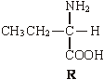
(i) Draw the structure of the zwitterion formed by R.

(ii) Draw the structure of the major organic product formed when an excess of R is reacted with bromomethane.

(iii) Name the mechanism of the reaction which results in the formation of the product given in part (ii).
.............................................................................................................
(3)
(Total 14 marks)

6. The compound (CH₃CH₂)₂NH can be made from ethene in a three-step synthesis as shown below.
(a) Name the compound (CH₃CH₂)₂NH
......................................................................................................................
(1)
(b) Identify compounds F and G.
Compound F ...............................................................................................
Compound G ...............................................................................................
(2)
(c) For the reactions in Steps 1, 2 and 3,
• give a reagent or reagents
• name the mechanism.
Balanced equations and mechanisms using curly arrows are not required.
......................................................................................................................
......................................................................................................................
......................................................................................................................
......................................................................................................................
......................................................................................................................
......................................................................................................................
......................................................................................................................
......................................................................................................................
(6)
(d) Identify one organic impurity in the product of Step 3 and give a reason for its formation.
......................................................................................................................
......................................................................................................................
......................................................................................................................
(2)
(Total 11 marks)

7. A possible synthesis of 1,4-diaminobenzene is shown below.
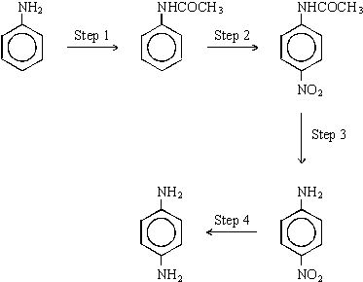
- Identify a suitable reagent or combination of reagents for Step 1. Name and outline a mechanism for the reaction.
.....................................................................................................................................................
.....................................................................................................................................................

(6)
(b) Identify a suitable reagent or combination of reagents for Step 2. Name and outline a mechanism for the reaction.
.....................................................................................................................................................
.....................................................................................................................................................

(6)
(c) Identify a suitable reagent or combination of reagents for Step 4. Draw the repeating unit of the polymer formed by reaction of 1,4-diaminobenzene with pentanedioic acid.
.....................................................................................................................................................
.....................................................................................................................................................

(3)
(Total 15 marks)

8. Describe how propanal, CH₃CH₂CHO, and propanone, CH₃COCH₃, can be distinguished using
(i) a chemical test and
(ii) the number of peaks in their proton n.m.r. spectra.
……………………………………………………………………………………………………………
……………………………………………………………………………………………………………
……………………………………………………………………………………………………………
……………………………………………………………………………………………………………
……………………………………………………………………………………………………………
……………………………………………………………………………………………………………
(Total 5 marks)

9. (a) Ester X, CH₃CH₂COOCH₃, can be produced by the reaction between propanoyl chloride and methanol. Name X and outline a mechanism for this reaction. Name the mechanism involved.
…………………………………………………………………………………………………………….
…………………………………………………………………………………………………………….
…………………………………………………………………………………………………………….

(6)

(b) The proton n.m.r. spectrum of X is shown below together with that of an isomeric ester, Y. Deduce which of Spectrum 1 and Spectrum 2 is that obtained from X. Use Table 1 on the Data Sheet and the integration data on the spectra to help you to explain your deduction. Suggest a structure for Y.
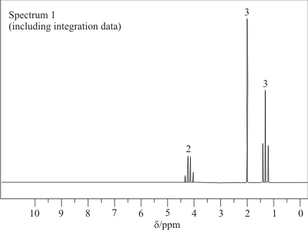
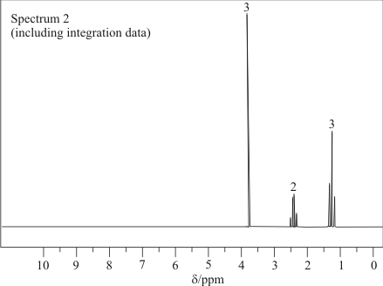
……………………………………………………………………………………………………………….
……………………………………………………………………………………………………………….
……………………………………………………………………………………………………………….
……………………………………………………………………………………………………………….
……………………………………………………………………………………………………………….
(4)
(Total 10 marks)
10. Lysine and alanine are two amino acids.

 | 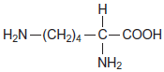  lysine | 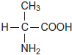  alanine

A dipeptide formed from one molecule of lysine and one molecule of alanine is hydrolysed in acid conditions and the mixture produced is analysed by column chromatography. The column is packed with a resin which acts as a polar stationary phase.
Suggest why lysine leaves the column after alanine.
........................................................................................................................
........................................................................................................................
........................................................................................................................
........................................................................................................................
(2)
(Total 2 marks)

11. Organic chemists use a variety of methods to distinguish between compounds. These methods include analytical and spectroscopic techniques.
Compounds J and K can also be distinguished using spectroscopic techniques such as ¹H n.m.r.
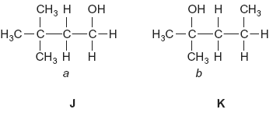
(i) Name compound J.
Give the total number of peaks in the ¹H n.m.r. spectrum of J.
State the splitting pattern, if any, of the peak for the protons labelled a.
.............................................................................................................
.............................................................................................................
.............................................................................................................
.............................................................................................................
.............................................................................................................
.............................................................................................................
(3)
(ii) Name compound K.
Give the total number of peaks in the ¹H n.m.r. spectrum of K.
State the splitting pattern, if any, of the peak for the protons labelled b.
.............................................................................................................
.............................................................................................................
.............................................................................................................
.............................................................................................................
.............................................................................................................
.............................................................................................................
(3)
(Total 6 marks)

12. It is necessary to use several analytical techniques to determine the structure of an unknown compound.
An analytical chemist was asked to determine the structure of compound Q which was found in a waste tank in a mixture of volatile liquids.
Compound Q has the molecular formula C₄H₇ClO. It is a volatile liquid which does not produce misty fumes when added to water.
(a) Suggest how the chemist could obtain a sample of Q for analysis from the mixture of volatile liquids.
......................................................................................................................
(1)
(b) The infra-red spectrum of Q contains a major absorption at 1724 cm^{–1}. Identify the bond which causes this absorption.
......................................................................................................................
(1)
(c) The proton n.m.r. spectrum of Q was recorded.
(i) Suggest a suitable solvent for use in recording this spectrum of Q.
.............................................................................................................
(ii) Give the formula of the standard reference compound used in recording proton
n.m.r. spectra.
.............................................................................................................
(2)
(d) The proton n.m.r. spectrum of Q shows 3 peaks. Complete the table below to show the number of adjacent, non-equivalent protons responsible for the splitting patterns.

 | Peak 1 | Peak 2 | Peak 3
Integration value | 3 | 3 | 1
Splitting pattern | doublet | singlet | quartet
Number of adjacent,  non-equivalent protons | 1

(1)
(e) Using the information in parts (b) and (d) deduce the structure of compound Q.

(1)
(f) A structural isomer of Q reacts with cold water to produce misty fumes. Suggest a structure for this isomer.

(1)
(Total 7 marks)

13.
 | (a) | (i) | ……………………………………………………………………………………………………………………………………………………………
 |  | (ii) | ……………………………………………………………………………………………………………………………………………………………  ……………………………………………………………………………………………………………………………………………………………
 |  | (iii) | ……………………………………………………………………………………………………………………………………………………………  ……………………………………………………………………………………………………………………………………………………………  ……………………………………………………………………………………………………………………………………………………………
 |  | (iv) | ……………………………………………………………………………………………………………………………………………………………  ……………………………………………………………………………………………………………………………………………………………  ……………………………………………………………………………………………………………………………………………………………

 | (b) | ……………………………………………………………………………………………………………………………………………………………  ……………………………………………………………………………………………………………………………………………………………  ……………………………………………………………………………………………………………………………………………………………  ……………………………………………………………………………………………………………………………………………………………  ……………………………………………………………………………………………………………………………………………………………  ……………………………………………………………………………………………………………………………………………………………  ……………………………………………………………………………………………………………………………………………………………  ……………………………………………………………………………………………………………………………………………………………  ……………………………………………………………………………………………………………………………………………………………  ……………………………………………………………………………………………………………………………………………………………
 | (c) | ……………………………………………………………………………………………………………………………………………………………  ……………………………………………………………………………………………………………………………………………………………  ……………………………………………………………………………………………………………………………………………………………  ……………………………………………………………………………………………………………………………………………………………
 | (d) | ……………………………………………………………………………………………………………………………………………………………  ……………………………………………………………………………………………………………………………………………………………  ……………………………………………………………………………………………………………………………………………………………  ……………………………………………………………………………………………………………………………………………………………  ……………………………………………………………………………………………………………………………………………………………  ……………………………………………………………………………………………………………………………………………………………  (Total 8 marks)

