A-LEVEL PAPER 2 PP4 MS
1. | 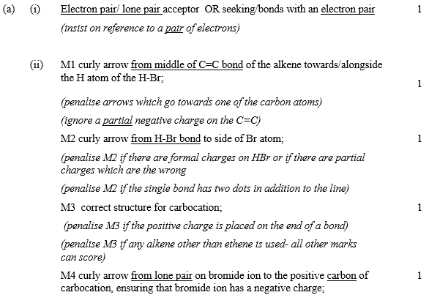
 | [13]
2.

 | (b) | [5]
3. | [2]
4. (a) Exp 2 14.(4) ×10^{–3} OR 1.4(4) ×10^{–2} or 0.014
Allow 2sf
1
Exp 3 0.1(0)
1
Exp 4 0.3(0)
If three wrong answers, check their value of k in 1(b).
They can score all 3 if they have used their (incorrect) value of k. see below.
Exp 2 rate = 0.096 × k
Exp 3 [Q] = 0.015/k
Exp 4 [P] = 0.116/√k
1
(b) 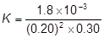
mark is for insertion of numbers into a correctly rearranged rate equ , k = etc
1
= 0.15 (min 2sfs) (allow )
if upside down, score only units mark
AE (–1) for copying numbers wrongly or swapping two numbers
1
mol^{–2} dm⁺⁶ s^{–1}
Any order
If k calculation wrong, allow units conseq to their k
1
(c) G
1
[7]

5. (a) necleophilic addition;
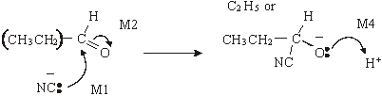
1
M3 structure;
(be lenient on position of charge on CN– )
(M2 not allowed independent of M1,
but allow M1 for correct attack on C+
if M2 show as independent first.)
(+on C of C=O loses M2 but ignore δ+ if correct)
(M4 for arrow and lone pair (only allow for correct M3 or close))
4
(b) (i) 2-hydroxybutanoic acid
1
(ii)
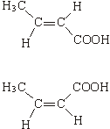

1
geometric(al) or cis-trans
1
(c) (i)
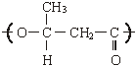
(one unit only) (ignore brackets or n) (trailing bonds are needed)
1
(ii) can be hydrolysed
OR
can be reacted with/attacked by acid/base/nucleophiles/H₂O/OH–;
1

(d) (i)
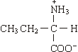
(allow –NH₃⁺)
1
(ii)
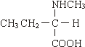
(or zwitterions product)
1
(iii) nucleophilic substitution;
1
[14]

6. (a) diethylamine OR ethyl ethanamine OR ethyl aminoethane
ignore N–
1
(b) For (b) and (c)
There are three valid routes for this synthesis called
Routes A, B and C below
• Decide which route fits the answer best (this may not be the
best for part b) to give the candidate the best possible overall mark.
• Mark part (b)
• For this best route mark the mechanism and reagent independently
• Migration from one route to another is not allowed
• Either name or formula is allowed in every case.
• Ignore conditions unless they are incorrect.

 | Route A | Route B | Route C
F | CH₃CH₂Br or CH₃CH₂Cl | C₂H₆ | CH₃CH₂OH | 1
G | CH₃CH₂NH₂ ethylamine OR ethanamine OR aminoethane | CH₃CH₂Br OR  CH₃CH₂Cl | CH₃CH₂Br OR  CH₃CH₂Cl | 1

(c)
 |  | Route A | Route B | Route C
Step 1 | Reagent(s) | HBr OR HCl | H₂/Ni (Not NaBH₄) | H₂O & H₃PO₄ OR  H₂O & H₂SO₄ | 1
 | Mechanism | Electrophilic addition | addition (allow electrophilic OR catalytic but not nucleophilic) ignore hydrogenation | Electrophilic addition | 1

Step 2 | Reagent(s) | NH₃ | Cl₂ OR Br₂ | HBr OR KBr & H₂SO₄ OR PCl₃ OR PCl₅ OR SOCl₂ | 1
 | Mechanism | Nucleophilic substitution | (free) radical substitution | Nucleophilic substitution | 1

Step 3 | Reagent(s) | CH₃CH₂Br OR CH₃CH₂Cl | CH₃CH₂NH₂ OR NH₃ but penalise excess ammonia here | CH₃CH₂NH₂  OR NH₃ but penalise excess ammonia here | 1
 | Mechanism | Nucleophilic substitution | Nucleophilic substitution | Nucleophilic substitution | 1

(d) tertiary amine OR triethylamine OR (CH₃CH₂)₃N
Quaternary ammonium salt
OR tetraethylammonium bromide OR chloride OR ion
OR (CH₃CH₂)₄N⁺ (Br– OR Cl–)
1
further substitution will take place OR
diethylamine is a better nucleophile than ethylamine
1
[11]

7. (a) CH₃COCl or (CH₃CO)₂O (1)
AlCl₃ or H₂O or CH₂SO₄ loses this mark
CH₃COOH loses reagent and M3, M4 = max 3
nucleophilic addition–elimination (1)
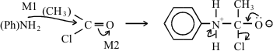
M3: structure
M4: 3 correct arrows
Allow M1 for attack on CH3‑C⁺=O
Penalise Cl– removing H⁺
6

(b) Conc HNO₃ (1)
Conc H₂SO₄ (1)
HNO₃ + 2 H₂SO₄ → NO₂⁺ + H₃O⁺ + 2 HSO₄– (2)
(or H₂SO₄ ) (or H₂O + HSO₄–)
HNO₃ / H₂SO₄ scores 1
Any 2
electrophilic substitution (1)
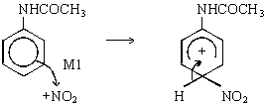
M2 structure
M3 arrow
6
(c) Sn (or Fe) / HCl or Ni / H₂ (1)
NOT LiAlH₄ NaBH₄
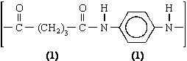
3
[15]

8. (i)

Reagent | Tollens | Fehlings or Benedicts | K₂Cr₂O₇/H⁺  or acidified | KMnO₄/H⁺ | I₂/NaOH
Propanal | silver (mirror) | red ppt or goes red  (not red solution) | goes green | goes colourless | No  reaction
Propanone | no reaction | no reaction | no reaction | no reaction | Yellow  (ppt)

(penalise incomplete reagent e.g. K₂Cr₂O₇ or Cr₂O₇^{2–}/H⁺ then mark on)
3
(ii) propanal 3 peaks
ignore splitting even if wrong
1
propanone 1 peak
1
[5]

9. X is methyl propanoate
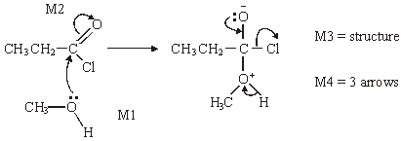
1
M1 for arrow and lone pair,
4
M2 for arrow
addition-elimination
1
Spectrum 2
if thinks Spectrum 1 = X can only score for structure of Y
1
Y is CH₃COOCH₂CH₃
1
The two marks for explanation are awarded for discussing one or more of the
four peaks (not those for the CH₃ of the ethyl groups)
for stated δ values the integration or the splitting should be related to the
structure: e.g. structure of X shows that
at δ 3.7 – 4.1 (1) spectrum of X should have integration 3 / singlet (1)
or
at δ 2.1 – 2.6 (1) spectrum of X should have integration 2 / quartet (1)
Spectrum 2 has these
[OR Spectrum 1 has
at 3.7 – 4.1 (1) quartet / integration 2 (1) so not X
at 2.1 – 2.6 (1) singlet / integration 3 (1) so not X]
2
[10]

10. M1 In acid lysine has double positive or more positive charge
1
M2 (Lysine ion) has greater affinity / greater attraction / adheres better / sticks better to polar / stationary phase
M2 only scores after a correct M1.
Ignore greater retention time.
1
[2]
11. (i) 3,3-dimethylbutan-1-ol
Allow 3,3-dimethyl-1-butanol
1
4
1
Triplet on three
1
(ii) 2-methylpentan-2-ol
Allow 2-methyl-2-pentanol
1
5
1
Singlet or one or no splitting
1
[6]

12. (a) GLC or distillation
1
(b) C=O
1
(c) (i) e.g. CDCl₃ or CCl₄
1
(ii) Si(CH₃)₄
1
(d) 0 and 3
1
(e)
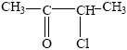
1
(f) CH₃CH₂CH₂COCl or (CH₃)₂CHCOCl
1
[7]

13. | (a)
 | (b)
 | (c)
 | (d)
 | [8]

