A-LEVEL CHEMISTRY

PAPER 2
PRACTICE PAPER 5

Answer all questions
Max 105 marks
2 hours

Name ……………………………………………………………..

Mark ……../105 ……....% Grade ………

1. | ……………………………………………………………………………………………………………………………………………………………………………..  ……………………………………………………………………………………………………………………………………………………………………………..  ……………………………………………………………………………………………………………………………………………………………………………..  ……………………………………………………………………………………………………………………………………………………………………………..  ……………………………………………………………………………………………………………………………………………………………………………..  ……………………………………………………………………………………………………………………………………………………………………………..  ……………………………………………………………………………………………………………………………………………………………………………..  ……………………………………………………………………………………………………………………………………………………………………………..  ……………………………………………………………………………………………………………………………………………………………………………..  ……………………………………………………………………………………………………………………………………………………………………………..  ……………………………………………………………………………………………………………………………………………………………………………..  ……………………………………………………………………………………………………………………………………………………………………………..  ……………………………………………………………………………………………………………………………………………………………………………..  (Total 7 marks)

2. | 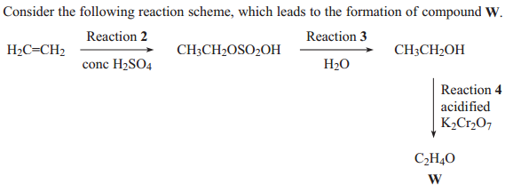
 | (a)
 | (b) | (Total 8 marks)
3. | 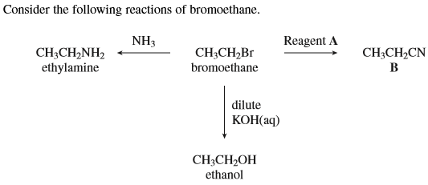
 | 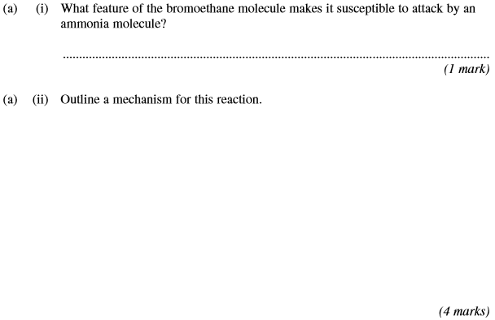
 | 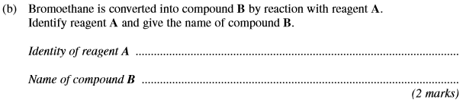
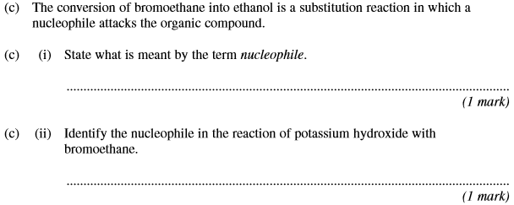
(Total 9 marks)

4. (a) In the presence of the catalyst rhodium, the reaction between NO and H₂ occurs according to the following equation.
2NO(g) + 2H₂(g) N₂(g) + 2H₂O(g)
The kinetics of the reaction were investigated and the rate equation was found to be
rate = k[NO]²[H₂]
The initial rate of reaction was 6.2 × 10^{–6} mol dm^{–3} s^{–1} when the initial concentration of NO was 2.9 × 10^{–2} mol dm^{–3} and the initial concentration of H₂ was 2.3× 10^{–2} mol dm^{–3}.
(i) Calculate the value of the rate constant under these conditions and give its units.
Calculation ..........................................................................................
.............................................................................................................
.............................................................................................................
.............................................................................................................
Units ....................................................................................................
.............................................................................................................
(3)
(ii) Calculate the initial rate of reaction if the experiment is repeated under the same conditions but with the concentrations of NO and of H₂ both doubled from their original values.
.............................................................................................................
.............................................................................................................
(1)

(b) Using the rate equation and the overall equation, the following three-step mechanism for the reaction was suggested. X and Y are intermediate species.
Step 1 NO + NO X
Step 2 X + H₂ Y
Step 3 Y + H₂ N₂ + 2H₂O
Suggest which one of the three steps is the rate-determining step.
Explain your answer.
Rate-determining step..................................................................................
Explanation ..................................................................................................
......................................................................................................................
......................................................................................................................
(2)
(Total 6 marks)

5. Acyl chlorides such as CH₃COCl are useful compounds in synthesis.
(a) The acyl chloride CH₃COCl reacts with benzene.
(i) Write an equation for this reaction and name the organic product.
Identify a catalyst for the reaction.
Write an equation to show how this catalyst reacts with CH₃COCl to produce a reactive intermediate.
...............................................................................................................
...............................................................................................................
...............................................................................................................
...............................................................................................................
(4)
(ii) Name and outline a mechanism for the reaction of benzene with the reactive intermediate in part (a)(i).
Name of mechanism .........................................................................................................
Mechanism

(4)
(b) Nucleophiles such as alcohols can react with CH₃COCl
The ion CH₃COO⁻ can act as a nucleophile in a similar way.
State the meaning of the term nucleophile.
Draw the structure of the organic product formed by the reaction of CH₃COO⁻ with CH₃COCl
Name the functional group produced in this reaction.
........................................................................................................................
........................................................................................................................
........................................................................................................................
........................................................................................................................
........................................................................................................................
........................................................................................................................
........................................................................................................................
........................................................................................................................
........................................................................................................................
(3)
(Total 11 marks)
6. A possible synthesis of the amino acid X is shown below.
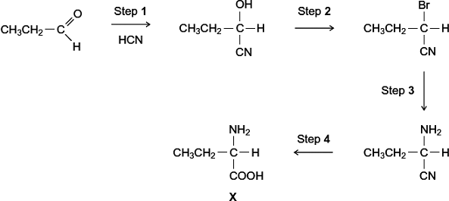
(a) Name and outline a mechanism for Step 1.
Name of mechanism .....................................................................................
Mechanism

(5)
(b) Give the IUPAC name of the product of Step 2.
........................................................................................................................
(1)
(c) For Step 3, give the reagent, give a necessary condition and name the mechanism.
Reagent .........................................................................................................
Condition ........................................................................................................
Name of mechanism .....................................................................................
(3)
(d) At room temperature, the amino acid X exists as a solid.
(i) Draw the structure of the species present in the solid amino acid.

(1)
(ii) With reference to your answer to part (d)(i), explain why the melting point of the amino acid X is higher than the melting point of CH₃CH₂CH(OH)COOH.
...............................................................................................................
...............................................................................................................
...............................................................................................................
...............................................................................................................
...............................................................................................................
(2)

(e) There are many structural isomers of X, CH₃CH₂CH(NH₂)COOH.
(i) Draw a structural isomer of X that is an ethyl ester.

(1)
(ii) Draw a structural isomer of X that is an amide and also a tertiary alcohol.

(1)
(iii) Draw a structural isomer of X that has an unbranched carbon chain and can be polymerised to form a polyamide.

(1)
(f) Draw the structure of the tertiary amine formed when X reacts with bromomethane.

(1)
(Total 16 marks)

7. Fibres are made from natural and from synthetic polymers. Both types of polymer have advantages and disadvantages.
(a) Amino acids are the building blocks of naturally-occurring polymers called proteins.
Consider the following amino acid.
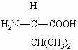
(i) Draw the structure of the amino acid species present in a solution at pH 12.

(ii) Use your understanding of amino acid chemistry to deduce the structure of the dipeptide formed from two molecules of this amino acid and illustrate your answer with a sketch showing the structure of the dipeptide.

(iii) Protein chains are often arranged in the shape of a helix. Name the type of interaction that is responsible for holding the protein chain in this shape.
.............................................................................................................
(3)
(b) Alkenes are the building blocks of synthetic addition polymers.
Consider the hydrocarbon G, (CH₃)₂C=CHCH₃, which can be polymerised.
(i) Draw the repeating unit of the polymer.

(ii) Draw the structure of an isomer of G which shows E-Z isomerism.

(iii) Draw the structure of an isomer of G which does not react with bromine water.

(3)
(c) Draw the repeating unit of the polymer formed by the reaction between butanedioic acid and hexane-1,6-diamine.

(2)
(d) Two plastic objects were manufactured, one from the polyalkene represented by the repeating unit in part (b)(i) and the other from the polyamide represented by the repeating unit in part (c).
After use it was suggested that both objects be disposed of as landfill.
(i) Describe an experiment in which you could compare the biodegradability of these two objects.
.............................................................................................................
.............................................................................................................
.............................................................................................................
.............................................................................................................
.............................................................................................................
.............................................................................................................
.............................................................................................................
(3)
(ii) Describe an advantage or a disadvantage of a different method of disposal of such objects compared with landfill.
.............................................................................................................
.............................................................................................................
.............................................................................................................
.............................................................................................................
.............................................................................................................
.............................................................................................................
(3)
(Total 14 marks)

8. Atenolol is an example of the type of medicine called a beta blocker. These medicines are used to lower blood pressure by slowing the heart rate. The structure of atenolol is shown below.
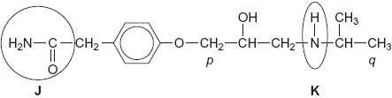
(a) Give the name of each of the circled functional groups labelled J and K on the structure of atenolol shown above.
Functional group labelled J .........................................................................
Functional group labelled K .........................................................................
(2)
(b) The ¹H n.m.r. spectrum of atenolol was recorded.
One of the peaks in the ¹H n.m.r. spectrum is produced by the CH₂ group labelled p in the structure of atenolol.
Use Table 2 on the Data Sheet to suggest a range of δ values for this peak.
Name the splitting pattern of this peak.
Range of δ values .......................................................................................
Name of splitting pattern ……......................................................................
(2)
(c) N.m.r. spectra are recorded using samples in solution.
The ¹H n.m.r. spectrum was recorded using a solution of atenolol in CDCl₃
(i) Suggest why CDCl₃ and not CHCl₃ was used as the solvent.
.............................................................................................................
.............................................................................................................
(1)
(ii) Suggest why CDCl₃ is a more effective solvent than CCl₄ for polar molecules such as atenolol.
.............................................................................................................
.............................................................................................................
(1)
(d) The ¹³C n.m.r. spectrum of atenolol was also recorded.
Use the structure of atenolol given to deduce the total number of peaks in the
¹³C n.m.r. spectrum of atenolol.
......................................................................................................................
(1)

(e) Part of the ¹³C n.m.r. spectrum of atenolol is shown below. Use this spectrum and Table 3 on the Data Sheet, where appropriate, to answer the questions which follow.
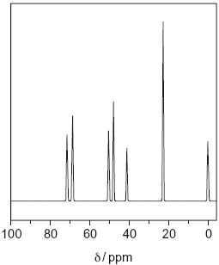
(i) Give the formula of the compound that is used as a standard and produces the peak at δ = 0 ppm in the spectrum.
.............................................................................................................
(1)
(ii) One of the peaks in the ¹³C n.m.r. spectrum above is produced by the CH₃ group labelled q in the structure of atenolol.
Identify this peak in the spectrum by stating its δ value.
.............................................................................................................
(1)
(iii) There are three CH₂ groups in the structure of atenolol. One of these CH₂ groups produces the peak at δ = 71 in the ¹³C n.m.r. spectrum above.
Draw a circle around this CH₂ group in the structure of atenolol shown below.
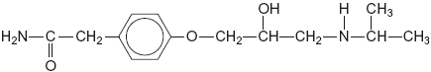
(1)

(f) Atenolol is produced industrially as a racemate (an equimolar mixture of two enantiomers) by reduction of a ketone. Both enantiomers are able to lower blood pressure. However, recent research has shown that one enantiomer is preferred in medicines.
(i) Suggest a reducing agent that could reduce a ketone to form atenolol.
.............................................................................................................
(1)
(ii) Draw a circle around the asymmetric carbon atom in the structure of atenolol shown below.
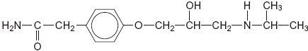
(1)
(iii) Suggest how you could show that the atenolol produced by reduction of a ketone was a racemate and not a single enantiomer.
.............................................................................................................
.............................................................................................................
.............................................................................................................
.............................................................................................................
(2)
(iv) Suggest one advantage and one disadvantage of using a racemate rather than a single enantiomer in medicines.
Advantage ...........................................................................................
.............................................................................................................
Disadvantage ......................................................................................
.............................................................................................................
(2)
(Total 16 marks)

9. The conversion of compound A into compound B can be achieved in two steps as shown below.
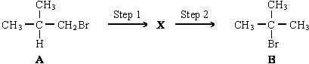
Show how the number of peaks in their proton n.m.r. spectra would enable you to distinguish between compounds A and B.
…………………………………………………………………………………………………………………
…………………………………………………………………………………………………………………
…………………………………………………………………………………………………………………
…………………………………………………………………………………………………………………
(2)
(Total 2 marks)

10. When the molecular formula of a compound is known, spectroscopic and other analytical techniques can be used to distinguish between possible structural isomers.
Draw one possible structure for each of the compounds described in parts (a) to (d).
(a) Compounds F and G have the molecular formula C₆H₄N₂O₄ and both are dinitrobenzenes.
F has two peaks in its ¹³C n.m.r. spectrum.
G has three peaks in its ¹³C n.m.r. spectrum.
F G

(2)
(b) Compounds H and J have the molecular formula C₆H₁₂.
Both have only one peak in their ¹H n.m.r. spectra.
H reacts with aqueous bromine but J does not.
H J

(2)

(c) K and L are cyclic compounds with the molecular formula C₆H₁₀O.
Both have four peaks in their ¹³C n.m.r. spectra.
K is a ketone and L is an aldehyde.
K L

(2)
(d) Compounds M and N have the molecular formula C₆H₁₅N.
M is a tertiary amine with only two peaks in its ¹H n.m.r. spectrum.
N is a secondary amine with only three peaks in its ¹H n.m.r. spectrum.
M N

(2)
(Total 8 marks)

11.
 | (a) | ……………………………………………………………………………………………………………………………………………………………………  ……………………………………………………………………………………………………………………………………………………………………  ……………………………………………………………………………………………………………………………………………………………………
 | (b) | ……………………………………………………………………………………………………………………………………………………………………  ……………………………………………………………………………………………………………………………………………………………………  ……………………………………………………………………………………………………………………………………………………………………  ……………………………………………………………………………………………………………………………………………………………………
 | (c)
 | (d) | ……………………………………………………………………………………………………………………………………………………………………  ……………………………………………………………………………………………………………………………………………………………………  ……………………………………………………………………………………………………………………………………………………………………  ……………………………………………………………………………………………………………………………………………………………………  ……………………………………………………………………………………………………………………………………………………………………  ……………………………………………………………………………………………………………………………………………………………………  ……………………………………………………………………………………………………………………………………………………………………  ……………………………………………………………………………………………………………………………………………………………………  ……………………………………………………………………………………………………………………………………………………………………  ……………………………………………………………………………………………………………………………………………………………………  ……………………………………………………………………………………………………………………………………………………………………  ……………………………………………………………………………………………………………………………………………………………………
 | (e) | ……………………………………………………………………………………………………………………………………………………………………  ……………………………………………………………………………………………………………………………………………………………………  ……………………………………………………………………………………………………………………………………………………………………  ……………………………………………………………………………………………………………………………………………………………………  ……………………………………………………………………………………………………………………………………………………………………  ……………………………………………………………………………………………………………………………………………………………………  ……………………………………………………………………………………………………………………………………………………………………
 | (f) | ……………………………………………………………………………………………………………………………………………………………………  ……………………………………………………………………………………………………………………………………………………………………  ……………………………………………………………………………………………………………………………………………………………………  (Total 8 marks)

