A-LEVEL PAPER 2 PP5 MS

1.
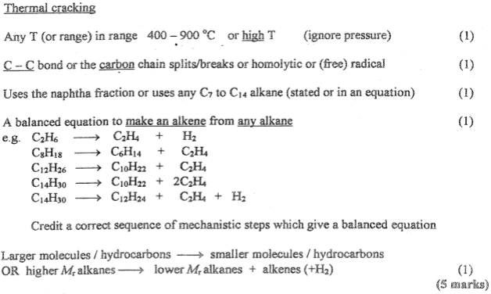
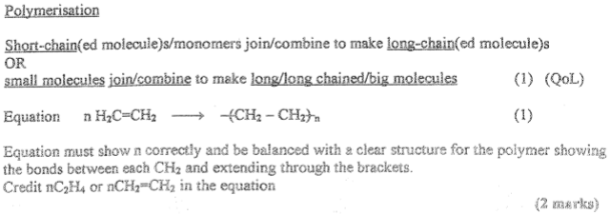
[7]

2.
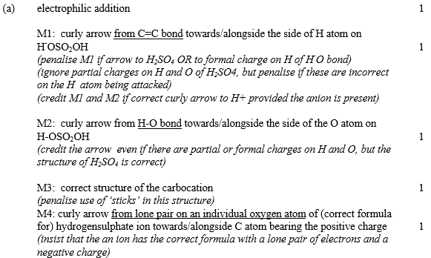
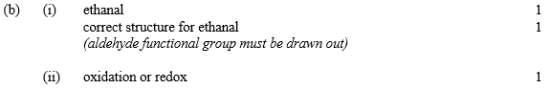
[8]

3.
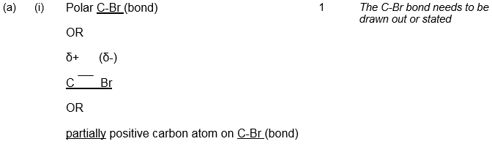
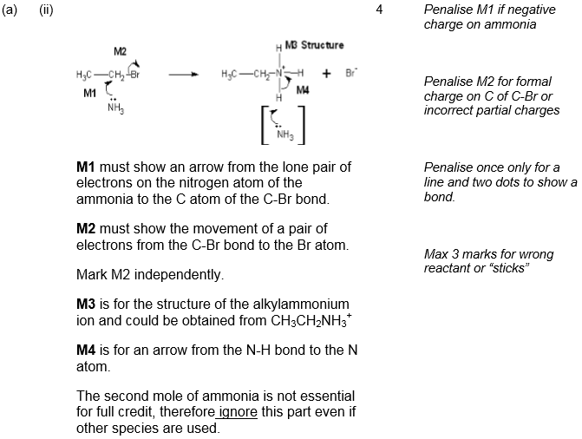
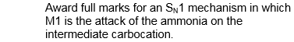
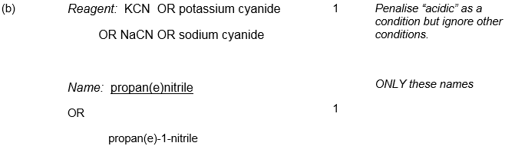
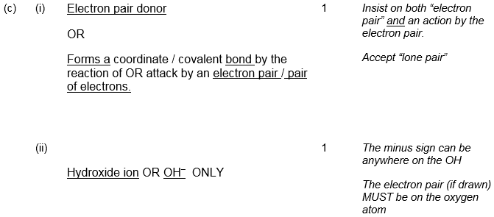
[9]
4. (a) (i) 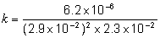
mark is for insertion of numbers into a correctly
rearranged rate equ, k = etc
AE (-1) for copying numbers wrongly or swapping two numbers
1
= 0.32 (min 2sfs)
1
mol^{–2} dm6 s^{–1} Units must be conseq to their k
Any order
If k calculation wrong, allow units conseq to their k
1
(ii) 4.95 × 10^{–5} to 4.97 × 10^{–5} or 5.0 × 10^{–5} (min 2 sfs)
(ignore units)
rate = their k × 1.547 × 10^{–4}
1
(b) Step 2
If wrong no further mark
1
One H₂ (and two NO) (appear in rate equation)
or species (in step 2) in ratio/proportion as in the rate equation
1
[6]

5. (a) (i) CH₃COCl + C₆H₆ → C₆H₅COCH₃ + HCl
Not molecular formulae Not allow C₆H₅CH₃CO
1
OR
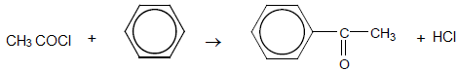
phenylethanone
Ignore number 1 in name but penalise other numbers
1
AlCl₃ can be scored in equation
1
Allow RHS as 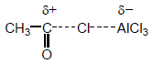

Allow + on C or O in equation but + must be on C in mechanism below
Ignore curly arrows in balanced equation even if wrong
1
(ii) Electrophilic substitution
1
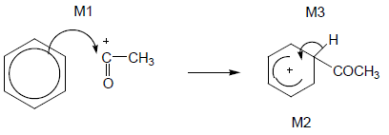
OR
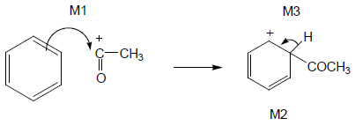
• M1 arrow from within hexagon
to C or to + on C
• + must be on C of CH₃CO in mechanism
• + in intermediate not too close to C1
• Gap in horseshoe must be centred approximately around C1
• M3 arrow into hexagon unless Kekulé
• Allow M3 arrow independent of M2 structure,
• ie + on H in intermediate loses M2 not M3
• Ignore base removing H for M3
3

(b) Electron pair donor or lone pair donor
Allow donator
Allow lone pair used in description of (dative) bond formation
1
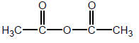
Allow (CH₃CO)₂O
1
(acid) anhydride
Allow ethanoic anhydride but not any other anhydride
1
[11]

6. (a)
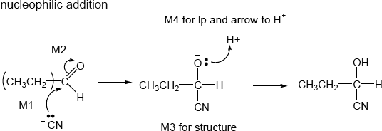
• allow :CN–
• M2 not allowed independent of M1, but
• allow M1 for correct attack on C+
• + rather than δ+ on C=O loses M2
• M3 is for correct structure including minus sign but lone pair is part of M4
• Allow C₂H₅
• M1 and M4 for lp and curly arrow
1
4
(b) 2-bromobutanenitrile
Allow 2-bromobutane-1-nitrile
1
(c) M1 ammonia or NH₃
Ignore temp or pressure
1
M2 excess (ammonia) excess tied to NH₃ and may score in M1 unless
contradicted
Ignore concentrated or sealed container, Acid loses conditions mark
1
M3 nucleophilic substitution
Allow close spelling
1
(d) (i)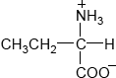
Allow C₂H₅
Allow –CO₂–
Allow ⁺NH₃–
Don’t penalize position of + on NH₃
1
(ii) M1 electrostatic forces between ions in X QOL
Allow ionic bonding.
1
Marks independent
M2 (stronger than) hydrogen bonding between CH₃CH₂CH(OH)COOH
CE mention of molecules of X or inter molecular forces between X loses both marks
1
(e) (i)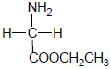OR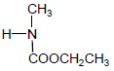
Isomer of C₄H₉NO₂
Allow NH₂–
1
(ii)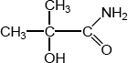
Isomer of C₄H₉NO₂ allow NH₂–
Allow 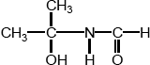
1
(iii) H₂N–CH₂CH₂CH₂–COOH or H₂N–(CH_{2)3–COOH}
Isomer of C₄H₉NO₂ allow NH₂–
OR
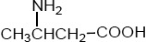
Do not allow –C₃H₆-
Beware – do not credit X itself
1
(f)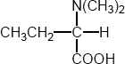
Answer has 6 carbons so NOT isomer of X
Allow C₂H₅
Must have bond from C to N not to methyl group
1
[16]

7. (a) (i)
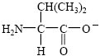
1
(ii)
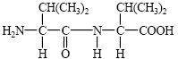
1
(iii) hydrogen bonding (do not allow H-bonding) QWC
do not penalise any error twice.
1
(b) (i)
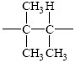
1
(ii)
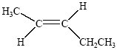
1
(iii) Isomer must be saturated or must not contain a double bond
1
(c)
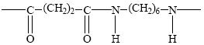
2
(d) (i) heat/reflux with aqu NaOH
1
poly(alkene) is inert/ no reaction
1
polyamide is hydrolysed (or undergoes hydrolysis)
to form acid salt and alcohol QWC
1
(ii) e.g combustion
1
heat energy produced
1
toxic gases produced
1
[14]

8. (a) J (acid) amide
not peptide, not N-substituted amide
1
K (secondary) amine or amino
penalise primary or tertiary
allow N-substituted amine
1

(b) (δ =) 3.1-3.9
1
doublet OR duplet
Not 3.7 – 4.1
Not secondary
name required not the number 2
1
(c) (i) Solvent must be proton-free
OR CHCl₃ has protons or has H or gives a peak
1
(ii) CDCl₃ is polar OR CCl₄ is non-polar
1
(d) 11 OR eleven
1
(e) (i) Si(CH₃)₄ OR SiC₄H₁₂
ignore TMS
1
(ii) a single number or a range within 21-25
penalise anything outside this range
1
(iii)
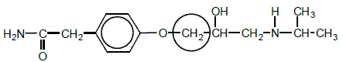
allow ring around the C only and also allow
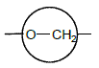
1

(f) (i) NaBH₄
ignore name if formula correct
ignore solvent
allow LiAlH₄ Zn/HCl Sn/HCl H₂/Ni H₂/Pt
1
(ii)
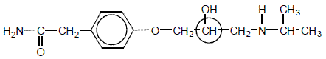
allow ring around the C only
1
(iii) (plane) polarised light OR light in a polarimeter
1
polarised light is not rotated or is unaffected
penalise bent/diffracted/deflected/reflected
Not just solution is optically inactive
1
(iv) adv cheaper medicine due to cost or difficulty of separation or
both can lower blood pressure
OR more effective/beneficial with a reason
or no need to separate
1
disadv may be side effects from one enantiomer in the mixture or
only half the product works or one enantiomer may be
ineffective or double dose required
1
[16]

9. A gives three peaks (1)
B gives one peak (1)
Allow one for “A has more peaks than B” when no number of peaks is given
2
[2]

10.

(a) F | G
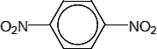 | 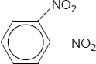

Penalize –O₂N once
Penalise missing circle once
Don’t penalise attempt at bonding in NO₂
1
1

(b) H | J
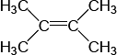 | 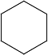

If both H and J correct but reversed, award one mark
1
1
A carbon in saturated ring structures should be shown as
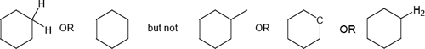
(c) K | L
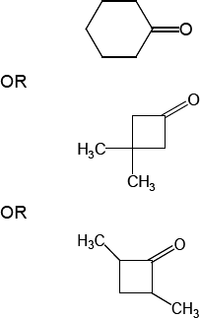 | 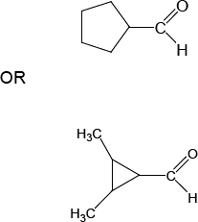

1
1
(d) M | N
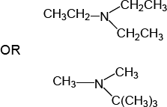 | 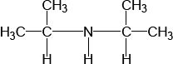

Allow C₂H₅ but
NOT allow C₄H₉ or C₃H₇
1
1
[8]

11.
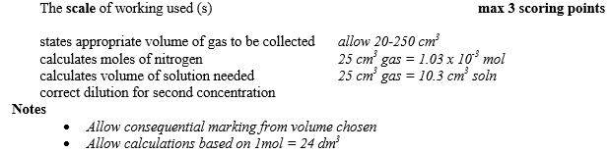
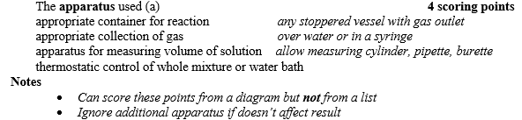
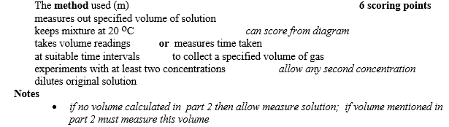
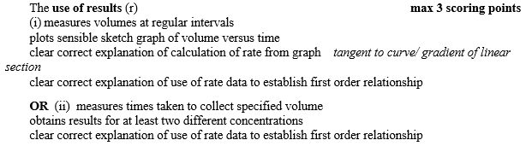
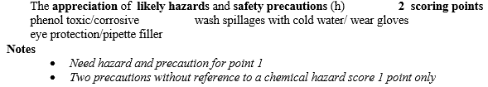
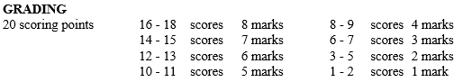
[8]

