A-LEVEL CHEMISTRY

PAPER 2
PRACTICE PAPER 6

Answer all questions
Max 105 marks
2 hours

Name ……………………………………………………………..

Mark ……../105 ……....% Grade ………

1. | 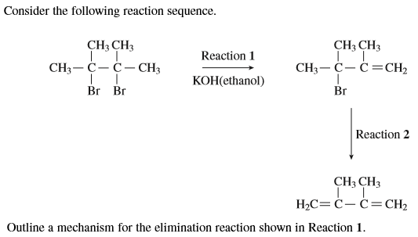  (Total 3 marks)

2. | 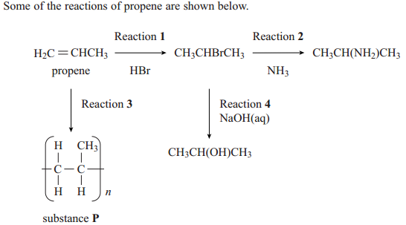
 | (a) | (4)
 | (b) | (4)
 | (c) | ……………………………………………………………………………………………………………………………………………………………………  ……………………………………………………………………………………………………………………………………………………………………  ……………………………………………………………………………………………………………………………………………………………………  ……………………………………………………………………………………………………………………………………………………………………  (3)
 | (d) | ……………………………………………………………………………………………………………………………………………………………………  ……………………………………………………………………………………………………………………………………………………………………  (2)  (Total 13 marks)
3. | 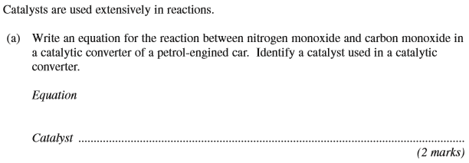
 | (b)
 | (c)
 | (d) | (Total 8 marks)

4. Aspirin can be made by reacting salicylic acid with ethanoic anhydride as outlined below.
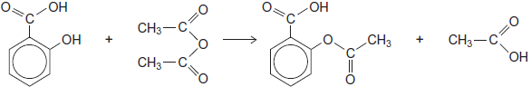
(a) In an experiment, after purification by recrystallisation, 1.76 g of aspirin (M_{r} = 180.0) were produced from 2.00 g of salicylic acid.
Calculate the percentage yield for this experiment.
........................................................................................................................
........................................................................................................................
........................................................................................................................
........................................................................................................................
(2)
(b) Suggest one practical reason why the yield of purified aspirin is less than 100%.
........................................................................................................................
........................................................................................................................
(1)
(Total 3 marks)

5. Ethyl ethanoate can be prepared by the reactions shown below.
Reaction 1
CH₃COOH(l) + C₂H₅OH(l) CH₃COOC₂H₅(l) + H₂O(l)
Reaction 2
CH₃COCl(l) + C₂H₅OH(l) → CH₃COOC₂H₅(l) + HCl(g)
Give one advantage and one disadvantage of preparing ethyl ethanoate by Reaction 1
rather than by Reaction 2.
........................................................................................................................
........................................................................................................................
........................................................................................................................
........................................................................................................................
(2)
(Total 2 marks)

6. Aldehydes can be prepared from acyl chlorides.
State how an aldehyde could be tested to show whether it is contaminated with traces of unreacted acyl chloride.
State what you would observe.
Test ........................................................................................................................
Observation ............................................................................................................
.................................................................................................................................
(Total 2 marks)

7. This question is about acylium ions, [RCO] ⁺
(a) The acylium ion can be formed from ethanoyl chloride. The ion reacts with benzene to form C₆H₅COCH₃
(i) Write an equation to show the formation of this acylium ion by the reaction of ethanoyl chloride with one other substance.
...............................................................................................................
(2)
(ii) Name and outline a mechanism for the reaction of benzene with this acylium ion.
Name of mechanism ...............................................................................
Mechanism

(4)
(iii) Ethanoic anhydride also reacts with benzene to form C₆H₅COCH₃
Write an equation for this reaction.
........................................................................................................................
(1)
(Total 7 marks)

8. An ester contains a benzene ring. The mass spectrum of this ester shows a molecular ion peak at m/z = 136.
(i) Deduce the molecular formula of this ester.
.............................................................................................................
.............................................................................................................
.............................................................................................................
(ii) Draw two possible structures for this ester.

(3)
(Total 3 marks)

9. Give one reason why methanol, synthesised from carbon dioxide and hydrogen, may not be a carbon-neutral fuel.
......................................................................................................................
......................................................................................................................
......................................................................................................................
(1)
(Total 1 marks)

10. Compound C is shown below
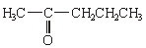
Deduce the number of peaks in the proton n.m.r. spectrum of C.
......................................................................................................................
(1)
(Total 1 mark)

11. (a) The table shows the results of three experiments to investigate the rate of reaction between compounds A and B dissolved in a given solvent.
All three experiments were carried out at the same temperature.

 |  | Experiment 1 | Experiment 2 | Experiment 3
 | Initial concentration of A / mol dm^{–3} | 1.60 × 10^{–2} | 2.40 × 10^{–2} | 3.60 × 10^{–2}
 | Initial concentration of B / mol dm^{–3} | 4.20 × 10^{–2} | 6.30 × 10^{–2} | 6.30 × 10^{–2}
 | Initial rate /mol dm^{–3} s^{–1} | 8.00 × 10^{–5} | 1.80 × 10^{–4} | 4.05 × 10^{–4}
(i) Deduce the order of reaction with respect to A.
Tick (✓) one box.

 | Order of reaction  with respect to A | Tick  (✓)
 | 0
 | 1
 | 2

(1)
(ii) Deduce the order of reaction with respect to B.
Tick (✓) one box.

 | Order of reaction  with respect to B | Tick  (✓)
 | 0
 | 1
 | 2

(1)

(b) The reaction between two different compounds, C and D, is studied at a given temperature.
The rate equation for the reaction is found to be
rate = k[C][D]²
(i) When the initial concentration of C is 4.55 × 10^{–2} mol dm^{–3} and the initial concentration of D is 1.70 × 10^{–2} mol dm^{–3}, the initial rate of reaction is 6.64 × 10^{–5} mol dm^{–3} s^{–1}.
Calculate the value of the rate constant at this temperature and deduce its units.
Calculation ............................................................................................
...............................................................................................................
...............................................................................................................
...............................................................................................................
Units of rate constant ............................................................................
...............................................................................................................
(3)
(ii) The experiment in part (i) is repeated at the same temperature but after the addition of extra solvent so that the total volume of the mixture is doubled.
Deduce the new initial rate of reaction.
...............................................................................................................
...............................................................................................................
(1)
(Total 6 marks)

12. Many aromatic nitro compounds are used as explosives. One of the most famous is 2-methyl-1,3,5-trinitrobenzene, originally called trinitrotoluene or TNT. This compound, shown below, can be prepared from methylbenzene by a sequence of nitration reactions.
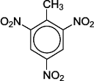
(b) Deduce the number of peaks in the ¹³C n.m.r. spectrum of TNT.
........................................................................................................................
(1)
(c) Deduce the number of peaks in the ¹H n.m.r. spectrum of TNT.
........................................................................................................................
(1)
(Total 2 marks)

13. The amino acids aspartic acid and phenylalanine react together to form a dipeptide.
This dipeptide can be converted into a methyl ester called aspartame.
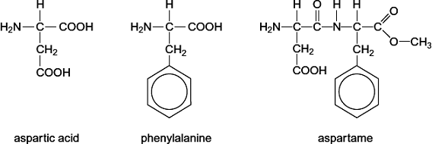
Aspartame has a sweet taste and is used in soft drinks and in sugar-free foods for people with diabetes.
Hydrolysis of aspartame forms methanol initially. After a longer time the peptide link breaks to form the free amino acids. Neither of these amino acids tastes sweet.
(a) Apart from the release of methanol, suggest why aspartame is not used to sweeten foods that are to be cooked.
........................................................................................................................
........................................................................................................................
(1)
(b) Give the IUPAC name of aspartic acid.
........................................................................................................................
(1)
(c) Draw the organic species formed by aspartic acid at high pH.

(1)
(d) Draw the zwitterion of phenylalanine.

(1)

(e) Phenylalanine exists as a pair of stereoisomers.
(i) State the meaning of the term stereoisomers.
...............................................................................................................
...............................................................................................................
...............................................................................................................
...............................................................................................................
(2)
(ii) Explain how a pair of stereoisomers can be distinguished.
...............................................................................................................
...............................................................................................................
...............................................................................................................
...............................................................................................................
(2)
(Total 8 marks)

14. Compound W can be formed via compounds H and S in the three-step synthesis shown below.
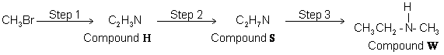
Identify compounds H and S and give reagents and conditions for Steps 1 and 2.
State the type of compound of which W is an example.
W reacts with a large excess of bromomethane to form a solid product. Draw the structure of this product and name the type of mechanism for this reaction.
…………………………………………………………………………………………………………………
…………………………………………………………………………………………………………………
…………………………………………………………………………………………………………………
…………………………………………………………………………………………………………………
…………………………………………………………………………………………………………………
…………………………………………………………………………………………………………………
…………………………………………………………………………………………………………………
…………………………………………………………………………………………………………………
…………………………………………………………………………………………………………………
…………………………………………………………………………………………………………………
…………………………………………………………………………………………………………………
…………………………………………………………………………………………………………………
…………………………………………………………………………………………………………………
…………………………………………………………………………………………………………………
…………………………………………………………………………………………………………………
…………………………………………………………………………………………………………………
(Total 9 marks)

15. Describe how you could distinguish between the compounds in the following pairs using one simple test-tube reaction in each case.
For each pair, identify a reagent and state what you would observe when both compounds are tested separately with this reagent.
(a)
Reagent .........................................................................................................
Observation with R.........................................................................................
........................................................................................................................
Observation with S.........................................................................................
........................................................................................................................
(3)
(b)
Reagent .........................................................................................................
Observation with T.........................................................................................
........................................................................................................................
Observation with U.........................................................................................
........................................................................................................................
(3)

(c)
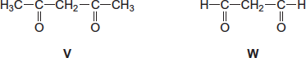
Reagent .........................................................................................................
Observation with V.........................................................................................
........................................................................................................................
Observation with W........................................................................................
........................................................................................................................
(3)
(Total 9 marks)

16. Infrared spectroscopy can be used to distinguish between esters, alcohols and carboxylic acids.
(a) Identify an absorption that would enable you to distinguish between methyl ethanoate and ethanoic acid.
........................................................................................................................
(1)
(b) Identify an absorption that would enable you to distinguish between methanol and ethanoic acid.
........................................................................................................................
(1)
(c) State how infrared spectroscopy can be used to show that an unknown ester is definitely methyl ethanoate.
........................................................................................................................
........................................................................................................................
........................................................................................................................
........................................................................................................................
(2)
(Total 4 marks)

17. Imipramine has been prescribed as an antidepressant. The structure of imipramine is shown below.
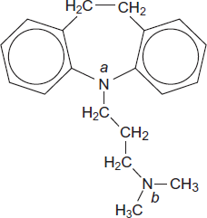
(a) The medicine is usually supplied as a salt. The salt is formed when one mole of imipramine reacts with one mole of hydrochloric acid.
Suggest why the nitrogen atom labelled b is more likely to be protonated than the nitrogen atom labelled a when the salt is formed.
........................................................................................................................
........................................................................................................................
........................................................................................................................
........................................................................................................................
........................................................................................................................
........................................................................................................................
........................................................................................................................
(3)
(b) Deduce the molecular formula of imipramine and give the number of peaks in its ¹³C n.m.r. spectrum.
........................................................................................................................
........................................................................................................................
........................................................................................................................
........................................................................................................................
........................................................................................................................
(2)
(Total 5 marks)

18. Salicylic acid can be used to make aspirin. Before using a sample of salicylic acid to make aspirin, a student purified the acid by recrystallisation. The method for recrystallisation is outlined below.
Step 1: The sample is dissolved in a minimum volume of hot water.
Step 2: The solution is filtered hot.
Step 3: The filtrate is cooled in ice to form crystals.
Step 4: The crystals are collected by filtration, washed with cold water and left to dry.
Explain the purpose of each underlined point.
Minimum volume .....................................................................................................
.................................................................................................................................
Hot water ................................................................................................................
.................................................................................................................................
Filtered hot ..............................................................................................................
.................................................................................................................................
Cooled in ice ...........................................................................................................
.................................................................................................................................
Washed with cold water ..........................................................................................
.................................................................................................................................
(Total 5 marks)

19.
 | (a)
 | (b)
 | (c)
 | (d)
 | (e)
 | (f)
 | (g)
 | (h)
 | (i)
 | (j) | (Total 14 marks)

