A-LEVEL CHEMISTRY

PAPER 2
PRACTICE PAPER 7

Answer all questions
Max 105 marks
2 hours

Name ……………………………………………………………..

Mark ……../105 ……....% Grade ………

- The maximum errors for the pipette and the burette are shown below. These errors take into account multiple measurements.
Pipette ± 0.05 cm³
Burette ± 0.15 cm³
Estimate the maximum percentage error in using each of these pieces of apparatus.
Use an average titre 24.25 cm³ to calculate the percentage error in using the burette.
Show your working.
Pipette ....................................................................................................................
.................................................................................................................................
Burette ....................................................................................................................
.................................................................................................................................
(Total 2 marks)

- The table contains some bond enthalpy data.

 | Bond | H−H | O=O | H−O
 | Bond enthalpy / kJ mol⁻¹ | 436 | 496 | 464

(a) The value for the H−O bond enthalpy in the table is a mean bond enthalpy.
State the meaning of the term mean bond enthalpy for the H−O bond.
........................................................................................................................
........................................................................................................................
........................................................................................................................
........................................................................................................................
........................................................................................................................
(2)
(b) Use the bond enthalpies in the table to calculate a value for the enthalpy of formation of water in the gas phase.
........................................................................................................................
........................................................................................................................
........................................................................................................................
........................................................................................................................
(3)

(c) The standard enthalpy of combustion of hydrogen, forming water in the gas phase, is almost the same as the correct answer to part (b).
(i) Suggest one reason why you would expect the standard enthalpy of combustion of hydrogen to be the same as the answer to part (b).
...............................................................................................................
...............................................................................................................
...............................................................................................................
...............................................................................................................
(1)
(ii) Suggest one reason why you would expect the standard enthalpy of combustion of hydrogen to differ slightly from the answer to part (b).
...............................................................................................................
...............................................................................................................
...............................................................................................................
...............................................................................................................
(1)
(Total 7 marks)

3. |  | 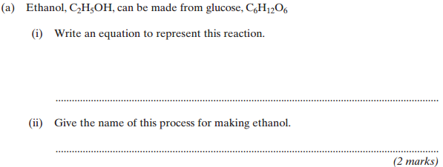
 |  | 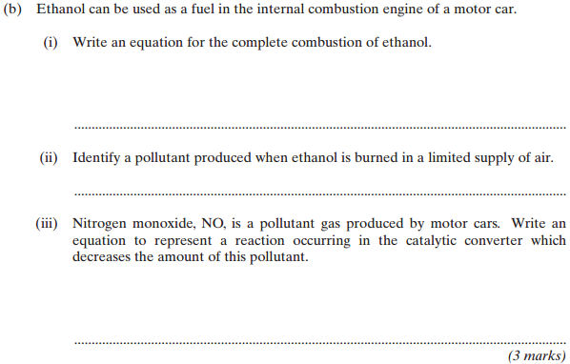
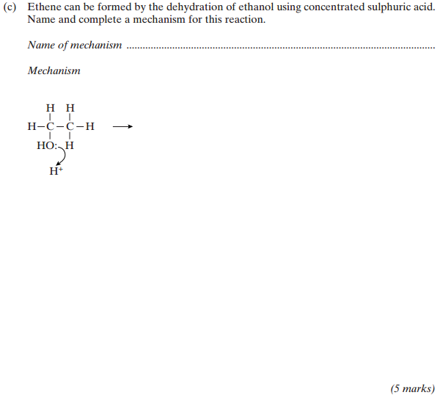
(Total 10 marks)

4. |  | 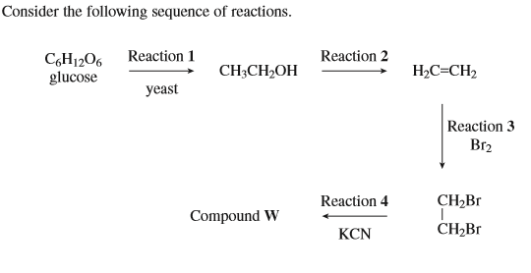  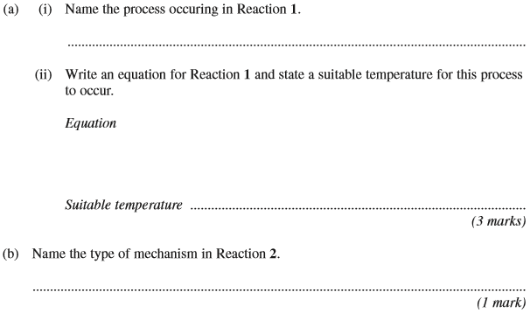
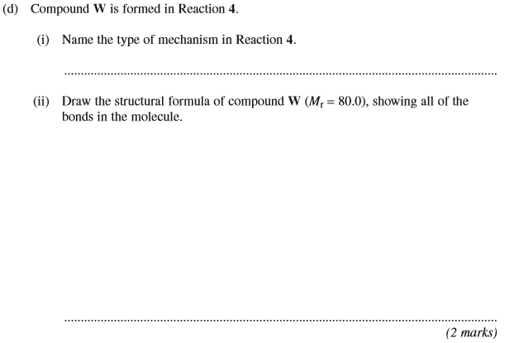
(Total 10 marks)

5.
 | (a)
 | (b)
 | (c)
 | (d)
 | (e) |  | (Total 14 marks)

6. When iodine molecules are dissolved in aqueous solutions containing iodide ions, they react to form triiodide ions (I₃–).
I₂ + I– I₃–
The rate of the oxidation of iodide ions to iodine by peroxodisulfate(VI) ions (S₂O₈^{2–}) was studied by measuring the concentration of the l₃– ions at different times, starting at time = 0, when the reactants were mixed together. The concentration of the l₃– ions was determined by measuring the absorption of light using a spectrometer.
The table below shows the results.

 | Time / s | Concentration of l₃– / mol dm^{–3}
 | 10 | 0.23
 | 20 | 0.34
 | 30 | 0.39
 | 40 | 0.42
 | 50 | 0.47
 | 60 | 0.44
 | 70 | 0.45

- Plot the values of the concentration of I₃– (y-axis) against time on the grid below.
(2)
(b) A graph of these results should include an additional point. On the grid, draw a ring around this additional point.
(1)
(c) Draw a best-fit curve on the grid, including the extra point from part (b).
(2)
(d) Draw a tangent to your curve at time = 30 seconds. Calculate the slope (gradient) of this tangent and hence the rate of reaction at 30 seconds. Include units with your final answer.
Show your working.
........................................................................................................................
........................................................................................................................
........................................................................................................................
(4)
(Total 9 marks)

7. | 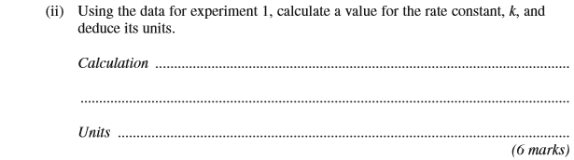
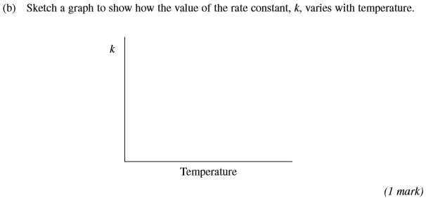
(Total 7 marks)

8. N-phenylethanamide is used as an inhibitor in hydrogen peroxide decomposition and also in the production of dyes.
N-phenylethanamide can be produced in a laboratory by the reaction between phenylammonium sulfate and an excess of ethanoic anhydride:
(a) A student carried out this preparation using 1.15 g of phenylammonium sulfate (M_{r} = 284.1) and excess ethanoic anhydride.
(i) Calculate the maximum theoretical yield of N−phenylethanamide that could be produced in the reaction. Record your answer to an appropriate precision.
Show your working.
...............................................................................................................
...............................................................................................................
...............................................................................................................
...............................................................................................................
...............................................................................................................
(3)
(ii) In the preparation, the student produced 0.89 g of N−phenylethanamide.
Calculate the percentage yield for the reaction.
...............................................................................................................
...............................................................................................................
...............................................................................................................
(1)

(b) The student purified the crude solid product, N−phenylethanamide, by recrystallisation.
(i) Outline the method that the student should use for this recrystallisation.
...............................................................................................................
...............................................................................................................
...............................................................................................................
...............................................................................................................
...............................................................................................................
...............................................................................................................
(4)
(ii) Outline how you would carry out a simple laboratory process to show that the recrystallised product is a pure sample of N−phenylethanamide.
...............................................................................................................
...............................................................................................................
...............................................................................................................
...............................................................................................................
...............................................................................................................
(3)
(iii) Assume that the reaction goes to completion.
Suggest two practical reasons why the percentage yield for this reaction may not be 100%.
1 ............................................................................................................
...............................................................................................................
2 ............................................................................................................
...............................................................................................................
(2)
(c) The reaction to form N−phenylethanamide would happen much more quickly if the student used ethanoyl chloride instead of ethanoic anhydride.
Explain why the student might prefer to use ethanoic anhydride, even though it has a slower rate of reaction.
........................................................................................................................
........................................................................................................................
........................................................................................................................
(2)
(Total 15 marks)
9. Aldehydes can be prepared from acyl chlorides.
State how an aldehyde could be tested to show whether it is contaminated with traces of unreacted acyl chloride.
State what you would observe.
Test ........................................................................................................................
Observation ............................................................................................................
.................................................................................................................................
(Total 2 marks)

10. Consider the following reaction sequence starting from methylbenzene.
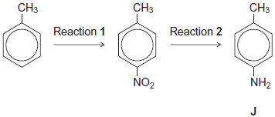
(a) Name the type of mechanism for reaction 1.
........................................................................................................................
(1)
(b) Compound J is formed by reduction in reaction 2.
(i) Give a reducing agent for this reaction.
...............................................................................................................
(1)
(ii) Write an equation for this reaction. Use [H] to represent the reducing agent.
...............................................................................................................
(1)
(iii) Give a use for J.
...............................................................................................................
(1)

(c) Outline a mechanism for the reaction of bromomethane with an excess of compound J.
You should represent J as RNH₂ in the mechanism.

(4)
(d) Compound K (C₆H₅CH₂NH₂) is a structural isomer of J.
Explain why J is a weaker base than K.
........................................................................................................................
........................................................................................................................
........................................................................................................................
........................................................................................................................
........................................................................................................................
........................................................................................................................
(3)
(Total 11 marks)

11. Equations for the hydrogenation of cyclohexene and of benzene, together with the enthalpies of hydrogenation, are shown.
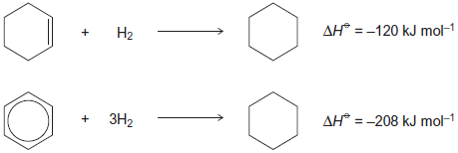
(a) (i) Use these data to show that benzene is 152 kJ mol⁻¹ more stable than the hypothetical compound cyclohexa−1,3,5−triene.
...............................................................................................................
...............................................................................................................
...............................................................................................................
...............................................................................................................
(1)
(ii) State, in terms of its bonding, why benzene is more stable than cyclohexa−1,3,5−triene.
...............................................................................................................
...............................................................................................................
...............................................................................................................
...............................................................................................................
(1)
(b) Three carbon−carbon bonds are labelled on the structures shown.
These bonds are of different lengths.
Write the letters w, x and y in order of increasing bond length.
........................................................................................................................
(1)

(c) The structures of two cyclic dienes are shown.
(i) Use the enthalpy of hydrogenation data given opposite to calculate a value for the enthalpy of hydrogenation of cyclohexa−1,4−diene.
...............................................................................................................
...............................................................................................................
(1)
(ii) Predict a value for the enthalpy of hydrogenation of cyclohexa−1,3−diene.
...............................................................................................................
(1)
(iii) Explain your answers to part (i) and part (ii) in terms of the bonding in these two dienes.
...............................................................................................................
...............................................................................................................
...............................................................................................................
...............................................................................................................
...............................................................................................................
...............................................................................................................
(3)
(Total 8 marks)

12. | 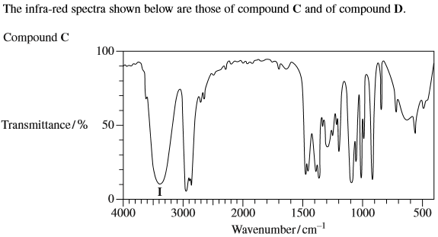  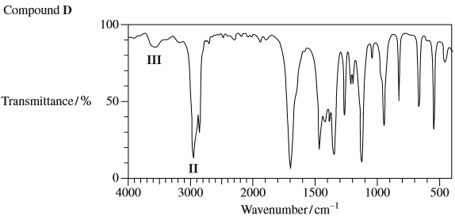  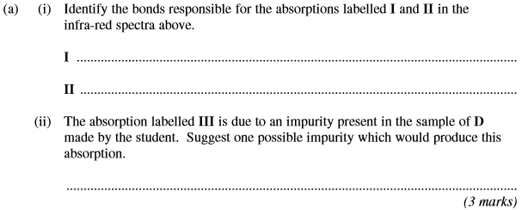
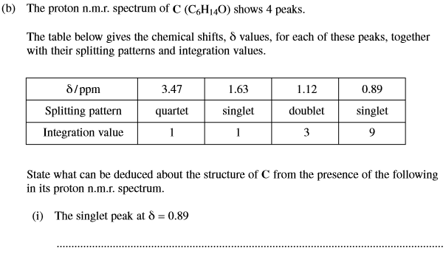
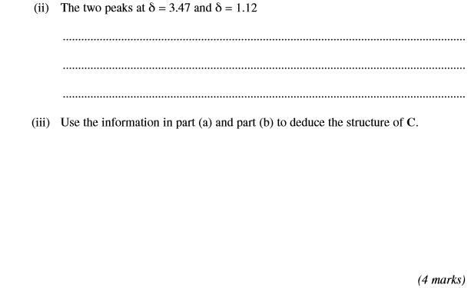
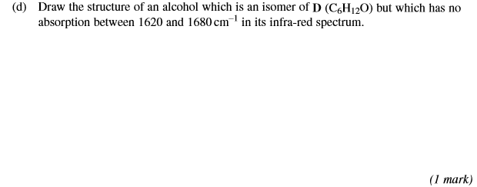
(Total 10 marks)

