A-LEVEL CHEMISTRY

PAPER 3
PRACTICE PAPER 10

Answer all questions
Max 90 marks
1 hour 45 minutes

Name ……………………………………………………………..

Mark ……../90 ……....% Grade ………

The first 10 multiple choice questions have already been used for AS-level resources

1. This question is about test-tube reactions of some ions in aqueous solution.
For each reaction in parts (a) to (c), state the colour of the original solution.
State what you would observe after the named reagent has been added to the solution.
In each case, write an equation for the reaction that occurs.
(a) Sodium hydroxide solution is added to a solution containing [Fe(H₂O)₆]³⁺ ions.
Colour of original solution ..............................................................................
Observation after reagent has been added ...................................................
........................................................................................................................
Equation
........................................................................................................................
(3)
(b) An excess of ammonia solution is added to a solution containing [Cu(H₂O)₆]²⁺ ions.
Colour of original solution ..............................................................................
Observation after an excess of reagent has been added .............................
........................................................................................................................
Equation
........................................................................................................................
(3)
(c) Sodium carbonate solution is added to a solution containing [Al(H₂O)₆]³⁺ ions.
Colour of original solution ..............................................................................
Observations after reagent has been added .................................................
........................................................................................................................
........................................................................................................................
........................................................................................................................
Equation
........................................................................................................................
(4)
(Total 10 marks)

2. (a) In an investigation of the rate of reaction between hydrochloric acid and pure magnesium, a student obtained the following curve.
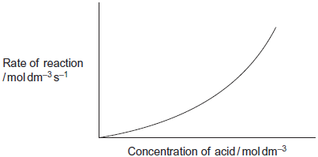
The reaction of magnesium with dilute hydrochloric acid is exothermic.
Use your understanding of collision theory to explain why the student did not obtain a straight line.
........................................................................................................................
........................................................................................................................
........................................................................................................................
........................................................................................................................
........................................................................................................................
........................................................................................................................
........................................................................................................................
........................................................................................................................
........................................................................................................................
(3)
(b) The magnesium used in a laboratory experiment was supplied as a ribbon. The ribbon was stored in an open plastic bag exposed to the air.
Explain why it is important to clean the surface of this magnesium ribbon when investigating the rate of its reaction with hydrochloric acid.
........................................................................................................................
........................................................................................................................
........................................................................................................................
........................................................................................................................
(2)

(c) Magnesium ribbon reacts with hot water. Heated magnesium ribbon reacts with steam. State two differences between these reactions.
Difference 1 ...................................................................................................
........................................................................................................................
Difference 2 ...................................................................................................
........................................................................................................................
(2)
(d) Pure magnesium reacts completely with an excess of dilute sulfuric acid.
The reaction of pure calcium with an excess of dilute sulfuric acid is very rapid initially.
This reaction slows down and stops before all of the calcium has reacted.
Use your knowledge of the solubilities of Group 2 sulfates to explain why these reactions of magnesium and calcium with dilute sulfuric acid are so different.
........................................................................................................................
........................................................................................................................
........................................................................................................................
........................................................................................................................
........................................................................................................................
........................................................................................................................
........................................................................................................................
(3)
(Total 10 marks)

3. Iodine and propanone react in acid solution according to the equation
I₂ + CH₃COCH₃ → CH₃COCH₂I + HI
The rate equation for the reaction is found to be
rate = k [CH₃COCH₃][H⁺]
(a) Deduce the order of reaction with respect to iodine and the overall order of reaction.
Order with respect to iodine .........................................................................
Overall order ................................................................................................
(2)

(b) At the start of the experiment, the rate of reaction was found to be 2.00 × 10^{–5} mol dm^{–3} s^{–1} when the concentrations of the reactants were as shown below.

Reactant | Concentration / mol dm^{–3}
CH₃COCH₃ | 1.50
I₂ | 2.00 × 10^{–2}
H⁺ | 3.00 × 10^{–2}

Use these data to calculate a value for the rate constant and deduce its units.
Rate constant ...............................................................................................
......................................................................................................................
......................................................................................................................
Units .............................................................................................................
(3)
(c) How can you tell that H⁺ acts as a catalyst in this reaction?
......................................................................................................................
......................................................................................................................
......................................................................................................................
(2)
(d) Calculate the initial rate of reaction if the experiment were to be repeated at the same temperature and with the same concentrations of iodine and propanone as in part (b) but at a pH of 1.25
......................................................................................................................
......................................................................................................................
......................................................................................................................
......................................................................................................................
......................................................................................................................
......................................................................................................................
(3)
(Total 10 marks)

4. The manufacture of food grade phosphoric acid for use in cola drinks begins with the production of pure white phosphorus from the mineral fluoroapatite, Ca₅F(PO₄)₃
(a) Complete the following equation for the manufacture of phosphorus.
....Ca₅F(PO₄)₃ + 9SiO₂ + ....C 9CaSiO₃ + CaF₂ + ....CO + ....P
(1)
(b) As the phosphorus cools, it forms white phosphorus, P₄
Give the oxidation state of phosphorus in each of the following.
P₄ .............................................................
H₃PO₄ ......................................................
(2)
(c) Fertiliser grade phosphoric acid is manufactured from sulfuric acid and calcium phosphate.
Use the following precise relative atomic mass data to show how mass spectrometry can be used to distinguish between pure sulfuric acid (H₂SO₄) and pure phosphoric acid (H₃PO₄) which both have M_{r} = 98 to two significant figures.

Atom | Precise relative atomic mass
¹H | 1.00794
¹⁶O | 15.99491
³¹P | 30.97376
³²S | 32.06550

........................................................................................................................
........................................................................................................................
........................................................................................................................
........................................................................................................................
(1)

(d) Concentrated phosphoric acid is used as a catalyst in the hydration of propene to form the alcohol CH₃CH(OH)CH₃ as the main organic product.
The industrial name for this alcohol is isopropyl alcohol.
(i) State the meaning of the term catalyst.
...............................................................................................................
...............................................................................................................
...............................................................................................................
(1)

(ii) State the meaning of the term hydration.
...............................................................................................................
...............................................................................................................
...............................................................................................................
(1)
(iii) Write an equation for the hydration of propene to form isopropyl alcohol.
Give the IUPAC name for isopropyl alcohol.
Equation ................................................................................................
IUPAC name ..........................................................................................
(2)
(Total 8 marks)

5. (a) State what is meant by the term co-ordinate bond.
......................................................................................................................
......................................................................................................................
(2)
(b) Define the term Brønsted–Lowry acid.
Brønsted–Lowry acid ...................................................................................
(1)
(c) State what is meant by the term bidentate ligand.
......................................................................................................................
......................................................................................................................
(2)

(d) State how the co-ordination number of cobalt(II) ions in aqueous solution changes when an excess of chloride ions is added. Give a reason for the change.
Change in co-ordination number ..................................................................
Reason for change .......................................................................................
......................................................................................................................
(2)
(e) Suggest why the enthalpy change for the following reaction is close to zero.
[Co(NH₃)₆]²⁺ + 3NH₂CH₂CH₂NH₂ → Co(NH₂CH₂CH₂NH₂)₃]²⁺ + 6NH₃
......................................................................................................................
......................................................................................................................
(2)
(f) Deduce the formula of the compound formed when ethane-1,2-diamine is treated with an excess of hydrochloric acid.
......................................................................................................................
(1)
(Total 10 marks)

6. (a) A mixture of lactic acid and its salt sodium lactate is used as an acidity regulator in some foods. An acidity regulator makes sure that there is little variation in the pH of food.
(i) Write an equation for the reaction of lactic acid with sodium hydroxide.
...............................................................................................................
(1)
(ii) The acid dissociation constant K_{a} for lactic acid has the value 1.38 × 10⁻⁴ mol dm⁻³ at 298 K.
Calculate the pH of an equimolar solution of lactic acid and sodium lactate.
...............................................................................................................
...............................................................................................................
...............................................................................................................
...............................................................................................................
(2)
(iii) Suggest an alternative name for the term acidity regulator.
Explain how a mixture of lactic acid and sodium lactate can act as a regulator when natural processes increase the acidity in some foods.
Name ...................................................................................................
Explanation ...........................................................................................
...............................................................................................................
...............................................................................................................
...............................................................................................................
(3)

(b) PLA is the condensation polymer formed from lactic acid. It is used to make plastic cups.
The polymer is described as 100% biodegradable and 100% compostable.
Compostable material breaks down slowly in contact with the moist air in a garden bin. This produces compost that can be used to improve soil.
The manufacturers stress that PLA cups differ from traditional plastic cups that are neither biodegradable nor compostable.
(i) Draw a section of PLA that shows two repeating units.

(2)
(ii) Name the type of condensation polymer in PLA.
...............................................................................................................
(1)
(iii) An intermediate in the production of PLA is a cyclic compound (C₆H₈O₄) that is formed from two PLA molecules.
Draw the structure of this cyclic compound.

(1)
(iv) Traditional non-biodegradable plastic cups can be made from poly(phenylethene), commonly known as polystyrene.
Draw the repeating unit of poly(phenylethene).

(1)
(v) The manufacturers of PLA claim that the material will break down to compost in just 12 weeks.
Suggest one reason why PLA in landfill may take longer than 12 weeks to break down.
...............................................................................................................
...............................................................................................................
(1)
(Total 12 marks)

7. Which of these atoms has the smallest number of neutrons?

 | A | ³H
 | B | ⁴He
 | C | ⁵He
 | D | ⁴Li

(Total 1 mark)

8. Which of the following contains the most chloride ions?

 | A | 10 cm³ of 3.30 × 10⁻² mol dm⁻³ aluminium chloride solution
 | B | 20 cm³ of 5.00 × 10⁻² mol dm⁻³ calcium chloride solution
 | C | 30 cm³ of 3.30 × 10⁻² mol dm⁻³ hydrochloric acid
 | D | 40 cm³ of 2.50 × 10⁻² mol dm⁻³ sodium chloride solution

(Total 1 mark)

9. When vanadium reacts with chlorine at 400°C, a brown compound is obtained. When an aqueous solution containing 0.193 g of this compound was treated with aqueous silver nitrate all the chlorine in the compound was precipitated as silver chloride. The mass of silver chloride (AgCl) produced was 0.574 g. Which one of the following could be the formula of the brown compound?
A VCl
B VCl₂
C VCl₃
D VCl₄
(Total 1 mark)

10. A student is provided with a 5.00 cm³ sample of 1.00 × 10⁻² mol dm⁻³ hydrochloric acid. The student is asked to devise a method to prepare a hydrochloric acid solution with a concentration of 5.00 × 10⁻⁴ mol dm⁻³ by diluting the sample with water.
Which of these is the correct volume of water that should be added?

 | A | 45.0 cm³
 | B | 95.0 cm³
 | C | 100 cm³
 | D | 995 cm³

(Total 1 mark)

11. Use the information below to answer this question.
C(s) + O₂(g) → CO₂(g) ∆H = −393.5 kJ mol⁻¹
H₂(g) + O₂(g) → H₂O(l) ∆H = −285.8 kJ mol⁻¹
3C(s) + 4H₂(g) → C₃H₈(g) ∆H = −104.0 kJ mol⁻¹
4C(s) + 5H₂(g) → C₄H₁₀(g) ∆H = −125.2 kJ mol⁻¹
The value in kJ mol⁻¹ for the enthalpy of combustion of propane is
A −211.7
B −419.7
C −2220
C −2878
(Total 1 mark)

12. The ester methyl ethanoate is hydrolysed as shown in the following equation.
CH₃COOCH₃(l) + H₂O(l) CH₃COOH(l) + CH₃OH(l) ΔH = +3 kJ mol⁻¹
Which one of the following compounds from the reaction mixture has no hydrogen bonding between its molecules when pure?
A CH₃COOCH₃(l)
B H₂O(l)
C CH₃COOH(l)
D CH₃OH(l)
(Total 1 mark)
13. Which one of the following statements about but-2-enal, CH₃CH=CHCHO, is not true?
A It has stereoisomers.
B It shows a strong absorption in the infra-red at about 1700 cm⁻¹.
C It will turn an acidified solution of potassium dichromate(VI) green.
D It can be dehydrated by concentrated sulphuric acid.
(Total 1 mark)

14. Which of these substances reacts most rapidly to produce a silver halide precipitate with acidified silver nitrate?

 | A | CH₃Br
 | B | CH₃Cl
 | C | CH₃F
 | D | CH₃l

(Total 1 mark)

15. When one mole of ammonia is heated to a high temperature, 50% dissociates according to the following equilibrium.
2NH₃(g) ⇌ N₂(g) + 3H₂(g)
What is the total number of moles of gas present in the equilibrium mixture?
A 1.5
B 2.0
C 2.5
D 3.0
(Total 1 mark)

16. The graph shows the equilibrium percentage of ammonia present during the formation of ammonia by the Haber process:
N₂ + 3H₂ ⇌ 2NH₃ ∆H = −92 kJ mol⁻¹
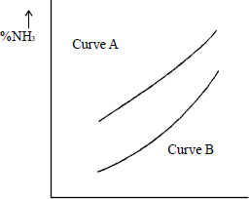
x axis
Which one of the following are correct labels for the graph?

 |  | x axis | Curve A | Curve B
 | A | temperature | high pressure | low pressure
 | B | temperature | low pressure | high pressure
 | C | pressure | high temperature | low temperature
 | D | pressure | low temperature | high temperature
(Total 1 mark)

Ethanedioic acid, (COOH)₂, is a diprotic acid with a Ka value for its first dissociation of 6.2 x 10⁻² moldm⁻³.

17. | 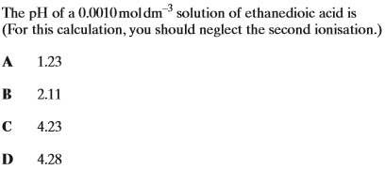
18. | 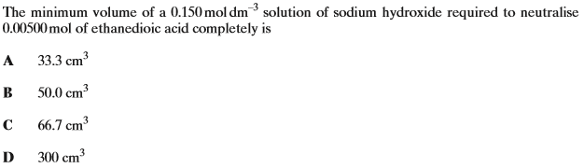
19. | 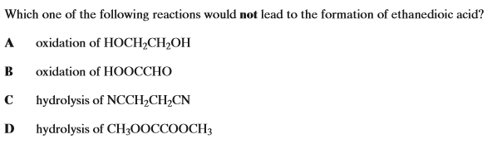  (Total 3 marks)
20. | 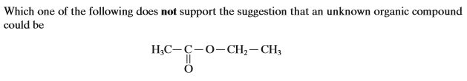
 | A
 | B | Its mass spectrum has a molecular ion peak at m/z = 88
 | C
 | D | its carbon-13 n.m.r spectrum has three peaks  (Total 1 mark)

Consider the reaction scheme below:
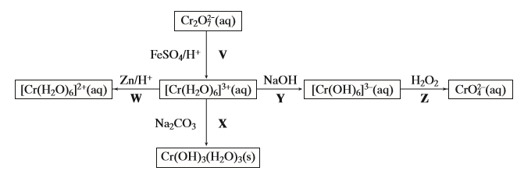

21. | Which of the following statements about the reaction scheme is incorrect?
 | A | sodium carbonate is an oxidising agent in step X
 | B | zinc is a reducing agent in step W
 | C | iron (II) sulphate is a reducing agent in step V
 | D | hydrogen peroxide is an oxidising agent in step Z
22. | Which of the following statements about the reaction scheme is incorrect?
 | A | the oxidation states of chromium shown are +2, +3 and +6
 | B | only step X will produce a precipitate and a gas
 | C | steps V, W and Z will produce a colour change
 | D | steps X and Y will involve a change in the oxidation state of chromium
23. | Which of the following is a correct equation for one of the steps above?
 | A
 | B
 | C
 | D | (Total 3 marks)

24. | Which of the following is not a correct statement about the complex ?
 | A | the ligand in the complex is bidentate
 | B | the oxidation state of cobalt in the complex is +3
 | C | the complex has an octahedral shape
 | D | the coordination number of cobalt in the complex is 3  (Total 1 mark)
25. | Which of the following is not a correct statement about 2-methylbutanal?
 | A
 | B
 | C
 | D | its proton n.m.r. spectrum includes only one peak that can be assigned to a methyl group.  (Total 1 mark)
26. | Which of the following is a correct statement about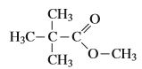?
 | A
 | B | It has a molecular ion peak at m/z = 130 in its mass spectrum
 | C
 | D | hydrolysis gives an organic product with a broad absorption in the infra-red at 3350 cm⁻¹.  (Total 1 mark)

Consider the reaction scheme below:
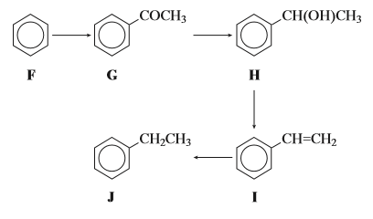
27. |  | Which of the conversions are reductions?
 |  | A | F into G and G into H
 |  | B | H into I and I into J
 |  | C | F into G and H into I
 |  | D | G into H and I into J
28. |  | Which of the following statements is incorrect?
 |  | A | ethanoyl chloride and aluminium chloride could achieve the conversion of F into G
 |  | B | G would show a molecular ion peak in its mass spectrum at m/z = 120
 |  | C | the conversion of H into I could be achieved with concentrated sulphuric acid as an example of homogeneous catalysis
 |  | D | the proton n.m.r. spectrum of J includes a triplet and a quartet in the area ratio 2:3 respectively  (Total 2 marks)
29. |  | Which type of reaction can the molecule below not undergo?  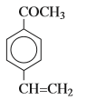
 |  | A | electrophilic addition
 |  | B | nucleophilic substitution
 |  | C | nucleophilic addition
 |  | D | electrophilic substitution  (Total 1 mark)
30. |  | 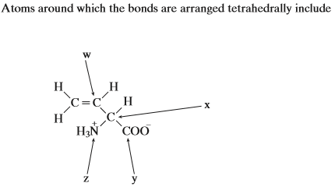
 |  | A | atom w and atom x
 |  | B | atom y and atom z
 |  | C | atom x and atom z
 |  | D | atom w and atom y  (Total 1 mark)
31. |  | Which of the following statements is incorrect?
 |  | A | a buffer solution is formed when a 0.1 moldm⁻³ aqueous solution of ethanedioic acid is mixed with an equal volume of a 0.05 moldm⁻³ solution of sodium hydroxide
 |  | B
 |  | C | The polymerisation of propene has a positive value for ΔS
 |  | D | Compared with an oxygen molecule, carbon monoxide can form a stronger co-ordinate bond with iron (II) in haemoglobin  (Total 1 mark)
32. |  | Which of the following statements is correct?
 |  | A | is redox reaction
 |  | B
 |  | C
 |  | D | Chromium increases its oxidation state from left to right in the series  (Total 1 mark)
33. |  | 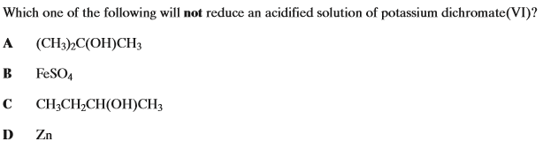  (Total 1 mark)
34. |  | 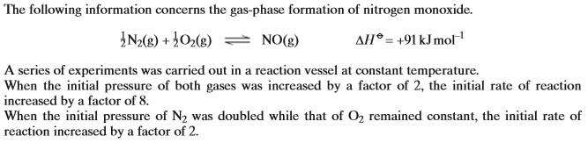  Which of the following statements is not true?  (Total 1 mark)
 |  | A | the reaction is first order with respect to nitrogen
 |  | B | Increasing the pressure of both gases by a factor of 3 increases the rate by a factor of 27
 |  | C | The equilibrium constant increases if the pressure is decreased
 |  | D | The rate constant has the units mol⁻²dm⁶s⁻¹
35. |  | 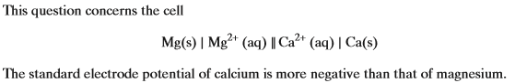  Which of the following statements is not true?
 |  | A | the cell has a negative potential
 |  | B | calcium is a stronger reducing agent than magnesium
 |  | C | electrons flow from calcium to magnesium
 |  | D | magnesium is more readily oxidised than calcium  (Total 1 mark)
36. | 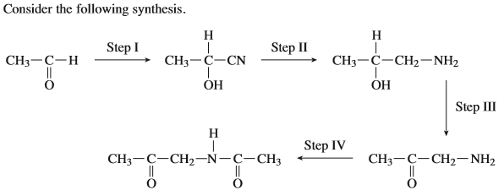  Which of the following would be suitable reagents in the steps above?
 | A
 | B
 | C
 | D |  |  | (Total 1 mark)

