A-LEVEL CHEMISTRY

PAPER 3
PRACTICE PAPER 11

Answer all questions
Max 90 marks
1 hour 45 minutes

Name ……………………………………………………………..

Mark ……../90 ……....% Grade ………

The first 10 multiple choice questions have already been used for AS-level resources

1. Sulfuric acid is manufactured by the Contact Process.
(a) In this process, sulfur dioxide reacts with oxygen.
The equation for the equilibrium that is established is
SO₂(g) + O₂(g) SO₃(g) ΔH = −98 kJ mol⁻¹
(i) State and explain the effect of a decrease in temperature on the equilibrium yield of SO₃.
Effect of a decrease in temperature on yield .......................................
Explanation ...........................................................................................
...............................................................................................................
...............................................................................................................
...............................................................................................................
...............................................................................................................
(3)
(ii) Give two features of a reaction at equilibrium.
Feature 1 ...............................................................................................
...............................................................................................................
...............................................................................................................
...............................................................................................................
Feature 2 ..............................................................................................
...............................................................................................................
...............................................................................................................
...............................................................................................................
(2)
(b) Write an equation for the reaction of concentrated sulfuric acid with potassium bromide to form potassium hydrogensulfate and hydrogen bromide.
...............................................................................................................
(1)

(c) Bromine is one of the products formed when concentrated sulfuric acid reacts with hydrogen bromide.
Write an equation for this reaction.
State the role of sulfuric acid in this reaction.
Equation
........................................................................................................................
Role of sulfuric acid .......................................................................................
(3)
(Total 9 marks)

2. Acyl chlorides and acid anhydrides are important compounds in organic synthesis.
(a) Outline a mechanism for the reaction of CH₃CH₂COCl with CH₃OH and name the organic product formed.
Mechanism

Name of organic product ...............................................................................
(5)

(b) A polyester was produced by reacting a diol with a diacyl chloride. The repeating unit of the polymer is shown below.
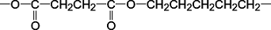
(i) Name the diol used.
...............................................................................................................
(1)
(ii) Draw the displayed formula of the diacyl chloride used.

(1)
(iii) A shirt was made from this polyester. A student wearing the shirt accidentally splashed aqueous sodium hydroxide on a sleeve. Holes later appeared in the sleeve where the sodium hydroxide had been.
Name the type of reaction that occurred between the polyester and the aqueous sodium hydroxide. Explain why the aqueous sodium hydroxide reacted with the polyester.
Type of reaction ....................................................................................
Explanation ...........................................................................................
...............................................................................................................
...............................................................................................................
...............................................................................................................
(3)

(c) (i) Complete the following equation for the preparation of aspirin using ethanoic anhydride by writing the structural formula of the missing product.

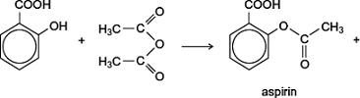 | ......................

(1)
(ii) Suggest a name for the mechanism for the reaction in part (c)(i).
...............................................................................................................
(1)
(iii) Give two industrial advantages, other than cost, of using ethanoic anhydride rather than ethanoyl chloride in the production of aspirin.
Advantage 1 ..........................................................................................
...............................................................................................................
...............................................................................................................
Advantage 2 ..........................................................................................
...............................................................................................................
...............................................................................................................
(2)
(d) Complete the following equation for the reaction of one molecule of benzene-1,2-dicarboxylic anhydride (phthalic anhydride) with one molecule of methanol by drawing the structural formula of the single product
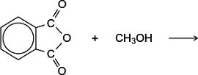
(1)

(e) The indicator phenolphthalein is synthesised by reacting phthalic anhydride with phenol as shown in the following equation.
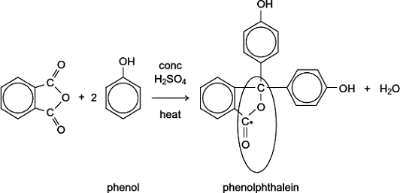
(i) Name the functional group ringed in the structure of phenolphthalein.
...............................................................................................................
(1)
(ii) Deduce the number of peaks in the ¹³C n.m.r. spectrum of phenolphthalein.
...............................................................................................................
(1)
(iii) One of the carbon atoms in the structure of phenolphthalein shown above is labelled with an asterisk (*).
Use Table 3 on the Data Sheet to suggest a range of δ values for the peak due to this carbon atom in the ¹³C n.m.r. spectrum of phenolphthalein.
...............................................................................................................
(1)

(f) Phenolphthalein can be used as an indicator in some acid–alkali titrations.
The pH range for phenolphthalein is 8.3 – 10.0
(i) For each acid.alkali combination in the table below, put a tick () in the box if phenolphthalein could be used as an indicator.

Acid | Alkali | Tick  box ()
sulfuric acid | sodium hydroxide
hydrochloric acid | ammonia
ethanoic acid | potassium hydroxide
nitric acid | methylamine
(2)
(ii) In a titration, nitric acid is added from a burette to a solution of sodium hydroxide containing a few drops of phenolphthalein indicator.
Give the colour change at the end-point.
...............................................................................................................
(1)
(Total 21 marks)

3. | 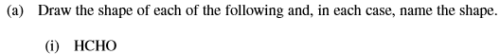  Name of shape:………………………………………………………………………………
 | Name of shape:………………………………………………………………………………
 | Name of shape:………………………………………………………………………………

Name of shape:………………………………………………………………………………
(8)
 | (2)

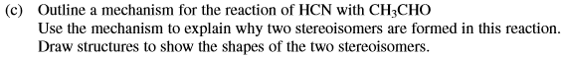

(5)
(Total 15 marks)

4. | 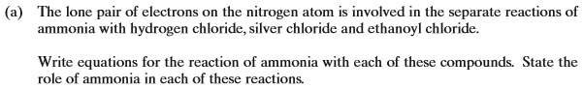  ………………………………………………………………………………………………………………………………………………………………………………..  ………………………………………………………………………………………………………………………………………………………………………………..  ………………………………………………………………………………………………………………………………………………………………………………..  ………………………………………………………………………………………………………………………………………………………………………………..  ………………………………………………………………………………………………………………………………………………………………………………..  ………………………………………………………………………………………………………………………………………………………………………………..  ………………………………………………………………………………………………………………………………………………………………………………..  ………………………………………………………………………………………………………………………………………………………………………………..  (7)

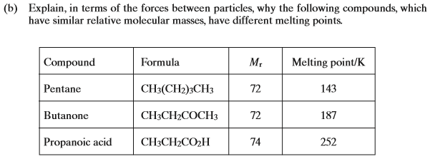

………………………………………………………………………………………………………………………………………………………………………………..

………………………………………………………………………………………………………………………………………………………………………………..

………………………………………………………………………………………………………………………………………………………………………………..

………………………………………………………………………………………………………………………………………………………………………………..

………………………………………………………………………………………………………………………………………………………………………………..

………………………………………………………………………………………………………………………………………………………………………………..

………………………………………………………………………………………………………………………………………………………………………………..

………………………………………………………………………………………………………………………………………………………………………………..
(8)
(Total 15 marks)

5. Which one of the following lists the first ionisation energies (in kJ mol⁻¹) of the elements Mg, Al, Si, P and S in this order?

 | A | 577 | 786 | 1060 | 1000 | 1260
 | B | 736 | 577 | 786 | 1060 | 1000
 | C | 786 | 1060 | 1000 | 1260 | 1520
 | D | 1060 | 1000 | 1260 | 1520 | 418

(Total 1 mark)

6. Sodium hydrogencarbonate decomposes on heating as shown by the equation below.
2NaHCO₃ → Na₂CO₃ + H₂O + CO₂
The volume of carbon dioxide, measured at 298 K and 101 kPa, obtained by heating 0.0500 mol of sodium hydrogencarbonate is
A 613 cm³
B 1226 cm³
C 613 dm³
D 1226 dm³
(Total 1 mark)

7. This question is about the reaction between propanone and an excess of ethane-1,2-diol, the equation for which is given below.
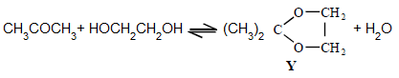
In a typical procedure, a mixture of 1.00 g of propanone, 5.00 g of ethane-1,2-diol and 0.100 g of benzenesulphonic acid, C₆H₅SO₃H, is heated under reflux in an inert solvent. Benzenesulphonic acid is a strong acid.
If 1.00 g of propanone was vapourised at 100 °C and 100 kPa pressure, the volume in m³ of gas formed would be
A 31.0
B 8.31
C 0.534
D 5.34 × 10⁻⁴
(Total 1 mark)

8. Use the information below to answer this question.
A saturated solution of magnesium hydroxide, Mg(OH)₂, contains 0.1166 g of Mg(OH)₂ in 10.00 dm³ of solution. In this solution the magnesium hydroxide is fully dissociated into ions.
Which one of the following is the concentration of Mg²⁺(aq) ions in the saturated solution?
A 2.82 × 10⁻² mol dm⁻³
B 2.00 × 10⁻³ mol dm⁻³
C 2.82 × 10⁻³ mol dm⁻³
D 2.00 × 10⁻⁴ mol dm⁻³
(Total 1 mark)

9. Which one of the following molecules is not planar?
A BF₃
B NCl₃
C C₂H₄
D HCHO
(Total 1 mark)

10. An aqueous solution of a white solid gives a yellow precipitate with aqueous silver nitrate. The formula of the white solid could be
A AgBr
B AgI
C NaBr
D NaI
(Total 1 mark)

11. An alkane contains 30 hydrogen atoms per molecule. Its empirical formula is
A C₆H₁₅
B C₇H₁₅
C C₁₄H₃₀
D C₁₅H₃₀
(Total 1 mark)

12. The correct systematic name for 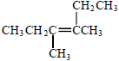 is

A 2,3-diethylbut-2-ene
B 2-ethyl-3-methylpent-2-ene
C 4-ethyl-3-methylpent-3-ene
D 3,4-dimethylhex-3-ene
(Total 1 mark)

13. The data below refer to the industrial production of nitric acid from ammonia.
Reaction 1 4NH₃(g) + 5O₂(g) 4NO(g) + 6H₂O(g) ∆H = −909 kJ mol⁻¹
Reaction 2 2NO(g) + O₂(g) 2NO₂(g) ∆H = −115 kJ mol⁻¹
Reaction 3 3NO₂(g) + H₂O(l) 2HNO₃(aq) + NO(g) ∆H = −117 kJ mol⁻¹
Possible units for the equilibrium constant, K_{c}, for reaction 2 are
A mol⁻² m⁶
B mol⁻¹ dm³
C no units
D mol dm⁻³
(Total 1 mark)

14. Which of these substances does not show hydrogen bonding?

 | A | HF
 | B | NH₃
 | C | CH₃COOH
 | D | CHF₃

(Total 1 mark)

15. | Hydrogen cyanide (HCN) molecules in the gas phase attract each other by:
 | A | Van der Waal’s forces and ionic bonds
 | B | Van der Waal’s forces and dipole-dipole forces
 | C | Ionic bonds and hydrogen bonds
 | D | Dipole-dipole forces and hydrogen bonds  (Total 1 mark)
16. | 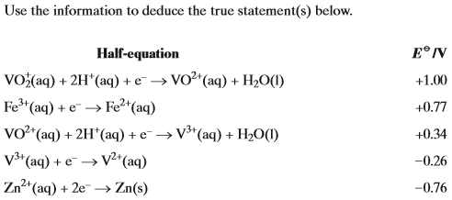  Which of the following statements is untrue?
 | A
 | B
 | C
 | D | Fe³⁺(aq) is capable of oxidising V²⁺(aq) to VO²⁺(aq) in acidic conditions.  (Total 1 mark)
17. | Which of the following statements about 1,2-diaminoethane,, is untrue?
 | A
 | B
 | C
 | D | (Total 1 mark)

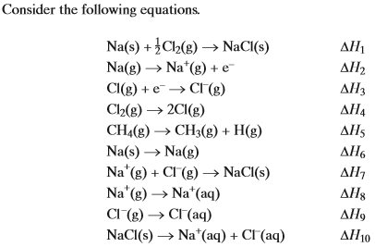
18. | Which enthalpy changes represent enthalpies of formation, bond dissociation or hydration?
 | A
 | B
 | C
 | D
19. | Which of the following enthalpy values would all be used in the calculation of the lattice enthalpy of NaCl using the Born-Haber cycle?
 | A
 | B
 | C
 | D | and ΔH₉  (Total 2 marks)

20. | 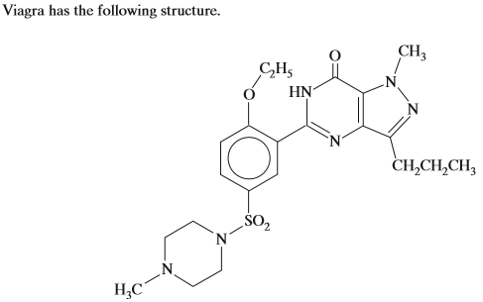  Which of the following statements about Viagra is untrue?
 | A | it can undergo Friedel-Crafts reactions
 | B | it exhibits optical isomerism
 | C | it is soluble in dilute hydrochloric acid
 | D | it can undergo addition polymerisation  (Total 1 mark)

Consider the following reaction sequence:
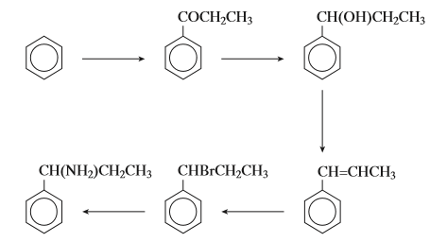

21. | Which of type of reaction is not involved in the above sequence?
 | A | Acylation
 | B | Dehydration
 | C | Hydrolysis
 | D | Reduction
22. | Which type of mechanism is not involved in the above sequence?
 | A | electrophilic addition
 | B | electrophilic substitution
 | C | nucleophilic addition-elimination
 | D | nucleophilic substitution  (Total 2 marks)
23. | Four pairs of reagents are listed below. Which of the statements about the spectra of the organic products of these reactions is incorrect?
 | A
 | B | methylpropanoyl chloride and ethanol 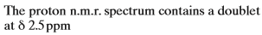
 | C
 | D | (Total 1 mark)

24. |  | Which of the following is not a correct statement about?
 |  | A |  | it can be formed by oxidation of pent-2-en-1-ol
 |  | B |  | it forms an addition polymer
 |  | C |  | it exists as two optical isomers
 |  | D |  | 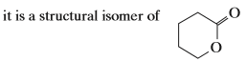  (Total 1 mark)
25. |  | 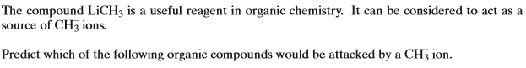
 |  | A |  | bromoethane and ethene
 |  | B |  | bromoethane and propanone
 |  | C |  | ethene and benzene
 |  | D |  | benzene and propanone  (Total 1 mark)
26. | Which of the following statements is incorrect?
 | A
 | B |  | nitriles
 | C |  | nitriles
 | D |  | the H-N-C bond angle in methylamine is greater than the H-O-C bond angle in methanol  (Total 1 mark)
27. | Which of the following statements is correct?
 | A
 | B
 | C |  | A redox reaction occurs between
 | D |  | A redox reaction occurs between  (Total 1 mark)
28. | Which of the following statements is correct?
 | A |  | The lattice dissociation energy of the sodium halide increases down Group VII
 | B
 | C |  | The production of nylon 6,6 by polymerisation involves free radicals
 | D |  | The reaction between produces more than one organic product  (Total 1 mark)

29. | 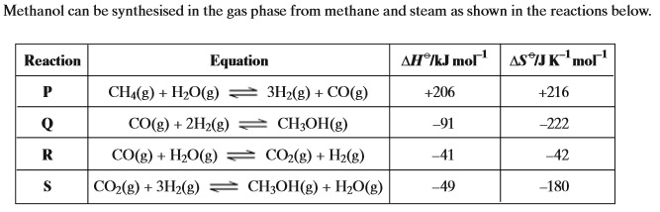  Which of these reactions is feasible at 900 K?
 | A | Reaction P
 | B | Reaction Q
 | C | Reaction R
 | D | Reaction S  (Total 1 mark)
30. | Which of the following species does not contain three atoms in a straight line?
 | A
 | B
 | C
 | D | (Total 1 mark)
31. | Which of the following solutions is colourless?
 | A | iron (III) chloride
 | B | silver nitrate
 | C | cobalt (II) sulphate
 | D | iodine and potassium iodide  (Total 1 mark)

32. | 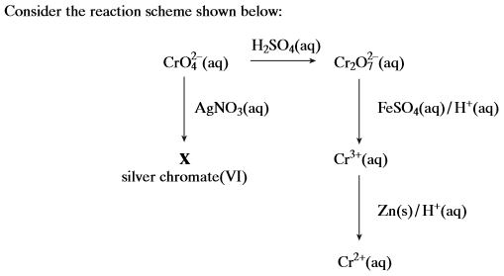  Which one of the following statements is correct?
 | A
 | B
 | C
 | D | The equation correctly describes the reduction of Cr₂O₇²⁻ by acidified FeSO₄  (Total 1 mark)
33. | Which of the following is an amphoteric hydroxide?
 | A | Mg(OH)₂
 | B | Al(OH)₃
 | C | Fe(OH)₃
 | D | Ba(OH)₂  (Total 1 mark)
34. | Which of the following structures does not have a central atom having a co-ordination number of 6 and an oxidation state of +2?
 | A
 | B
 | C
 | D

