A-LEVEL CHEMISTRY

PAPER 3
PRACTICE PAPER 12

Answer all questions
Max 90 marks
1 hour 45 minutes

Name ……………………………………………………………..

Mark ……../90 ……....% Grade ………

The first 10 multiple choice questions have already been used for AS-level resources

1. A student investigated how the initial rate of reaction between sulfuric acid and magnesium at 20 °C is affected by the concentration of the acid.
The equation for the reaction is
H₂SO₄(aq) + Mg(s) MgSO₄(aq) + H₂(g)
(a) The student made measurements every 20 seconds for 5 minutes. The student then repeated the experiment using double the concentration of sulfuric acid.
State a measurement that the student should make every 20 seconds. Identify the apparatus that the student could use to make this measurement.
...........................................................................................................................
...........................................................................................................................
...........................................................................................................................
...........................................................................................................................
(2)
(b) State one condition, other than temperature and pressure, that would need to be kept constant in this investigation.
...........................................................................................................................
...........................................................................................................................
(1)
(c) When the student had finished the investigation, an excess of sodium hydroxide solution was added to the reaction mixture. This was to neutralise any unreacted sulfuric acid. The student found that a further reaction took place, producing magnesium hydroxide.
(i) Draw a diagram to show how the student could separate the magnesium hydroxide from the reaction mixture.

(2)
(ii) Suggest one method the student could use for removing soluble impurities from the sample of magnesium hydroxide that has been separated.
...............................................................................................................
...............................................................................................................
...............................................................................................................
...............................................................................................................
(1)
(Total 6 marks)
2. The carbonyl compound CH₃CH₂CHO reacts very slowly with HCN
(a) In practice, KCN rather than HCN is added to the carbonyl compound.
Given that K_{a} for HCN = 4.0 × 10^{–10} mol dm^{–3}, suggest why the reaction with HCN is very slow.
........................................................................................................................
........................................................................................................................
........................................................................................................................
........................................................................................................................
(2)
(b) Acrylic fibres are used as a substitute for wool. Acrylics are copolymers of acrylonitrile with other compounds.
Acrylonitrile is the common name for the following compound.
H₂C = CH − C ≡ N
(i) Acrylonitrile can be formed from propene.
Write an equation for the reaction of propene with ammonia and oxygen to form acrylonitrile and one other product.
...............................................................................................................
(1)
(ii) The term copolymer is used to describe the product obtained when two or more different monomers form a polymer.
Draw the repeating unit of the acrylic copolymer that contains 75% acrylonitrile monomer and 25% chloroethene monomer.

(1)
(iii) Name the type of polymerisation involved in part (ii)
...............................................................................................................
(1)
(Total 5 marks)

3. | 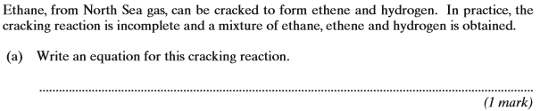
 | 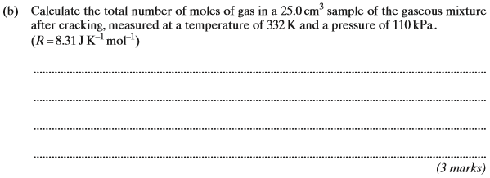
 | 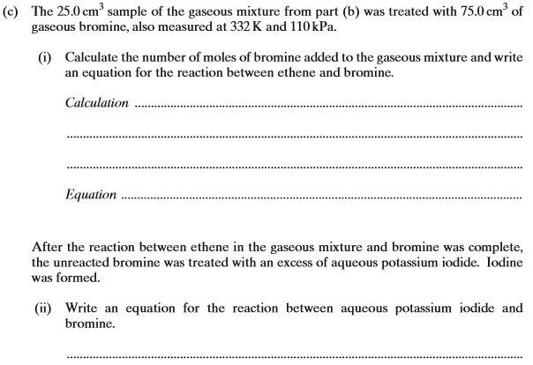
 | 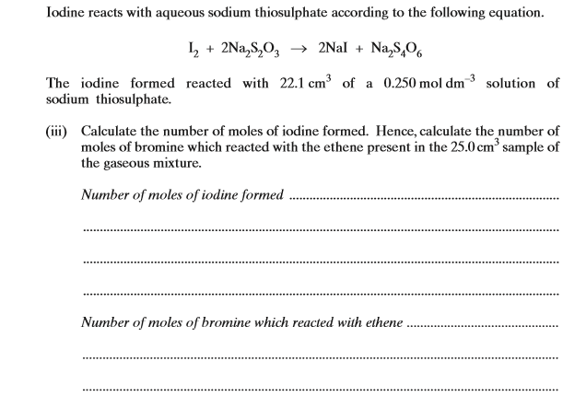
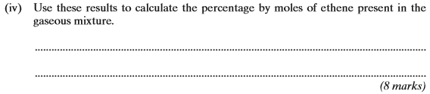
(Total 12 marks)

4. | 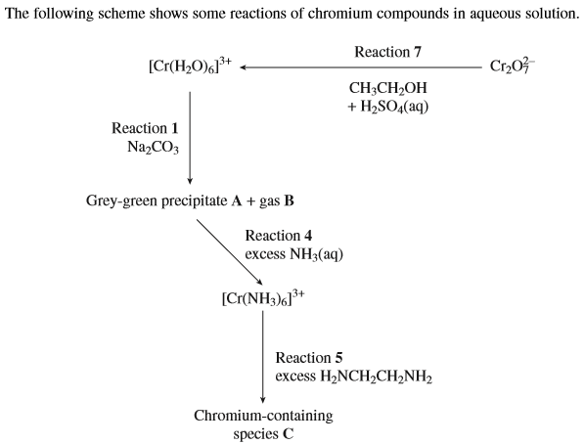  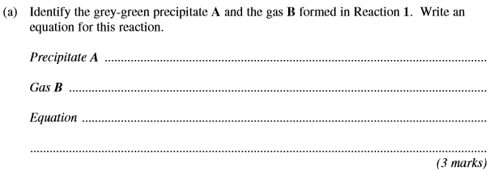
 | (b) | 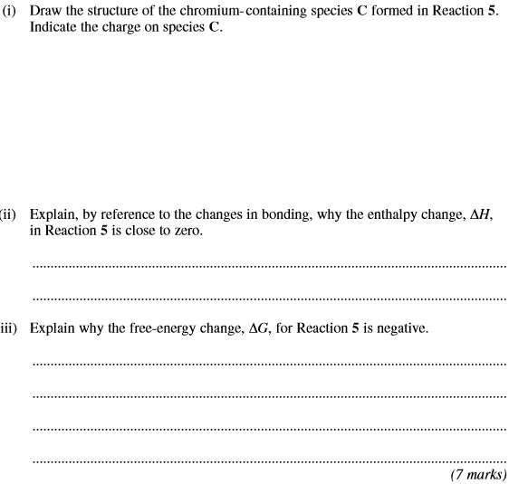
 | (c) | 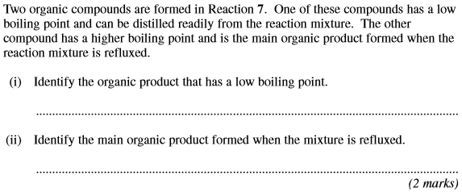  (Total 12 marks)

5. | ………………………………………………………………………………………………………………………………………………………………………………..  ………………………………………………………………………………………………………………………………………………………………………………..  ………………………………………………………………………………………………………………………………………………………………………………..  ………………………………………………………………………………………………………………………………………………………………………………..  ………………………………………………………………………………………………………………………………………………………………………………..  ………………………………………………………………………………………………………………………………………………………………………………..  (5)
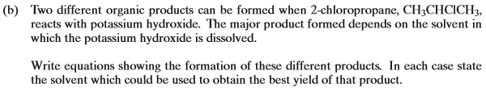

………………………………………………………………………………………………………………………………………………………………………………..

………………………………………………………………………………………………………………………………………………………………………………..

………………………………………………………………………………………………………………………………………………………………………………..

………………………………………………………………………………………………………………………………………………………………………………..

………………………………………………………………………………………………………………………………………………………………………………..
(4)

………………………………………………………………………………………………………………………………………………………………………………..

………………………………………………………………………………………………………………………………………………………………………………..

………………………………………………………………………………………………………………………………………………………………………………..

………………………………………………………………………………………………………………………………………………………………………………..
(3)
(Total 12 marks)

6. | 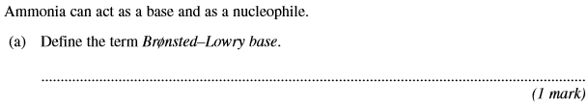
 | 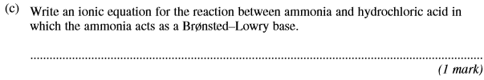
 | 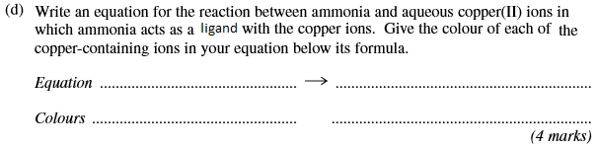
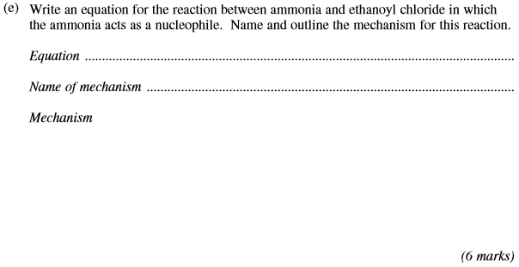
(Total 13 marks)

7. Silver oxide, Ag₂O, can be reduced by passing hydrogen gas over the heated oxide. The maximum mass of silver that could be obtained from 2.32 g of silver oxide is
A 2.02 g
B 2.06 g
C 2.12 g
D 2.16 g
(Total 1 mark)

8. 25.0 cm³ of ethanedioic acid required 22.5 cm³ of 0.100 mol dm⁻³ potassium hydroxide solution for complete neutralisation.
The concentration of ethanedioic acid is
A 0.0225 mol dm⁻³
B 0.0450 mol dm⁻³
C 0.0560 mol dm⁻³
D 0.0900 mol dm⁻³
(Total 1 mark)

9. The ester methyl ethanoate is hydrolysed as shown in the following equation.
CH₃COOCH₃(l) + H₂O(l) CH₃COOH(l) + CH₃OH(l) ΔH = +3 kJ mol⁻¹
A 3 mol sample of methyl ethanoate was mixed with 3 mol of water and left to reach equilibrium at 298 K. The equilibrium yield of ethanoic acid was 2 mol. The value of K_{c} for this reaction at 298 K is
A
B
C 2
D 4
(Total 1 mark)

10. An equation for the incomplete combustion of butane in oxygen is
C₄H₁₀ + 4 O₂ → 4CO + 5H₂O
The volume in dm³ of oxygen at 295 K and 100 kPa required to burn 0.1 mol of butane to form steam and carbon monoxide only is
A 8.6
B 11
C 12
C 16
(Total 1 mark)

11. Which type of bond is formed between N and B when a molecule of NH₃ reacts with a molecule of BF₃?

 | A | Ionic.
 | B | Covalent.
 | C | Co-ordinate.
 | D | Van der Waals.

(Total 1 mark)

12. The table below shows data for the four hydrocarbons ethyne, propyne, propene and propane. ΔHc is the standard enthalpy of combustion of these hydrocarbons.

 | Compound | Name | M_{r} | −ΔHc / kJ mol⁻¹
 | HC≡CH | ethyne | 26 | 1300
 | HC≡CCH₃ | propyne | 40 | 1940
 | H₂C=CHCH₃ | propene | 42 | 2060
 | CH₃CH₂CH₃ | propane | 44 | 2220

The complete combustion of 2.0 g of one of the above hydrocarbons releases exactly 100 kJ of heat energy.
This hydrocarbon is
A ethyne
B propyne
C propene
D propane
(Total 1 mark)

13. On heating, magnesium reacts vigorously with element X to produce compound Y. An aqueous solution of Y, when treated with aqueous silver nitrate, gives a white precipitate that is readily soluble in dilute aqueous ammonia. What is the minimum mass of X that is needed to react completely with 4.05 g of magnesium?
A 11.83 g
B 5.92 g
C 5.33 g
D 2.67 g
(Total 1 mark)

14. Use the information below to answer this question.
C(s) + O₂(g) → CO₂(g) ∆H = −393.5 kJ mol⁻¹
H₂(g) + O₂(g) → H₂O(l) ∆H = −285.8 kJ mol⁻¹
3C(s) + 4H₂(g) → C₃H₈(g) ∆H = −104.0 kJ mol⁻¹
4C(s) + 5H₂(g) → C₄H₁₀(g) ∆H = −125.2 kJ mol⁻¹
The value in kJ mol⁻¹ of the enthalpy of thermal dissociation when butane forms propane, hydrogen and carbon is
A −26.3
B −17.5
C +17.5
C +21.2
(Total 1 mark)

15. Which one of the following molecules or ions is pyramidal in shape?
A BF₃
B CH
C CH
D SF
(Total 1 mark)

16. The removal of silicon dioxide with limestone in the Blast Furnace can be represented by the following equation.
CaCO₃(s) + SiO₂(s) → CaSiO₃(l) + CO₂(g)
The minimum mass of calcium carbonate needed to remove 1.00 tonne (1000 kg) of silicon dioxide is
A 0.46 tonne
B 0.60 tonne
C 1.67 tonne
D 2.18 tonne
(Total 1 mark)

17. | Which of the following will not form a precipitate with aqueous silver nitrate in the presence of an excess of aqueous ammonia?
 | A | NaCl(aq)
 | B | KBr(aq)
 | C | KI(aq)
 | D | CH₃CHO(aq)  (Total 1 mark)
18. | Which of the following ions could not catalyse this reaction:
 | A | Fe²⁺(aq)
 | B | Cu²⁺(aq)
 | C | Zn²⁺(aq)
 | D | Fe³⁺(aq)  (Total 1 mark)
19. |  | Intermolecular hydrogen bonding does not affect the boiling points of:
 | A | alcohols
 | B | aldehydes
 | C | carboxylic acids
 | D | Amines  (Total 1 mark)
20. | 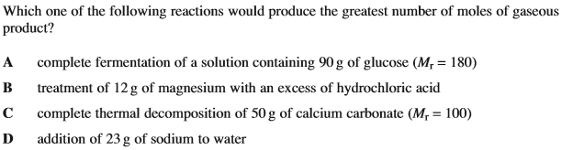  (Total 1 mark)
21. | 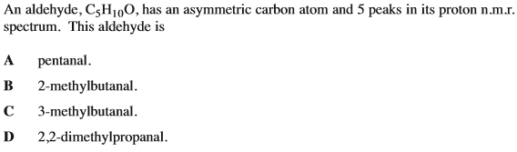  (Total 1 mark)
22. | 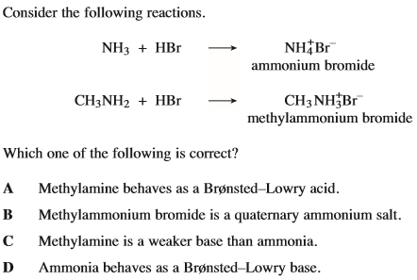  (Total 1 mark)
23. | 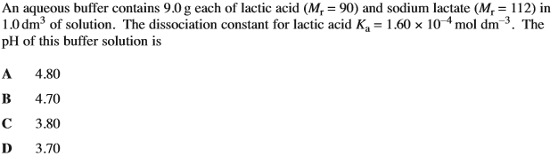  (Total 1 mark)
24. | 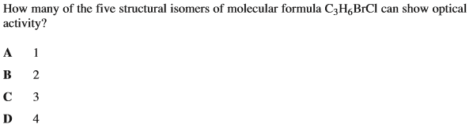  (Total 1 mark)
25. | 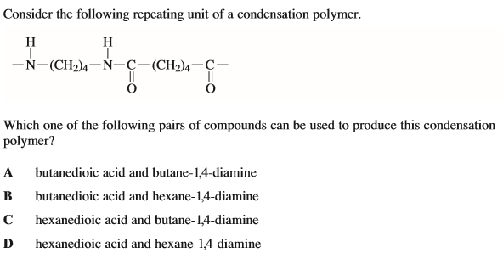  (Total 1 mark)
26. | 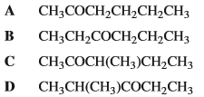  (Total 1 mark)
27. | 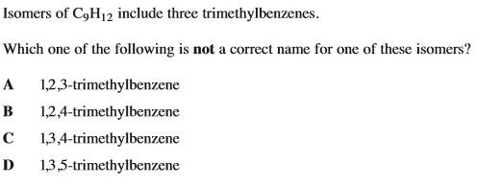  (Total 1 mark)

28. | 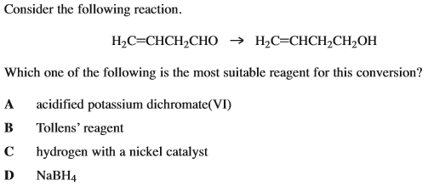  (Total 1 mark)
29. | Which of the following species does not contain two or more co-ordinate bonds?
 | A
 | B
 | C
 | D | (Total 1 mark)
30. | Which of the following reations involves ligand substitution without a change in coordination number?
 | A
 | B
 | C
 | D | (Total 1 mark)

31. |  | Which of the following is not a correct statement about the equilibrium mixture?
 |  | A
 |  | B
 |  | C
 |  | D |  | (Total 1 mark)
32. | 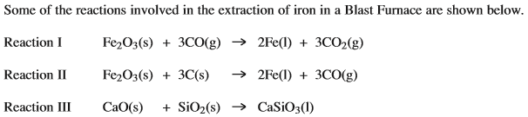  Which of the following statements is untrue?
 | A
 | B
 | C
 | D |  | (Total 1 mark)
33. | Which of the following supports the identification of an unknown compound as propanoyl chloride?
 | A
 | B |  | a triplet, a quartet and a singlet in its proton n.m.r. spectrum
 | C
 | D |  | (Total 1 mark)
34. | 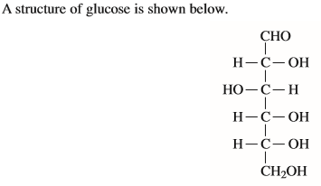  Which of the following statements about glucose is not correct?
 | A
 | B
 | C
 | D |  | (Total 1 mark)
35. | 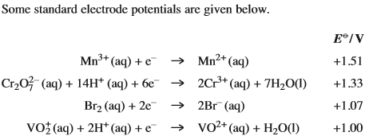  Which of the following statements is incorrect?
 | A
 | B
 | C
 | D |  | (Total 1 mark)

36. | Which of the following pairs of reagents forms a white precipitate when mixed?
 | A
 | B
 | C
 | D | (Total 1 mark)

