A-LEVEL CHEMISTRY

PAPER 3
PRACTICE PAPER 13

Answer all questions
Max 90 marks
1 hour 45 minutes

Name ……………………………………………………………..

Mark ……../90 ……....% Grade ………

The first 10 multiple choice questions have already been used for AS-level resources

1.
 | (c)
 | (Total 18 marks)
2. | 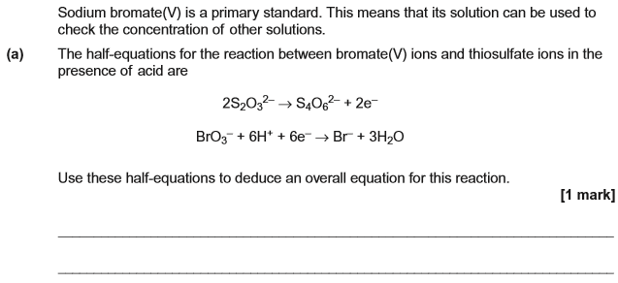
 | 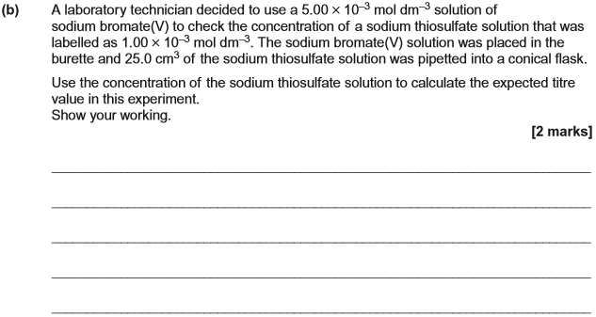
 | 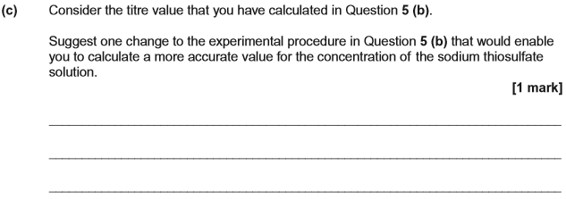
 | (d) | 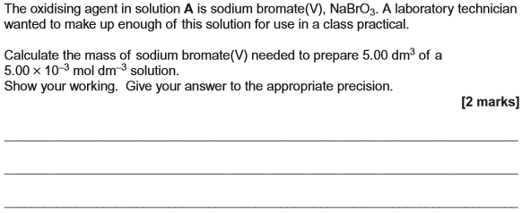  (Total 6 marks)
3. | 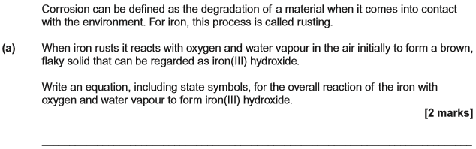
 | 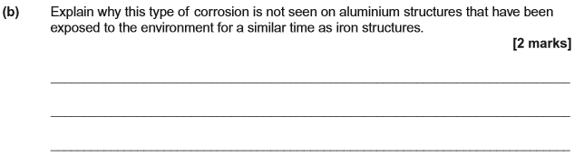
 | 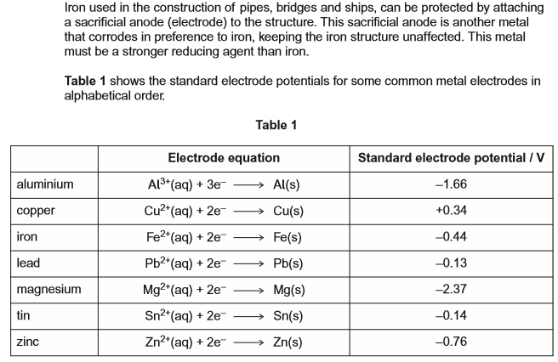
 | (c)
 | (d)
 | (e)
 | 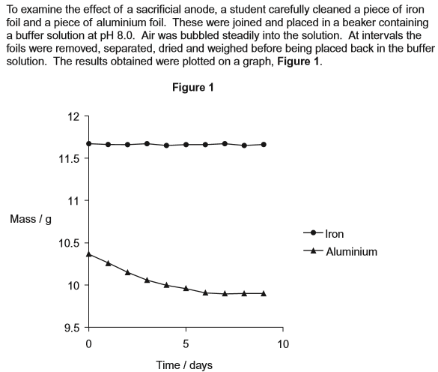
 | (f)
 | (g) | (Total 13 marks)
4. | 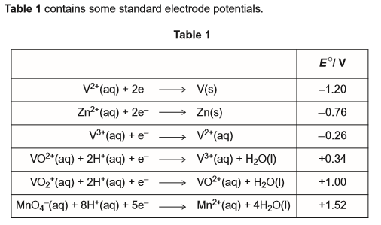
 | 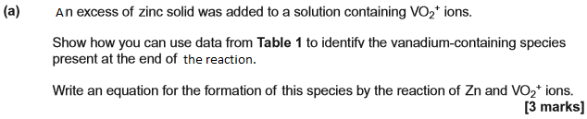
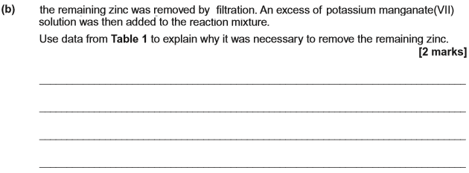
(Total 5 marks)

5. | 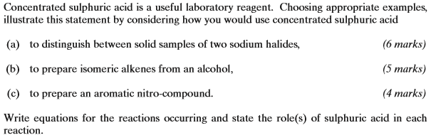  ………………………………………………………………………………………………………………………………………………………………………………..  ………………………………………………………………………………………………………………………………………………………………………………..  ………………………………………………………………………………………………………………………………………………………………………………..  ………………………………………………………………………………………………………………………………………………………………………………..  ………………………………………………………………………………………………………………………………………………………………………………..  ………………………………………………………………………………………………………………………………………………………………………………..  ………………………………………………………………………………………………………………………………………………………………………………..  ………………………………………………………………………………………………………………………………………………………………………………..  ………………………………………………………………………………………………………………………………………………………………………………..  ………………………………………………………………………………………………………………………………………………………………………………..  ………………………………………………………………………………………………………………………………………………………………………………..  ………………………………………………………………………………………………………………………………………………………………………………..  ………………………………………………………………………………………………………………………………………………………………………………..  ………………………………………………………………………………………………………………………………………………………………………………..  ………………………………………………………………………………………………………………………………………………………………………………..  ………………………………………………………………………………………………………………………………………………………………………………..  ………………………………………………………………………………………………………………………………………………………………………………..  ………………………………………………………………………………………………………………………………………………………………………………..  ………………………………………………………………………………………………………………………………………………………………………………..  ………………………………………………………………………………………………………………………………………………………………………………..  (Total 15 marks)
6. (a) Some metal ions are toxic to humans. A substance that can be used to treat such poisoning contains the ion EDTA^{4–}.
EDTA^{4–} forms very stable complexes with metal ions. These complexes are not toxic.
(i) Write an equation for the reaction of EDTA^{4–} with aqueous copper(II) ions, [Cu(H₂O)₆]²⁺.
...............................................................................................................
(1)
(ii) A solution containing EDTA^{4–} can also be used in a titration to determine the concentration of metal ions in solution.
A river was polluted with copper(II) ions. When a 25.0 cm³ sample of the river water was titrated with a 0.0150 mol dm^{–3} solution of EDTA^{4–}, 6.45 cm³ were required for complete reaction.
Calculate the concentration, in mol dm^{–3}, of copper(II) ions in the river water.
Show your working.
...............................................................................................................
...............................................................................................................
...............................................................................................................
...............................................................................................................
(2)
(b) The determination of the concentration of copper(II) ions in a single sample of river water gives an unreliable value for the copper(II) ion pollution in the river.
Give one reason why this value is unreliable.
........................................................................................................................
........................................................................................................................
(1)
(c) Silver complexes can be used to identify a particular organic functional group.
Give one example of a silver complex that can be used in this way and state the organic functional group it identifies.
Silver complex ...............................................................................................
Organic functional group ...............................................................................
(2)
(Total 6 marks)

7. Which atom has an incomplete sub-shell?
A Be
B Ca
C Ge
D Zn
(Total 1 mark)

8. When TiCI₄ is reduced with hydrogen under certain conditions, a new compound is produced which contains 68.9% chlorine by mass. Which one of the following could be the formula of the new compound?
A TiH₂Cl₂
B TiCl
C TiCl₂
D TiCl₃
(Total 1 mark)

9. Which one of the following is the most likely value for the bond angle α shown in the diagram of SF₄ below?
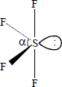
A 118°
B 101°
C 90°
D 88°
(Total 1 mark)

10. In which one of the following reactions is the standard enthalpy change equal to the standard enthalpy of formation of lithium fluoride?
A Li(g) + F(g) → LiF(s)
B Li⁺(g) + F⁻(g) → LiF(s)
C Li⁺(aq) + F⁻(g) → LiF(s)
D Li(s) + F₂(g) → LiF(s)
(Total 1 mark)

11.
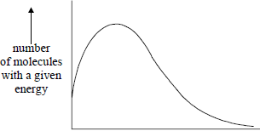
energy
The total area under the distribution curve represents
A total energy.
B activation energy.
C total number of reacting molecules.
D total number of molecules present.
(Total 1 mark)

12. A sample of chlorine gas was sealed in a tube, heated and an equilibrium was established.
Cl₂(g) ⇌ 2Cl(g)
Which one of the following is not true?
A The concentration of chlorine atoms remains the same when a catalyst is added to the tube.
B Increase in temperature causes an increase in the concentration of chlorine atoms.
C Increase in pressure causes an increase in the concentration of chlorine atoms relative to chlorine molecules.
D Addition of more chlorine gas to the tube causes an increase in the concentration of chlorine atoms.
(Total 1 mark)

13. Which of these species is the best reducing agent?

 | A | Cl₂
 | B | Cl⁻
 | C | I₂
 | D | I⁻

(Total 1 mark)
14. The number of structural isomers of C₃H₂Cl₆ is
A 2
B 3
C 4
D 5
(Total 1 mark)

15. Which of these substances does not contribute to the greenhouse effect?

 | A | Unburned hydrocarbons.
 | B | Carbon dioxide.
 | C | Water vapour.
 | D | Nitrogen.

(Total 1 mark)

16. | 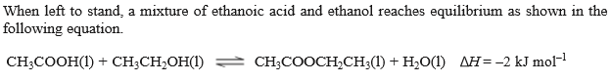  The amount of CH₃CH₂OH at equilibrium cannot be increased by:
 | A | adding more water
 | B | raising the temperature
 | C | adding some dilute aqueous sodium hydroxide
 | D | adding a catalyst  (Total 1 mark)
17. | 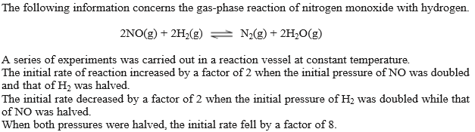  Which statement is correct?
 | A | the overall order of reaction is 2
 | B | the reaction is first order with respect to nitrogen monoxide
 | C | the reaction is second order with respect to hydrogen
 | D | the overall order of reaction is 3  (Total 1 mark)
18. | Which of the following processes is not accompanied by an increase in entropy?
 | A | decomposing ammonia gas into hydrogen and nitrogen
 | B | melting ice
 | C | dissolving magnesium sulphate in water
 | D | converting sulphur dioxide gas into sulphur trioxide in the Contact Process  (Total 1 mark)
19. | 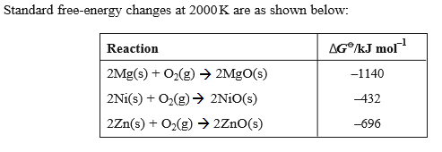  Which of the following reactions is feasible at 2000 K?
 | A | reduction of zinc oxide by magnesium
 | B | reduction of zinc oxide by nickel
 | C | oxidation of nickel by magnesium oxide
 | D | oxidation of nickel by zinc oxide  (Total 1 mark)
20. | Cyanide ions will react with:
 | A | C₂H₆ and C₆H₆
 | B | CH₃CH₂Br and CH₃COCH₃
 | C | C₂H₆ and CH₃CH₂Br
 | D | C₆H₆ and CH₃COCH₃  (Total 1 mark)
21.
 | A | and
 | B | and
 | C | and
 | D | and  (Total 1 mark)

22. | In water, hydrogen cyanide is a weak acid with a pK_{a} of 9.4. Which of the following is not true concerning 500 cm of aqueous HCN that has a concentration of 0.10 moldm⁻³?
 | A | It will react completely with 2.5 g of sodium hydroxide
 | B | The pH of the solution is 5.2
 | C | it can be formed by dissolving 1.35 g of HCN in water and making up to 500 cm³ of solution
 | D | the amount of HCN in the solution can be determined accurately by titration of a 25.0 cm³ sample with a 0.1 moldm⁻³ solution of NaOH using methyl orange as indicator  (Total 1 mark)
23.
 | A | 10H⁺ + SO₄²⁻ + 8I⁻ H₂S + I₂ + 4H₂O
 | B
 | C
 | D | (Total 1 mark)
24. | Which of the following is true concerning the CH₃⁻ ion?
 | A | it has bond angles of 120º
 | B | it is an electrophile
 | C | it has two lone pairs of electrons
 | D | It is a base  (Total 1 mark)
25. | 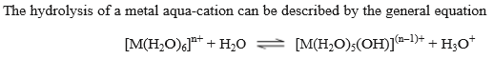  In this reaction, which of the following is not true?
 | A | the solvent H₂O is acting as a base by accepting a proton
 | B | the pH of the solution will be lower if the value of n is 3 rather than 2
 | C | the equilibrium position lies more to the right if the value of n is 3 rather than 2
 | D | the oxidation state of the central metal cation has decreased from n to n-1

26. | Which of the following involves the reduction of a transition metal?
 | A
 | B
 | C
 | D | (Total 1 mark)
27. | Which of the following statements is true?
 | A | 6.6 g of ethanol were used in the reaction
 | B | both ethanol and ethanal have three different proton environments
 | C | the theoretical yield of ethanal is 6.6 g
 | D | Tollen’s reagent will oxidise both ethanol and ethanal to ethanoic acid  (Total 1 mark)
28. | Which of the following statements is untrue?
 | A | The colour changes from colourless to purple at the equivalence point
 | B | Dilute H₂SO₄ is a suitable acid for use in this titration
 | C | Each mole of H₂O₂ accepts one mole of electrons
 | D | [Mn(H₂O)₆]²⁺ is formed in the reaction  (Total 1 mark)

29. | Which of the following conversions is a reduction?
 | A | 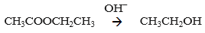
 | B | 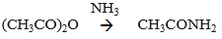
 | C | 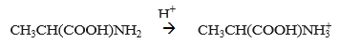
 | D | 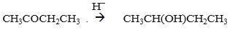  (Total 1 mark)
30. | An inorganic species does not act as the nucleophile in the reaction between:
 | A
 | B
 | C
 | D | (Total 1 mark)
31.
 | A | an electron pair acceptor and a catalyst
 | B | an electron pair acceptor and oxidising agent
 | C | an oxidising agent and a base
 | D | an electron pair acceptor and a base  (Total 1 mark)

32. | Which of the following statements correctly describe which molecules are capable of forming hydrogen bonds?
 | A | but not
 | B | but not
 | C | and
 | D | and
33. | 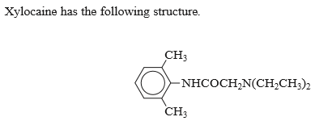  Which of the following statements about xylocaine is incorrect?
 | A | it is soluble in dilute hydrochloric acid
 | B | it can form a quaternary ammonium salt
 | C | it contains a chiral centre
 | D | it can undergo Friedel-Crafts reactions

