A-LEVEL CHEMISTRY

PAPER 3
PRACTICE PAPER 14

Answer all questions
Max 90 marks
1 hour 45 minutes

Name ……………………………………………………………..

Mark ……../90 ……....% Grade ………

This paper contains structured questions only

1. | (3 marks)  (Total 3 marks)
2. | 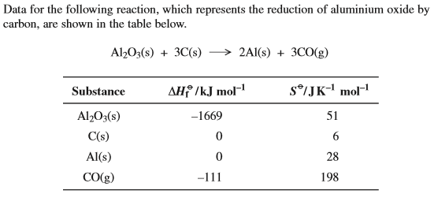  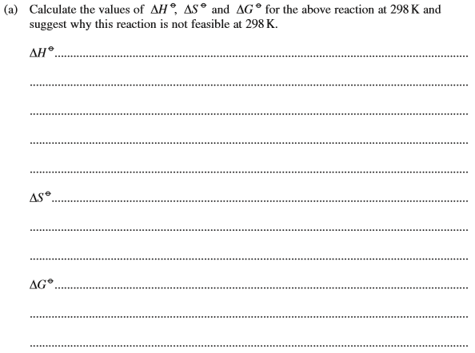  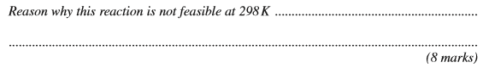
 | 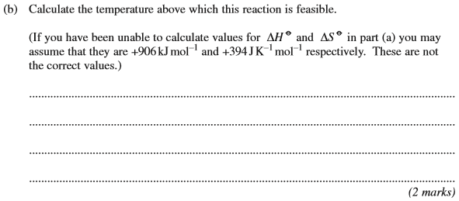
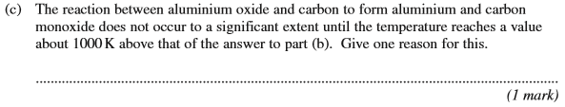
(Total 11 marks)

3. | 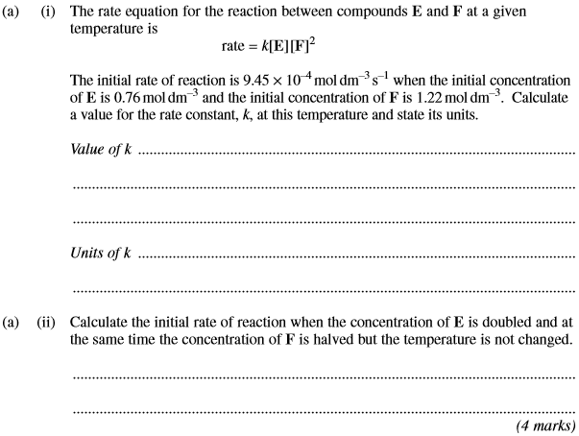
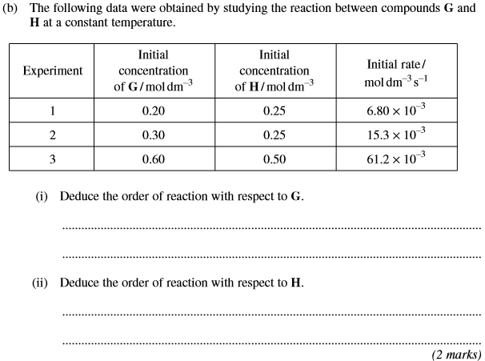
(Total 6 marks)

4. | 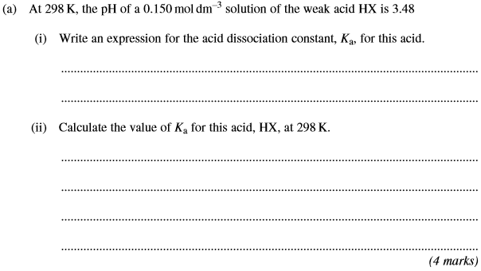
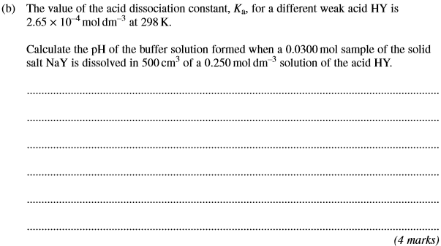
(Total 8 marks)

5. | 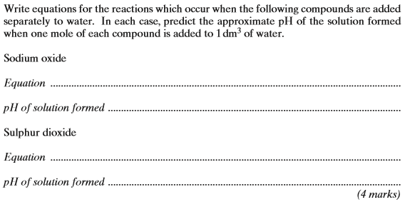  (Total 4 marks)
6. | 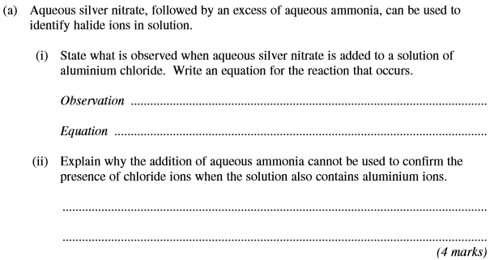
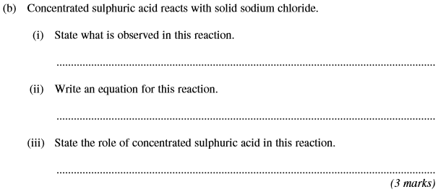
(Total 7 marks)

7. | ……………………………………………………………………………………………………………………………………………………………………………  ……………………………………………………………………………………………………………………………………………………………………………  ……………………………………………………………………………………………………………………………………………………………………………  (2 marks)

……………………………………………………………………………………………………………………………………………………………………………

……………………………………………………………………………………………………………………………………………………………………………

……………………………………………………………………………………………………………………………………………………………………………

……………………………………………………………………………………………………………………………………………………………………………

……………………………………………………………………………………………………………………………………………………………………………

……………………………………………………………………………………………………………………………………………………………………………

……………………………………………………………………………………………………………………………………………………………………………

……………………………………………………………………………………………………………………………………………………………………………

……………………………………………………………………………………………………………………………………………………………………………

……………………………………………………………………………………………………………………………………………………………………………

……………………………………………………………………………………………………………………………………………………………………………
(9 marks)

……………………………………………………………………………………………………………………………………………………………………………

……………………………………………………………………………………………………………………………………………………………………………

……………………………………………………………………………………………………………………………………………………………………………
(2 marks)
(Total 13 marks)

8. | 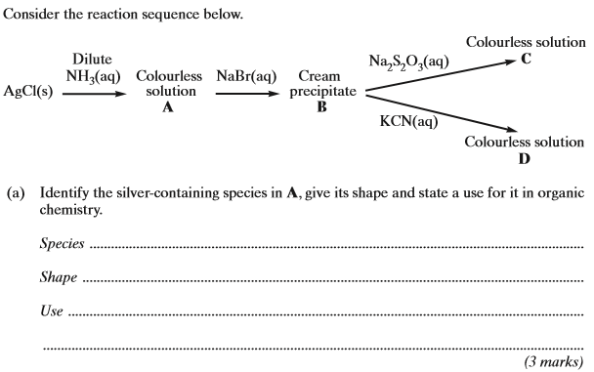
 | (b) | 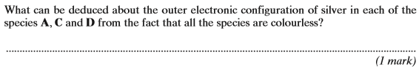  (Total 4 marks)
9. | 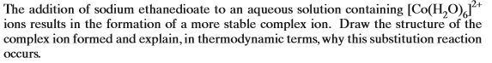  ……………………………………………………………………………………………………………………………………………………………………………  ……………………………………………………………………………………………………………………………………………………………………………  ……………………………………………………………………………………………………………………………………………………………………………  (Total 4 marks)
10. | 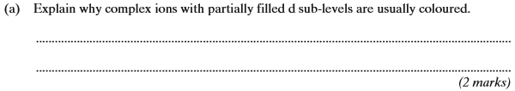
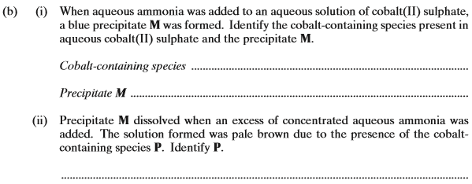
(3 marks)
(Total 5 marks)

11. | ……………………………………………………………………………………………………………………………………………………………………………  ……………………………………………………………………………………………………………………………………………………………………………  ……………………………………………………………………………………………………………………………………………………………………………  ……………………………………………………………………………………………………………………………………………………………………………  ……………………………………………………………………………………………………………………………………………………………………………  ……………………………………………………………………………………………………………………………………………………………………………  ……………………………………………………………………………………………………………………………………………………………………………  ……………………………………………………………………………………………………………………………………………………………………………  ……………………………………………………………………………………………………………………………………………………………………………  ……………………………………………………………………………………………………………………………………………………………………………  ……………………………………………………………………………………………………………………………………………………………………………  ……………………………………………………………………………………………………………………………………………………………………………  ……………………………………………………………………………………………………………………………………………………………………………  (Total 11 marks)

12. | ……………………………………………………………………………………………………………………………………………………………………………  ……………………………………………………………………………………………………………………………………………………………………………  ……………………………………………………………………………………………………………………………………………………………………………  ……………………………………………………………………………………………………………………………………………………………………………  (6 marks)

……………………………………………………………………………………………………………………………………………………………………………

……………………………………………………………………………………………………………………………………………………………………………

……………………………………………………………………………………………………………………………………………………………………………

……………………………………………………………………………………………………………………………………………………………………………

(8 marks)
(Total 14 marks)

