A-LEVEL CHEMISTRY

PAPER 3
PRACTICE PAPER 5

Answer all questions
Max 90 marks
1 hour 45 minutes

Name ……………………………………………………………..

Mark ……../90 ……....% Grade ………

The first 10 multiple choice questions have already been used for AS-level resources

1. Group 2 metals and their compounds are used commercially in a variety of processes and applications.
(a) State a use of magnesium hydroxide in medicine.
......................................................................................................................
(1)
(b) Calcium carbonate is an insoluble solid that can be used in a reaction to lower the acidity of the water in a lake.
Explain why the rate of this reaction decreases when the temperature of the water in the lake falls.
......................................................................................................................
......................................................................................................................
......................................................................................................................
......................................................................................................................
......................................................................................................................
(3)
(c) Strontium metal is used in the manufacture of alloys.
(i) Explain why strontium has a higher melting point than barium.
.............................................................................................................
.............................................................................................................
.............................................................................................................
.............................................................................................................
(2)
(ii) Write an equation for the reaction of strontium with water.
.............................................................................................................
(1)

(d) Magnesium can be used in the extraction of titanium.
(i) Write an equation for the reaction of magnesium with titanium(IV) chloride.
.............................................................................................................
(1)
(ii) The excess of magnesium used in this extraction can be removed by reacting it with dilute sulfuric acid to form magnesium sulfate.
Use your knowledge of Group 2 sulfates to explain why the magnesium sulfate formed is easy to separate from the titanium.
.............................................................................................................
.............................................................................................................
.............................................................................................................
(1)
(Total 9 marks)

2. Hydrogen gas is used in the chemical industry.
(a) Tungsten is extracted by passing hydrogen over heated tungsten oxide (WO₃).
(i) State the role of the hydrogen in this reaction.
.............................................................................................................
(1)
(ii) Write an equation for this reaction.
.............................................................................................................
(1)
(iii) State one risk of using hydrogen gas in metal extractions.
.............................................................................................................
.............................................................................................................
(1)

(b) Hydrogen is used to convert oleic acid into stearic acid as shown by the following equation.
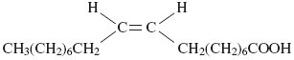 + H₂ 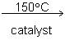 CH₃(CH₂)₁₆COOH
oleic acid stearic acid
(i) Use your knowledge of the chemistry of alkenes to deduce the type of reaction that has occurred in this conversion.
.............................................................................................................
(1)
(ii) State the type of stereoisomerism shown by oleic acid.
.............................................................................................................
(1)
(c) Hydrogen reacts with nitrogen in the Haber Process. The equation for the equilibrium that is established is shown below.
N₂(g) + 3H₂(g) 2NH₃(g)
(i) State Le Chatelier’s principle.
.............................................................................................................
.............................................................................................................
(1)
(ii) Use Le Chatelier’s principle to explain why an increase in the total pressure of this equilibrium results in an increase in the equilibrium yield of ammonia.
.............................................................................................................
.............................................................................................................
.............................................................................................................
.............................................................................................................
(2)

(d) Hydrogen reacts with oxygen in an exothermic reaction as shown by the following equation.
H₂(g) + O₂(g) → H₂O(g) ∆H = –242 kJ mol^{–1}
Use the information in the equation and the data in the following table to calculate a value for the bond enthalpy of the H–H bond.

 | O–H | O=O
Mean bond enthalpy / kJ mol^{–1} | + 463 | + 496
......................................................................................................................
......................................................................................................................
......................................................................................................................
......................................................................................................................
(3)
(Total 11 marks)

3. (a) Any ethanol present in the breath of a drinker can be detected by using a breathalyser.
The ethanol is converted into ethanoic acid. The breathalyser has negative and positive electrodes. A current is measured and displayed in terms of alcohol content.
The overall redox equation is as follows
CH₃CH₂OH(I) + O₂(g) CH₃COOH(I) + H₂O(I)
(i) Draw the displayed formula for ethanoic acid.

(1)
(ii) Deduce a half-equation for the reduction of atmospheric oxygen to water in acidic solution at one electrode of the breathalyser.
...............................................................................................................
(1)
(iii) Deduce a half-equation for the oxidation of ethanol in water to ethanoic acid at the other electrode of the breathalyser.
...............................................................................................................
(1)
(b) The fermentation of glucose from crops is the main method for the production of ethanol. The product is called bioethanol. The European Union has declared that bioethanol is carbon-neutral.
State the meaning of the term carbon-neutral.
...............................................................................................................
...............................................................................................................
...............................................................................................................
(1)
(Total 4 marks)

4. The pH curve shown below was obtained when a 0.150 mol dm^{–3} solution of sodium hydroxide was added to 25.0 cm³ of an aqueous solution of a weak monoprotic acid, HA.
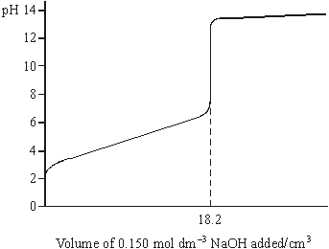
(a) Use the information given to calculate the concentration of the acid.
......................................................................................................................
......................................................................................................................
......................................................................................................................
(2)
(b) (i) Write an expression for the acid dissociation constant, K_{a}, for HA.
.............................................................................................................
(ii) Write an expression for pK_{a}
.............................................................................................................
(iii) Using your answers to parts (b)(i) and (b)(ii), show that when sufficient sodium hydroxide has been added to neutralise half of the acid,
pH of the solution = pK_{a} for the acid HA
.............................................................................................................
.............................................................................................................
.............................................................................................................
(4)
(c) Explain why dilution with a small volume of water does not affect the pH of a buffer solution.
......................................................................................................................
......................................................................................................................
(2)
(d) (i) Calculate the change in pH when 0.250 mol dm^{–3} hydrochloric acid is diluted with water to produce 0.150 mol dm^{–3} hydrochloric acid.
.............................................................................................................
.............................................................................................................
.............................................................................................................
(ii) Calculate the volume of water which must be added to 30.0 cm³ of 0.250 moldm⁻³ hydrochloric acid in order to reduce its concentration to 0.150 mol dm^{–3}.
.............................................................................................................
.............................................................................................................
.............................................................................................................
(4)
(Total 12 marks)

5. Consider the reaction scheme below and answer the questions which follow.
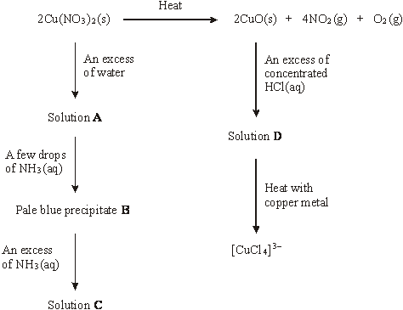
(a) A redox reaction occurs when Cu(NO₃)₂ is decomposed by heat. Deduce the oxidation state of nitrogen in Cu(NO₃)₂ and in NO₂ and identify the product formed by oxidation in this decomposition.
Oxidation state of nitrogen in Cu(NO₃)₂ ........................................................
Oxidation state of nitrogen in NO₂ ................................................................
Oxidation product .........................................................................................
......................................................................................................................
(3)
(b) Identify and state the shape of the copper-containing species present in solution A.
Copper-containing species ..........................................................................
Shape ..........................................................................................................
(2)

(c) (i) Identify the pale blue precipitate B and write an equation, or equations, to show how B is formed from the copper-containing species in solution A.
Identity of precipitate B ........................................................................
Equation(s) ..........................................................................................
.............................................................................................................
(ii) In what way does the NH₃ behave as a Brønsted–Lowry base?
.............................................................................................................
(3)
(d) Identify the copper-containing species present in solution C. State the colour of this copper-containing species and write an equation for its formation from
precipitate B.
Identity ................................................................................................
Colour .................................................................................................
Equation …..........................................................................................
.............................................................................................................
(3)
(e) Identify the copper-containing species present in solution D. State the colour and shape of this copper-containing species.
Identity .........................................................................................................
Colour ..........................................................................................................
Shape ..........................................................................................................
.....................................................................................................................
(3)
(f) The oxidation state of copper in [CuCl₄]^{3–} is +1.
(i) Give the electron arrangement of a Cu⁺ ion.
.............................................................................................................
(ii) Deduce the role of copper metal in the formation of [CuCl₄]^{3–} from the copper-containing species in solution D.
.............................................................................................................
(2)
(Total 16 marks)

6. Hydrogen peroxide is used as an oxidising agent in the preparation of transition metal complexes.
(a) Consider the following reaction scheme. All the complexes are in aqueous solution.
Reaction 1
[Co(H₂O)₆]²⁺ cobalt(II) complex
Identify a reagent for Reaction 1 and describe the colour change that occurs.
.............................................................................................................
.............................................................................................................
.............................................................................................................
.............................................................................................................
(3)
(b) The concentration of a hydrogen peroxide solution can be determined by titration with acidified potassium manganate(VII) solution. In this reaction the hydrogen peroxide is oxidised to oxygen gas.
A 5.00 cm³ sample of the hydrogen peroxide solution was added to a volumetric flask and made up to 250 cm³ of aqueous solution. A 25.0 cm³ sample of this diluted solution was acidified and reacted completely with 24.35 cm³ of 0.0187 mol dm^{–3} potassium manganate(VII) solution.
Write an equation for the reaction between acidified potassium manganate(VII) solution and hydrogen peroxide.
Use this equation and the results given to calculate a value for the concentration, in mol dm^{–3}, of the original hydrogen peroxide solution.
(If you have been unable to write an equation for this reaction you may assume that 3 mol of KMnO₄ react with 7mol of H₂O₂. This is not the correct reacting ratio.)
......................................................................................................................
......................................................................................................................
......................................................................................................................
......................................................................................................................
......................................................................................................................
......................................................................................................................
......................................................................................................................
......................................................................................................................
......................................................................................................................
......................................................................................................................
(5)
(Total 8 marks)

7. An atom in which the number of protons is greater than the number of neutrons is
A ²³⁴U
B ⁶Li
C ³He
D ²H
(Total 1 mark)

8. Which of these elements has the highest second ionisation energy?

 | A | Na
 | B | Mg
 | C | Ne
 | D | Ar

(Total 1 mark)

9. What is the total volume of gas remaining after 20 cm³ ethane are burned completely in 100 cm³ oxygen? All volumes are measured at the same pressure and the same temperature, which is above 100 °C.
C₂H₆ + 3O₂ 2CO₂ + 3H₂O

 | A | 40 cm³
 | B | 100 cm³
 | C | 120 cm³
 | D | 130 cm³

(Total 1 mark)

10. Which one of the following ions has three lone pairs of electrons around the central atom?
A BF
B NH
C ClF
D PF
(Total 1 mark)

11. When ethanamide (CH₃CONH₂) burns in oxygen the carbon is converted into carbon dioxide, the hydrogen is converted into water and the nitrogen forms nitrogen gas.

 | Substance | ethanamide | carbon dioxide | water
 | Enthalpy of formation () / kJ mol⁻¹ | −320 | −394 | −286

Using the data above, which one of the following is a correct value for the enthalpy of combustion of ethanamide?
A −1823 kJ mol⁻¹
B −1183 kJ mol⁻¹
C −1000 kJ mol⁻¹
D −360 kJ mo1⁻¹
(Total 1 mark)

12. The standard enthalpy of formation, ΔH_{f} for O₃(g) is + 142 kJ mol^{–1}. In which one of the following would both the changes shown increase the amount of O₂ gas in an equilibrium mixture containing only O₂(g) and O₃(g)?
A increasing the temperature and increasing the pressure
B increasing the temperature and decreasing the pressure
C decreasing the temperature and increasing the pressure
D decreasing the temperature and decreasing the pressure
(Total 1 mark)

13. Which one of the following statements is true?
A Bromine liberates iodine from aqueous sodium iodide.
B Chlorine liberates fluorine from aqueous sodium fluoride.
C Silver iodide is soluble in aqueous ammonia.
D Concentrated sulphuric acid liberates chlorine from solid sodium chloride.
(Total 1 mark)

14. Which one of the following is the correct name for 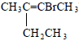 ?
A 2-bromo-3-methylpent-2-ene
B 2-bromo-3-ethylbut-2-ene
C 3-bromo-2-ethylbut-2-ene
D 4-bromo-3-methylpent-3-ene
(Total 1 mark)

15. Which statement about ethanal is correct?

 | A | It reacts with Tollens’ reagent to form silver.
 | B | It has a higher boiling point than ethanol.
 | C | Its empirical and molecular formulas are different.
 | D | It belongs to a homologous series with general formula C_{n}H_{2n+1}O

(Total 1 mark)

16. This question is about the reaction between propanone and an excess of ethane-1,2-diol, the equation for which is given below.
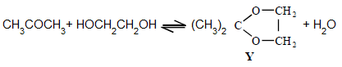
In a typical procedure, a mixture of 1.00 g of propanone, 5.00 g of ethane-1,2-diol and 0.100 g of benzenesulphonic acid, C₆H₅SO₃H, is heated under reflux in an inert solvent. Benzenesulphonic acid is a strong acid.
The products would not have an absorption in the infra-red at
A 1050 cm⁻¹
B 1720 cm⁻¹
C 2950 cm⁻¹
D 3400 cm⁻¹
(Total 1 mark)

17. Which of the following is a correct statement about 2-bromo-2-methylpropane?
A it is a secondary haloalkane.
B it exhibits hydrogen bonding between molecules.
C it has an M_{r} of 138
D it forms 2-methylpropene when heated with ethanolic NaOH
(Total 1 mark)

18. Which of the following statements would not support the identification of an unkwown compound as 2- methylpropan-2-ol?
A a broad absorption in its infra-red spectrum at 3350 cm⁻¹
B two singlets in its proton n.m.r. spectrum
C a reaction with concentrated sulphuric acid to give a compound which decolorises a solution of bromine
D turning acidified potassium dichromate (VI) solution from orange to green
(Total 1 mark)

19. | 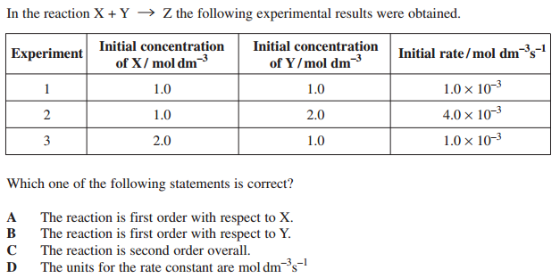  (Total 1 mark)
20.  21. | 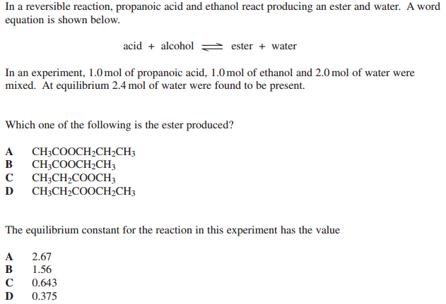  (Total 2 marks)
22. | 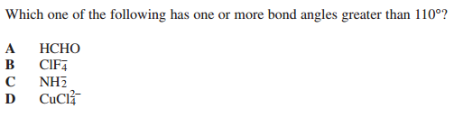  (Total 1 mark)
23. | 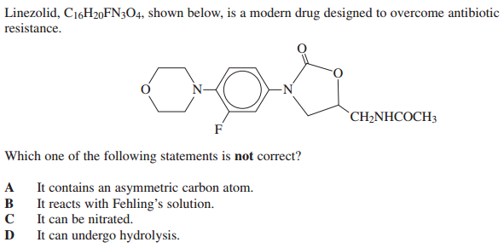  (Total 1 mark)
24. | 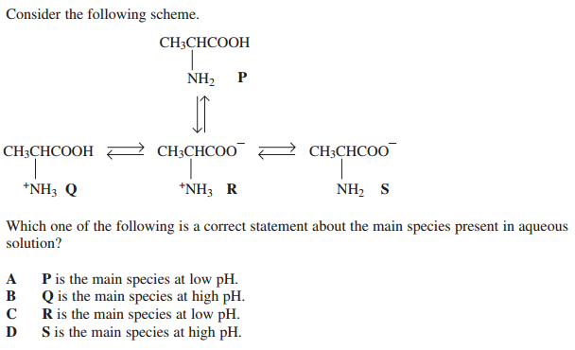  (Total 1 mark)
25. | (Total 1 mark)
26. | (Total 1 mark)
27. | (Total 1 mark)
28. | (Total 1 mark)
29. | 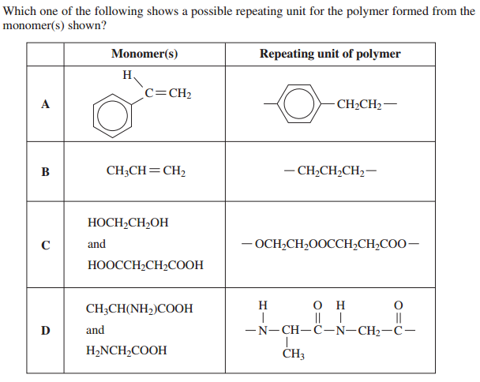  (Total 1 mark)
30. | 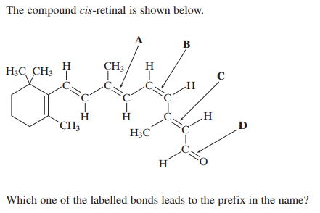  (Total 1 mark)
31. | 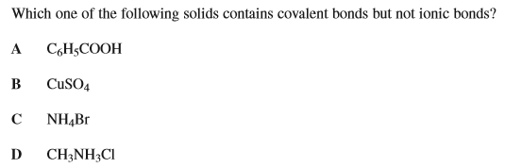  (Total 1 mark)
32. | 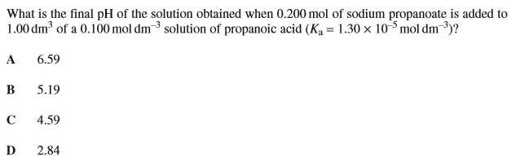  (Total 1 mark)
33.  34.  35. | 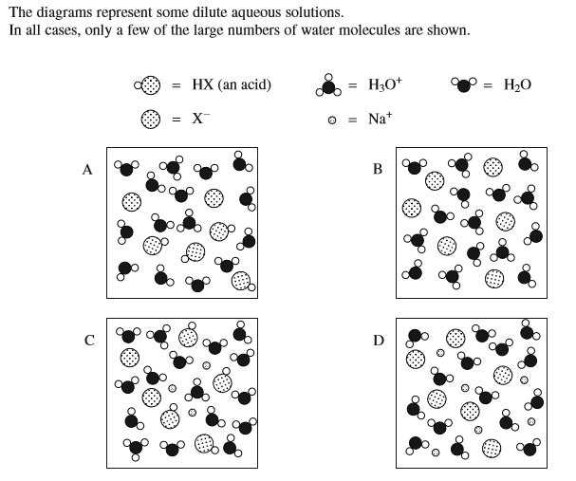  (Total 3 marks)
36. | 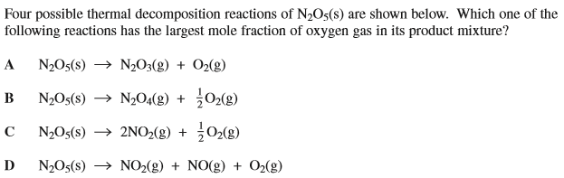  (Total 1 mark)

