A-LEVEL CHEMISTRY

PAPER 3
PRACTICE PAPER 6

Answer all questions
Max 90 marks
1 hour 45 minutes

Name ……………………………………………………………..

Mark ……../90 ……....% Grade ………

The first 10 multiple choice questions have already been used for AS-level resources

1. Nitric acid is manufactured from ammonia in a process that involves several stages.
(a) In the first stage, ammonia is converted into nitrogen monoxide and the following equilibrium is established.
4NH₃(g) + 5O₂(g) 4NO(g) + 6H₂O(g) ∆H = –905 kJ mol^{–1}
The catalyst for this equilibrium reaction is a platinum–rhodium alloy in the form of a gauze. This catalyst gauze is heated initially but then remains hot during the reaction.
(i) In terms of redox, state what happens to the ammonia in the forward reaction.
.............................................................................................................
(1)
(ii) Suggest a reason why the catalyst must be hot.
.............................................................................................................
(1)
(iii) Suggest a reason why the catalyst remains hot during the reaction.
.............................................................................................................
(1)
(iv) State how a catalyst increases the rate of a reaction.
.............................................................................................................
.............................................................................................................
.............................................................................................................
.............................................................................................................
(2)
(b) In the second stage, nitrogen monoxide is converted into nitrogen dioxide. The equation for the equilibrium that is established is shown below.
2NO(g) + O₂(g) 2NO₂(g) ∆H = –113 kJ mol^{–1}
Explain why the equilibrium mixture is cooled during this stage of the process.
......................................................................................................................
......................................................................................................................
......................................................................................................................
......................................................................................................................
(2)

(c) In the final stage, nitrogen dioxide reacts with water as shown by the following equation.
2NO₂(g) + H₂O(l) → H⁺(aq) + NO₃–(aq) + HNO₂(aq)
Give the oxidation state of nitrogen in each of the following.
NO₂ ...............................................................................................................
NO₃– …...........................................................................................................
HNO₂ .............................................................................................................
(3)
(Total 10 marks)

2. The following pairs of compounds can be distinguished by simple test-tube reactions.
For each pair, give a suitable reagent that could be added separately to each compound to distinguish between them.
Describe what you would observe in each case.
(a) AgBr(s) and AgI(s)
Reagent .........................................................................................................
Observation with AgBr(s)...............................................................................
........................................................................................................................
Observation with AgI(s) .................................................................................
........................................................................................................................
(3)
(b) HCl(aq) and HNO₃(aq)
Reagent .........................................................................................................
Observation with HCl(aq) ...............................................................................
........................................................................................................................
Observation with HNO₃(aq) ..........................................................................
........................................................................................................................
(3)

(c) Cyclohexane and cyclohexene
Reagent .........................................................................................................
Observation with cyclohexane .......................................................................
........................................................................................................................
Observation with cyclohexene ......................................................................
........................................................................................................................
(3)
(d) Butanal and butanone
Reagent .........................................................................................................
Observation with butanal ...............................................................................
........................................................................................................................
Observation with butanone ............................................................................
........................................................................................................................
(3)
(Total 12 marks)

3. In its reactions with transition metal ions, ammonia can act as a Brønsted–Lowry base and as a Lewis base.
(a) Write an equation for a reaction between aqueous copper(II) ions ([Cu(H₂O)₆]²⁺) and ammonia in which ammonia acts as a Brønsted–Lowry base. State what you would observe.
........................................................................................................................
........................................................................................................................
........................................................................................................................
........................................................................................................................
(2)
(b) Write an equation for a different reaction between aqueous copper(II) ions ([Cu(H₂O)₆]²⁺) and ammonia in which ammonia does not act as a Brønsted–Lowry base. State what you would observe.
........................................................................................................................
........................................................................................................................
........................................................................................................................
........................................................................................................................
(2)

(c) An excess of dilute ammonia solution is added to an aqueous solution containing iron(II) ions in a test tube that is then left to stand for some time.
State and explain what you would observe.
........................................................................................................................
........................................................................................................................
........................................................................................................................
........................................................................................................................
........................................................................................................................
........................................................................................................................
........................................................................................................................
........................................................................................................................
(4)
(d) Diaminoethane (H₂NCH₂CH₂NH₂), like ammonia, can react as a base and as a ligand.
(i) Write an equation for the reaction that occurs between an aqueous solution of aluminium chloride and an excess of aqueous diaminoethane.
Describe the appearance of the aluminium-containing reaction product.
...............................................................................................................
...............................................................................................................
...............................................................................................................
...............................................................................................................
(3)
(ii) Write an equation for the reaction that occurs between an aqueous solution of cobalt(II) sulfate and an excess of aqueous diaminoethane.
Draw a diagram to show the shape of and bonding in the complex product.
...............................................................................................................
...............................................................................................................
...............................................................................................................
...............................................................................................................
...............................................................................................................
...............................................................................................................
...............................................................................................................
...............................................................................................................
(3)
(Total 14 marks)
4. The hydrolysis of methyl propanoate was studied in acidic conditions at 25°C and the rate equation was found to be
rate = k[CH₃CH₂COOCH₃][H+]
(a) Use the data below to calculate the value of the rate constant, k, at this temperature.
Deduce its units.
Initial rate of reaction /  mol dm^{–3} s^{–1} | Initial concentration of methyl propanoate / mol dm^{–3} | Initial concentration of hydrochloric acid / mol dm^{–3}
1.15 × 10^{–4} | 0.150 | 0.555

Rate constant ...............................................................................................
......................................................................................................................
......................................................................................................................
Units .............................................................................................................
......................................................................................................................
(3)
(b) The reaction in part (a) was repeated at the same temperature, but water was added so that the volume of the reaction mixture was doubled. Calculate the initial rate of reaction under these conditions.
......................................................................................................................
......................................................................................................................
(1)
(c) A third experiment was carried out at a different temperature. Some data from this experiment are shown in the table below.
Initial rate of reaction / mol dm^{–3} s^{–1} | Value of rate constant at this different temperature | Initial methyl propanoate / mol dm^{–3}
4.56 × 10^{–5} | 8.94 × 10^{–4} | 0.123

Calculate the initial pH of the reaction mixture. Give your answer to two decimal places.
......................................................................................................................
......................................................................................................................
......................................................................................................................
......................................................................................................................
(3)
(Total 7 marks)

5. (a) The reaction between aqueous persulphate ions, , and iodide ions, I–(aq), is catalysed by Fe²⁺(aq) ions. Suggest why this reaction has a high activation energy.
Write equations to explain the catalytic action of Fe²⁺(aq) ions.
Suggest why V³⁺(aq) ions will also act as a catalyst for this reaction but Mg²⁺(aq) ions will not.
......................................................................................................................
......................................................................................................................
......................................................................................................................
......................................................................................................................
......................................................................................................................
......................................................................................................................
......................................................................................................................
......................................................................................................................
(6)
(b) Outline a mechanism for the reaction between benzene and ethanoyl chloride and explain why AlCl₃ acts as a catalyst for this reaction. Predict, with an explanation in each case, the suitability of FeCl₃ and of NH₄Cl to act as a catalyst for this reaction.

......................................................................................................................
......................................................................................................................
......................................................................................................................
......................................................................................................................
......................................................................................................................
......................................................................................................................
......................................................................................................................
......................................................................................................................
......................................................................................................................
......................................................................................................................
......................................................................................................................
(9)
(Total 15 marks)
6. Ammonia and methylamine were dissolved in separate samples of water. The two solutions had equal molar concentrations.
State one simple method, other than smell, of distinguishing these solutions.
State what you would observe.
Method ....................................................................................................................
Observation .............................................................................................................
.................................................................................................................................
.................................................................................................................................
(Total 2 marks)

7. Which one of the following does not have a pair of s electrons in its highest filled electron energy sub-level?
A H⁻
B Mg
C P³⁺
D Ar
(Total 1 mark)

8. Which one of the following samples of gas occupies the largest volume?
A 1.0 g of ozone (O₃) at l00 kPa and 300 K
B 1.0 g of oxygen at 100 kPa and 300 K
C 1.0 g of water vapour at 250 kPa and 450 K
D 1.0 g of methane at 333 kPa and 500 K
(Total 1 mark)

9. What is the formula of calcium nitrate(V)?

 | A | CaNO₃
 | B | Ca(NO₃)₂
 | C | Ca₂NO₂
 | D | Ca(NO₂)₂

(Total 1 mark)

10. Which one of the following is the electronic configuration of the strongest reducing agent?
A 1s² 2s² 2p⁵
B 1s² 2s² 2p⁶ 3s²
C 1s² 2s² 2p⁶ 3s² 3p⁵
D 1s² 2s² 2p⁶ 3s² 3p⁶ 4s²
(Total 1 mark)

11. The structure of the molecule of methyl 2-methylpropenoate is shown below.
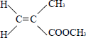
Which one of the following statements concerning this compound is not true?
A It displays geometrical isomerism.
B It forms an addition polymer.
C It undergoes reduction.
D It decolourises bromine.
(Total 1 mark)

12. The correct systematic name for 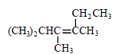 is
A 2-ethyl-3,4-dimethylpent-2-ene
B 4-ethyl-2,3-dimethylpent-3-ene
C 2,3,4-trirmethylhex-3-ene
D 3,4,5-trimethylhex-3-ene
(Total 1 mark)

13. Which of these pieces of apparatus has the lowest percentage uncertainty in the measurement shown?

 | A | Volume of 25 cm³ measured with a burette with an uncertainty of ±0.1 cm³.
 | B | Volume of 25 cm³ measured with a measuring cylinder with an uncertainty of ±0.5 cm³.
 | C | Mass of 0.150 g measured with a balance with an uncertainty of ±0.001 g.
 | D | Temperature change of 23.2 °C measured with a thermometer with an uncertainty of ±0.1 °C.

(Total 1 mark)

14. A white salt dissolves in water to give a solution which gives a cream coloured precipitate when aqueous silver nitrate is added. This precipitate is insoluble in dilute aqueous ammonia but is soluble in concentrated aqueous ammonia. The original white salt could be
A AgI
B NaI
C AgBr
D NaBr
(Total 1 mark)
15. Consider the reactions
C₂H₄(g) + 2O₂(g) → 2CO(g) + 2H₂O(g) ∆H = −758 kJ mol⁻¹
2C(s) + 2H₂(g) → C₂H₄(g) ∆H = +52 kJ mol⁻¹
H₂(g) + O₂(g) → H₂O(g) ∆H = −242 kJ mol⁻¹
The enthalpy of formation of carbon monoxide is
A −111 kJ mol⁻¹
B −163 kJ mol⁻¹
C −222 kJ mol⁻¹
D -464 kJ mol⁻¹
(Total 1 mark)

16. Ethanoic acid reacts with ethanol in a reversible reaction represented by the equation below.
In an experiment 3.0 mol of ethanoic acid were mixed with 1.0 mol of ethanol and when the reaction had reached equilibrium 0.9 mol of water had been formed.
CH₃COOH(l) + C₂H₅OH(l) CH₃COOC₂H₅(l) + H₂O(l)
The percentage of ethanoic acid converted into the ester CH₃COOC₂H₅ in this reaction is
A 22.5%
B 30%
C 43%
C 90%
(Total 1 mark)

17. | Which of the following statements is correct?
 | A | one thousand moles of electrons would produce 9.0 kg of aluminium during the electrolysis of aluminium oxide
 | B | 11.2 kg of carbon monoxide would produce 8.4 kg of iron from an excess of Fe₂O₃ using the equation Fe₂O₃ + 3CO 2Fe + 3CO₂
 | C | The electronegativity of the halogens increases down Group VII
 | D | The oxidising ability of the halogens in aqueous solution increases down Group VII  (Total 1 mark)
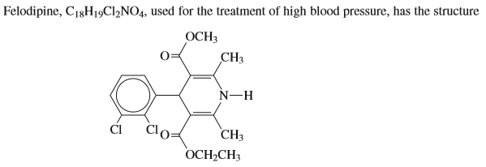

18. | Which of the following statements about felodipine is incorrect?
 | A | It contains an symmetric carbon atom
 | B | It is a diester
 | C | It will react with hydrochloric acid
 | D | It will not decolorise bromine water

19. | Which of the following statements about felodipine is incorrect?
 | A | It can be acylated with ethanoyl chloride
 | B | It shows geometrical isomerism
 | C | It can form mononitroderivatives
 | D | It does not give a silver mirror with Tollen’s reagent  (Total 2 marks)
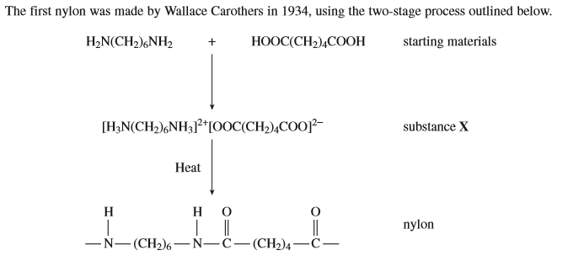
20. | Which of the following statements about the process is incorrect?
 | A | Hydrogen bonds exist between nylon molecules
 | B | One of the starting materials is a weak base
 | C | One of the starting materials is a strong acid
 | D | One of the starting materials is called hexane-1,6-diamine
21. | Which of the following statements about the process is incorrect?
 | A | When 1 mol of X is completely dehydrated to form nylon, 2 mol of water are produced
 | B | Substance X is likely to have a higher melting point than either starting material
 | C | The final product is nylon 6,4
 | D | One of the starting materials is hexanedioic acid

22. | Which of the following statements about the process is correct?
 | A | Substance X is a zwitterion
 | B | Nylon is a polyester
 | C | Only one of the starting materials is capable of hydrogen bonding
 | D | Substance X is a salt  (Total 3 marks)
23. | Which of the following statements is incorrect?
 | A
 | B | Compared with an oxygen molecule, carbon monoxide can form a stronger co-ordinate bond
 | C | In Al₂Cl₆, two of the chlorine atoms form both a covalent bond and a co-ordinate bond with the aluminium atom
 | D | Al(H₂O)₃(OH)₃ will react with both dilute HCl and dilute NaOH  (Total 1 mark)

24. | 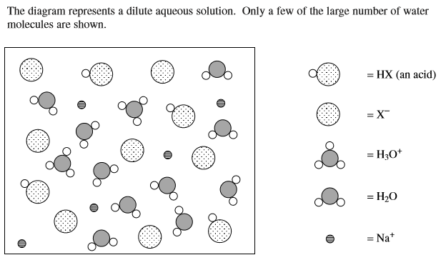
 | Which of the following solutions could not be represented by this diagram?
 | A | a buffer solution
 | B | a solution of a strong acid to which an excess of sodium hydroxide has been added
 | C | a solution of sodium hydroxide to which an excess of a weak acid has been added
 | D | the mixture before the equivalence point of a titration of a weak acid against sodium hydroxide  (Total 1 mark)
25. | 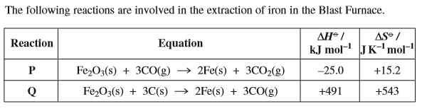  Which of the following statements is incorrect?  (Total 1 mark)
 | A | Reaction P is feasible at all temperatures
 | B | In reaction P, the formation of 55.8 g of iron is accompanied by the formation of approximately 42.0 g of carbon dioxide.
 | C | Reaction Q is only feasible above a certain temperature
 | D | In reaction Q, 18 g of carbon is needed to produce 55.8 g of iron  (Total 1 mark)
26. | In which of the following conversions does an element change oxidation state from +3 to +6?
 | A
 | B
 | C | Mn₂O₃ MnO₄⁻
 | D | (Total 1 mark)
27. | Which one of the following is not a pair of isomers?
 | A | ethanoic acid and methyl methanoate
 | B | ethanal and ethenol
 | C | propanal and propanone
 | D | ethanoyl chloride and chloroethanoic acid  (Total 1 mark)

28. | 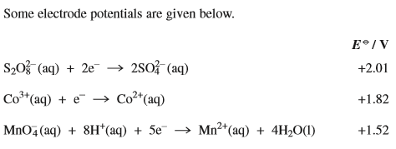  Which of the following statements is incorrect?
 | A
 | B
 | C | when peroxodisulphate (VI) ions are reduced to sulphate ions, the oxidation state of sulphur is unchanged
 | D | acidified potassium manganate (VII) can oxidise sulphate ions to peroxodisulphate (VI) ions  (Total 1 mark)
29. | 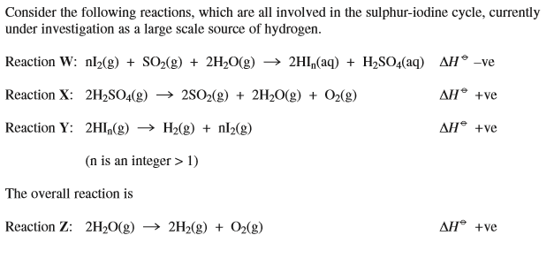  Which of the following statements about these reactions is correct?
 | A
 | B | reactions X and Z become less feasible at higher temperatures.
 | C
 | D | (Total 1 mark)

30. | In which series does the indicated element not increase its oxidation state from left to right?
 | A | vanadium in V²⁺, V³⁺, VO₂⁺
 | B
 | C
 | D | (Total 1 mark)
31. | Which of the following substances does not release a gas when treated with aqueous sodium carbonate?
 | A
 | B | HCOOH
 | C | HOCH₂COOH
 | D | (Total 1 mark)
32. | 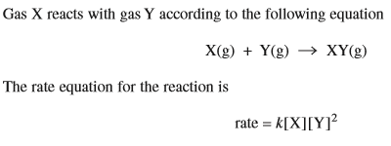  Which of the following statements, at constant temperature, is incorrect?
 | A | doubling the concentration of X, keeping the concentration of Y constant, will double the rate of reaction
 | B | halving the concentration of Y, keeping the concentration of X constant, will decrease the rate by a factor of 4
 | C | trebling the concentration of both X and Y will increase the rate by a factor of 27
 | D | quadrupling the concentration of Y, keeping the concentration of X constant, will increase the rate by a factor of 64  (Total 1 mark)
33. | 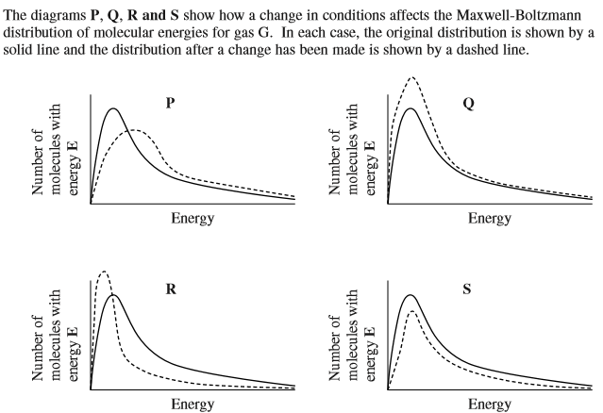  Which of the diagrams illustrate changes which alter the value of the rate constant for the decomposition of gas G?
 | A | P and R
 | B | Q and S
 | C | Q and R
 | D | P and S  (Total 1 mark)
34. | Which of the following substances does not form an acidic solution when added to water?
 | A | AlCl₃
 | B | Cl₂
 | C | CH₃COCl
 | D | NaCl  (Total 1 mark)

35. | Which of the following solutions forms bubbles of a gas with solid Na₂CO₃?
 | A | CH₃CHO
 | B | CrCl₂
 | C | CrCl₃
 | D | HCOOCH₃  (Total 1 mark)
36. | 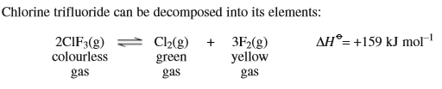  Which of the following statements is incorrect?
 | A
 | B
 | C
 | D | the reaction has a positive entropy change.  (Total 1 mark)

