AS-LEVEL PAPER 1 PP19 MS

1.
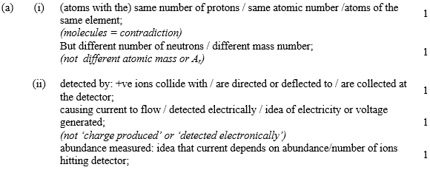
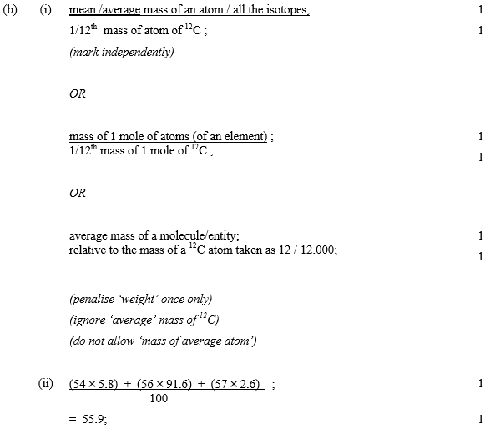
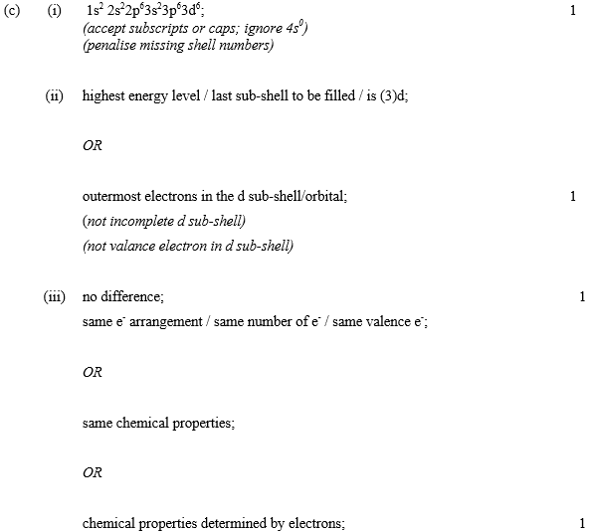
[13]

2. A chlorine atom has more protons in its nucleus than has a sodium atom
1
Both have three shells of electrons
1
Electrons more strongly attracted by chlorine nucleus so size smaller than Na
1
An electron shell is lost when a sodium ion is formed from a sodium atom
1
Inner electrons more strongly attracted so ion smaller than atom
1
An electron is added to the outer shell when a chloride ion is formed
1
Greater repulsion between shells so size of chloride ion greater than Cl atom
1
MAX 6
QWC
[6]

3.
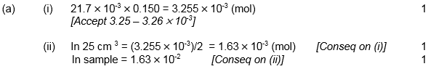
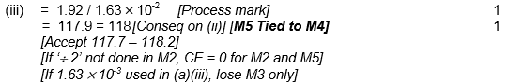
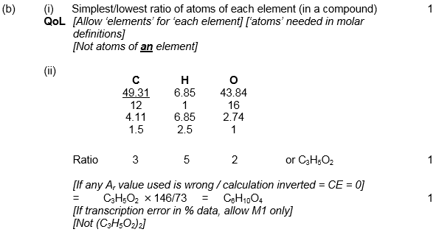
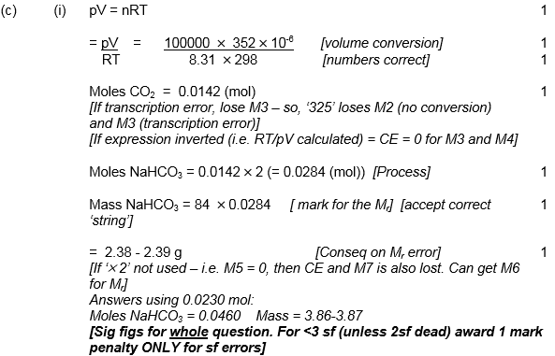[16]
4.
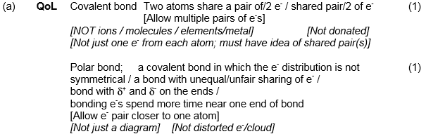
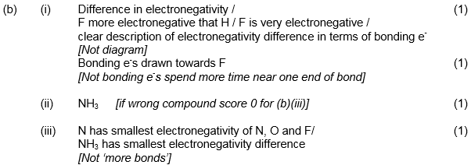
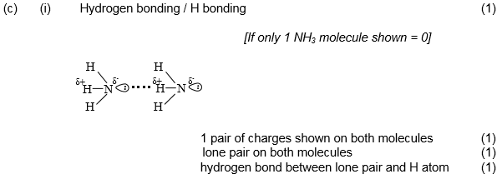
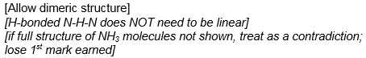

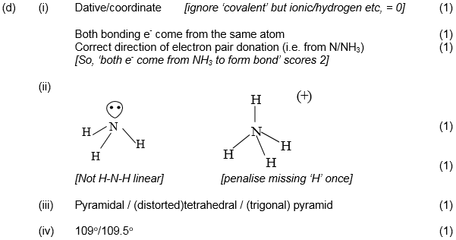
[17]
5.
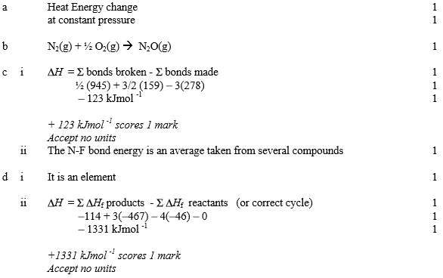[11]
6.
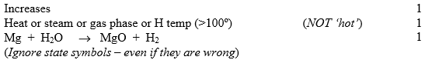
[3]
7.
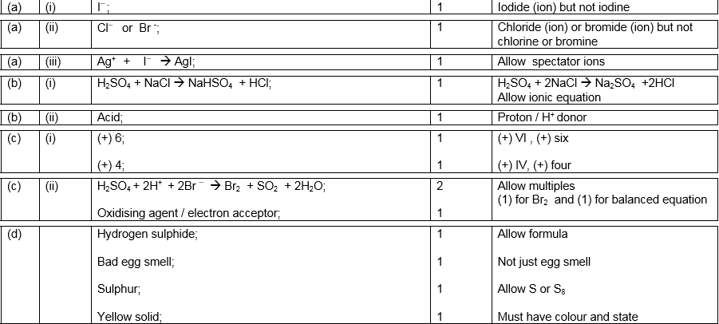
[14]

