1. (a) (i) Different number / amount of neutrons
Not different neutrons
Ignore same protons and/or electrons
CE incorrect statement relating to protons / electrons
1
(ii) Same electron configuration / same number of
electrons (in the outer shell)
Ignore same no of protons
Ignore electrons determine chemical properties
CE if wrong statement relating to protons / neutrons
1
(b) Average mass of 1 atom (of an element)
1/12 mass atom of ¹²C
OR
Average/mean mass of atoms of an element
1/12 mass of one atom of ¹²C
OR
(Average) mass of one mole of atoms
1/12 mass of one mole of ¹²C
OR
(Weighted) average mass of all the isotopes
1/12 mass of one atom of ¹²C
OR
Average mass of an atom/isotope compared to C-12
on a scale in which an atom of C-12 has a mass of 12
If moles and atoms mixes Max = 1
Mark top and bottom line independently
1/12 on bottom line can be represented as x 12 on top line
This expression = 2 marks
2
(c) (i) 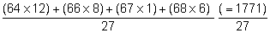
= 65.6
If not 27 max 1 mark (for top line)
Mark is for dividing by 27 or string
If evidence of arithmetic or transcription error seen in M1 or M2 allow consequential M3 and consequential (c)(ii)
65.6 = 3 marks
3
(ii) ⁶⁴Zn⁺
M1 for identifying Zn / zinc
M2 is for the + sign and the 64
M2 is dependent on M1
2
(d) Size of the charge (on the ion) / different charges / different m/z
Allow forms 2+ ions
QWC
1
(e) (ions hit detector and) cause current/(ions) accept
electrons/cause electron flow/electric pulse caused
bigger current = more of that isotope/current proportional to abundance
Implication that current depends on the number of ions
M2 dependent on M1
2
[12]

2. (a) 4LiH + AlCl₃ → LiAlH₄ + 3LiCl
1
(b) Tetrahedral or diagram
(Not distorted tetrahedral)
1
(Equal) repulsion
1
between four bonding pairs / bonds
(Not repulsion between H atoms loses M2 and M3)
(Not ‘separate as far as possible’)
(‘4’ may be inferred from a correct diagram)
1
(c) Dative (covalent) or coordinate
1
Lone pair or non-bonding pair of electron or both e–
1
QoL Donated from H– to Al or shared between H and Al
(tied to M2)
(Not ‘from H atom’) (Not ‘to Al ion’) (Not ‘e–s transferred’)
1
[7]
3. (a) Hydrogen bonding / hydrogen bonds / H-bonding / H-Bonds
Not just hydrogen.
1
(b)
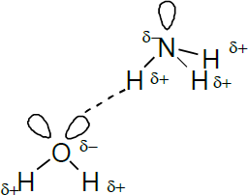
One mark for minimum of 4 correct partial charges shown on the N-H and O-H
One mark for the 3 lone pairs.
One mark for H bond from the lone pair on O or N to the H^{δ+}
OR
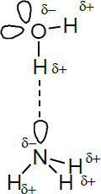
The N-H-O should be linear but can accept if the lone pair on O or N hydrogen bonded to the H
If wrong molecules or wrong formula, CE = 0/3
3

(c) (Phosphine) does not form hydrogen bonds (with water)
1
[5]

4. (a) Lithium / Li
Penalise obvious capital I (second letter).
1
(b) (i) Increase / gets bigger
Ignore exceptions to trend here even if wrong
1
(ii) Boron / B
If not Boron, CE = 0/3
1
Electron removed from (2)p orbital /sub-shell / (2)p electrons removed
If p orbital specified it must be 2p
1
Which is higher in energy (so more easily lost) / more shielded (so more
easily lost) / further from nucleus
1
(c) C / carbon
1
(d) Below Li
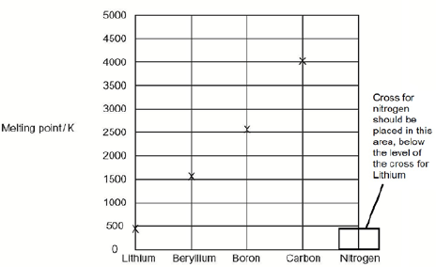
The cross should be placed on the diagram, on the column for nitrogen, below the level of the cross printed on the diagram for Lithium.
1
(e) Macromolecular / giant molecular / giant atomic
Allow giant covalent (molecule) = 2
1
Covalent bonds in the structure
1
Strong (covalent) bonds must be broken or overcome / (covalent) bonds need
a lot of energy to break
Ignore weakening / loosening bonds
If ionic / metallic/molecular/ dipole dipole/ H bonds/ bonds between molecules, CE = 0/3
Ignore van der Waals forces
Ignore hard to break
1
[10]

5. Ideal gas equation: pV = nRT (1)
Calculation: n = pV/RT = 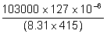 (1)
mark for volume conversion fully correct
= 3.79 × 10^{–3} (mol) (1)
range 3.79 × 10^{–3} to 3.8 × 10^{–3}
M_{r} = m/n = .304/3.79 × 10^{–3} = 80.1 (1)
range 80 – 80.3
min 2 s.f. conseq
If ‘V’ wrong lose M2; ‘p’ wrong lose M3; ‘inverted’ lose M3 and M4
[5]
6. X = Mg;
(accept Be,Ca)
1
Y = Ba;
(accept Sr)
1
MgCl₂(aq) + 2NaOH(aq) → Mg(OH)₂(s) + 2NaCl(aq)
Species;
1
State symbols & balance;
1
BaCl₂(aq) + Na₂SO₄(aq) → BaSO₄(s) + 2NaCl(aq);
Species;
1
State symbols & balance;
(accept ionic equations)
1
[6]

7. M1 and M2 (either order)
Any two from
• purple vapour / gas
• (white solid goes to) black or black / grey or black / purple
solid
• bad egg smell or words to this effect
Ignore misty white fumes
Ignore yellow solid
Ignore purple solid
Ignore “goes (dark) brown”
M3
Or multiples for possible equation in M3
The iodide ion(s) / they lose (an) electron(s)
OR
2I⁻ I₂ + 2e⁻
M4
Accept “changes by − 8”
Oxidation state of S changes from +6 to −2 or changes by 8
M5
H₂SO₄ + 8H⁺ + 8e⁻ H₂S + 4H₂O
OR
SO₄²⁻ + 10H⁺ + 8e⁻ H₂S + 4H₂O
[5]

8. (a) Cl₂ 0.4
1
NOCl 1.7
1
(b) (i) K_{c}= 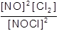

Penalise expression containing V
Allow ( ) here, but must have all brackets.
If K_{c} expression wrong, max 2 in (b)(ii) for
M1 for correct rearrangement of their K_{c} and
M4 for multiplying by 15
1
(ii) M1 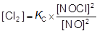

Mark is for rearrangement of correct K_{c} expression.
If K_{c} rearrangement wrong, can only score max 2 for:
M3 and M4
1
M2
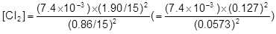
Rounding 1.90 / 15 wrongly to 0.126 is AE
1
M3 [Cl₂] = 0.0361 to 0.0365 (min 2 sfs)
Mark for correct calculation of [Cl₂]
1
M4 mol Cl₂ = 0.54 to 0.55
Correct answer scores 4 ignore working
Mark is for answer of (M3 × 15)
1
(iii) ((7.4 × 10⁻³) = ) 0.086
Allow 0.085 to 0.086)
Mark for answer OR conseq on their Cl₂
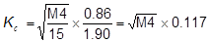

Or
1
mol ^{½} dm^{−3/2} OR mol ^{0.5} dm ^{−1.5}

NOT
1
[9]

9.
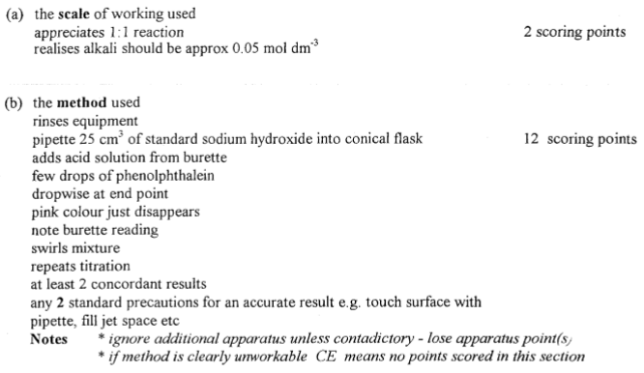
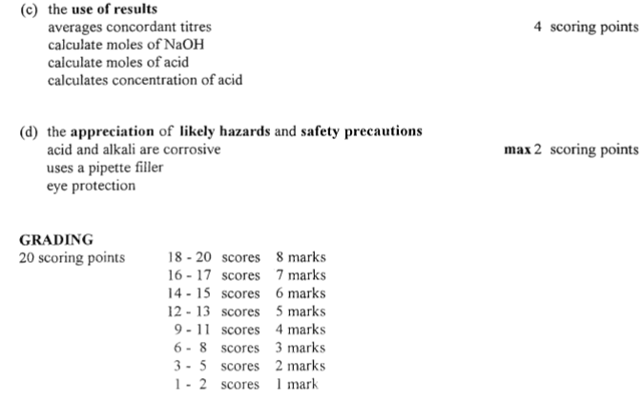[8]

10. C
11. B
12. D
13. B
14. D
15. C
16. D
17. C
18. B
19. D
20. B
21. B
22. A

