1. (a) Average / mean mass of 1 atom (of an element)
1/12 mass of one atom of ¹²C
If moles and atoms mixed, max = 1
1
Mark top and bottom line independently.
All key terms must be present for each mark.
1
OR
Average / mean mass of atoms of an element
1/12 mass of one atom of ¹²C
OR
Average / mean mass of atoms of an element ×12
mass of one atom of ¹²C
OR
(Average) mass of one mole of atoms
1/12 mass of one mole of ¹²C
OR
(Weighted) average mass of all the isotopes
1/12 mass of one atom of ¹²C
OR
Average mass of an atom / isotope (compared to C−12) on a scale in which an atom of C−12 has a mass of 12
This expression = 2 marks.
(b) 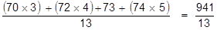
1
1
= 72.4
72.4 only
1
(c) ⁽⁷²⁾Ge⁺ or germanium⁺
Must show ‘+’ sign.
Penalise wrong mass number
1
(d) 70
If M1 incorrect or blank CE = 0/2
Ignore symbols and charge even if wrong.
1
Lowest mass / lowest m/z
Accept lightest.
Accept fewest neutrons.
1
(e) Electron(s) transferred / flow (at the detector)
M1 must refer to electron flow at the detector.
If M1 incorrect CE = 0/2
1
(From detector / plate) to the (+) ion
Do not allow from a charged plate.
1

(f) They do not have the same electron configuration / they have different number of electrons (in the outer shell)
Ignore electrons determine the properties of an atom.
Ignore they are different elements or different number of protons.
1
[11]

2. (a) Silicon / Si
If not silicon then CE = 0 / 3
1
covalent (bonds)
M3 dependent on correct M2
1
Strong or many of the (covalent) bonds need to be broken / needs a lot of energy to break the (covalent) bonds
Ignore hard to break
1
(b) Argon / Ar
If not argon then CE = 0 / 3. But if Kr chosen, lose M1 and allow M2+M3
1
Large(st) number of protons / large(st) nuclear charge
Ignore smallest atomic radius
1
Same amount of shielding / same number of shells / same number of energy levels
Allow similar shielding
1
(c) Chlorine / Cl
Not Cl₂, Not CL, Not Cl²
1

(d) (i)
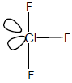
Or any structure with 3 bonds and 2 lone pairs
Ignore any angles shown
1
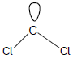
Or a structure with 2 bonds and 1 lone pair
1
(ii) Bent / v shape
Ignore non-linear, angular and triangular
Apply list principle
1
(iii) Cl₂ + F₂ ClF₃
No multiples
Ignore state symbols
1
[11]

3. (a) (i) Cu + 4HNO₃ → Cu(NO₃)₂ + 2NO₂ + 2H₂O
Or multiples
Ignore state symbols
1
(ii) M1 HNO₃ (+) 5
M2 NO₂ (+) 4
Ignore working out
M1 Credit (V)
M2 Credit (IV)
2
(iii) HNO₃ + H⁺ + e– → NO₂ + H₂O
OR
NO₃– + 2H⁺ + e– → NO₂ + H₂O
Or multiples
Ignore state symbols
Ignore charge on the electron unless incorrect and accept loss of electron on the RHS
1

(b) (i) In either order
M1 Concentration(s) (of reactants and products)
remain(s) constant / stay(s) the same / remain(s)
the same / do(es) not change
M2 Forward rate = Reverse / backward rate
For M1 accept [ ] for concentration
NOT “equal concentrations” and NOT “concentration(s) is/are the same”
NOT “amount”
Ignore “dynamic” and ignore “speed”
Ignore “closed system”
It is possible to score both marks under the heading of a single feature
2
(ii) M1
The (forward) reaction / to the right is endothermic
or takes in / absorbs heat
OR
The reverse reaction / to the left is exothermic or gives
out / releases heat
M2 depends on correct M1 and must refer to temperature/heat
The equilibrium shifts / moves left to right to oppose the increase in temperature
M2 depends on a correct statement for M1
For M2, the equilibrium shifts/moves
to absorb the heat OR
to lower the temperature OR
to cool the reaction
2
(iii) M1 refers to number of moles
There are fewer moles (of gas) on the left OR more
moles (of gas) on the right.
OR there is one mole (of gas) on the left and 2 moles
on the right.
M2 depends on correct M1 and must refer to pressure
The equilibrium shifts / moves right to left to oppose the
increase in pressure
M2 depends on a correct statement for M1
For M2, the equilibrium shifts/moves to lower the pressure.
2
[10]

4. (a) (i) 4FeS₂ + 11O₂ 2Fe₂O₃ + 8SO₂
2 5½ (1) 4
Or multiples of this equation
1
(ii) M1 (+) 4
M2 – 1
Ignore working
M1, credit (+) IV
M2, credit – I
2
(b) M1 Lower/smaller/decreases/reduced yield
OR equilibrium shifts (right) to left
M2 (Forward) reaction is exothermic OR reverse reaction is endothermic
M3 (By Le Chatelier’s principle) equilibrium responds/shifts/moves
(R to L)
to lower the temperature
OR to absorb the heat
OR to cool the reaction
If M1 is blank, mark on and credit M1 in the text.
If M1 is incorrect, only credit correct M2
Mark M2 independently – it may be above the arrow in the equation
For M3, not simply “to oppose the change/temperature”
3
(c) M1 Fe₂O₃ + 3CO 2Fe + 3CO₂
Or multiples
Ignore state symbols
M2 Reducing agent
OR Reduce(s) (Fe₂O₃/iron(III) oxide)
OR Electron donor
OR to remove the oxygen (from iron(III) oxide to form CO₂)
OR reductant
For M2, credit “reduction”
2
[8]

5. (a) (i) ½Cl₂ + I ⁻ ½ I₂ + Cl⁻
Only these two equations.
OR
Cl₂ + 2I⁻ I₂ + 2Cl⁻
1
(ii) (Solution turns from colourless to) brown / red-brown solution
Allow grey / black solid.
Ignore “purple”.
1
(b) 2Cl₂ + 2H₂O 4HCl + O₂
(4H⁺ + 4Cl⁻)
Credit multiples.
1

(c) M1 The relative size (of the molecules / atoms)
Chlorine is smaller than bromine OR has fewer electrons / electron shells
OR It is smaller / It has a smaller atomic radius / it is a smaller molecule / or has smaller M_{r}
(or converse for bromine)
Ignore general Group 7 statements.
For M1 ignore whether it refers to molecules or atoms.
M2 How size of the intermolecular force affects energy needed
The forces between chlorine / Cl₂ molecules are weaker (than the forces between bromine / Br₂ molecules leading to less energy needed to separate the molecules)
(or converse for bromine)
OR chlorine / Cl₂ has weaker / less / fewer forces between molecules OR chlorine / Cl₂ has weaker / less / fewer intermolecular forces
(or converse for bromine)
CE=0 for reference to (halide) ions.
QoL for clear reference to the difference in size of the force between molecules.
Penalise M2 if (covalent) bonds are broken.
2
[5]

6.
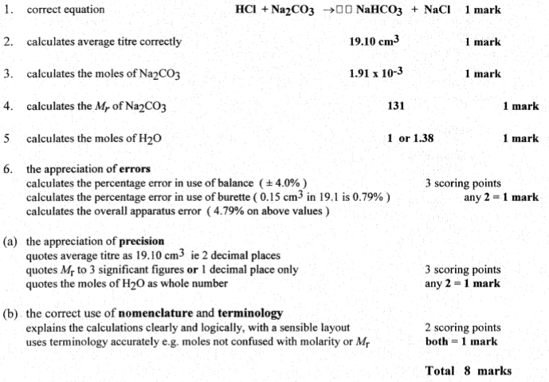
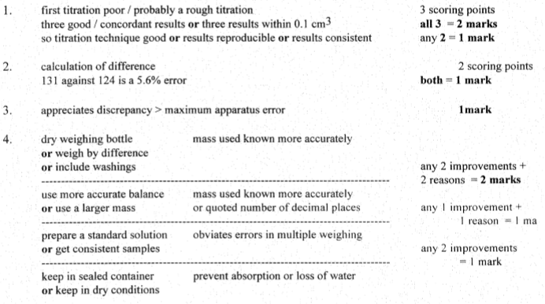

7.
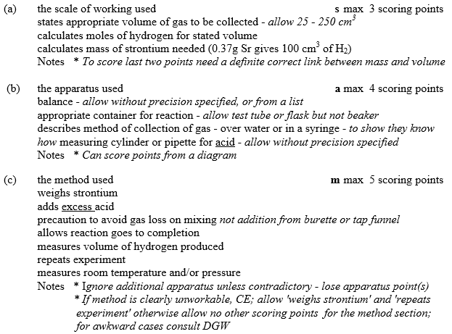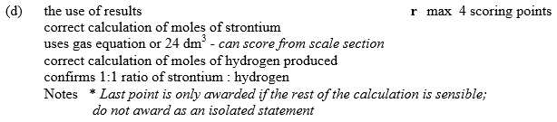
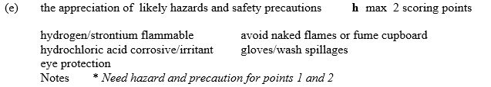
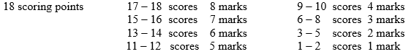
8. A
9. B
10. A
11. B
12. A
13. A
14. D
14. D
16. C
17. D
18. D
19. C
20. C

