AS-LEVEL PAPER 2 PP18
1.
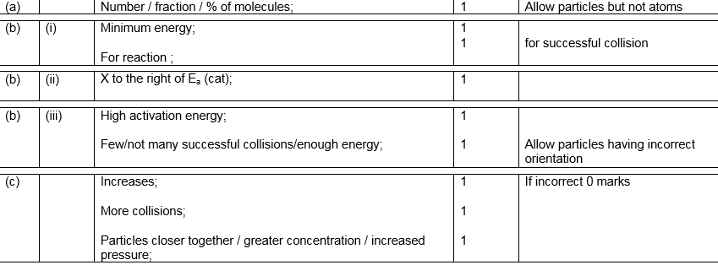
[9]

2. (a) (i) C₄H₁₀ + 6O₂ → 4CO₂ + 5H₂O
Allow multiples
1
(ii) insufficient oxygen/low temperature/poor mixing of
butane and air
Allow insufficient air
Allow lack or oxygen/air
Do not allow no oxygen
Not incomplete combustion
1
(b) (i) Sulfur dioxide/SO₂
Allow sulfur trioxide/SO₃
(allow spelling of sulphur to be sulphur)
1
(ii) It is basic/the gas (SO₂) is acidic
Idea of neutralisation
It = calcium oxide
1
(iii) bigger surface area to react
Do not allow cheaper
1
[5]

3. (a) Crude oil OR petroleum
Not petrol.
1
Fractional distillation / fractionation
Not distillation alone.
1
(b) C₁₂H₂₆ + 12.5O₂ 12CO + 13H₂O
Allow balanced equations that produce CO₂ in addition to CO.
Accept multiples.
1

(c) (i) M1 Nitrogen and oxygen (from air) react / combine / allow a correct equation
If nitrogen from petrol / paraffin / impurities CE = 0 / 2.
1
M2 at high temperatures
Allow temperatures above 1000 °C or spark.
Not just heat or hot.
M2 dependent on M1.
But allow 1 mark for nitrogen and oxygen together at high temperatures.
1
(ii) 2NO + O₂ 2NO₂
Allow multiples.
1
(iii) 4NO₂ + 2H₂O + O₂ 4HNO₃
Allow multiples.
1
(d) (i) C_{n}H_{2n+2}
Allow C_{x}H_{2x+2}
CnH2n+2
Allow CxH2x+2
1
(ii) C₁₂H₂₆ C₆H₁₄ + C₆H₁₂
Only.
1
C₃H₇
Only.
1
Zeolite / aluminosilicate(s)
Ignore aluminium oxide.
1
(iii) Larger molecule / longer carbon chain / more electrons / larger surface area
1

More / stronger van der Waals’ forces between molecules
Allow dispersion forces / London forces / temporary induced dipole-dipole forces between molecules.
If breaking bonds, CE = 0 / 2.
1
(e) 2,2,3,3,4,4-hexamethylhexane
Only.
Ignore punctuation.
1
Chain
Ignore branch(ed).
1
(f) Cl₂
Only.
Cl–Cl
Not CL₂ or Cl2 or CL2 or Cl² or CL².
Ignore Chlorine.
1
[16]

4. (a) (i) M1 double-headed curly arrow from the lone pair of the bromide ion to the C atom of the CH₂
Penalise additional arrows.
M2 double-headed arrow from the bond to the O atom
As follows
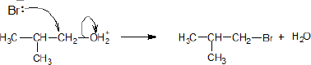
2
(ii) M1 nucleophilic substitution
M1 both words needed (allow phonetic spelling).
M2 1-bromo(-2-)methylpropane
M2 Require correct spelling in the name but ignore any hyphens or commas.
2
(b) M1 hydrolysis
For M1 give credit for ‘hydration’ on this occasion only.
M2 C≡N with absorption range 2220–2260 (cm⁻¹)
Credit 1 mark from M2 and M3 for identifying C≡N and either O–H(acids) or C=O or C–O without reference to wavenumbers or with incorrect wavenumbers.
M3 O–H(acids) with absorption range 2500–3000 (cm⁻¹)
OR
C=O with absorption range 1680–1750 (cm⁻¹)
OR
C–O with absorption range 1000–1300 (cm⁻¹)
Apply the list principle to M3
3
(c) (i) M1 Yield / product OR ester increases / goes up / gets more
M2 (By Le Chatelierߣs principle) the position of equilibrium is driven / shifts / moves to the right / L to R / in the forward direction / to the product(s)
M3 – requires a correct statement in M2
(The position of equilibrium moves)
to oppose the increased concentration of ethanol
to oppose the increased moles of ethanol
to lower the concentration of ethanol
to oppose the change and decrease the ethanol
If no reference to M1, marks M2 and M3 can still score BUT if M1 is incorrect CE=0
If there is reference to ‘pressure’ award M1 ONLY.
3

(ii) M1
Catalysts provide an alternative route / pathway / mechanism
OR
surface adsorption / surface reaction occurs
For M1, not simply ‘provides a surface’ as the only statement.
M1 may be scored by reference to a specific example.
M2
that has a lower / reduced activation energy
OR
lowers / reduces the activation energy
Penalise M2 for reference to an increase in the energy of the molecules.
For M2, the student may use a definition of activation energy without referring to the term.Reference to an increase in successful collisions in unit time alone is not sufficient for M2 since it does not explain why this has occurred.
2
[12]
5. (a) (i) single (C-C) bonds only/no double (C=C) bonds
1
Allow all carbon atoms bonded to four other atoms
Single C-H bonds only = 0
C=H CE
C and H (atoms) only/purely/solely/entirely
Not consists or comprises
Not completely filled with hydrogen
CH molecules = CE
Element containing C and H = CE
1
(ii) C_{n}H_{2n+2}
Formula only
C_{x}H_{2x+2}
1
(b) (i) C₅H₁₂ + 8O₂ → 5CO₂ + 6H₂O
Accept multiples
Ignore state symbols
1
(ii) gases produced are greenhouse gases/contribute to Global
warming/effect of global warming/climate change
Allow CO₂ or water is greenhouse gas/causes global warming
Acid rain/ozone CE = 0
1
(c) carbon
Allow C
Allow soot
1
(d) (i) C₉H₂₀ → C₅H₁₂ + C₄H₈
OR
C₉H₂₀ → C₅H₁₂ + 2C₂H₄
Accept multiples
1
(ii) Plastics, polymers
Accept any polyalkene/haloalkanes/alcohols
1
(iii) so the bonds break OR because the bonds are strong
IMF mentioned = 0
1
(e) (i) 1,4-dibromo-1-chloropentane/1-chloro-1,4-dibromopentane
Ignore punctuation
1
(ii) Chain/position/positional
Not structural or branched alone
1
[11]

6.
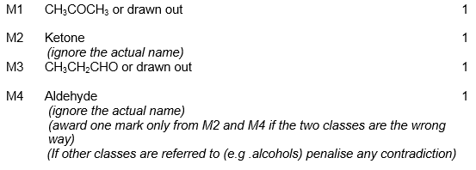[4]

7.
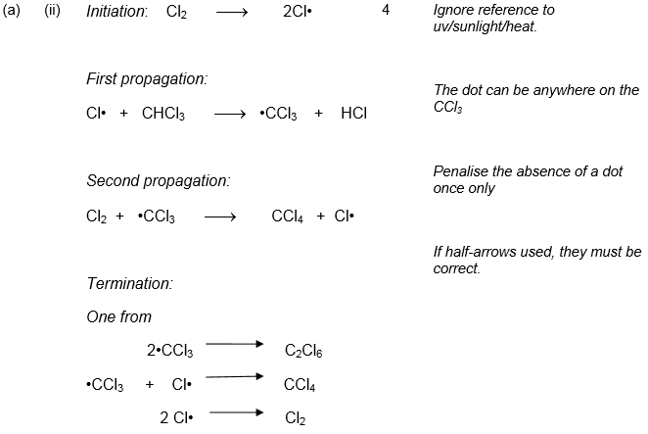
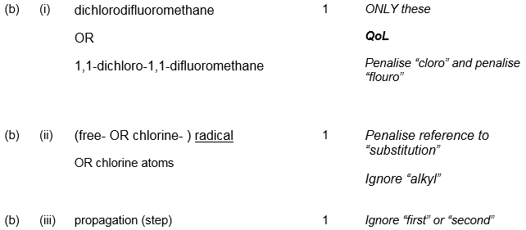[8]

8.
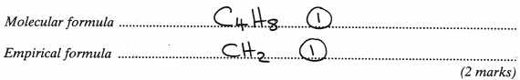
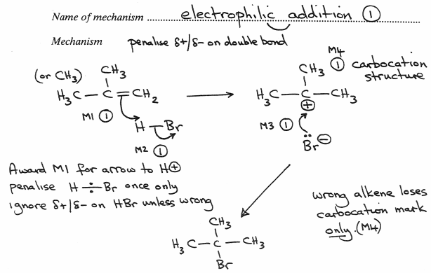
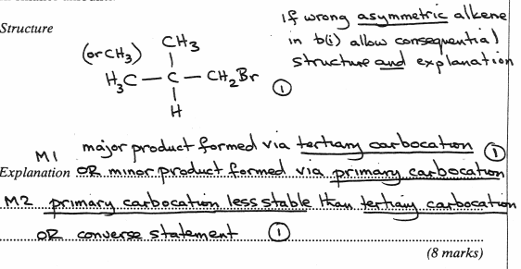
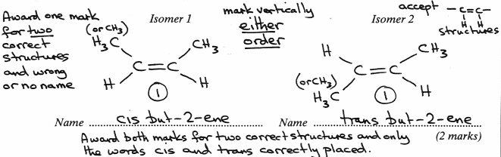
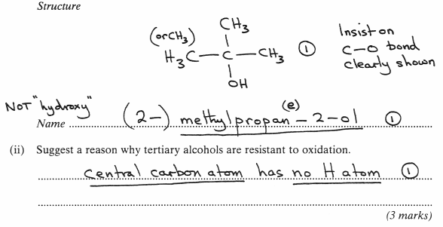[15]

