A-LEVEL PAPER 2 PP19 MS
1.
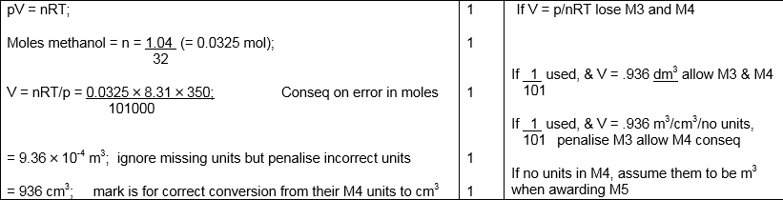
[5]

2.
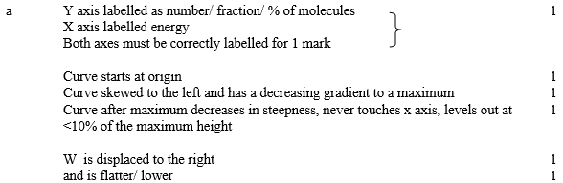
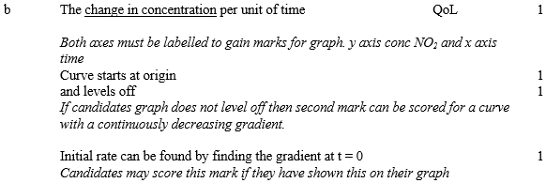
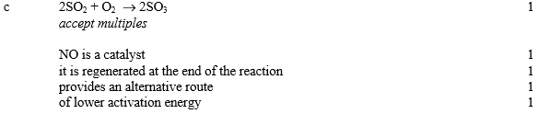[15]
3. (a) (i) C_{n}H_{2n} / C_{x}H_{2x}
1
(ii) Fractional distillation / GLC / gas liquid chromatography / fractionation
Do not allow cracking / distillation
1
(b) (i) But-1-ene / but1ene
Ignore hyphens and commas
Do not allow butene-1 / but-2-ene / butane / butane /alkene / C₄H₈ / propene / straight-chain alkene
1
(ii) A structure of cyclobutane or
methyl-cyclopropane
Allow skeletal formula.
1
(c) (i) C₁₅H₃₂ → 2C₄H₈ + C₇H₁₆
Do not accept multiples.
1
(ii) Thermal cracking
Not catalytic cracking or cracking.
1
To produce products that are in greater demand / more valuable / more
expensive / more profitable
The (unsaturated) alkene or the (unsaturated) molecule or X produced can be polymerised or can be made into plastics.
Ignore more useful products.
1
(iii) Break (C–C or C–H) bonds
Allow to overcome the activation energy.
Allow to break the carbon chain.
Penalise breaking wrong bonds.
1
(d) (i) C₄H₁₀ + 2.5O₂ → 4C + 5H₂O
Accept multiples.
1
(ii) SO₂ / sulfur dioxide
If other sulfur oxides, mark on.
1
Calcium oxide / CaO / lime / quicklime
Allow CaCO₃ / allow Ca(OH)₂ or names.
Allow any solid base.
M2 dependent on M1.
Do not allow limewater.
1
(iii) Neutralisation
Allow acid-base reaction.
Allow flue gas desulfurisation / FGD
1
(e) (Molecules) are similar sizes / have similar M_{r} / have similar number of electrons
Chemical error CE = 0/2 if breaking bonds.
Allow similar number of carbon and hydrogen atoms / similar surface area / similar chain length.
Can accept same number of carbon atoms.
Do not accept same number of H atoms / same number of bonds.
Ignore similar amount of bonds.
1
Similar van der Waals forces between molecules / similar intermolecular forces
(IMF)
Not similar incorrect IMF eg dipole-dipole
1
[14]

4. (a) (i) Prevents release of toxic CO
More energy efficient (releases more energy on combustion)
1
(ii) C₆H₁₄ + 6.5O₂ → 6CO + 7H₂O
1
Suitable product eg CO or C
1
Balanced equation
1
(iii) Detect CO gas or C (soot or particles) in exhaust gases
1
(b) CH₃CH₂CH₂CH(CH₃)₂
1
2-methylpentane
1
CH₃CH₂CH(CH₃)CH₂CH₃ etc
1
(c) (i) CH₃CH₂CH₂CH=CH₂
1
(ii) Alumino silicate etc
1
(iii) Can be made into polymers (or alcohols etc)
1
(d) (i) % atom economy = mass CH₂Cl₂/total mass
reactants = 85 × 100/158
1
= 53.8%
1
(ii) Because expensive chlorine is not incorperated into
desired product Raise money by selling HCl
1
[14]

5.
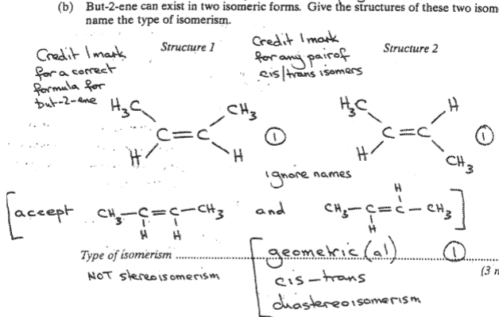[3]
6.
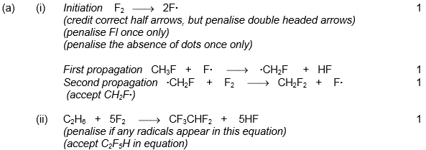 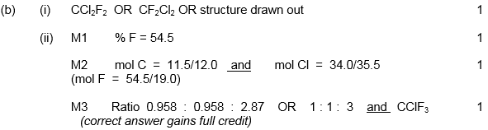[8]

7.
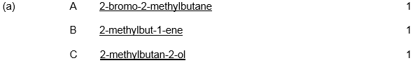
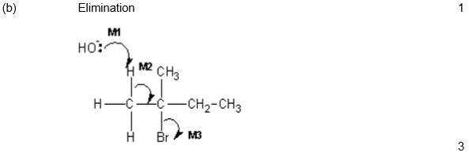
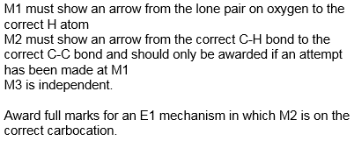
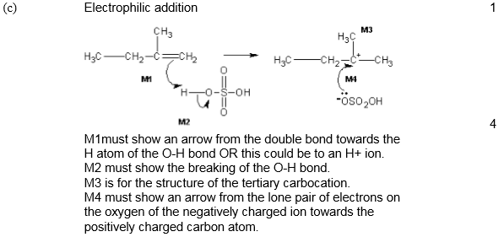
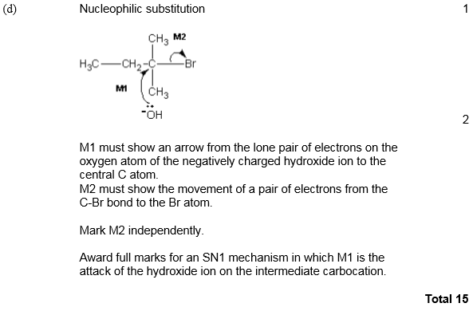
8.
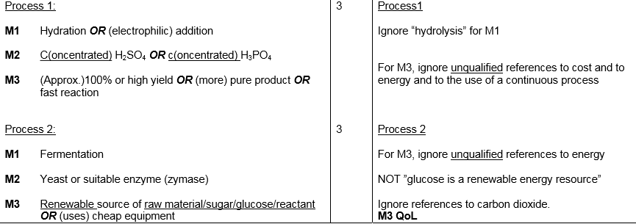
[6]

