AS LEVEL CHEMISTRY

PAPER 2
PRACTICE PAPER 2
Answer all questions
Max 80 marks

Name ……………………………………………………………..

Mark ……../80 ……....% Grade ………

1. There are several oxides of nitrogen.
(a) An oxide of nitrogen contains 25.9% by mass of nitrogen. Determine the empirical formula of this oxide.
......................................................................................................................
......................................................................................................................
......................................................................................................................
......................................................................................................................
(3)
(b) Give one reason why the oxide NO is a pollutant gas.
......................................................................................................................
......................................................................................................................
(1)
(c) The oxide NO reacts with oxygen to form nitrogen dioxide. Write an equation for this reaction.
......................................................................................................................
(1)
(d) Explain how NO is produced in the engine of a motor vehicle.
......................................................................................................................
......................................................................................................................
......................................................................................................................
(2)
(e) Write an equation to show how NO is removed from the exhaust gases in motor vehicles using a catalytic converter.
......................................................................................................................
(1)
(Total 8 marks)

2. The diagram shows the Maxwell-Boltzmann distribution of molecular energies in a gas at two different temperatures.
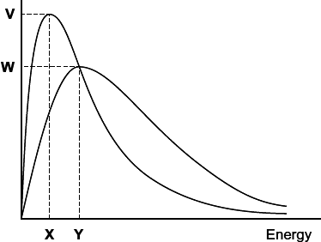
(a) One of the axes is labelled. Complete the diagram by labelling the other axis.
(1)
(b) State the effect, if any, of a solid catalyst on the shape of either of these distributions.
........................................................................................................................
........................................................................................................................
(1)
(c) In the box, write the letter, V, W, X or Y, that represents the most probable energy of the molecules at the lower temperature.
(1)
(d) Explain what must happen for a reaction to occur between molecules of two different gases.
........................................................................................................................
........................................................................................................................
........................................................................................................................
........................................................................................................................
(2)
(e) Explain why a small increase in temperature has a large effect on the initial rate of a reaction.
........................................................................................................................
........................................................................................................................
........................................................................................................................
........................................................................................................................
(1)
(Total 6 marks)
3. A dynamic equilibrium is established when gas A is mixed with gas B at a given temperature.
A(g) + B(g) C(g) + D(g)
The figure below shows how the concentrations of reactants and products change with time.
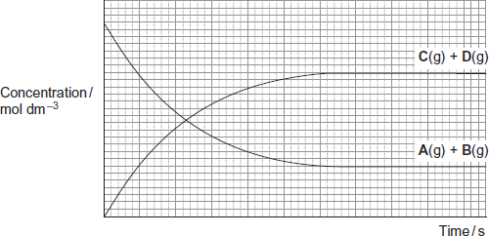
(a) (i) On the appropriate axis of the figure, place an X to show the time when equilibrium is first established.
(1)
(ii) State how the rate of the forward reaction and the rate of the reverse reaction are related to each other at equilibrium.
...............................................................................................................
...............................................................................................................
(1)
(b) Give the meaning of the term dynamic in the context of a dynamic equilibrium.
........................................................................................................................
........................................................................................................................
........................................................................................................................
(1)

(c) The total pressure on the system is increased at constant temperature.
(i) State and explain the effect, if any, of this change on the position of this equilibrium.
Effect .....................................................................................................
Explanation ...........................................................................................
...............................................................................................................
...............................................................................................................
...............................................................................................................
(2)
(ii) State and explain the effect, if any, of this change on the time taken to reach this equilibrium.
Effect .....................................................................................................
Explanation ...........................................................................................
...............................................................................................................
...............................................................................................................
...............................................................................................................
...............................................................................................................
(3)
(Total 8 marks)

4. Hexane (C₆H₁₄) is a member of the homologous series of alkanes.
(a) (i) Name the raw material from which hexane is obtained.
...............................................................................................................
(1)
(ii) Name the process used to obtain hexane from this raw material.
...............................................................................................................
(1)
(b) C₆H₁₄ has structural isomers.
(i) Deduce the number of structural isomers with molecular formula C₆H₁₄
Write the number in this box.

(1)
(ii) State one type of structural isomerism shown by the isomers of C₆H₁₄
...............................................................................................................
(1)
(c) One molecule of an alkane X can be cracked to form one molecule of hexane and two molecules of propene.
(i) Deduce the molecular formula of X.
...............................................................................................................
...............................................................................................................
(1)
(ii) State the type of cracking that produces a high percentage of alkenes. State the conditions needed for this type of cracking.
Type of cracking ....................................................................................
Conditions .............................................................................................
...............................................................................................................
(2)
(iii) Explain the main economic reason why alkanes are cracked.
...............................................................................................................
...............................................................................................................
(1)
(d) Hexane can react with chlorine under certain conditions as shown in the following equation.

 | C₆H₁₄ | + | Cl₂ |  | C₆H₁₃Cl | + | HCl

(i) Both the products are hazardous. The organic product would be labelled ‘flammable'.
Suggest the most suitable hazard warning for the other product.
...............................................................................................................
(1)
(ii) Calculate the percentage atom economy for the formation of C₆H₁₃Cl (M_{r} = 120.5) in this reaction.
...............................................................................................................
...............................................................................................................
(1)
(e) A different chlorinated compound is shown below. Name this compound and state its empirical formula.
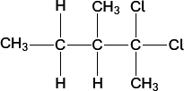
Name ............................................................................................................
Empirical formula ..........................................................................................
(2)
(Total 12 marks)
5. Chlorine can be used to make chlorinated alkanes such as dichloromethane.
(a) Write an equation for each of the following steps in the mechanism for the reaction of chloromethane (CH₃Cl) with chlorine to form dichloromethane (CH₂Cl₂).
Initiation step
........................................................................................................................
First propagation step
........................................................................................................................
Second propagation step
........................................................................................................................
The termination step that forms a compound with empirical formula CH₂Cl.
........................................................................................................................
(4)
(b) When chlorinated alkanes enter the upper atmosphere, carbon-chlorine bonds are broken. This process produces a reactive intermediate that catalyses the decomposition of ozone. The overall equation for this decomposition is
2O₃ 3O₂
(i) Name the type of reactive intermediate that acts as a catalyst in this reaction.
...............................................................................................................
(1)
(ii) Write two equations to show how this intermediate is involved as a catalyst in them decomposition of ozone.
Equation 1................................................................................................
Equation 2................................................................................................
(2)
(Total 7 marks)

6. Organic reaction mechanisms help to develop an understanding of how and why reactions occur.
(a) Propene reacts with hydrogen bromide by an electrophilic addition mechanism forming 2-bromopropane as the major product.
The equation for this reaction is shown below.
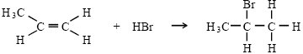
(i) Outline the mechanism for this reaction, showing the structure of the intermediate carbocation formed.

(ii) Give the structure of the alternative carbocation which could be formed in the reaction between propene and hydrogen bromide.

(5)
(b) A substitution reaction occurs when 2-bromopropane reacts with aqueous sodium hydroxide.
(i) Draw the structure of the organic product of this reaction and give its name.
Structure

Name ..................................................................................................
(ii) Name and outline the mechanism for this reaction.
Name of mechanism ...........................................................................
Mechanism

(5)
(c) Under different conditions, 2-bromopropane reacts with sodium hydroxide to produce propene.
(i) Name the mechanism for this reaction
.............................................................................................................
(ii) State the role of sodium hydroxide in this reaction
.............................................................................................................
(2)
(Total 12 marks)
7.
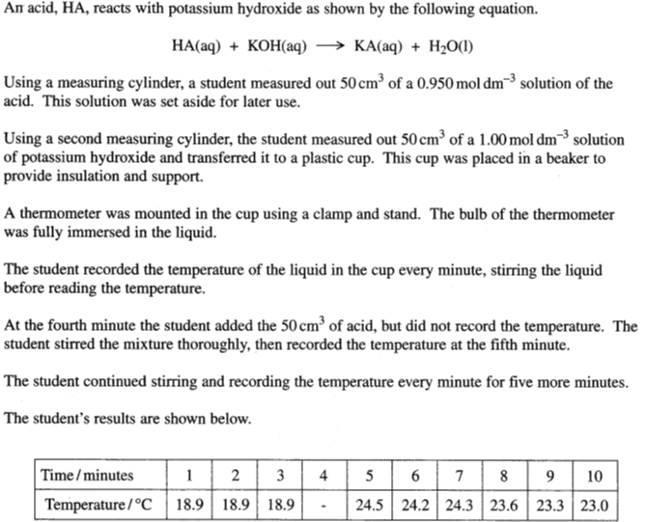
a)
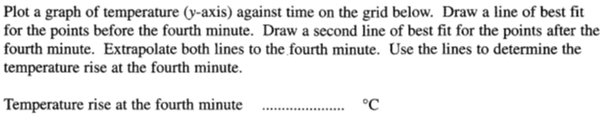
b)
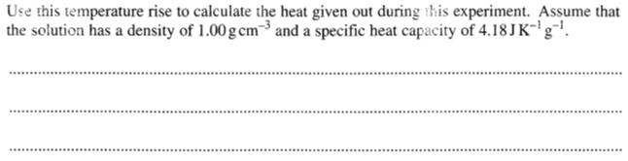
c)
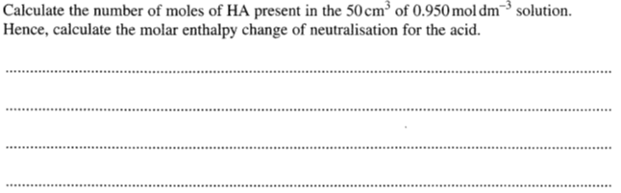
d)
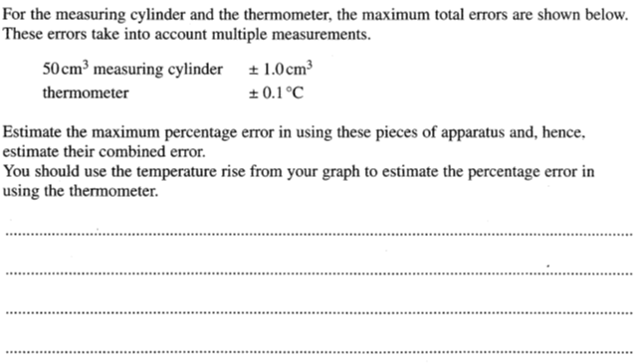
e)
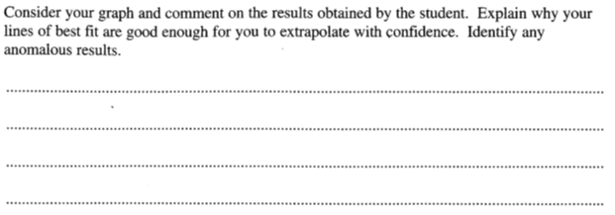
f)
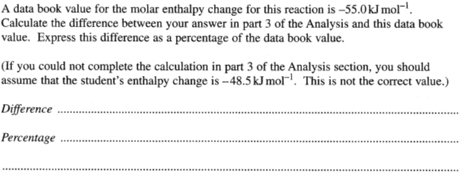
g)
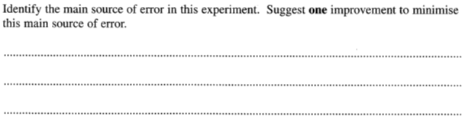
h)
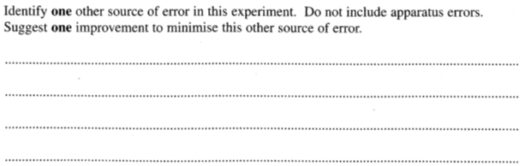
(Total 14 marks)

8. | 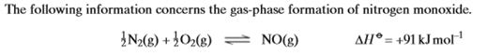  Which of the following statements is true?
 | A | the equilibrium constant has the units mol⁻¹dm⁻³.
 | B | the yield increases if the pressure is increased.
 | C | the rate increases if the pressure is increased.
 | D | the equilibrium constant decreases if the temperature is increased.
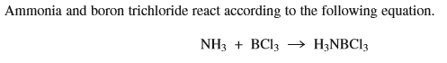
9. | Which of the following statements about this reaction is incorrect?
 | A
 | B
 | C
 | D
10. | Which of the following statements about this reaction is correct?
 | A
 | B
 | C
 | D | The ammonia molecule behaves as an electron pair donor in the reaction
11. | 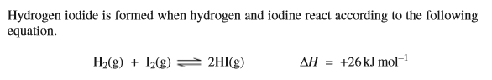  Which of the following statements about this reaction is correct?
 | A | increasing the total pressure increases the yield of HI
 | B | the use of a catalyst would have no effect on the yield of HI
 | C | decreasing the temperature increases the yield of HI
 | D | increasing the temperature decreases the rate of the backward reaction

12. | In which of the following is the shape influenced by the presence of one or more lone pairs of electrons?
 | A
 | B
 | C
 | D
13. | Which of the following statements is correct?
 | A | show an increase from left to right
 | B | show an increase from left to right
 | C
 | D
14. | Which of the following statements is incorrect?
 | A
 | B | Carbon monoxide is formed during the incomplete combustion of alkanes
 | C
 | D

15.
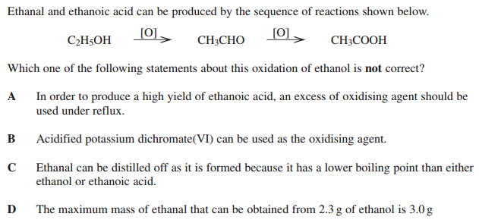

16.
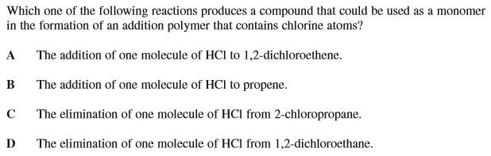

17.
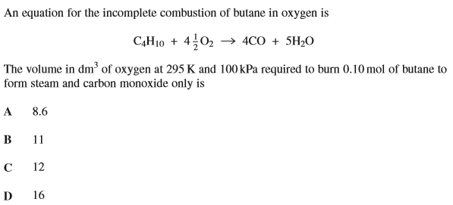

18.
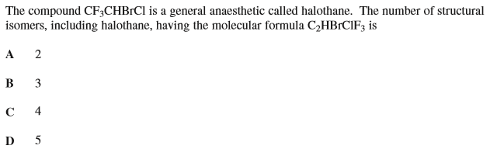
19.
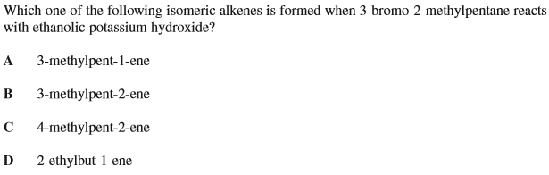

20.
