AS-LEVEL PAPER 2 PP24 MS
1.
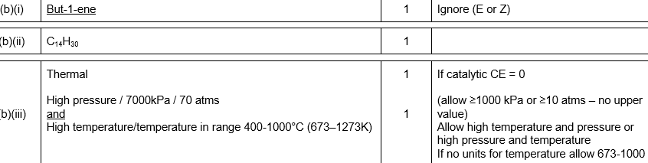
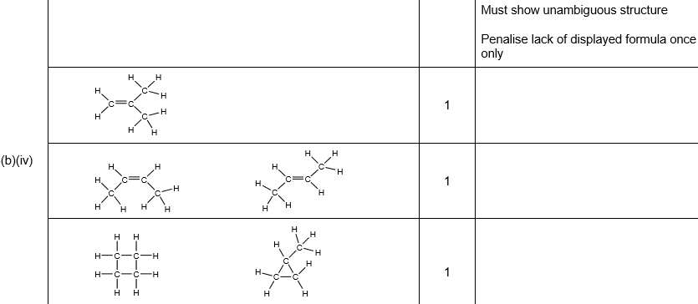[10]

2.
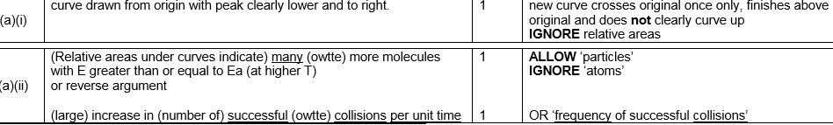
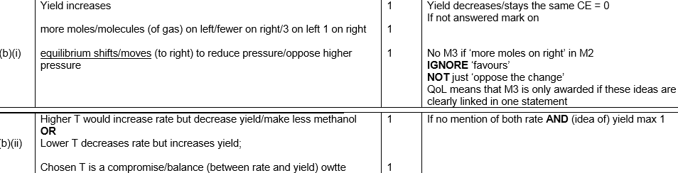
[8]

3.
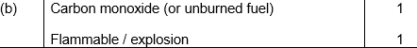
[4]
4. | (a) | 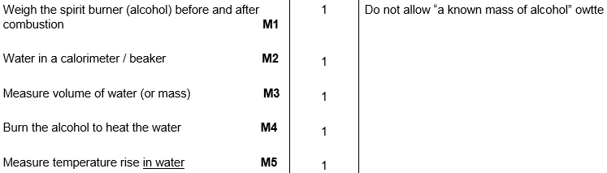
 | (b) | 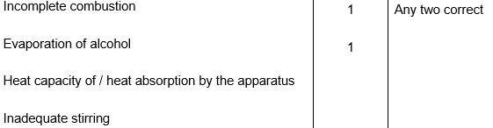
 | (c) | 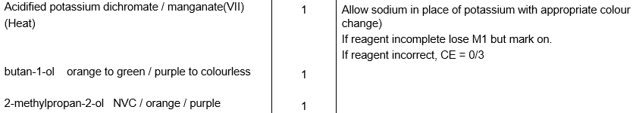
 | (d) | 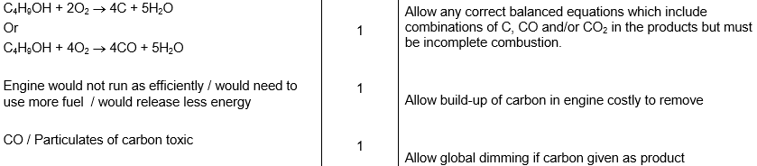  [13]
5.
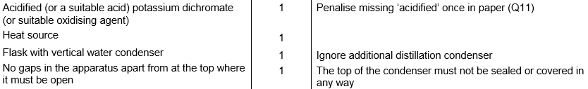
[4]

6.
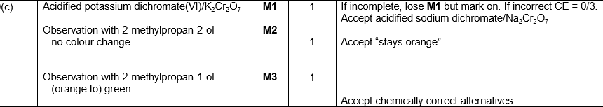
[5]

7.
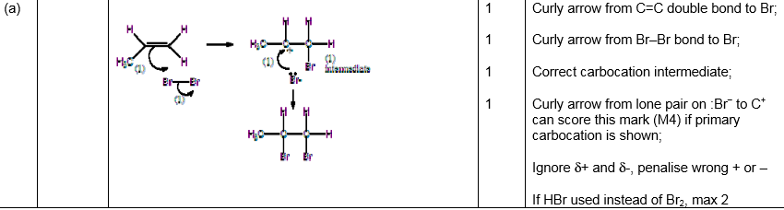
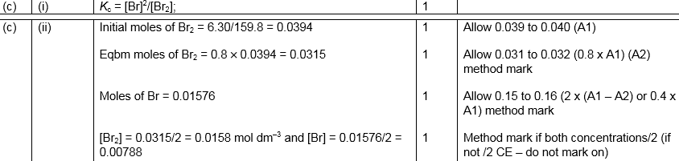
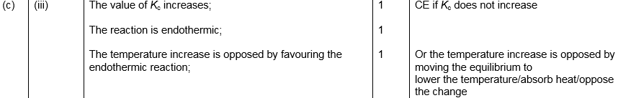
[15]

8.
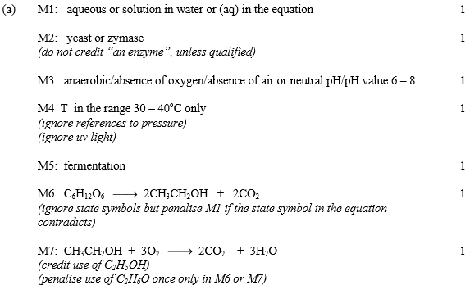
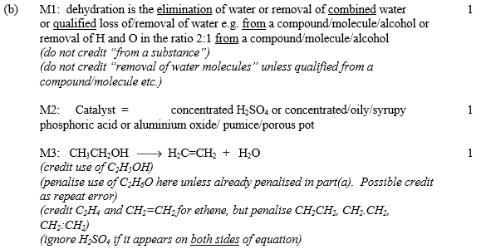
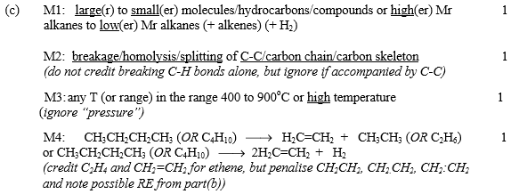
[14]

9.
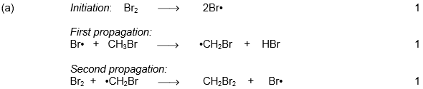
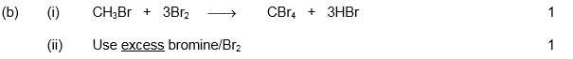
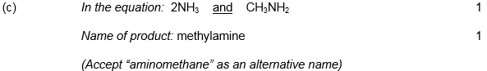 [7]

