AS-LEVEL PAPER 2 AP2

1. (a) O = 74.1%
1
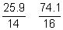
If atomic numbers or molecular masses are used lose M2
1
1.85 4.63
1 2.5
N₂O₅
1
This ratio alone will not score the final mark. (It would get 2)
Allow 3 marks for N₂O₅

(b) Toxic/poisonous/forms an acidic gas/forms NO₂ which is acidic/
respiratory irritant/forms HNO₃ when NO reacts with water and oxygen/
triggers asthma attacks/greenhouse gas/photochemical smog/
contributes to global warming/formation of acid rain
ignore NO is an acidic gas or NO is acidic in water
Not references to ozone layer
1
(c) 2NO + O₂ → 2NO₂
Accept multiples or fractions of equation
Ignore wrong state symbols
1
(d) Nitrogen/N₂ and oxygen/O₂ combine/react
QWC (not N and O combine)
Not nitrogen in fuel
Allow N₂ + O₂ → 2NO for M1 only
1
spark/high temperature/2500-4000 °C
1
(e) 2NO + 2CO → N₂ + 2CO₂
OR
2NO → N₂ + O₂
Accept multiples or fractions of equation
Ignore wrong state symbols
Allow C₈H₁₈ + 25NO → 8CO₂ + 12.5N₂ + 9H₂O
1
[8]

2. (a) Number / proportion / percentage / fraction of molecules
Ignore “particles”
1
(b) None OR no effect OR no change
1
(c) X
1

(d) Answers in either order
M1 collision OR collide
Mark independently
M2 collision / molecules / particles
Ignore “correct” amount of energy
with the activation energy
OR with E > E_{act}
OR with sufficient /enough energy
OR with the minimum energy
OR with the correct orientation
2
(e) A small increase in temperature results in many more / much higher proportion of
/ a lot more / significantly more molecules / particles / collisions with E ≥ E_{act} / energy greater than the activation energy / sufficient energy / enough energy / minimum
energy to react
(compared with a small increase in concentration)
Not just “more molecules with E ≥ E_{act}”
The answer must convey that the increase is significant
Accept reference to “atoms”, “molecules”, “particles”
Ignore “species”
1
[6]

3. (a) (i) Award mark for X on the time axis at the point where the lines just become horizontal
Allow this mark if X is above the letters “sh” in the word “show” in part(ii) - in the range of lines 31 to 33.
1
(ii) They are equal / the same
OR
Forward (rate) = Reverse / backward (rate)
Allow the word ‘speed’ in this context.
Ignore reference to concentration.
1
(b) Both OR forward and reverse reactions occur at the same time
OR both are occurring at once
OR both occur all of the time
OR both are ongoing
OR both never stop
Ignore ‘at equal rates’.
Ignore reference to concentration or equilibrium.
The idea that both reactions occur simultaneously is essential.
The simple idea of ‘both reactions occurring’ is insufficient for the mark.
1

(c) (i) M1 No effect / no change / none / stays the same
M2 requires correct M1
In M2, ignore reference to particles or atoms.
M2 Equal (number of) moles / molecules on both sides
2
(ii) M1 Less time or it decreases or (equilibrium) reached faster (ie M1 is a reference to time taken)
If M1 is ‘more time / it increases’ or ‘no effect’, then CE=0 for the clip.
Reference to faster / increased rate / increased speed alone penalises M1, but mark on M2 and M3.
M2 More particles / molecules in a given volume / space
OR the particles / molecules are closer together
If M1 is blank, then look for all three marks in the text.
M3 More successful / productive collisions in a given time
OR more collisions with E>E_{Act} in a given time
OR more frequent successful / productive collisions
OR increased / greater successful / productive collision frequency / rate
Ignore reference to reactants / products.
Penalise M3 if an increase / decrease in the value of E_{Act} is stated.
3
[8]

4. (a) (i) Crude oil / oil / petroleum
Do not allow ‘petrol’
1
(ii) Fractional distillation / fractionation / fractionating
Not distillation alone
1
(b) (i) 5
Allow five / V
1
(ii) Chain (isomerism)
Allow branched chain / chain branched / side chain (isomerism)
Ignore position (isomerism)
Do not allow straight chain / geometric / branched / function
1
(c) (i) C₁₂H₂₆ / H₂₆C₁₂
Only
1
(ii) Thermal cracking
If not thermal cracking, CE = 0/2
If blank mark on
1
High temperature
Allow ‘high heat’ for ‘high temperature’
(400°C < T < 900°C) or (650 K < T < 1200 K)
Not ‘heat’ alone
If no T, units must be 650 – 900
and
High pressure (> 10 atm, > 1 MPa, >1000 kPa)
1
(iii) To produce substances which are (more) in demand / produce products with a
high value / products worth more
Ignore ‘to make more useful substances’
1

(d) (i) Corrosive or diagram to show this hazard symbol
Ignore irritant, acidic, toxic, harmful
1
(ii) ( 120.5 × 100)(86 + 71 )
=76.75(%) or 76.8(%)
Allow answers > 3 sig figs
1
(e) 2,2-dichloro-3–methylpentane
Ignore punctuation
Any order
1
C₃H₆Cl
1
[12]

5. (a) Initiation
Cl₂ 2Cl•
Penalise absence of dot once only.
First propagation
Cl• + CH₃Cl •CH₂Cl + HCl
Credit the dot anywhere on the radical.
Second propagation
Cl₂ + •CH₂Cl CH₂Cl₂ + Cl•
Termination (must make 1,2-dichloroethane)
2 •CH₂Cl CH₂ClCH₂Cl
Penalise C₂H₄Cl₂
4
(b) (i) (chlorine free) radical
Ignore formula.
1
(ii) M1 Cl• + O₃ ClO• + O₂
M2 ClO• + O₃ Cl• + 2O₂
M1 and M2 could be in either order.
Credit the dot anywhere on the radical.
Penalise absence of dot once only.
Individual multiples acceptable but both need to be doubled if two marks are to be awarded.
2
[7]

6. (a) (i)
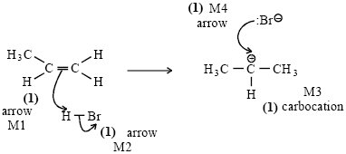
If wrong carbocation, lose structure mark
If wrong alkene, lose structure mark
Can still score ¾ i.e. penalise M3
Penalise M2 if polarity included incorrectly
no bond between H and Br
bond is shown as or
4
(ii)
CH₃CH₂CH₂
credit secondary carbocation here if primary carbocation has
been used in (i)
Ignore attack on this carbocation by o
1
(b) (i) Structure: 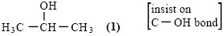
1
Name: propan-2-ol
Not 2-hydroxypropane
1
(ii) Name of mechanism: nucleophilic substitution (both words)
(NOT S_{N}1 or S_{N}2)
1
Mechanism:
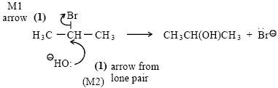
penalise incorrect polarity on C-Br (M1)
Credit the arrows even if incorrect haloalkane
If S_{N}1, both marks possible
2
(c) (i) elimination
1
(ii) base
OR proton acceptor
NOT nucleophile
1
[12]

7. (a)  (b)  (c)  (d) | 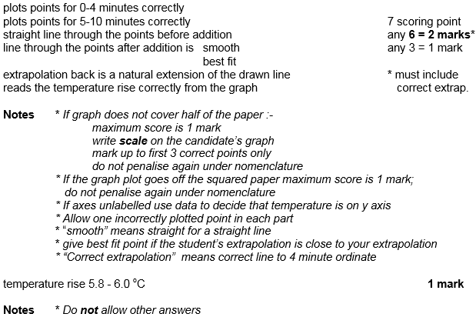  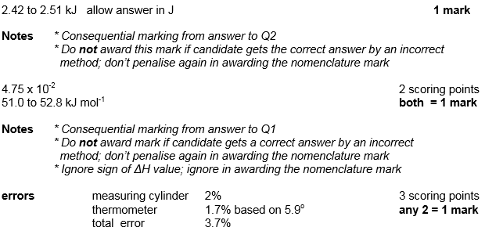  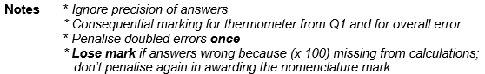

(e)  (f)  (g)  (h) | 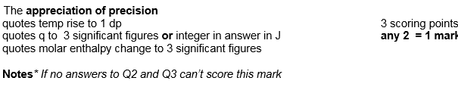  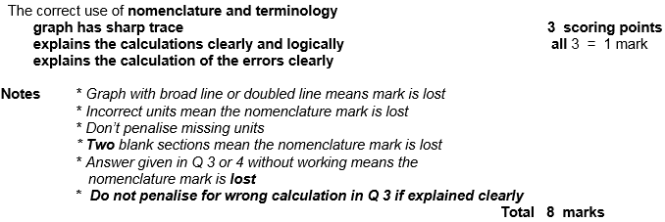  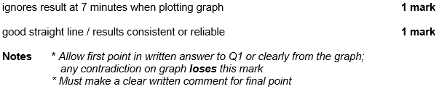  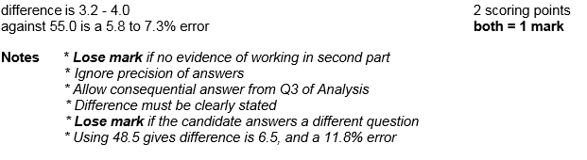  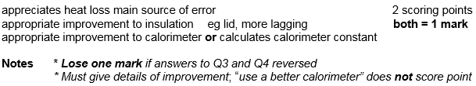  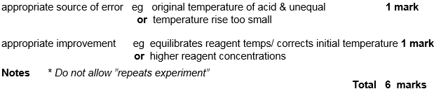

8. C
9. D
10. D
11. B
12. D
13. C
14. C
15. D
16. D
17. B
18. C
19. C
20. C

