AS-LEVEL PAPER 2 PP4 MS

1. (a) The molecular ion is
• The molecule with one/an electron knocked off/lost
Ignore the highest or biggest m/z peak
OR
• The molecule with a (single) positive charge
OR
• the ion with/it has the largest/highest/biggest m/z (value/ratio)
Ignore “the peak to the right”
OR
• the ion with/it has an m/z equal to the M_{r}
Ignore “compound”
1
(b) (i) 2(14.00307) + 15.99491 = 44.00105
A sum is needed to show this
1
(ii) Propane/C₃H₈ and carbon dioxide/CO₂ (and N₂O) or
they or both the gases/molecules or all three gases/molecules
have an (imprecise) M_{r} of 44.0 (OR 44)
OR
they have the same M_{r} or molecular mass (to one d.p)
This could be shown in a calculation of relative masses for propane and carbon dioxide
1
(iii) By definition
OR
The standard/reference (value/isotope)
Ignore “element”
Ignore “atom”
1
(c) (i) M1 (could be scored by a correct mathematical expression)
ΔH = ΣΔH_{products} – ΣΔH_{reactants}
OR a correct cycle of balanced equations
M1 and M2 can be scored with correct moles as follows
ΔH + 2(– 46) = +82 + 3(– 286)
ΔH – 92 = – 776
ΔH = 92 – 776 OR 92 + 82 – 858
M3
ΔH = – 684 (kJ mol^{–1}) (This is worth 3 marks)
Award 1 mark ONLY for + 684
Full marks for correct answer.
Ignore units.
Deduct one mark for an arithmetic error.
3
(ii) The value is quoted at a pressure of 100 kPa OR 1 bar or 10⁵ Pa
OR
All reactants and products are in their standard states/their normal
states at 100 kPa or 1 bar
Ignore 1 atmosphere/101 kPa
Ignore “constant pressure”
1
[8]

2. (a) M1 The activation energy is the minimum / least / lowest energy
Mark independently
Ignore “heat” and ignore “enthalpy”
M2 (energy) for a reaction to occur / to go / to start
OR (energy) for a successful / effective collision
Ignore “breaking the bonds”
2
(b) M1 Catalysts provide an alternative route OR an
alternative mechanism OR alternative / different path(way)
M2 Lowers the activation energy
Mark independently
Ignore reference to “surface”
2
(c) (i) Stay(s) the same
1
(ii) Increases
Credit “increase” or “increased”
1
(iii) Increases
Credit “increase” or “increased”
1
(iv) Stay(s) the same
1
(d) (i) M1 yeast or zymase
M2 ethanol
Ignore “enzyme”
In M2, ignore “alcohol” and ignore any formula
2
(ii) M1 (Concentrated) H₃PO₄ OR (Concentrated) H₂SO₄
M2 butan-2-ol
Credit correct names
Ignore “hydrogenphosphate or hydrogensulfate”
Ignore “dilute” or “aq”
Do not penalise absence of hyphens in name.
In M2, ignore any formula
2
[12]

3. (a) C_{n} H_{2n+2}
Allow x in place of n
1
(b)
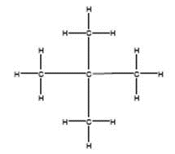
Chain
Must show every bond
Allow branched chain
2

(c) C₉H₂₀
Only
1
To break the (C-C and/or C-H) bonds
M2=0 if break C=C
1
To make products which are in greater demand / higher
value / make alkenes
Not more useful products
Allow specific answers relating to question
1
(d) C₅H₁₂ + 3O₂ → 5C + 6H₂O
Allow other balanced equations which give C and CO/CO₂
1
Causes global dimming / exacerbates asthma / causes
breathing problems / makes visibility poor / smog
Apply list principle
Ignore causes cancer / toxic
1
(e) 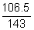 (x 100)
1
74.48%
Allow 74.5%
1
3
Only
1
(f) 2,3-dichloro-3-methylpentane
Ignore punctuation
1
C₃H₆Cl
Only
1
[13]

4. (a) Compounds with the same molecular formula
1
but different structures due to different positions of the
same functional group on the same carbon skeleton/chain
1
(b) Compound A is butan-1-ol only
1
Compound C is butanone or butan-2-one
(penalise but-1-ol, but allow repeat error for but-2-one)
(credit butane-1-ol)
1

(c) (i) oxidation or redox
1
(ii) K₂Cr₂O₇ or potassium dichromate(VI)
(penalise the dichromate ion or incorrect oxidation state,
but mark on)
1
acidified or H₂SO₄ (or other identified strong acid)
(penalise H⁺)
(do not credit the acid unless M1 has been correctly attempted)
1
(iii) (heat under) reflux
OR use excess oxidising agent
1
(iv) correctly drawn structure of 2-methylpropan-2-ol
(insist on clearly drawn C-C and C-0 bonds)
1
(v) correctly drawn structure of methanoic acid
(insist on C-0 and C=O displayed in the formula)
1
(d) (i) Tollens’ reagent or this whole reagent specified
(ammoniacal silver nitrate)
OR Fehling’s solution
OR acidified potassium dichromate(VI)
1
(ii) correctly drawn structure of methylpropanal
(insist on C-H and C=O of aldehyde displayed in the formula)
1
[12]

5. | (a)
(b)
(c)
(d)
(e)
 | (f) | 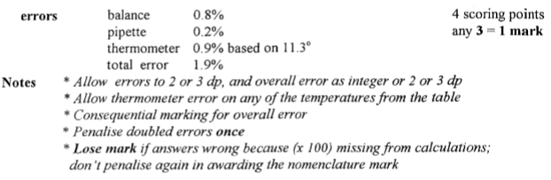

 |  | 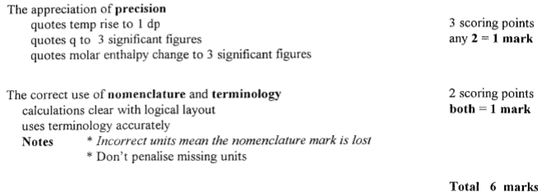
 | (g) | 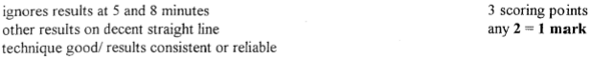
 | (h) | 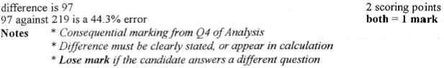
 | (i)
 | (j) | 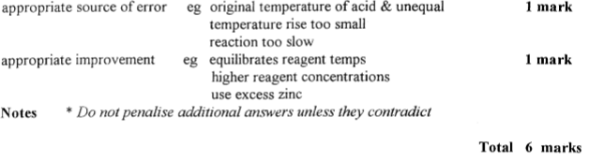
6.

7. C
8. C
9. B
10. A
11. D
12. B
13. C
14. C
15. C
16. D

17. C

18. A

19. D

20. A

21. B

