AS LEVEL CHEMISTRY

PAPER 2
PRACTICE PAPER 7
Answer all questions
Max 80 marks

Name ……………………………………………………………..

Mark ……../80 ……....% Grade ………

Note – the multiple choice questions used in this paper are recycled from the assessed homeworks, tests and assessment points for the AS-level/1st Year course

1. Methanol, CH₃OH, is a convenient liquid fuel.
(a) An experiment was conducted to determine the enthalpy of combustion of liquid methanol. The energy obtained from burning 2.12 g of methanol was used to heat 150 g of water. The temperature of the water rose from 298 K to 362 K. (The specific heat capacity of water is 4.18 J K^{–1} g^{–1})
(i) Define the term standard enthalpy of combustion.
……………………………………………………………………………………………………..
……………………………………………………………………………………………………..
……………………………………………………………………………………………………..
(ii) Use the data above to calculate a value for the enthalpy of combustion of one mole of liquid methanol.
……………………………………………………………………………………………………..
……………………………………………………………………………………………………..
……………………………………………………………………………………………………..
……………………………………………………………………………………………………..
……………………………………………………………………………………………………..
(7)
(b) Methanol can be synthesised from methane and steam by a process that occurs in two stages.
Stage 1 CH₄(g) + H₂O(g) 3H₂(g) + CO(g) ΔH^{ο} = +206 kJ mol^{–1}
Stage 2 CO(g) + 2H₂(g) CH₃OH(g) ΔH^{ο} = –91 kJ mol^{–1}
(i) Explain why, in Stage 1, a higher yield of hydrogen and carbon monoxide is not obtained if the pressure is increased.
……………………………………………………………………………………………………..
……………………………………………………………………………………………………..
……………………………………………………………………………………………………..
(ii) Stage 2 is carried out at a compromise temperature of 500K. By considering what would happen at higher and lower temperatures, explain why 500 K is considered to be a compromise for Stage 2.
……………………………………………………………………………………………………..
……………………………………………………………………………………………………..
……………………………………………………………………………………………………..
(5)

(c) The standard enthalpies of combustion of carbon monoxide and of hydrogen are
–283 kJ mol^{–1} and –286 kJ mol^{–1}, respectively. Use these data and the enthalpy change for Stage 2 to calculate a value for the standard enthalpy of combustion of gaseous methanol.
....................................................................................................................................................
....................................................................................................................................................
....................................................................................................................................................
....................................................................................................................................................
(3)
(Total 15 marks)

2. The diagram below shows the Maxwell–Boltzmann distribution of molecular energies in a sample of a gas.
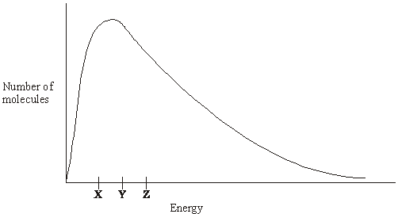
(a) (i) State which one of X, Y or Z best represents the mean energy of the molecules.
.............................................................................................................
(ii) Explain the process that causes some molecules in this sample to have very low energies.
.............................................................................................................
.............................................................................................................
(3)
(b) On the diagram above, sketch a curve to show the distribution of molecular energies in the same sample of gas at a higher temperature.
(2)

(c) (i) Explain why, even in a fast reaction, a very small percentage of collisions leads to a reaction.
...........................................................................................................................................
...........................................................................................................................................
(ii) Other than by changing the temperature, state how the proportion of successful collisions between molecules can be increased. Explain why this method causes an increase in the proportion of successful collisions.
Method for increasing the proportion of successful collisions ...........................................
...........................................................................................................................................
Explanation …....................................................................................................................
...........................................................................................................................................
(4)
(Total 9 marks)

3. The mechanism for the reaction of methane with fluorine is a free-radical substitution similar to the chlorination of methane.
(a) Outline the following steps in the mechanism for the reaction of methane with fluorine to form fluoromethane, CH₃F
Initiation step
....................................................................................................................................................
First propagation step
....................................................................................................................................................
Second propagation step
....................................................................................................................................................
A termination step
....................................................................................................................................................
(4)
(b) Write an overall equation for the reaction of fluorine with fluoromethane to form tetrafluoromethane.
....................................................................................................................................................
(1)
(Total 5 marks)

4. Propene reacts with bromine by a mechanism known as electrophilic addition.
(a) Explain what is meant by the term electrophile and by the term addition.
Electrophile ..................................................................................................
......................................................................................................................
Addition ........................................................................................................
......................................................................................................................
(2)
(b) Explain why bromine, a non-polar molecule, is able to react with propene.
......................................................................................................................
......................................................................................................................
......................................................................................................................
(2)
(c) Outline the mechanism for the electrophilic addition of bromine to propene. Give the name of the product formed.
Mechanism

Name of product ...........................................................................................
(5)
(d) The polymerisation of propene to form poly(propene) is an important industrial process.
Name the type of polymerisation involved.
......................................................................................................................
(1)
(Total 10 marks)

5. Four isomers with the formula C₄H₉OH are given below.

CH₃CH₂CH₂CH₂OH |  | 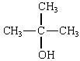 | 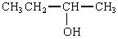

(a) One of the isomers in part (a) is resistant to oxidation by acidified potassium dichromate(VI).
(i) Identify this isomer.
...........................................................................................................................................
(ii) This isomer can be dehydrated. Give a suitable dehydrating agent and write an equation for this dehydration reaction.
Dehydrating agent..............................................................................................................
Equation ............................................................................................................................
(3)
(b) (i) Identify the isomer in part (a) which can be oxidised to a ketone. Give the structure of the ketone formed.
Isomer .................................................................................................
Structure of the ketone

(ii) Identify one of the isomers in part (a) which can be oxidised to an aldehyde. Give the structure of the aldehyde formed.
Isomer .................................................................................................
Structure of the aldehyde

(iii) Give a reagent that can be used in a test to distinguish between a ketone and an aldehyde. State what you would observe in the test.
Reagent ..............................................................................................
Observation with ketone ......................................................................
.............................................................................................................
Observation with aldehyde ..................................................................
.............................................................................................................
(7)

(c) Butan-1-ol can be oxidised to form a carboxylic acid. Using [O] to represent the oxidising agent, write an equation for this reaction and name the product.
Equation ......................................................................................................
Name of product ..........................................................................................
(2)
(Total 12 marks)

6. When 2-chloropropane reacts with sodium hydroxide, two different reactions occur.
Each reaction produces a different organic product.
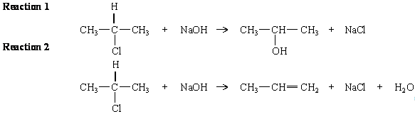
(a) Outline a mechanism for Reaction 1 and state the role of the hydroxide ion in this reaction.
Mechanism

Role of the hydroxide ion ....................................................................
(b) Outline a mechanism for Reaction 2 and state the role of the hydroxide ion in this reaction.
Mechanism

Role of the hydroxide ion ....................................................................
(7)
(Total 7 marks)

7. | 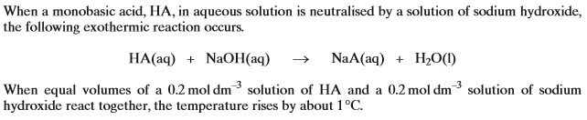  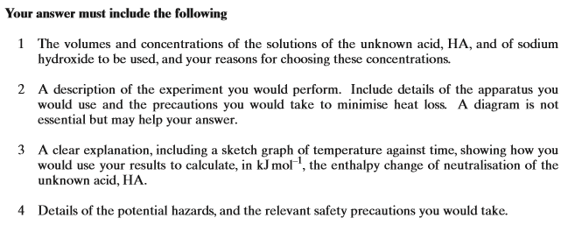
………………………………………………………………………………………………………………………………………………………………………………
………………………………………………………………………………………………………………………………………………………………………………
………………………………………………………………………………………………………………………………………………………………………………
………………………………………………………………………………………………………………………………………………………………………………
………………………………………………………………………………………………………………………………………………………………………………
………………………………………………………………………………………………………………………………………………………………………………
………………………………………………………………………………………………………………………………………………………………………………
………………………………………………………………………………………………………………………………………………………………………………
………………………………………………………………………………………………………………………………………………………………………………
………………………………………………………………………………………………………………………………………………………………………………
………………………………………………………………………………………………………………………………………………………………………………
………………………………………………………………………………………………………………………………………………………………………………
………………………………………………………………………………………………………………………………………………………………………………
………………………………………………………………………………………………………………………………………………………………………………
………………………………………………………………………………………………………………………………………………………………………………
………………………………………………………………………………………………………………………………………………………………………………
………………………………………………………………………………………………………………………………………………………………………………
………………………………………………………………………………………………………………………………………………………………………………
………………………………………………………………………………………………………………………………………………………………………………
………………………………………………………………………………………………………………………………………………………………………………
………………………………………………………………………………………………………………………………………………………………………………
………………………………………………………………………………………………………………………………………………………………………………
………………………………………………………………………………………………………………………………………………………………………………
………………………………………………………………………………………………………………………………………………………………………………
………………………………………………………………………………………………………………………………………………………………………………
………………………………………………………………………………………………………………………………………………………………………………
………………………………………………………………………………………………………………………………………………………………………………
………………………………………………………………………………………………………………………………………………………………………………
………………………………………………………………………………………………………………………………………………………………………………
………………………………………………………………………………………………………………………………………………………………………………
………………………………………………………………………………………………………………………………………………………………………………
………………………………………………………………………………………………………………………………………………………………………………
………………………………………………………………………………………………………………………………………………………………………………
………………………………………………………………………………………………………………………………………………………………………………
………………………………………………………………………………………………………………………………………………………………………………
………………………………………………………………………………………………………………………………………………………………………………
………………………………………………………………………………………………………………………………………………………………………………
………………………………………………………………………………………………………………………………………………………………………………
………………………………………………………………………………………………………………………………………………………………………………
………………………………………………………………………………………………………………………………………………………………………………
………………………………………………………………………………………………………………………………………………………………………………
………………………………………………………………………………………………………………………………………………………………………………
………………………………………………………………………………………………………………………………………………………………………………
………………………………………………………………………………………………………………………………………………………………………………
………………………………………………………………………………………………………………………………………………………………………………
………………………………………………………………………………………………………………………………………………………………………………
………………………………………………………………………………………………………………………………………………………………………………
………………………………………………………………………………………………………………………………………………………………………………
(Total 8 marks)

8 – 10 These questions are about the reaction between propanone and an excess of ethane-1,2- diol, the equation for which is given below.
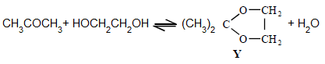
In a typical procedure, a mixture of 1.00 g of propanone, 5.00 g of ethane-1,2-diol and 0.100 g of benzenesulphonic acid, C₆H₅SO₃H, is heated under reflux in an inert solvent. Benzenesulphonic acid is a strong acid.
8. The products would not have an absorption in the infra-red at
A 1050 cm⁻¹
B 1720 cm⁻¹
C 2950 cm⁻¹
D 3400 cm⁻¹
(Total 1 mark)

9. If 1.00 g of propanone was vapourised at 100 °C and 100 kPa pressure, the volume in m³ of gas formed would be
A 31.0
B 8.31
C 0.534
D 5.34 × 10⁻⁴
(Total 1 mark)

10. Which one of the following statements is not true?
A Ethane-1,2-diol and water can form hydrogen bonds.
B Ethane-1,2-diol is soluble in water.
C Propane has a higher boiling point than ethane-1,2-diol.
D Y and water are polar molecules.
(Total 1 mark)

11 - 13. Use the information below to answer these questions.
C(s) + O₂(g) → CO₂(g) ∆H = −393.5 kJ mol⁻¹
H₂(g) + O₂(g) → H₂O(l) ∆H = −285.8 kJ mol⁻¹
3C(s) + 4H₂(g) → C₃H₈(g) ∆H = −104.0 kJ mol⁻¹
4C(s) + 5H₂(g) → C₄H₁₀(g) ∆H = −125.2 kJ mol⁻¹
11. The value in kJ mol⁻¹ of the enthalpy of thermal dissociation when butane forms propane, hydrogen and carbon is
A −26.3
B −17.5
C +17.5
D +21.2
(Total 1 mark)

12. The value in kJ mol⁻¹ for the enthalpy of combustion of propane is
A −211.7
B −419.7
C −2220
D −2878
(Total 1 mark)

13. The standard enthalpy of combustion of butane, in kJ mol⁻¹, is
A −2880
B −2590
C −806
D −554
(Total 1 mark)

14. This question concerns the preparation of the plastic poly(methyl 2-methylpropenoate) (Perspex), starting from propanone.
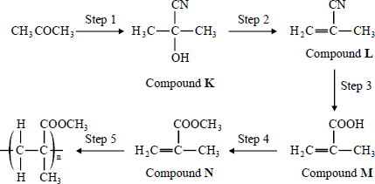
Which one of the following is not a structural isomer of Compound M?
A 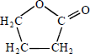
B 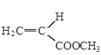
C 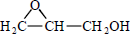
D 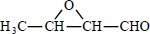
(Total 1 mark)

15. Ethanoic acid reacts with ethanol in a reversible reaction represented by the equation below.
In an experiment 3.0 mol of ethanoic acid were mixed with 1.0 mol of ethanol and when the reaction had reached equilibrium 0.9 mol of water had been formed.
CH₃COOH(l) + C₂H₅OH(l) CH₃COOC₂H₅(l) + H₂O(l)
The percentage of ethanoic acid converted into the ester CH₃COOC₂H₅ in this reaction is
A 22.5%
B 30%
C 43%
C 90%
(Total 1 mark)

16. An equation for the incomplete combustion of butane in oxygen is
C₄H₁₀ + 4 O₂ → 4CO + 5H₂O
The volume in dm³ of oxygen at 295 K and 100 kPa required to burn 0.1 mol of butane to form steam and carbon monoxide only is
A 8.6
B 11
C 12
C 16
(Total 1 mark)

17. For this question refer to the reaction scheme below.
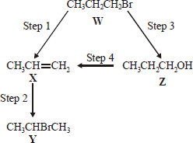
Which one of the following reagents would not bring about the reaction indicated?
A Step 1 : alcoholic KOH
B Step 2 : aqueous Br₂
C Step 3 : aqueous NaOH
C Step 4 : concentrated H₂SO₄
(Total 1 mark)

18. Use the information about the following solutions to answer the question below.
Solution F: This is a mixture of 1 mol of propanoic acid, 1 mol of methanol and 2 mol of water.
Solution G: This was originally the same mixture as solution F but it has been left to reach equilibrium.
Solution G was found to contain 0.5 mol of propanoic acid. Which one of the following is the value of the equilibrium constant (K_{c}) for the following equilibrium?
propanoic acid + methanol methyl propanoate + water
A 0.2
B 1
C 5
D 10
(Total 1 mark)

19. 25.0 cm³ of ethanedioic acid required 22.5 cm³ of 0.100 mol dm⁻³ potassium hydroxide solution for complete neutralisation.
The concentration of ethanedioic acid is
A 0.0225 mol dm⁻³
B 0.0450 mol dm⁻³
C 0.0560 mol dm⁻³
D 0.0900 mol dm⁻³
(Total 1 mark)

20. Which one of the following molecules is not planar?
A BF₃
B NCl₃
C C₂H₄
D HCHO
(Total 1 mark)

21. The compound cis-retinal is shown below.
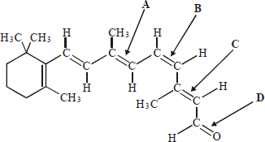
Which one of the labelled bonds leads to the prefix in the name?
(Total 1 mark)

