AS LEVEL CHEMISTRY

PAPER 2
PRACTICE PAPER 8
Answer all questions
Max 80 marks

Name ……………………………………………………………..

Mark ……../80 ……....% Grade ………

Note – this paper only contains 9 multiple choice questions

1. Potassium nitrate, KNO₃, decomposes on strong heating, forming oxygen and solid Y as the only products.
(a) A 1.00 g sample of KNO₃ (M_{r} = 101.1) was heated strongly until fully decomposed into Y.
(i) Calculate the number of moles of KNO₃ in the 1.00 g sample.
.............................................................................................................
.............................................................................................................
(ii) At 298 K and 100 kPa, the oxygen gas produced in this decomposition occupied a volume of 1.22 × 10^{–4} m³.
State the ideal gas equation and use it to calculate the number of moles of oxygen produced in this decomposition.
(The gas constant R = 8.31 J K^{–1} mol^{–1})
Ideal gas equation ..............................................................................
Moles of oxygen ..................................................................................
.............................................................................................................
.............................................................................................................
.............................................................................................................
.............................................................................................................
(5)
(b) Compound Y contains 45.9% of potassium and 16.5% of nitrogen by mass, the remainder being oxygen.
(i) State what is meant by the term empirical formula.
.............................................................................................................
.............................................................................................................
(ii) Use the data above to calculate the empirical formula of Y.
.............................................................................................................
.............................................................................................................
.............................................................................................................
(4)
(c) Deduce an equation for the decomposition of KNO₃ into Y and oxygen.
......................................................................................................................
(1)
(Total 10 marks)

2. One of the first substances used as an anaesthetic in medicine was chloroform (trichloromethane, CHCl₃). By 1950, halothane was in common use but by 1990 this had been replaced by more acceptable anaesthetics such as desflurane.
CF₃CHBrCl CF₃CHFOCHF₂
halothane desflurane
One reason for replacing halothane was that it is an organic compound that contains chlorine. Chlorine-containing organic compounds are thought to cause damage to the ozone layer in the upper atmosphere.
(a) Name and outline a mechanism for the reaction of chlorine with methane to form chloromethane (CH₃Cl).
Write an overall equation for the reaction of chlorine with methane to form trichloromethane (CHCl₃).
......................................................................................................................
......................................................................................................................
......................................................................................................................
......................................................................................................................
......................................................................................................................
......................................................................................................................
......................................................................................................................
......................................................................................................................
......................................................................................................................
(5)
(b) Explain how chlorine atoms are formed from chlorine-containing organic compounds in the upper atmosphere.
Explain, with the aid of equations, how chlorine atoms act as a catalyst in the decomposition of ozone into oxygen.
......................................................................................................................
......................................................................................................................
......................................................................................................................
......................................................................................................................
......................................................................................................................
......................................................................................................................
......................................................................................................................
(6)

(c) Use the formulae of the two anaesthetics, halothane and desflurane, to help to explain why desflurane is considered to be a more environmentally acceptable anaesthetic than halothane.
......................................................................................................................
......................................................................................................................
......................................................................................................................
......................................................................................................................
(2)
(Total 13 marks)

3. A method of synthesising ammonia directly from nitrogen and hydrogen was developed by Fritz Haber. On an industrial scale, this synthesis requires a high temperature, a high pressure and a catalyst and is very expensive to operate.
(a) Use the data given below to calculate a value for the enthalpy of formation of ammonia

Bond | N ≡N | H – H | N – H
Mean bond enthalpy/kJ mol^{–1} | 945 | 436 | 391

…………………………………………………………………………………………………………………………………………………………..

…………………………………………………………………………………………………………………………………………………………..

…………………………………………………………………………………………………………………………………………………………..

…………………………………………………………………………………………………………………………………………………………..
(3)
(b) A manager in charge of ammonia production wished to increase the daily production of ammonia and reduce the production costs. How would a chemist explain the factors that would influence the commercial efficiency of this production process?

…………………………………………………………………………………………………………………………………………………………..

…………………………………………………………………………………………………………………………………………………………..

…………………………………………………………………………………………………………………………………………………………..

…………………………………………………………………………………………………………………………………………………………..

…………………………………………………………………………………………………………………………………………………………..

…………………………………………………………………………………………………………………………………………………………..

…………………………………………………………………………………………………………………………………………………………..

…………………………………………………………………………………………………………………………………………………………..

…………………………………………………………………………………………………………………………………………………………..

…………………………………………………………………………………………………………………………………………………………..
(8)
(Total 11 marks)
4. Methanol (CH₃OH) is an important fuel that can be synthesised from carbon dioxide.
(a) The table shows some standard enthalpies of formation.

 | CO₂(g) | H₂(g) | CH₃OH(g) | H₂O(g)
∆H_{f}^{Ɵ}/kJ mol^{–1} | – 394 | 0 | – 201 | – 242

(i) Use these standard enthalpies of formation to calculate a value for the standard enthalpy change of this synthesis.

CO₂(g) | + | 3H₂(g) |  | CH₃OH(g) | + | H₂O(g)

...............................................................................................................
...............................................................................................................
...............................................................................................................
...............................................................................................................
...............................................................................................................
...............................................................................................................
...............................................................................................................
(3)
(ii) State why the standard enthalpy of formation for hydrogen gas is zero.
...............................................................................................................
...............................................................................................................
(1)
(b) State and explain what happens to the yield of methanol when the total pressure is increased in this synthesis.
Effect on yield ................................................................................................
Explanation ....................................................................................................
........................................................................................................................
........................................................................................................................
........................................................................................................................
........................................................................................................................
........................................................................................................................
(3)

(c) The hydrogen required for this synthesis is formed from methane and steam in a reversible reaction. The equation for this reaction is shown below.
CH₄(g) + H₂O(g) C0(g) + 3H₂(g) ∆H = +206 kJ mol^{–1}
State and explain what happens to the yield of hydrogen in this reaction when the temperature is increased.
Effect on yield ................................................................................................
Explanation ....................................................................................................
........................................................................................................................
........................................................................................................................
........................................................................................................................
........................................................................................................................
........................................................................................................................
(3)
(d) The methanol produced by this synthesis has been described as a carbon-neutral fuel.
(i) State the meaning of the term carbon-neutral.
...............................................................................................................
...............................................................................................................
...............................................................................................................
...............................................................................................................
(1)
(ii) Write an equation for the complete combustion of methanol.
...............................................................................................................
(1)
(iii) The equation for the synthesis of methanol is shown below.

CO₂(g) | + | 3H₂(g) |  | CH₃OH(g) | + | H₂O(g)

Use this equation and your answer to part (d)(ii) to deduce an equation to represent the overall chemical change that occurs when methanol behaves as a carbon-neutral fuel.
Equation ...............................................................................................
(1)

(e) A student carried out an experiment to determine the enthalpy change when a sample of methanol was burned.
The student found that the temperature of 140 g of water increased by 7.5 °C when 0.011 mol of methanol was burned in air and the heat produced was used to warm the water.
Use the student’s results to calculate a value, in kJ mol^{–1}, for the enthalpy change when one mole of methanol was burned.
(The specific heat capacity of water is 4.18 J K^{–1} g^{–1}).
........................................................................................................................
........................................................................................................................
........................................................................................................................
........................................................................................................................
........................................................................................................................
........................................................................................................................
(3)
(Total 16 marks)

5. (a) In an experiment, at a fixed temperature, an equilibrium mixture contained the following amounts, in moles, of each component.

 | CH₃CH₂COOH | CH₃CH₂OH | CH₃CH₂COOCH₂CH₃ | H₂O
 | 0.0424 | 0.0525 | 0.0745 | 0.0813

Use the data in the table above to calculate a value for the equilibrium constant, K_{c,} at this fixed temperature.
Record your answer to the appropriate precision.
........................................................................................................................
........................................................................................................................
........................................................................................................................
(2)
(b) If the mixture is uncovered during the time it is left to reach equilibrium, some of the ester formed will evaporate.
Explain why a smaller volume of sodium hydroxide would then be required in the titration compared with the volume for the covered mixture.
........................................................................................................................
........................................................................................................................
........................................................................................................................
(2)
(Total 4 marks)
6. Reaction of 2-bromobutane with potassium hydroxide can produce two types of product depending on the solvent used. In aqueous solution, the formation of an alcohol, E, is more likely but in ethanolic solution the formation of alkenes is more likely.
(a) For each type of product, name the type of reaction occurring and state the role of the potassium hydroxide.

…………………………………………………………………………………………………………………………………………………………..

…………………………………………………………………………………………………………………………………………………………..

…………………………………………………………………………………………………………………………………………………………..

…………………………………………………………………………………………………………………………………………………………..
(4)
(b) Name alcohol E and draw its structural formula. By reference to the structure of the halogenoalkane, explain why the initial step in the mechanism of the reaction producing the alcohol occurs.

…………………………………………………………………………………………………………………………………………………………..

…………………………………………………………………………………………………………………………………………………………..

…………………………………………………………………………………………………………………………………………………………..

…………………………………………………………………………………………………………………………………………………………..

…………………………………………………………………………………………………………………………………………………………..
(5)
(c) When 2-bromobutane reacts with ethanolic potassium hydroxide, two structurally isomeric alkenes are produced, one of which shows stereoisomerism.
Outline the mechanism for the formation of one of the structurally isomeric alkenes.
Explain why two structurally isomeric alkenes are formed and draw the structure of the second structural isomer. Draw the structural formulae of the two stereoisomers.

………………………………………………………………………………………………………………………………………………..

…………………………………………………………………………………………………………………………………………………………..

…………………………………………………………………………………………………………………………………………………………..

…………………………………………………………………………………………………………………………………………………………..

…………………………………………………………………………………………………………………………………………………………..

…………………………………………………………………………………………………………………………………………………………..

…………………………………………………………………………………………………………………………………………………………..

…………………………………………………………………………………………………………………………………………………………..
(8)
(Total 17 marks)

7 - 8. | 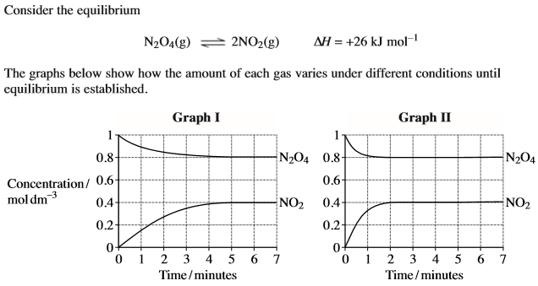
7. | 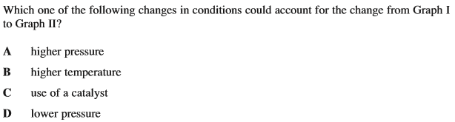
8. | 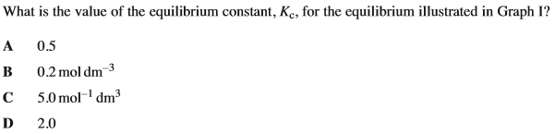

9. | 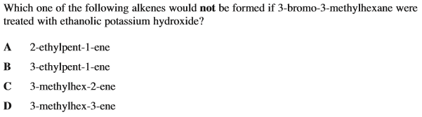
10. | 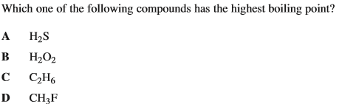
11. | 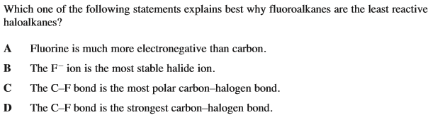
12.
 | A | 0.36 mol methane
 | B | 0.24 mol ethanol
 | C | 0.18 mol propanal
 | D | 0.12 mol butanoic acid

13. | 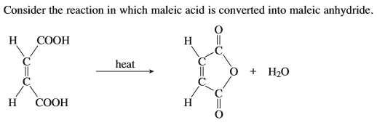  Which of the following statements is incorrect?
 | A
 | B | The type of reaction is a dehydration.
 | C
 | D
14. | Which of the following species is not planar?
 | A
 | B
 | C
 | D | XeF₄
15. In a vessel of volume 1.80 dm³, a reaction mixture contains 0.0700 mol of SO₃(g), 0.0500 mol of SO₂(g) and 0.0900 mol of O₂(g) at a total pressure of 623 kPa. The temperature in the equilibrium vessel is
A 307 °C
B 596 K
C 337 °C
D 642 K
(Total 1 mark)

