DEPARTMENT OF CHEMISTRY
FOURAH BAY COLLEGE – UNIVERSITY OF SIERRA LEONE

CHEM 121

KINETICS, THERMODYNAMICS AND ELECTROCHEMISTRY

Unit 1 – Energetics and Thermodynamics

CONTINUOUS ASSESSMENT
TEST

2 pm Wednesday 15th August

You must have your own scientific calculator
Answer all questions
Time allowed: 55 minutes

Name: ……………………………………………………

Adm/Reg No. ………………..

Unit 1 Continuous Assessment is worth 15% of the total marks for CHEM 121
Your score will be divided into three parts:
Lecture and Tutorial Attendance 10%
Assignment 40%
Test 50%

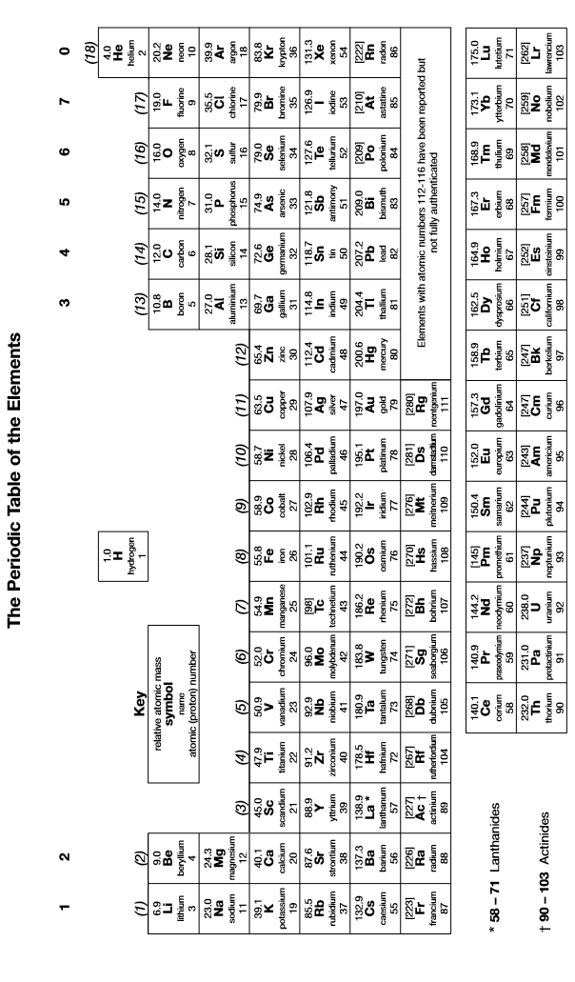
1. | The standard enthalpy of combustion of methane (CH₄) is -890 kJmol⁻¹.
 | (a) | 0.1 g of methane is burned inside a calorimeter with a heat capacity of 120 JK⁻¹. Calculate the temperature change in the calorimeter.
 | (b) | Calculate the mass of carbon dioxide released when enough methane is burned to release 10,000 kJ of energy.  [5]
2. | An experiment was conducted to determine the enthalpy of combustion of liquid methanol. The energy obtained from burning 2.12 g of methanol was used to heat 150 g of water. The temperature of the water rose from 298 K to 362 K. The specific heat capacity of water is 4.18 J K^{–1} g^{–1}.
 | (a) | Use this information to calculate the standard enthalpy of combustion of methanol.
 | (b) | Identify the main source of error in the experiment.  [5]

3. | (a) | Write an equation for the reaction whose enthalpy change represents the enthalpy of neutralization of magnesium oxide by hydrochloric acid.
 | (b) | In an experiment, an excess of solid magnesium oxide was added to 50 cm³ of 3.0 mol dm^{–3} hydrochloric acid. The initial temperature of the solution was 21 °C. After reaction, the temperature had risen to 53 °C. The specific heat capacity of water is 4.2 J K^{–1} g^{–1}.  Use this information to calculate the enthalpy change for the reaction of one mole of magnesium oxide with hydrochloric acid.  [5]
4. | (a) | Write an equation to show the complete combustion of gaseous ethane (C₂H₆).
 | (b) | Use the information below to calculate the standard enthalpy of combustion of ethane.
 | (c) | Calculate the energy released when 100 g of ethane is completely burned.  [5]

5. | (a) | Use the mean bond enthalpy data from the table and the equation given below to calculate a value for the standard enthalpy of combustion of propene. All substances are in the gaseous state.  Bond C == C C—C C—H O == O O == C O—H  Mean bond enthalpy/ kJ mol^{–1} 612 348 412 496 743 463  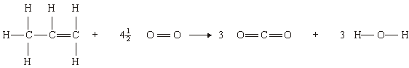
 | (b) | The accepted value for the standard enthalpy of combustion of propene is -2058 kJmol⁻¹. Suggest why this value is different from your answer to 4 (a).  [5]
6. | (a) | State Hess’ Law.
 | (b) | In a reforming reaction, hexane (C₆H₁₄) is converted into benzene (C₆H₆) and hydrogen gas.
 |  | (i) | Write an equation for this reaction.
 |  | (ii) | Use the following information to calculate the enthalpy change for the conversion of hexane into benzene and hydrogen:  - C₆H₁₄(g) + 9.5O₂(g) 6CO₂(g) + 7H₂O(l); ΔHº = -4163 kJmol⁻¹  - C₆H₆(g) + 7.5O₂(g) 6CO₂(g) + 3H₂O(l); ΔHº = -3267 kJmol⁻¹  - H₂(g) + 0.5O₂(g) H₂O(l); ΔHº =-286 kJmol⁻¹  [5]
7. | (a) | Draw a Born-Haber cycle to show the formation of silver fluoride from its elements.
 | (b) | Use your Born-Haber cycle and the information below to calculate the bond dissociation enthalpy of the F-F bond:  [5]
8. | The standard enthalpy of solution of silver chloride is +77 kJmol⁻¹.
 | (a) | Write an equation for the reaction for which the enthalpy change is the standard enthalpy of solution of silver chloride.
 | (b) | Draw an energy cycle to show the changes taking place when silver chloride dissolves in water.
 | (c) | Calculate the hydration enthalpy of the chloride ion, given that the lattice formation enthalpy for silver chloride is -905 kJmol⁻¹ and the hydration enthalpy of the silver ion is -464 kJmol⁻¹.
 | (d) | Comment on the likely solubility of silver chloride in water.  [5]

