DEPARTMENT OF CHEMISTRY
FOURAH BAY COLLEGE – UNIVERSITY OF SIERRA LEONE

CHEM 122

INTRODUCTION TO GROUP CHEMISTRY AND NUCLEAR CHEMISTRY

Unit 1 – Introduction to Group Chemistry

CONTINUOUS ASSESSMENT
TEST

10.00 am Monday 20th August

Answer all questions
Time allowed: 55 minutes

Name: ……………………………………………………

Adm/Reg No. ………………..

Unit 1 Continuous Assessment is worth 15% of the total marks for CHEM 122
Your score will be divided into three parts:
Lecture and Tutorial Attendance 10%
Assignment 40%
Test 50%

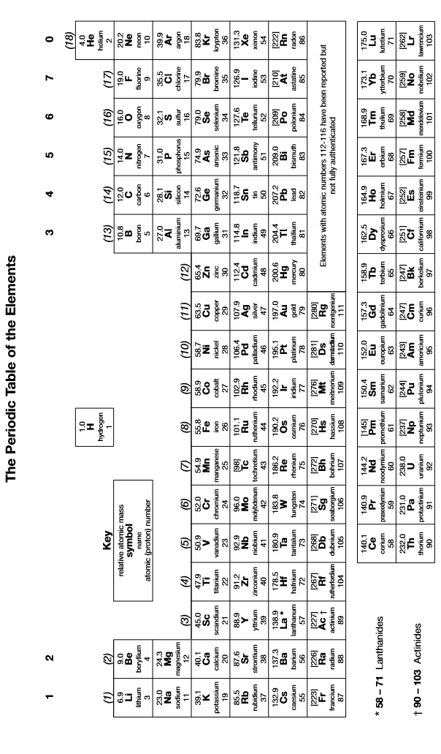
1. | (a) | Describe and explain the general trend in first ionization energy across a period.  …………………………………………………………………………………………………………………………………………………………………………  …………………………………………………………………………………………………………………………………………………………………………  …………………………………………………………………………………………………………………………………………………………………………  …………………………………………………………………………………………………………………………………………………………………………  …………………………………………………………………………………………………………………………………………………………………………
 | (b) | Describe and explain how first ionization energy changes down a group.  …………………………………………………………………………………………………………………………………………………………………………  …………………………………………………………………………………………………………………………………………………………………………  …………………………………………………………………………………………………………………………………………………………………………  …………………………………………………………………………………………………………………………………………………………………………  …………………………………………………………………………………………………………………………………………………………………………  [5]
2. | (a) | Define the term electronegativity.  …………………………………………………………………………………………………………………………………………………………………………  …………………………………………………………………………………………………………………………………………………………………………
 | (b) | Use the concept of electronegativity to explain why sodium is a metal but chlorine is a non-metal.  …………………………………………………………………………………………………………………………………………………………………………  …………………………………………………………………………………………………………………………………………………………………………  …………………………………………………………………………………………………………………………………………………………………………  …………………………………………………………………………………………………………………………………………………………………………  …………………………………………………………………………………………………………………………………………………………………………  …………………………………………………………………………………………………………………………………………………………………………  …………………………………………………………………………………………………………………………………………………………………………  …………………………………………………………………………………………………………………………………………………………………………  …………………………………………………………………………………………………………………………………………………………………………  [5]

3. | (a) | Write an equation for the reaction of lithium with oxygen to form lithium oxide.  …………………………………………………………………………………………………………………………………………………………………………
 | (b) | When sodium reacts with oxygen, a different oxide is formed. Name this oxide and write an equation for the reaction. Explain the difference between the two oxides.  …………………………………………………………………………………………………………………………………………………………………………  …………………………………………………………………………………………………………………………………………………………………………  …………………………………………………………………………………………………………………………………………………………………………  …………………………………………………………………………………………………………………………………………………………………………  …………………………………………………………………………………………………………………………………………………………………………  …………………………………………………………………………………………………………………………………………………………………………  …………………………………………………………………………………………………………………………………………………………………………  …………………………………………………………………………………………………………………………………………………………………………  …………………………………………………………………………………………………………………………………………………………………………  [5]
4. | (a) | Use ideas about polarising power to explain why magnesium chloride is ionic but beryllium chloride is covalent.  …………………………………………………………………………………………………………………………………………………………………………  …………………………………………………………………………………………………………………………………………………………………………  …………………………………………………………………………………………………………………………………………………………………………  …………………………………………………………………………………………………………………………………………………………………………  …………………………………………………………………………………………………………………………………………………………………………  …………………………………………………………………………………………………………………………………………………………………………  …………………………………………………………………………………………………………………………………………………………………………  …………………………………………………………………………………………………………………………………………………………………………
 | (b) | Write equations to show what happens when magnesium chloride and beryllium chloride are added separately to water.  …………………………………………………………………………………………………………………………………………………………………………  …………………………………………………………………………………………………………………………………………………………………………  [5]
5. | (a) | Beryllium and calcium form different carbides. Write the formulae of beryllium carbide and calcium carbide and explain how they are different.  …………………………………………………………………………………………………………………………………………………………………………  …………………………………………………………………………………………………………………………………………………………………………  …………………………………………………………………………………………………………………………………………………………………………  …………………………………………………………………………………………………………………………………………………………………………  …………………………………………………………………………………………………………………………………………………………………………
 | (b) | Describe what would happen if beryllium oxide and calcium oxide were added separately to a solution of sodium hydroxide. Write equations for any reactions occurring.  …………………………………………………………………………………………………………………………………………………………………………  …………………………………………………………………………………………………………………………………………………………………………  …………………………………………………………………………………………………………………………………………………………………………  …………………………………………………………………………………………………………………………………………………………………………  …………………………………………………………………………………………………………………………………………………………………………  [5]
6. | (a) | Explain why the melting point of the alkali metals decreases down the group from Li to Rb.  …………………………………………………………………………………………………………………………………………………………………………  …………………………………………………………………………………………………………………………………………………………………………  …………………………………………………………………………………………………………………………………………………………………………  …………………………………………………………………………………………………………………………………………………………………………  …………………………………………………………………………………………………………………………………………………………………………
 | (b) | Explain why the melting point of the halogens increases down the group from F₂ to I₂.  …………………………………………………………………………………………………………………………………………………………………………  …………………………………………………………………………………………………………………………………………………………………………  …………………………………………………………………………………………………………………………………………………………………………  …………………………………………………………………………………………………………………………………………………………………………  …………………………………………………………………………………………………………………………………………………………………………  [5]

7. | (a) | Describe how you could distinguish experimentally between aqueous solutions of potassium chloride and potassium iodide.  …………………………………………………………………………………………………………………………………………………………………………  …………………………………………………………………………………………………………………………………………………………………………  …………………………………………………………………………………………………………………………………………………………………………  …………………………………………………………………………………………………………………………………………………………………………  …………………………………………………………………………………………………………………………………………………………………………
 | (b) | Describe how you could distinguish experimentally between aqueous solutions of magnesium chloride and barium chloride.  …………………………………………………………………………………………………………………………………………………………………………  …………………………………………………………………………………………………………………………………………………………………………  …………………………………………………………………………………………………………………………………………………………………………  …………………………………………………………………………………………………………………………………………………………………………  …………………………………………………………………………………………………………………………………………………………………………  [5]
8. | (a) | State explain the trend in reducing power of the halides from Cl⁻ to I⁻.  …………………………………………………………………………………………………………………………………………………………………………  …………………………………………………………………………………………………………………………………………………………………………  …………………………………………………………………………………………………………………………………………………………………………
 | (b) | Identify any halogen-containing and sulphur-containing products formed as a result of redox reactions when concentrated sulphuric acid is added separately to solid samples of NaCl, NaBr and NaI. Explain your answer in terms of the relative reducing power of the halides.  …………………………………………………………………………………………………………………………………………………………………………  …………………………………………………………………………………………………………………………………………………………………………  …………………………………………………………………………………………………………………………………………………………………………  …………………………………………………………………………………………………………………………………………………………………………  …………………………………………………………………………………………………………………………………………………………………………  …………………………………………………………………………………………………………………………………………………………………………  [5]

