Course Title: | Basic Physical Chemistry I
Course Code: | CHEM211
Credit Hours: | 2.0
Requires: | 111
Required for: | honours
Course Outline: | How does the vapour pressure of a liquid vary with temperature? What is the link between vapour pressure and boiling point? What is Raoult’s Law? What is an ideal mixture? How can Raoult’s Law be used to generate vapour pressure-composition and boiling point-composition curves for ideal mixtures? Why are some solutions not ideal? What are azeotropes? What is the theory of fractional distillation? What are colligative properties of liquids? How does the presence of non-volatile solutes affect the properties of liquids?  What are electrolytes? What are strong and weak electrolytes? What are the colligative properties of electrolytes? What are Faraday’s Laws of electrolysis? What is meant by the resistance and conductance of solutions and how are they measured? What is meant by the specific conductivity and molar conductivity of solutions and what is a cell constant?  What is the relationship between molar conductivity and concentration for strong and weak electrolytes and why? What is meant by the molar conductivity of an ion? What is limiting molar conductivity and how is it determined for strong and weak electrolytes? What is Kohlrausch’s Law? What are transport numbers and ionic velocities and how are they measured? Why do different ions have different mobilities? How can conductance measurements be used to determine acid dissociation constants and degree of dissociation for weak acids, and solubilities and solubility products of sparingly soluble salts? What are conductometric titrations?
Lesson 1: | Vapour Pressure, Ideal Solutions and Raoult’s Law
Lesson 2: | Non-Ideal solutions and Azeotropes
Lesson 3: | Colligative Properties of Liquids
Lesson 4: | Strong and Weak Electrolytes
Lesson 5: | Resistance and Conductance of Solutions and Faraday’s Laws of Electrolysis
Lesson 6: | Conductivity, molar conductivity and its dependence on concentration
Lesson 7: | Limiting molar conductivity and Kohlrausch’s Law
Lesson 8: | Transport numbers, ionic velocities and ionic mobilities
Lesson 9: | Applications of Conductance Measurements

SECTION 3 – THE BEHAVIOUR OF LIQUIDS AND SOLUTIONS

- PURE LIQUIDS

- In liquids, all particles are close together but able to move past each other because some of the bonds between the particles have been broken. The particles are therefore vibrating as well as moving around. Most of the bonds holding the particles together, however, are still intact.

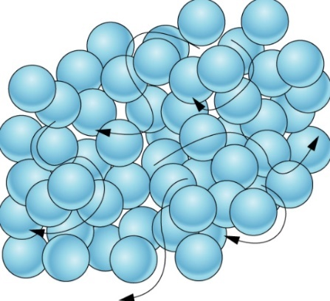
- Liquids do not have a fixed shape and can flow, because the particles can move past each other. Liquids cannot be compressed or squashed because the particles are already close together and have no space to move in to.

- A liquid is a state with lower order (more disorder) and more randomness than a solid.

- As liquids are heated, the particles gain more energy and move around faster. Eventually, the particles have sufficient energy to break the remaining bonds holding the particles together, so the particles are no longer attracted to each other and move apart. When the particles are no longer close together, a change of state from liquid to gas has taken place. This change of state is known as boiling (the reverse is known as condensing).

- Not all particles in a liquid are moving at the same speed at the same time – the speed changes every time two particles collide. Sometimes, particles at the surface of a liquid have enough energy to escape from the liquid and temporarily become gas particles. This process is known as evaporation. As a result, all liquids contain a small amount of vapour immediately above it. The pressure exerted by this vapour is known as the vapour pressure of the liquid. In a closed system, this vapour pressure will reach an equilibrium with the liquid. This pressure is known as the saturated vapour pressure, and it depends on the liquid and the temperature only (ie it is an intrinsic property of the liquid).

- The saturated vapour pressure is the equilibrium constant K_{p} for the following equation:
H₂O(l) H₂O(g)
K_{p} = $\frac{p_{H2O(g)}}{p_{H2O(l)}}$ but because p_{H2O(l)} is fixed, K_{p} = p_{H2O(g)}
ΔGº = -RTlnK_{p} = ΔH – TΔS so lnK_{p} = $\frac{TΔS- ΔH}{RT}$ = $\frac{ΔS}{R}-\frac{ΔH}{RT}$
The ratio of the vapour pressures at two different temperatures, T₁ and T₂, will be $\frac{K_{pT1}}{K_{pT2}}$
So ln($\frac{K_{pT1}}{K_{pT2}}$) = lnK_{pT1} – lnK_{PT2} = $\frac{ΔH}{RT_{2}}- \frac{ΔH}{RT_{1}}$ = $\frac{ΔH}{R}\left(\frac{1}{T_{2}}- \frac{1}{T_{1}}\right)$; this relationship is known as the Van’t Hoff equation
- As the temperature increases, the vapour pressure of the liquid increases. When the vapour pressure of a liquid equals the atmospheric pressure, the liquid turns into a gas.
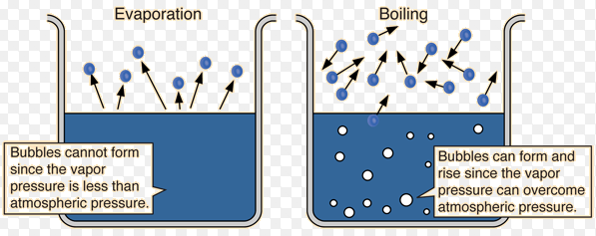

- The temperature at which a liquid turns into a gas is known as the boiling point of the liquid. The standard boiling point of a liquid is therefore the temperature at which the vapour pressure of the liquid is equal to 1 atm pressure (100,000 Pa – this is normal atmospheric pressure).

- SOLUTIONS OF LIQUIDS IN LIQUIDS

- Ideal Solutions

- If two volatile liquids are mixed together to form a solution, then the vapour pressure of each liquid will depend on the mole fraction of each liquid in the solution: p_{A} = $\frac{n_{A}}{n_{T}}$P⁰_{A}, where p_{A} is the partial vapour pressure of liquid A, $\frac{n_{A}}{n_{T}}$ is the mole fraction of A in the mixture and P⁰_{A} is the vapour pressure of pure A. This is known as Raoult’s Law. The total vapour pressure, according to Dalton’s Law, is the sum of the vapour pressures of the components:
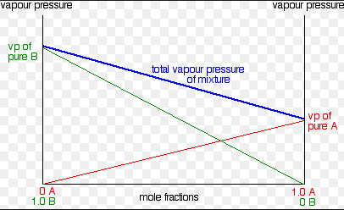www.chemguide.co.uk

- The composition of the vapour above a mixture is generally not the same as the composition of the liquid; the more volatile component will make a larger contribution to the vapour pressure and the vapour will therefore be richer in that component. This means that if a mixture of two components A and B is boiled, and then condensed again, its composition will change.
This change can be shown in boiling point-composition graphs for a mixture of two liquids:
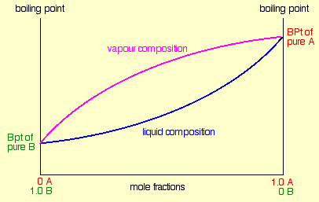 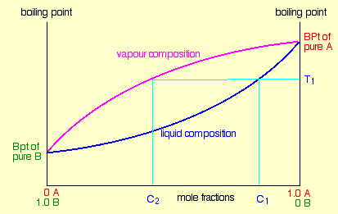www.chemguide.co.uk
- A mixture of composition C₁ will boil at temperature T₁ to give a vapour of composition T₂, which when cooled will give a liquid of composition T₂. This is the basis of fractional distillation.

- A solution which obeys Raoult’s Law is called an ideal solution. It assumes that the ΔH of the mixing process is 0.

- Non-ideal solutions

- Many solutions do not obey Raoult’s Law. If ΔH_{mixing} = +ve, the vapour pressure is higher than predicted by Raoult’s Law. This is known as a positive deviation from Raoult’s Law:

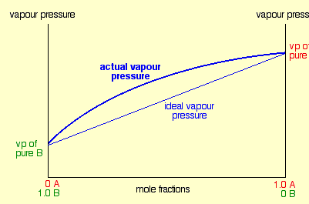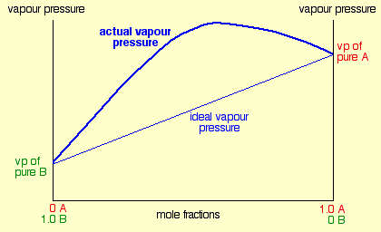
www.chemguide.co.uk
Small positive deviation large positive deviation

- If ΔH_{mixing} = -ve, the vapour pressure is lower than predicted by Raoult’s Law. This is known as a negative deviation from Raoult’s Law:

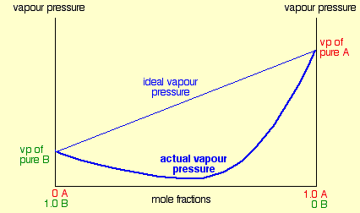www.chemguide.co.uk
Large negative deviation

- If there is a large positive or negative deviation from Raoult’s Law, the vapour pressure at some compositions may be greater (with positive deviations) or lower (with negative deviations) than either pure substance. This means that the boiling points also reach maxima or minima:
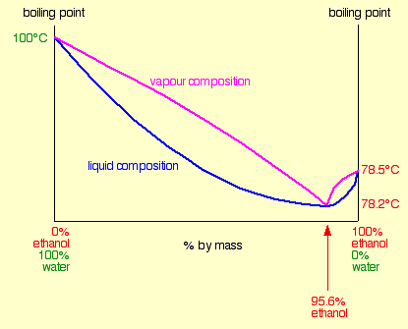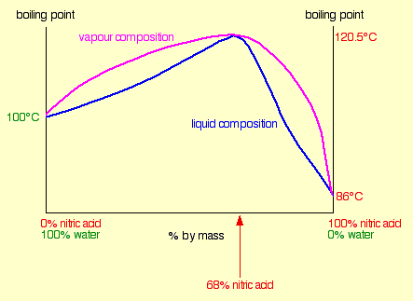
www.chemguide.co.uk
Large positive deviation large negative deviation

- At the compositions at which the boiling point reaches a maximum or minimum, the vapour will have the same composition as the liquid. Such a mixture is called an azeotrope.
- Azeotropic mixtures cannot be separated by fractional distillation, which means that other physical methods are required to separate them
- Mixtures containing a lower composition of A than the azeotrope can be fractionally distilled to give pure A and the azeotrope. Mixtures containing a higher composition of A than the azeotrope can be fractionally distilled to give pure B and the azeotrope.

- SOLUTIONS OF SOLIDS IN LIQUIDS

- Solutions of solids in liquids can be considered as solutions of liquids in liquids, except that the solute is non-volatile and hence has zero vapour pressure.

- Assuming the solution is ideal, the effect of the solute on the behaviour of the solvent depends on the concentration of the solution but not on the identity of the solute. These properties are known as colligative properties.

- Solutions show four important colligative properties which depend on the concentration of the solute
- Reduction in vapour pressure
- Increase in boiling point
- Depression of freezing point
- Osmotic Pressure

- Reduction in Vapour Pressure

- The vapour pressure of a solution containing a non-volatile solvent is always lower than the vapour pressure of the pure solvent.

- Raoult’s Law can be used to predict the effect of a non-volatile solute on the vapour pressure of a liquid. Assuming that the partial vapour pressure of the non-volatile solute B is always zero, the vapour pressure of the solution will be $\frac{n_{A}}{n_{T}}$P⁰_{A}.

- The change in vapour pressure ΔP = P⁰_{A} – P = P⁰_{A} - $\frac{n_{A}}{n_{T}}$P⁰_{A} = P⁰_{A}(1 - $\frac{n_{A}}{n_{T}}$) = P⁰_{A}$\frac{n_{B}}{n_{T}}$
So $\frac{ΔP}{P_{A}^{0}}$ = $\frac{n_{B}}{n_{T}}$

- The ratio of the change in vapour pressure to the vapour pressure of the pure solvent is equal to the mole fraction of the solute.

- Increase in boiling point

- Because solid solutes always lower the vapour pressure of a solution, it follows that they will also increase the boiling point of a solution

- If the change in boiling point is small relative to the original boiling point, and the solution is fairly dilute, it is possible to derive an expression for the change in boiling point as follows:
ΔT_{b} = $\frac{RT_{0}^{2}}{ΔH_{v}n}m$
T_{o} = boiling point of the solvent, $ΔH_{v}$ = enthalpy of vaporisation of the solvent, n = 1000/m_{r} of the solvent and m = molality of the solution

- $\frac{RT_{0}^{2}}{ΔH_{v}n}$ can be converted into the single constant K_{b}, so that ΔT_{b} = K_{b}m

- K_{b} is known as the ebullioscopic constant of the liquid
- Depression of freezing point

- The presence of solutes in a solution also lowers the freezing point of the solution

- If the change in freezing point is small relative to the original freezing point, and the solution is fairly dilute, it is possible to derive an expression for the change in freezing point as follows:
ΔT_{f} = $\frac{RT_{0}^{2}}{ΔH_{m}n}m$
T_{o} = boiling point of the solvent, $ΔH_{m}$ = enthalpy of fusion (melting) of the solvent, n = 1000/m_{r} of the solvent and m = molality of the solution

- $\frac{RT_{0}^{2}}{ΔH_{m}n}$ can be converted into the single constant K_{f}, so that ΔT_{f} = K_{f}m

- K_{b} is known as the cryoscopic constant of the liquid

- Osmotic Pressure

- Osmosis is the movement of solvent through a semi-permeable membrane from an area of low solute concentration to an area of high solute concentration

- The mechanical pressure which must be applied to the solution to prevent osmosis from taking place is called the osmotic pressure (Π) of the solution.

- For dilute solutions, the osmotic pressure can be shown to obey the equation ΠV = nRT (n = number of moles of solute); this is known as Van’t Hoff’s Law for ideal solutions. It can also be expressed as
Π = $\frac{nRT}{V}$ = CRT

SOLUTIONS OF ELECTROLYTES IN LIQUIDS

- Electrochemistry and Electrolytes

- Electrochemistry is the general study of the behaviour of ions in solution.

- In other words, electrochemistry is the study of electrolytes. An electrolyte is a species which can conduct electricity due to the movement of ions. Most electrolytes are liquids (eg aqueous solutions of ionic compounds), but there are some examples of solid electrolytes (eg superionic conductors) and gaseous electrolytes (eg HCl at high temperature or low pressure).

- A narrower interpretation of electrochemistry would be to define it as the relationship between electricity and chemical change – or the study of electrochemical cells. There are two types of electrochemical cell:
- a device which can use electricity to create a chemical change is called an electrolytic cell
- a device which can create electricity as a result of a spontaneous chemical reaction is called a voltaic cell

All electrochemical cells consist of two electrodes and an electrolyte.

- Electrolytes are formed when an ionic compound dissolves in a solvent resulting in the complete separation of the ions, or when a covalent substance dissolves in a solvent and then dissociates into ions. Electrolytes can be classified as strong electrolytes or weak electrolytes, depending on the extent of dissociation:

- Strong electrolytes are those which are fully dissociated in solution:
A_{x}B_{y} xA^{z+} + yB^{z-}
If the molarity of a strong electrolyte is C, the molarity in solution of A^{z+} will be xC, the molarity of B^{z-} will be yC and the molarity of undissociated A_{x}B_{y} will be zero.
A strong electrolyte should be almost fully dissociated at all moderate concentrations.

- Weak electrolytes are only partially dissociated in solution
A_{x}B_{y} xA^{z+} + yB^{z-}
If the molarity of a weak electrolyte is C, the molarity in solution of A^{z+} will be αxC, the molarity of B^{z-} will be αyC and the molarity of undissociated A_{x}B_{y} will be C(1-α); where α is the degree of dissociation of the weak electrolyte.

- The study of electrolytic cells requires an understanding of the basic physical relationships involving electrical charge (Q), current (I), time (t), voltage (V), power (P) and energy (E or W)
Q = It P = VI W = VIt = QV

- Colligative properties of electrolytes

- Colligative properties can be given by the general expression C = kn_{t}
C = colligative property, k = constant, n_{t} = total molarity

- For non-electrolytes = n_{t} = molarity (n), but for electrolytes, n_{t} > n due to the dissociation of the electrolyte; hence solutions of electrolytes show greater colligative effects than solutions of non-electrolytes of the same concentration

- The Van’t Hoff ratio i = ratio of colligative effect of an electrolyte to the colligative effect of a non-electrolyte of the same concentration so i = $\frac{n_{t}}{n}$
C = kn_{t} or C = ikn
The ratio can be used to describe any of the four colligative properties:
i = $\frac{ΔT_{f}}{{\left(∆T_{f}\right)}_{0}}$ = $\frac{ΔT_{b}}{{\left(∆T_{b}\right)}_{0}}$= $\frac{ΔP}{{\left(∆P\right)}_{0}}$= $\frac{Π}{{\left(Π\right)}_{0}}$ = $\frac{C}{C_{0}}$
If the electrolyte is fully dissociated, i should be equal to the total number of ions per molecule v (so for NaCl, i = 2 and for BaCl₂, i = 3)
- If the electrolyte is not fully dissociated, i will also depend on the degree of dissociation.
A_{x}B_{y} = xA^{z+} + yB^{z-}
n(1-α) = xnα + ynα
total moles of electrolyte n_{t} = n – nα + xnα + ynα
= n(1 – α + xα + yα)
= n(1 + α(x + y - 1))
Total number of ions per molecule v = x + y, so n_{t} = n(1 + α(v - 1))
so $\frac{n_{t}}{n}$ = i = 1 + α(v - 1)
So α = $\frac{i-1}{v-1}$
In weak electrolytes, α is small; in strong electrolytes, α = 1

- Electrolysis

- During electrolysis, cations move to the cathode, where there is a reduction half-reaction. Anions move to the anode, where there is an oxidation half-reaction

- Faraday’s 1st Law: mass of a substance produced at electrodes is directly proportional to the quantity of charged passed through the solution
Faraday’s 2nd Law: mass of substances produced at each electrode are directly proportional to their equivalent weights
- Consider the cathode reaction Cu²⁺ + 2e Cu
It is clear that if two moles of electrons are passed through the solution, one mole of Cu will be deposited at the cathode. Each electron carries a charge (e) of 1.6 x 10⁻¹⁹ C, so one mole of electrons carries a charge of eL = 96500 C. This is known as the Faraday constant.
One Faraday of charge will deposit 0.5 moles of Cu (or one equivalent of Cu) at the cathode.
- Consider the anode reaction 4OH⁻ O₂ + 2H₂O + 4e⁻
One Faraday of charge will deposit 0.25 moles of O₂ (or one equivalent of O₂) at the anode.
- Note that one mole of electrons (1 F) only produces 0.5 moles of copper and 0.25 moles of oxygen. The mass of an element produced at an electrode as a result of the passage of 1 F of charge is called the electrochemical equivalent (z) of that element. For Cu, z = 31.8 g, for O, z = 8 g, for Na, z = 23.0 g
- Electrical Conductance of solutions containing electrolytes

- Important terms concerning the electrical conductance of solutions

- In solution, it is usual to measure conductance L rather than resistance R: L = $\frac{1}{R}$

- The resistance of a material, like its conductance, depends on the length of the material (l) and its cross-sectional area (A); in the case of solutions, this means the distance between the electrodes and their cross-sectional area
Resistance can be expressed as R = $\frac{ρl}{A}$; ρ is an intrinsic property of a material at a given temperature and is called the resistivity (units Ωm)
Conductance can be expressed as L = L_{S}$\frac{A}{l}$; L_{S} is an intrinsic property at a given temperature and is called the conductivity (units Ω⁻¹m⁻¹); L_{S} = $\frac{1}{ρ}$; L_{S} can be considered the conductance per metre, or the conductance of the solution when the two electrodes are 1 m apart

- The ratio $\frac{l}{A}$ is known as the cell constant K, so L_{S} = KL or L_{S} = $\frac{K}{R}$. K is fixed for a particular cell, and can be found by measuring the conductance or resistance of a solution of known conductivity in that cell. Once K is known, L_{S} can be determined easily from conductance or resistance measurements.

- The molar conductivity Λ of a solution it its conductivity per unit concentration Λ = $\frac{L_{s}}{C}$
(units Ω⁻¹m²mol⁻¹); (sometimes equivalent conductivity is used instead, which is the conductivity per concentration equivalent)

- The conductance of a solution is in part due to the movement of the cation, and in part due to the movement of the anion: Λ = l₊ + l₋; l₊ and l₋ are the molar ionic conductivities of the individual cation and anion respectively. The conductance of a solution is the sum of the conductances of the ions involved; this is known as Kohlrausch’s Law of independent mobilities Λ = l₊ + l₋

- Measuring the Resistance of a Solution

- Conductance is measured via resistance, which is measured via a Wheatstone bridge.
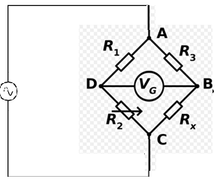
- The cell is placed in the R_{X} position. R₁ and R₃ are known and fixed. R₂ is known and variable.
When $\frac{R_{x}}{R_{3}}$ = $\frac{R_{2}}{R_{1}}$, the potential at points B and D are equal and no current will flow through the ammeter (V_{g}). R₂ is adjusted until this is the case. R_{x} = $\frac{R_{2}R_{3}}{R_{1}}$, and so the resistance of the cell can be calculated.

- In the special case of measuring the resistance of cells, alternating current must be used, as direct current would cause electrolysis and therefore a change in concentration.

- Because the conductance of electrolytes varies so much, it may be necessary to adjust the cell in order to ensure that its resistance allows R₂ to operate within its range. For solutions with very high conductivities, cells with electrodes far apart should be used to reduce the conductance, and for solutions with very low conductivities, cells with electrodes close together should be used to increase the conductance.

- Because the cell behaves as a capacitor, it will store and discharge current which creates an error in the reading. To compensate for this, another variable capacitor should be placed across one of the other resistors whose capacitance should be adjusted so that it compensates for the capacitance of the cell

- It is not possible to measure the conductances of individual ions by this method; it is only possible to measure the conductance of a solution.

- Molar conductivities of solutions

- Weak electrolytes have a much lower molar conductivity than strong electrolytes, as the degree of dissociation is much lower. According to the laws of chemical equilibrium, the degree of dissociation of a weak electrolyte will decrease as the concentration of electrolyte increases; in other words, the dissociation is highest at very low concentrations. It can be shown that for very weak electrolytes at relatively high concentrations, α $∝$ $\frac{1}{\sqrt{C}}$. The electrolyte is only fully dissociated in infinitely dilute solutions.
- The molar conductivities of weak electrolytes therefore decrease significantly with increasing concentration due to the smaller degree of dissociation of the electrolyte.

- Strong electrolytes are fully dissociated at almost all concentrations and so according to Arrhenius theory, the molar conductivity of strong electrolytes should be independent of concentration. It is observed, however, that molar conductivity decreases with increasing concentration even for strong electrolytes. The decrease in molar conductivity of strong electrolytes with increasing concentration can be explained by the Debye-Huckel theory of interionic attraction:
- Ions in solution do not behave independently of each other but are attracted to each other; as a result each ion is surrounded by more ions of opposite charge than of the same charge. This is called the ionic atmosphere of an ion.
- When a potential difference is applied, the ionic atmosphere becomes distorted as the ion starts moving in the opposite direction to its atmosphere; the force exerted by the atmosphere behind the ion than in front of it, which slows the ion down and reduces the molar conductivity
- In addition, many of the solvent molecules are attached to the oppositely charged ion and therefore moving in the opposite direction, making it more difficult for the ion to move
- Both of these effects are more pronounced at increasing concentration, and hence the molar conductivity decreases with increasing concentration
- The molar conductivity of strong electrolytes decreases with increasing concentration because interionic attractions are more significant at higher concentrations.

- The following graph shows the variation of molar conductivities of strong and weak electrolytes with concentration:

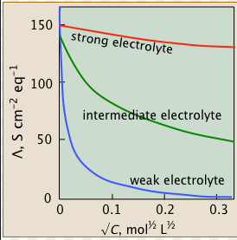www.chem.libretexts.org

- Note that although molar conductivity decreases with increasing concentration for all electrolytes, the variation is much stronger for weak electrolytes because of the different reasons for the variation

- Limiting Molar Conductivity

- Molar conductivities reach an upper limit, as the concentration becomes so low that dissociation is complete (for weak electrolytes) and the effect of interionic attractions is negligible (for strong electrolytes).

- This upper limit is called the limiting molar conductivity or the molar conductivity at infinite dilution (Λ_{o}). It is an intrinsic property of the solute, and a measure of its ability to move through a potential difference in the absence of any interionic effects.
- The ratio of molar conductivity to the limiting molar conductivity $\frac{Λ}{Λ_{0}}$ is called the conductivity ratio. In weak electrolytes the conductivity ratio is the degree of dissociation: α = $\frac{Λ}{Λ_{0}}$ but in weak electrolytes the conductivity ratio depends on the strength of the interionic attractions.

- At infinite dilution, when dissociation is complete and there are no interionic effects, the limiting molar conductivities of each ion l⁰₊ and l⁰₋ should be independent of each other and so also have a fixed value at a particular temperature

- Kohlrausch’s Law can be used to predict the Λ₀ value of a solution without measuring it directly – if the Λ₀ value of three solutions AC, AD and BC are known, the Λ₀ value of solution BD can be determined:
Λ⁰_{BC} + Λ⁰_{AD} - Λ⁰_{AC} = Λ⁰_{BD}
Λ⁰_{BC} + Λ⁰_{AD} - Λ⁰_{AC} = l⁰_{B} + l⁰_{C} + l⁰_{A} + l⁰_{D} - l⁰_{A} - l⁰_{C} = l⁰_{B} + l⁰_{D} = Λ⁰_{BD}

- The limiting molar conductivity of strong electrolytes can be measured using a relationship observed by Kohlrausch - that the variation of Λ with √C is linear for strong electrolytes at low concentrations:
Λ = Λ₀ - b√C.
Λ₀ for strong electrolytes can therefore be deduced by measuring the molar conductivities at different concentrations, plotting a graph of Λ against √C and extrapolating the line to C = 0.

This method does not work for weak electrolytes as the concentrations required for the Λ vs √C relationship to be linear are so low that the dissociation of water becomes a significant contributor to the total conductance. Λ₀ for weak electrolytes must be determined by Kohlrausch’s Law – the Λ₀ of a weak electrolyte BD can be determined from the Λ₀ of three strong electrolytes AC, AD and BC.

- Transport numbers

- The transport number (t₊ or t₋) of an ion in an electrolyte is the fraction of the total current it carries. Ions with higher l₀ values move faster than ions with lower l₀ values and so carry a greater proportion of the total current.
t₊ = $\frac{I_{+}}{I}$ and t₊ + t₋ = 1
The transport number must be related to the ionic molar conductivities as follows:
l₊ = t₊Λ l₋ = t₋Λ

- The ratio of transport numbers (and hence ionic molar conductivities) is also the ratio of the velocities of the two ions:
If an ion is moving at velocity v m/s between two plates d m apart, the total charge carried by the ion in
one second will be the total number of ions n, multiplied by the charge on each ion ze, multiplied by the proportion able to reach the electrode in one second $\frac{v}{d}$
So I⁺ = $\frac{N_{+}v_{+}z_{+}e}{d}$ I⁻ = $\frac{N_{-}v_{-}z_{-}e}{d}$ so I = $\frac{N_{-}v_{-}z_{-}e +N_{+}v_{+}z_{+}e }{d}$
Due to the electrical neutrality of solutions n₋z₋ = n₊z₊ = nv, where nz is the total charge (+ or -)
So I = $\frac{Nze\left(v_{+}+v_{-}\right)}{d}$ so t₊ = $\frac{I_{+}}{I}$ = $\frac{v_{+}}{v_{+}+ v_{-}}$ and t₋ = $\frac{I_{-}}{I}$ = $\frac{v_{-}}{v_{+}+ v_{-}}$ and therefore $\frac{t_{+}}{t_{-}}$ = $\frac{v_{+}}{v_{-}}$.

- It is possible to determine transport numbers experimentally by the Hirtoff method. This is because unequal velocities of two ions will result in a build up of ions at the electrode to which the faster ion is migrating and a shortage of ions at the electrode to which the slower ion is migrating. Faster ions will migrate into or out of an electrode compartment more rapidly than anion. This is the basis of Hirtoff’s rule, which states that the increase of decrease in the number of ions in an electrode due to migration is directly proportional to the velocity of the ion, which is in turn proportional to the transport number:
$\frac{Δn_{+}z_{+}}{Δn_{-}z_{-}}$ =$\frac{v_{+}}{v_{-}}$ = $\frac{t_{+}}{t_{-}}$
Hirtoff’s rule can be used to determine transport numbers experimentally by the following method:
- from orginal concentration, determine original moles of ion in electrode compartment
- by analysis, determine final moles of ion in electrode compartment
- hence calculate change in moles of ion in electrode compartment
- from total Faradays used, calculate expected change in moles of ion due to electrolysis
- hence determine change in moles of ion due to migration
- hence determine change in charge passed due to migration of that ion
- calculate the transport number by expressing this charge as a fraction of the total charge passed

- It is also possible to determine transport numbers experimentally by the moving boundary method.
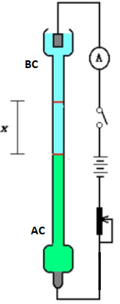
A cell is arranged vertically with cathode at the top and the anode at the bottom. In order to determine the transport number of a cation B in a solution of BC, two different solutions AC and BC – C being an anion common to both solutions - should be placed in the vessel, one (AC) at the bottom surrounding the anode and one (BC) at the top surrounding the cathode. Solution AC should have a higher density than solution BC the solution at the top so that a clearly visible boundary can form between the two solutions, and the electrode at the anode should be made of A (ie the same as the cation in AC) so that the electrode dissolves during electrolysis. Usually, the anode is made of cadmium and solution AC is cadmium chloride. During electrolysis, Cd dissolves in the anode and B migrates upwards to the cathode. The boundary will therefore move upwards.
- measure the distance x moved by the boundary
- record It and hence Q, the total charge passed
- measure x, the distance moved by the boundary, and hence calculate the volume of solution displaced (=Ad, where A is the cross-sectional area of the vessel)
- hence the number of moles of solution BC, and hence of cation B, which has been displaced
- hence calculate the total charge displaced due the migration of B
- calculate the transport number of B by expressing this number as a fraction of the total charge passed

If an ion is moving at velocity v m/s between two plates d m apart, the total charge carried by the ion in
one second will be the total number of ions n, multiplied by the charge on each ion ze, multiplied by the proportion able to reach the electrode in one second $\frac{v}{d}$
So I⁺ = $\frac{n_{+}v_{+}z_{+}e}{d}$ I⁻ = $\frac{n_{-}v_{-}z_{-}e}{d}$ so I = $\frac{n_{-}v_{-}z_{-}e +n_{+}v_{+}z_{+}e }{d}$
Due to the electrical neutrality of solutions n₋z₋ = n₊z₊ = nv, where nz is the total charge (+ or -)
So I = $\frac{nze\left(v_{+}+v_{-}\right)}{d}$ so t₊ = $\frac{I_{+}}{I}$ = $\frac{v_{+}}{v_{+}+ v_{-}}$ and t₋ = $\frac{I_{-}}{I}$ = $\frac{v_{-}}{v_{+}+ v_{-}}$ and therefore $\frac{t_{+}}{t_{-}}$ = $\frac{v_{+}}{v_{-}}$.

- By measuring transport numbers, it is therefore possible to calculate molar conductivities of individual ions if the total conductivity of the solution is known. This is how individual ionic molar conductivities can be determined.

- Ionic velocities

- Ionic velocities can be measured directly by the moving boundary method: v = x/t

- It is also possible to deduce ionic speeds from molar ionic conductivities as follows:
We know that I = $\frac{nze\left(v_{+}+v_{-}\right)}{d}$
n and z are the number and charge of either ion, v₊ and v₋ are the speeds of the individual ions and d is the distance between the electrodes
If one mole of electrolyte A_{x}B_{y} dissociates fully into xA^{z+} + yB^{z-}, the solution will contain x moles of A^{z+} and y moles of B^{z-} and xz⁺ = yz⁻.
So one mole of electrolyte contains Nxz⁺ or Nyz⁻ ions (call this quantity Nxz)
So for one mole of A_{x}B_{y},I = $\frac{Nxze\left(v_{+}+v_{-}\right)}{d}$ = $\frac{zxF\left(v_{+}+v_{-}\right)}{d}$
Λ = $\frac{L_{s}}{C}$ so L_{S} = ΛC L = L_{S}$\frac{A}{d}$ so L = $\frac{ΛCA}{d}$ so I = VL = $\frac{VΛCA}{d}$
The concentration of A ions is xC = $\frac{xn}{V}$ = $\frac{xn}{Ad}$, so I = $\frac{VΛCA}{d}$ = $\frac{VΛxn}{d^{2}}$
So I for one mole of A_{x}B_{y} = $\frac{VΛx}{d^{2}}$
therefore $\frac{VΛx}{d^{2}}$ = $\frac{Fxz\left(v_{+}+v_{-}\right)}{d}$, so $\frac{V}{d}Λ$ = $Fz\left(v_{+}+v_{-}\right)$, so Λ = Fz$(\frac{v_{+}}{\frac{V}{d}}$ + $\frac{v_{-}}{\frac{V}{d}})$
V/d is the voltage gradient (in Vm⁻¹). The velocity of an ion per unit voltage gradient is called the ionic mobility (μ₊ or μ₋) of an ion. The equation than therefore be written: Λ = Fz(μ₊ + μ₋) = Fzμ₊ + Fzμ₋

But Λ = l₊ + l₋, which suggests that l₊ = Fzμ₊ and l₋ = Fzμ₋, so μ₊ = $\frac{l_{+}}{Fz}$ and μ₋ = $\frac{l_{-}}{Fz}$

- The ionic velocities can be calculated from the ionic mobilities using μ = $\frac{vd}{V}$ so v = $\frac{μV}{d}$

- For weak electrolytes, Nxz becomes αNxz, so μ₊ = $\frac{{αl}_{+}}{Fz}$

- Explaining differences in molar conductivities of ions

- The molar conductivity of an ion depends on the mass of the ion (ions with lower mass move faster), the cross-sectional area of the ion (ions with a lower cross-sectional area move faster) and the charge of the ion (ions with a higher charge move faster).

- The effect of charge is clearly apparent in the conductivity data of different ions. Ions with a +2 charge have molar conductivities approximately twice as high as ions with a +1 charge. This effect can be eliminated by considering the equivalent conductivities.

- The effect of mass and area, however, is less clear – in fact some small ions with low m_{r} values such as Li⁺ appear to have low conductivities. This is because ions in solution are hydrated – which means that they are surrounded by water. So the formula of aqueous Li⁺ is actually Li(H₂O)_{n}⁺, and the value of n is different for different ions. In fact, the smaller the ion, the greater its charge density, so the greater the number of water molecules it attracts and the larger the hydrated ion. As a result, there is no clear correlation between ionic size and mass and ionic conductivity – the lower conductivity of small ions can be explained by the higher degree of hydration.

- H⁺ and OH⁻ have a much higher conductivity than all other ions in aqueous solution. This is because these ions are able to move through water in a different way from other ions, which have to migrate gradually through the water and other ions.
- When H⁺ and OH⁻ are hydrated in water, they form complex ions with the formula (H_{2n+1}O_{n})⁺ and
(H_{2n-1}O_{n})⁻. The hydrated H⁺ ion is often simplified to H₃O⁺. When these ions collide with water molecules, H⁺ ions can be passed from one molecule to another simply by the movement of a lone pair of electrons on the oxygen atom:
H₃O⁺ H₂O H₂O H₂O H₂O
H₂O H₃O⁺ H₂O H₂O H₂O
H₂O H₂O H₃O⁺ H₂O H₂O
H₂O H₂O H₂O H₃O⁺ H₂O
H₂O H₂O H₂O H₂O H₃O⁺
- The same thing can happen with OH⁻
OH⁻ H₂O H₂O H₂O H₂O
H₂O OH⁻ H₂O H₂O H₂O
H₂O H₂O OH⁻ H₂O H₂O
H₂O H₂O H₂O OH⁻ H₂O
H₂O H₂O H₂O H₂O OH⁻
- So the higher mobility of H⁺ and OH⁻ ions in solution is because they can be passed from hydrated ion to hydrated ion without having to migrate. All other ions have to migrate

- Applications of Conductance Measurements

(α) Determining degree of dissociation and acid dissociation constants

- For weak electrolytes, α = $\frac{Λ}{Λ_{0}}$, and so α can be determined from conductance measurements

- This can be used to determine the acid dissociation constant K_{a}:
K_{a} = $\frac{\left[H^{+}\right]\left[A^{-}\right]}{\left[HA\right]}$ = $\frac{\left(αC\right)\left(αC\right)}{\left(1- α\right)C}$ = $\frac{α^{2}C}{\left(1- α\right)}$

(β) Determining the solubility and solubility products of sparingly soluble salts

- The solubility of a sparingly soluble salt can be determined by measuring the conductance of a saturated solution of the salt.

- At very low concentrations, the conductance of water becomes significant and so must be taken into account.

- L_{S} = L_{S(salt)} + L_{S(water),} so L_{S(salt) =} L_{S} - L_{S(water)}
L_{S(salt)} = ΛC so C = $\frac{L_{s\left(salt\right)}}{Λ}$

- Assuming Λ = Λ_{o} because the concentration is low, the concentration can be estimated from the following calculation: C = $\frac{L_{s}}{Λ_{0}}$

(γ) Determining the degree of dissociation and the ionic product of water

- The degree of dissociation of water can be determined by measuring the L_{S} of pure water
- The molarity C of water can be determined from its density: C = $\frac{n}{V}$ = $\frac{m}{Vm_{r}}$ = $\frac{ρ}{m_{r}}$

- Therefore Λ for pure water can be deduced from the equation L_{S} = ΛC = $\frac{Λρ}{m_{r}}$ so Λ = $\frac{L_{S}m_{r}}{ρ}$

- Λ₀ for pure water = l⁰_{H+} + l⁰_{OH-} so α = $\frac{Λ}{Λ_{0}}$ = $\frac{L_{S}m_{r}}{ρΛ_{0}}$

- [H⁺] = [OH⁻] = αC = $\frac{αρ}{m_{r}}$ = $\frac{L_{S}}{Λ_{0}}$ so K_{w} = [H⁺][OH⁻] = ($\frac{L_{S}}{Λ_{0}}$)²

(δ) Determining concentration by conductimetric titrations

- Because different ions have different mobilities, the conductance of a solution will change as the ions present in solution change.

- The determination of an equivalence point by monitoring changes in conductance is called a conductometric titration.

- Conductometric titrations are most commonly used to determine the equivalence point of precipitation reactions. Conductance decreases rapidly as the insoluble salt is formed, before increasing rapidly again after the equivalence point.

- Conductometric titrations are also useful in acid-base titrations, especially if the solution is coloured (which means that indicators cannot be used). The variation of conductance with the volume of base added depends on whether the acid and base are strong or weak.
Strong acid-strong base titrations:
- on addition of base, the highly mobile H⁺ is replaced with the less mobile Na⁺ so the conductance decreases rapidly
- the conductance then increases rapidly after the equivalence point as [OH⁻] increases
Weak acid-strong base titrations:
- on addition of base, there is an initial decrease in conductance as H⁺ is replaced by the less mobile Na⁺, but the conductance then increases slowly as the weak electrolyte (with H⁺) is replaced with a strong electrolyte (without H⁺)
- conductance then increases rapidly after the equivalence point as [OH⁻] increases
Strong acid-weak base titrations:
- on addition of base, the highly mobile H⁺ is replaced with the less mobile Na⁺ so the conductance decreases rapidly
- after the equivalence point, there is little change in conductance as the additional weak base is unable to dissociate in the presence of its salt
Weak acid-weak base titrations:
- on addition of base, there is an initial decrease in conductance as H⁺ is replaced by a less mobile cation, but the conductance then increases slowly as the weak electrolyte (with H⁺) is replaced with a stronger electrolyte (without H⁺)
- after the equivalence point, there is little change in conductance as the additional weak base is unable to dissociate in the presence of its salt
- The graphs of conductance vs volume of base added for the different types of acid and base are shown below:
