6.2 CLASS WORKSHEET - PROPERTIES OF RADIATION AND RADIOACTIVE ISOTOPES

1. Ionizing and penetrating power of radiation

Complete the following table by adding the words “high”, “medium” or “low”

Type of Radiation | Ionizing Power | Penetrating Power
alpha
beta
gamma

2. Calculating and using half-lives

(a) | Magnesium-28 is radioactive. A sample of magnesium-28 was monitored over several days and its rate of decay is shown in the graph below:  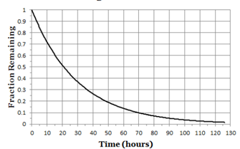
 | (ii) | Use the graph above to note the time taken for:
 |  |  | Time
 |  | 50% of the sample to decay
 |  | 75% of the sample to decay
 | (iii) | Hence estimate the half-life of magnesium-28

(b) | (i) | Uranium-238 has a half-life of 160,000 years.  Marcus has 2000 atoms of uranium-238.
 |  | (α) | How many uranium-238 atoms will she have after 540,000 years?
 | (ii) | Janika has some radium-224. It is radioactive.  She notices that after 14.5 days her sample is emitting radiation at 6.25% of its original rate.  What is the half-life of radium-224?

